OurFamilyWizard

Fee Waiver Program
Our Family Wizard (OFW)
Fee Waiver Program Information
OFW Website: https://www.ourfamilywizard.com/

FIRST COMPLETE THE FOLLOWING:

- I received pro-bono dependency court co-mediation services from: SOUTHERN CALIFORNIA FAMILY MEDIATION.
- Date of Mediation: Click or tap here to enter text.
- My Name: Click or tap here to enter text.
- Co-Parent’s Name: Click or tap here to enter text.
- Additional Co-Parent’s Name (if any): Click or tap here to enter text.

NEXT PROCEED TO:

OFW Fee Waiver Application: https://www.ourfamilywizard.com/plans-and-pricing/scholarships

START YOUR APPLICATION

Note: You will need your co-parent’s phone number. However, since co-parents may not know. I guess, you might just put anything in there?

Fee waiver application

Eligibility reason
Choose:
- I am receiving legal services pro bono or at a reduced rate
- Documentation needed: Signed letter from the professional on their letterhead dated within the past 12 months.
- I received pro-bono co-mediation services from: SOUTHERN CALIFORNIA FAMILY MEDIATION IN July of 2025.

CONTINUE


- I received pro-bono co-mediation services from: SOUTHERN CALIFORNIA FAMILY MEDIATION IN July of 2025.

UPLOAD THIS ACTUAL DOCUMENT: OFW Fee Waiver - SCFM
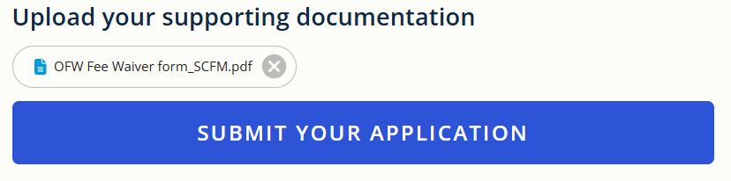

TADA! We did it together!

Would you or anyone you know like to invest in Peace by supporting SoCal Family Mediation volunteers? Invest in Peace>> https://www.paypal.com/paypalme/SCFamilyMediation
Mail checks to: SoCal Family Mediation PO Box 7576 Burbank CA 91510

