MINUTES OF THE
BOROUGH OF BURY VETERANS ASSOCIATION MEETING HELD IN FISHPOOL LIBERAL CLUB,
79 NELSON STREET, BURY, BL9 9HX,
AT 1200 HRS ON SUNDAY 02nd JUNE 2019

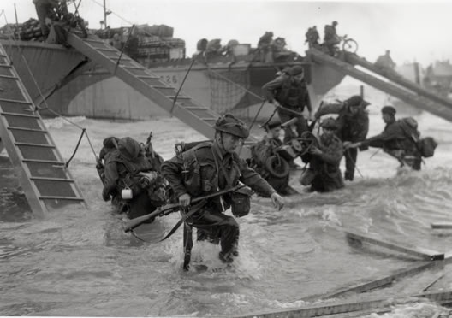

Picture: Commandos on Juno Beach D-Day 1944. Source: Google
Apologies for Absence:
Army Sec; Owen Dykes RA, Civ Sec; Leah Simmons, Entertainments Coordinator; Roy Counsell RLC, Welfare Officer; Marina Jones.
Present:
Committee:
President; Chris Harness RCT/RLC, Treas Steve Collins, RN Chmn; Leanne Rothwell RN, RN Secretary; Kevin Rowe RN. Army Chmn; Baz Phillips RGJ, RAF Chmn; Paul Newton RAF, RAF Secretary; Debbie Wilson RAF, Civ Chmn; Shirley Simmons, Civ Sec; Sam Phillips, Saddleworth Coordinator: Nikki Grey RAF; Assn Photographer; Anthony Dalton-Hughes RRF.
Members:

ROYAL NAVY:
.
ARMY:
.
ROYAL AIR FORCE:
.
CIVILIAN:
.
(TOTAL IN ATTENDANCE: 67).
Presiding Member:
- Welcome Ladies and Gentlemen to the meeting, please be upstanding for the Loyal Toast.
  - Her Majesty, The Queen.
- Ladies and Gentlemen, please remain standing for a number of dedications, the eulogy followed by two minute’s silence to remember Our Fallen Comrades.
Led by: Gary Best RGJ.
“They shall grow not old as we that are left grow old:
Age shall not weary them nor the years condemn,
At the going down of the sun and in the morning
we will remember them.”
(one minute’s silence).
Ladies and Gentlemen Our Fallen Comrades.
Our Fallen Comrades.
- Previous Minutes and Matters Arising. Hopefully, you have all seen the previous minutes either electronically or hard copy, has anyone not seen them? Is anyone having difficulty obtaining a copy? Are there any points from anyone?
No points were raised.
- The Veterans Afternoon Tea with The New Mayor of Bury -26th June 2019. To mark Armed Forces week the new Mayor of Bury is holding an Afternoon Tea for veterans on 26th June 2019 from 4 bells afternoon watch (1400 hrs / 2pm) to 8 bells of same watch (1600 hrs / 4pm) at The Mayor’s Parlour, Bury Town Hall. If you would like to attend you need to book your place either via email engagement@bury.gov.uk or telephone 0161 253 7931. Places are limited.
Treasurer:
- Branch Accounts: In summary as at 02nd Jun 2019:
May 2019 bank balance: £
Paid In: £
Paid Out: £
Jun 2019 bank balance: £
  - Are there are any questions regarding the account?
- Association Subscriptions. A reminder that subscriptions are now due, £10 per member, £4 OAP, over 80s free. Payment can be made via cash, cheque or online, ask for bank details.
  - Individuals who are not online can setup a standing order if they so wish, please ask for bank details if you need them.
Royal Navy Chair:
- Gibraltar Trip 3rd – 5th April 2020. Form is up on the board, please put your name down if interested and also if you are willing to share a room to keep the cost down. Please come and speak to me or a member of the committee if you are wanting to attend but not wanting to share a room.
Prices we received for this year including flights were:
*Single room £299 - £389 per person.
*Double room £236.50 - £289 per person.
- Xmas Party 2019.
  - We would like to propose to hold a "Mess Dinner" type Xmas event, this would be a formal event with distinguished guests invited.
  - I have been in contact with a few venues, and I have been able to gain a fantastic deal with The Village Hotel at a price of £25.00 a ticket for both members and guests, this will include:
    - Drink on arrival (glass of house wine, bottled beer or soft drink).
    - 3 Course Meal.
    - Tot of Port or Rum for toasts.
    - DJ.
    - A guaranteed NO Baz Phillips singing.
    - 10% discount on rooms if you wish to stay the night, individual to book.
    - As an indicator the Imperial War Museum wanted £80 per ticket for a similar package.
  - Dress: Blazers and medals (no headdress) if possible, please. No jeans, no trainers.
  - There will be a small raffle which will include 2 prizes donated by The Village Hotel:
    - 1 for an overnight stay for 2 including breakfast, and
    - 1 for a carvery meal for 2.
  - A list will be up at the next meeting, we will require a £13 non-refundable deposit per ticket and the balance of £12 at the start of October 2019 please.
  - Can I ask please for a show of hands of those that are interested and if the price point is acceptable. Does anyone have any comments?
- Association Merchandise. Wristbands. We have ordered some wristbands which we are hoping to have before Armed Forces Day. These will be on sale at £1 per band, all proceeds to the Association.

- Royal British Legion D-Day 75th Anniversary Poppy Collection. I have 50 of these 75th Anniversary pins. They are priced at £3 each and money will be going to RBL towards the poppy collection. Anyone interested in one please see me after the meeting.
Royal Navy Secretary:
- Standard Bearers. We are putting together a directory of standard bearers; please add you name to the list on the board if you are already a standard bearer of if you would like to be trained as bearer. Can you also please indicate if you are able to instruct on standard bearing. Thanks.
- Armed Forces Day Manchester - 29th June 2019. We are still awaiting firm details for Manchester Armed Forces Day. We will have a stall in St Peters Square which will be advertising the Association. There is also a similar Armed Forces Day event in Bolton where we will also have a stall shared with the RAF Association. Please try and support 1 of the events.
Army Chairman:
- Service of Remembrance, Heywood – Saturday 22nd June 2019. Last reminder at 1100 hrs on Saturday 22nd June 2019 there will be a Service of Remembrance in Heywood Remembrance Gardens to commemorate the 'Forgotten Wars', Aden, Korea, Far East & Falklands, and the 50th Anniversary of Operation Banner 14th August 1969 – 31st July 2007.
  - Form up at 1045 for service at 1100 and then back to The Heywood pub.
  - Parking is expected to be limited, please allow plenty of time to find a parking bay.
Army Secretary:
- My apologises for my absence however I am at the Zone in Bury doing a Sparthron with my youngest daughter Tarryn. Thank you to everyone that sponsored her, if you are in Bury after the meeting then please drop in at the zone and have a laugh at me getting my arse kicked and throw some change in the pot.
- Forever Manchester CarFinance 247. We have again been fortunate to receive funding award from CarFinance 247 for £1000.
- Photo Board. I am still after photos for the photo board, copies of photos of members service life, on exercise, on barracks, on operational tours, at sea on boats for the Navy and in hotels for the RAF. You can either send the photos to me by email or PM on facebook or give me permission to raid your Facebook accounts. Thanks to the members who have already sent me photos and also given me permission to raid their Facebook accounts.
- Manchester 10km. Thank you to everyone for their support for the BOBVA team that ran the Manchester 10km, Gary Best couldn’t handle his excitement as he ran past Old Trafford, also thank you to everyone that shared the shining light campaign to family and friends.
RAF Chairman:
- RAF Cosford Air Show – 09th June 2019. Just two tickets left. For those that are travelling:
  - Travel time to Cosford is approximately 2 hours, access to the event is extremely busy and we have been advised that it can take up to an hour to get parked up. The coach will therefore be leaving Bury at 0715 hrs, we ask that those attending are at the Fusilier Museum at 0700 hrs so we can depart promptly. We should be at Cosford parked up by 1015. We ask for your patience on arrival.
  - Flying displays start at 1200 hrs and finishes at 1730 hours. Please be back at the coach for 1800 hrs to return to Bury, again please be patient as exit can take some amount of time but we would hope to be back in Bury at around 2130 hrs.
- RAF Association / BOBVA Collection. Recently there was a stall at Tesco in Bury raising funds for the RAF Association and our Association. A big thank you to Debbie Wilson managed to collect over £300. Well done Debbie!
- Eden Camp Trip – 08th September 2019. List is up at the back, please add your names. Camp Modern History Theme Museum located at Malton in Yorkshire; details of Eden camp can be found at https://www.edencamp.co.uk/. Again, list on the board.
RAF Secretary:
- Nothing to report.
Civilian Chair:
- Nothing to report.
Civilian Secretaries:
- Nothing to report.
Welfare Officers:
- Nothing to report.
Entertainments Coordinator:
- Armed Forces Day Bay Horse, Unsworth – Sunday 30th June 2019. Similar to last year BBQ, singer, maybe a raffle and the infamous Roy Counsells’ Play Your Cards Right.
- Yorkshire Wartime Experience – Saturday 06th July 2019. Full details to follow as soon as we have this trip finalised.
Saddleworth Coordinator:
- For those that have put their names down to volunteer, can you please tick the sheet if you want to attend the Victory Spring Ball on the Saturday evening. Thanks.
Association Photographer:
- Anyone who needs a photo for an ID Card, or simply needs to check if their ID Card has arrived, please see me after the meeting.
Any Other Business:
- Range Day. Paul Kerr. Lots of interest in this, list on the board as usual, date TBC. Leanne Rothwell suggested that we build on the range day and develop an interservice competition. Any suggestions for similar events please speak to a member of the committee.
- 75th D-Day Anniversary – 6th June 2019. Kevin Heselwood. A ceremony to mark the 75th anniversary of D-Day. Meetup at the memorial in Bury at 0645, service commences 0700 hrs on 06th June 2019. After the service breakfast at a local establishment.
Closing Remarks:
- Anyone with any suggestions for trips or otherwise please speak to a member of the committee and we will see what can be done.
- As usual sandwiches are available, thanks to Vikie and Tim Murphy.
- We once again would like to thank everyone for your continued support.
NEXT ASSOCIATION MEETING WILL BE HELD AT
FISHPOOL LIBERAL CLUB, 79 Nelson St, Bury BL9 9HX,
COMMENCING AT 1200 HRS SUNDAY THE 07th JULY 2019.

Borough of Bury Veterans Association Key Personnel:
email: boroughofburyveterans@gmail.com

PRESIDENT | Chris Harness MBE RCT/RLC.  Email: buryveteranspresident@gmail.com  Contact Number: 07792699684
TREASURER  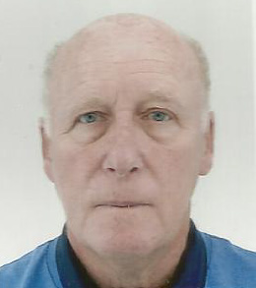 | Steve Collins RN.  Email: buryveteransassoctreasurer@gmail.com.  Contact Number:
ROYAL NAVY CHAIRMAN  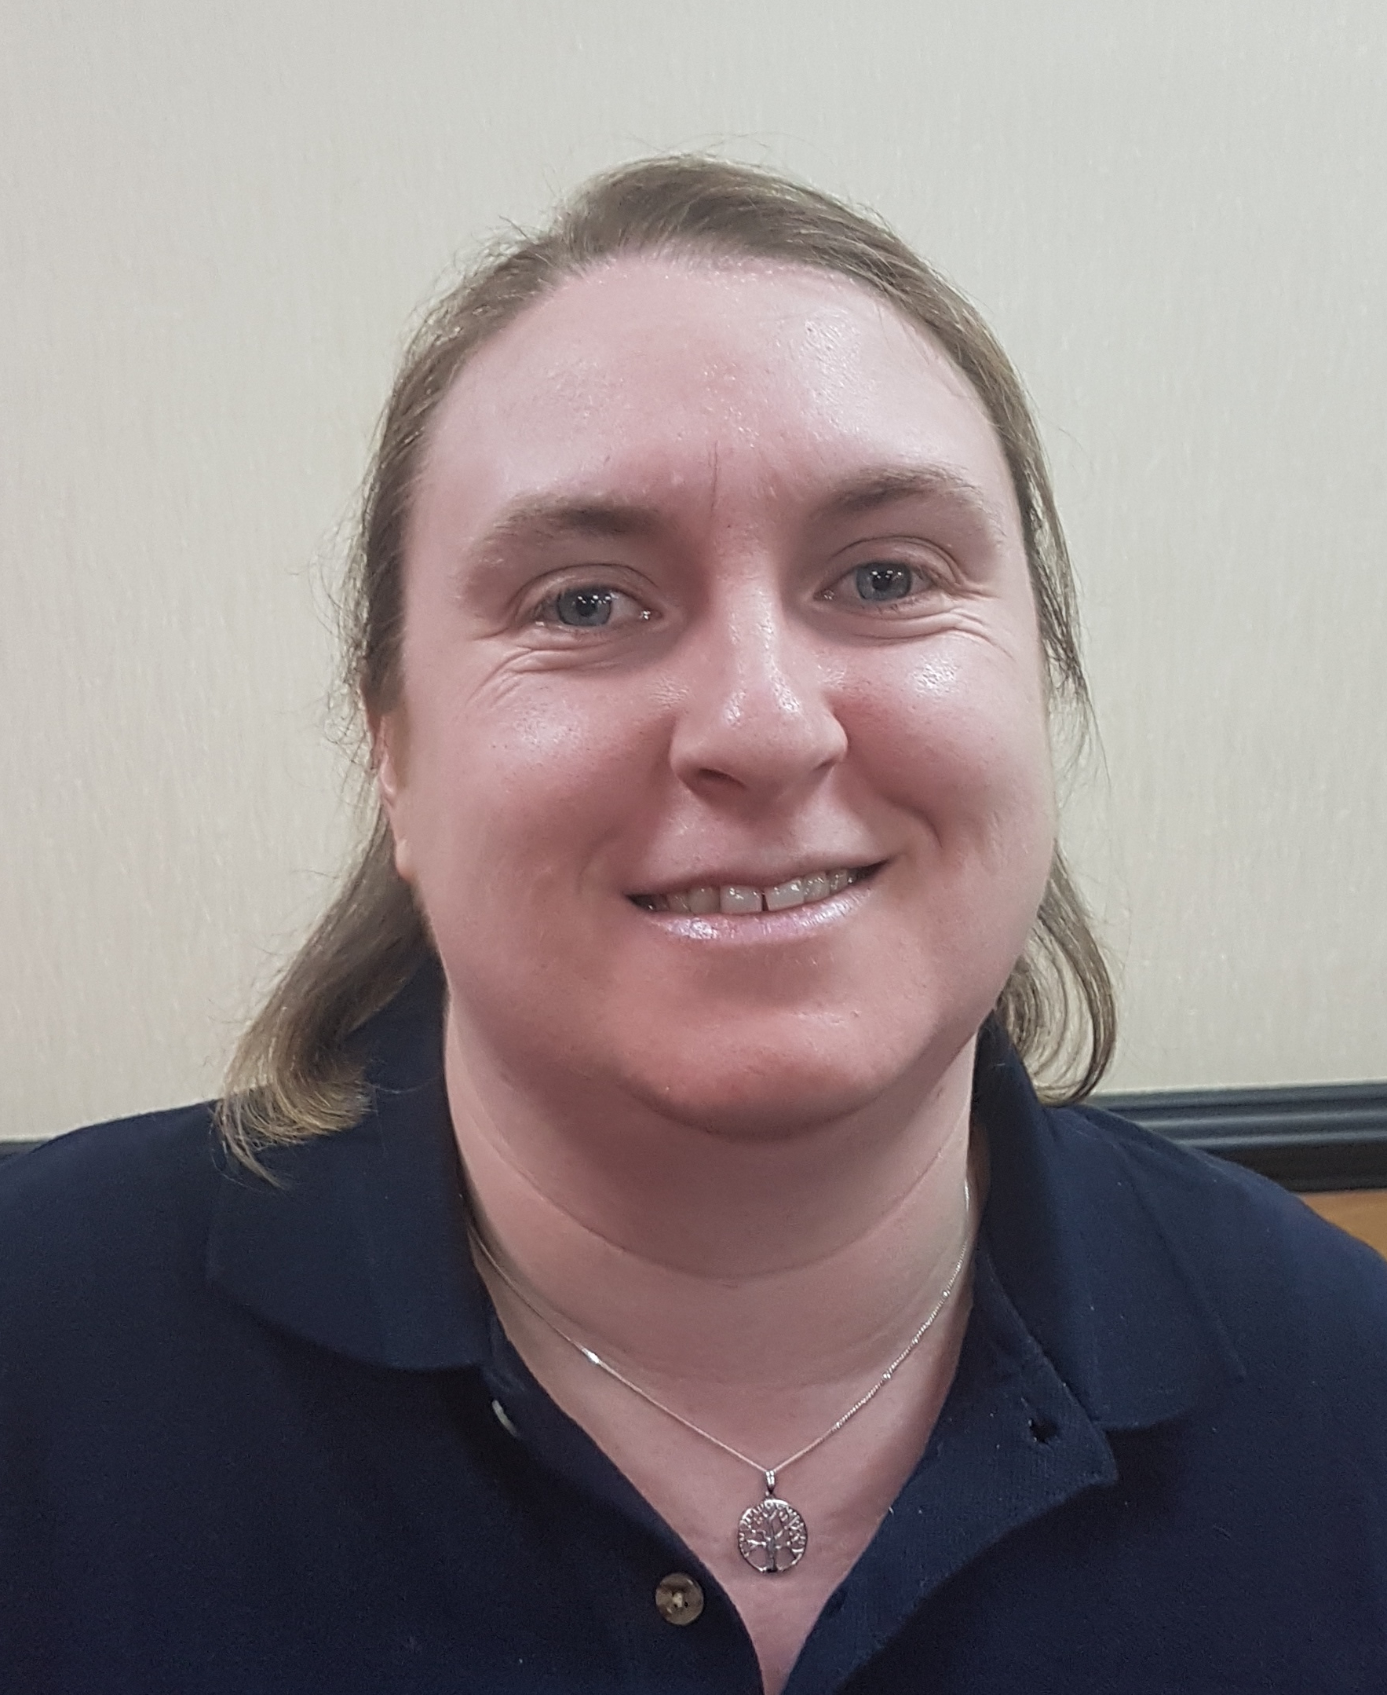 | Leanne Rothwell RN.  Email: buryveteransnavychair@gmail.com  Contact Number:
ROYAL NAVY SECRETARY  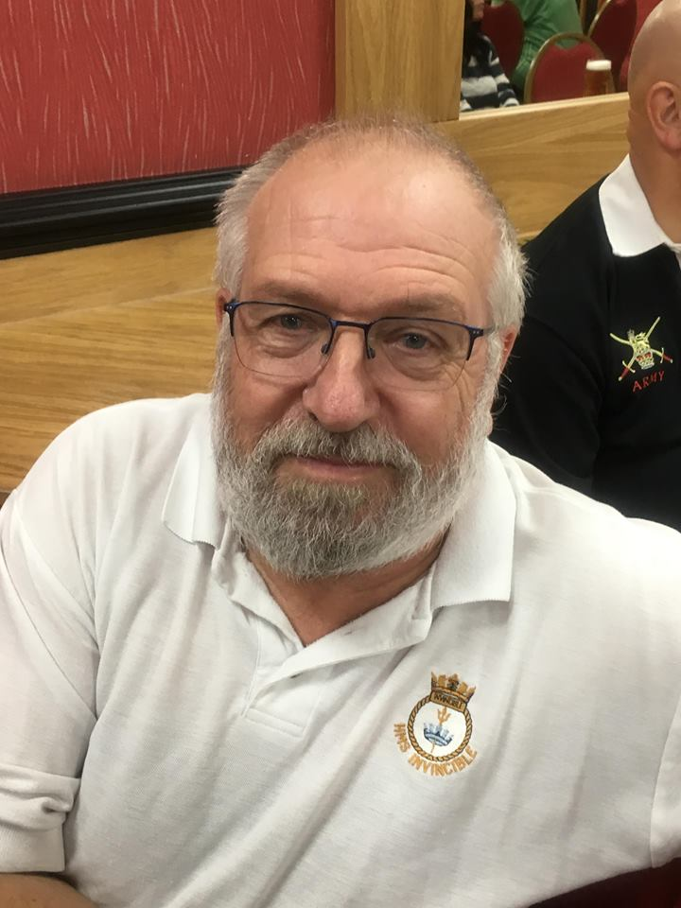 | Kevin Rowe RN.  Email: buryveteransnavysecetary@gmail.com  Contact Number:
ARMY CHARIMAN | Baz Phillips RGJ.  Email: buryveteransarmychairman@gmail.com  Contact Number: 07926 945911
ARMY SECRETARY | Owen Dykes RA.  Email: buryveteransarmysec@gmail.com  Contact Number: 07428143923
RAF CHAIRMAN  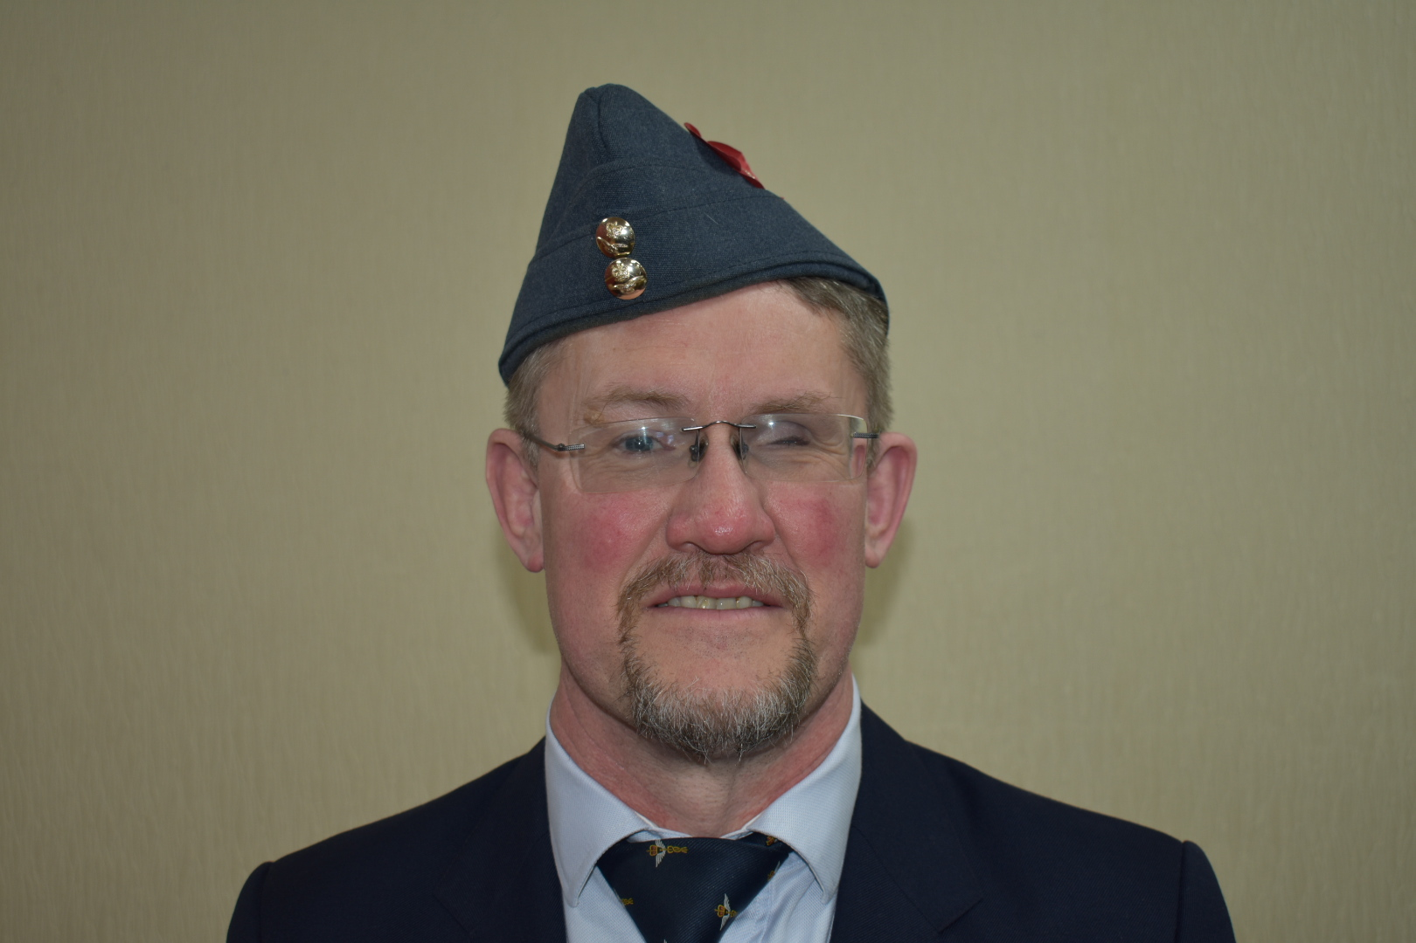 | Paul Newton RAF.  Email: buryveteransassocrafchair@gmail.com  Contact Number:
RAF SECRETARY | Debbie Wilson.  Email: .  Contact Number:
CIVILIAN CHAIRMAN | Shirley Simmons.  Email: buryveteranscivvychairman@gmail.com  Contact Number: 07983933755
CIVILIAN SECRETARY | Leah Simmons and Sam Phillips.  Email: .  Contact Number: 07856703323 (Leah) & 07488323290 (Sam)
WELFARE OFFICER | Marina Jones  Email:  Contact Number:
ENTERTAINMENTS COORDINATOR | Roy Counsell RLC.  Email:  Contact Number:
SADDLEWORTH COORDINATOR | Nicola Grey RAF  Email:  Contact Number:
ASSN PHOTOGRAPHER | Anthony Dalton-Hughes RRF.  Email:  Contact Number:

2019 FORECAST OF EVENTS

Thursday 06th June 2019

75th D-Day Anniversary.

Sunday 09th June 2019

Cosford Air Show.

Saturday 22nd June 2019

Armed Forces Day Heywood.

Saturday 29th June 2019

Armed Forces Day Parade, Manchester.

Sunday 30th June 2019

Armed Forces Day BBQ, Bay Horse, Unsworth.

Saturday 06th July 2019

Yorkshire Wartime Experience.

Sunday 04th August 2019

Minden Drum Head Service.

Saturday & Sunday 10th & 11th August 2019

Yanks Are Back In Saddleworth.

Tuesday 03rd September 2019

Merchant Navy Day.

Sunday 08th September 2019

Eden Camp.

Sunday 15th September 2019

Battle of Britain Day.

Sunday 29th September 2019

National Memorial Arboretum
Sunday 10th November 2018

Remembrance Sunday.
Monday 11th November 2018

Remembrance Day.

Sunday 24th November 2019

Birmingham International Tattoo.

Saturday 30th November 2019

Association Xmas Dinner.

ASSOCIATION MEETING DATES 2019

07th July 2019.
04th August 2019.
01st September 2019.
06th October 2019.
03rd November 2019.
01st December 2019.

