2026 Seasonal Container Reservation Program (SCRP)
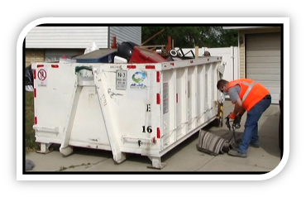
In 2025, Wasatch Front Waste & Recycling District (WFWRD) introduced a tiered reservation system designed to make the program more accessible for residents across the Salt Lake Valley. This tiered process will continue in 2026. All reservations open at 8:00 AM on your area’s designated reservation days.

Reservation Tiers by Location:

- Early Bird Residents: Residents who were on last year’s waitlist and did not receive a container, or who did not participate in 2025, receive early access to the reservation calendar. This group will have a dedicated three-day window to reserve a container.

- General Access Residents: After the Early Bird window closes, any remaining containers become available to all other eligible residents in the designated area on a first-come, first-served basis for the remainder of the reservation period.

This phased structure helps promote broader access to the program for residents.

All reservations must be completed online by the homeowner due to required disclosures and forms. Availability is limited, so we encourage residents to reserve a container as early as possible.

Pro Tip: Consider sharing a container with neighbors to make the most of this complementary seasonal service that is funded through your base service fees.

For 2026 reservation dates, service areas, and full details, watch for your SCRP postcard in the mail with your designated website link and QR code. For an interactive experience lookup your service information by address or visit https://wfwrdutah.gov/SCRP!

Earth Day is April 22nd

Earth Day serves as a reminder that small everyday actions can have a big impact on our environment. Simple habits like recycling and properly disposing of green waste help conserve natural resources, reduce pollution, and keep valuable materials out of landfills.

Recycling items like paper, cardboard, plastic bottles, and metal cans allows those materials to be turned into new products while saving energy and raw resources. Properly managing green waste, such as grass clippings, leaves, and branches helps create nutrient-rich compost and reduces methane emissions from landfills.

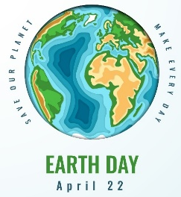
This Earth Day, consider refreshing your recycling habits by taking advantage of WFWRD’s curbside green waste subscription service. Together, small efforts can help protect our community and the planet for future generations.

https://wfwrdutah.gov/services-requests/additional-subscription/green-waste

We’re Switching to a
New Payment Vendor in April

We’re updating our online payment system to a new, easier-to-use platform with Point & Pay! Beginning in early April, if we have your email on file, you will receive an email from “noreply+wasatch-fwr-district@paydici.com” with a link to set up your account.

Please keep an eye out for this email in your junk or promotions folder. Until then, please continue to use the current online payment platform with Xpress Bill Pay.

With Point & Pay, you will find:

- EASY WAYS TO VIEW AND PAY YOUR BILL
- Secure Online Payments

- Autopay/Scheduled Payments/One-time Payments
- Paperless Billing
- Text/Email Notifications
- Multiple Language Preferences
More information is coming soon!

