Monthly Billing Starts This Month!

Wasatch Front Waste and Recycling District is transitioning from quarterly billing to a monthly billing cycle this month. This change does not mean your bill is increasing. The total amount you pay each year for waste and recycling services will stay the same - only the billing schedule is changing.

Instead of receiving one quarterly bill for three months of service, you’ll now receive a monthly bill for the previous one month’s services. Most residents find monthly billing easier to plan for with smaller amounts due and quicker visibility if services are added or removed.

Here’s what to expect:
- Your February bill will cover January services
- Your March bill will cover February services
- This pattern will continue moving forward

Your basic $26.00 monthly fee includes weekly 96-gallon curbside garbage and recycling collection plus several additional programs and services provided at no charge:
- Bulky waste collection via the Seasonal Container Reservation Program (SCRP), typically performed from Mid-April through September
- Landfill vouchers for disposal of residential truck, car, or trailer loads
- Central glass drop-off locations and collection services
- Container repair and replacement (typically 5 to 7 business days)
- Seasonal central leaf bag drop-off program
- Seasonal curbside Christmas tree collection program
- In-house, Local Customer Service (M-F 8:00 a.m. - 4:45 p.m.)
- In-House, Local Billing/Account Management

Visit https://wfwrdutah.gov/services-and-request/basic-services for more information.

To help cut down on paper waste and reduce postage costs, we encourage residents to sign up for e-billing. With e-billing, you’ll receive your monthly bill by email. This keeps your billing simple, reliable, and paper-free! Sign up for paperless billing at https://wfwrdutah.gov/form/paperless-sign-up.

What is the “Clean Recycle Rate” — and Why Does it Matter?

Each week, Wasatch Front Waste and Recycling District collects recycling from over 86,000 homes throughout our service area. Once materials leave your curb, they’re taken to Rocky Mountain Recycling’s Materials Recovery Facility (MRF), where equipment and employees work together to sort accepted materials like clean plastic bottles, jars, jugs and tubs, aluminum and steel cans, cardboard, and paper.
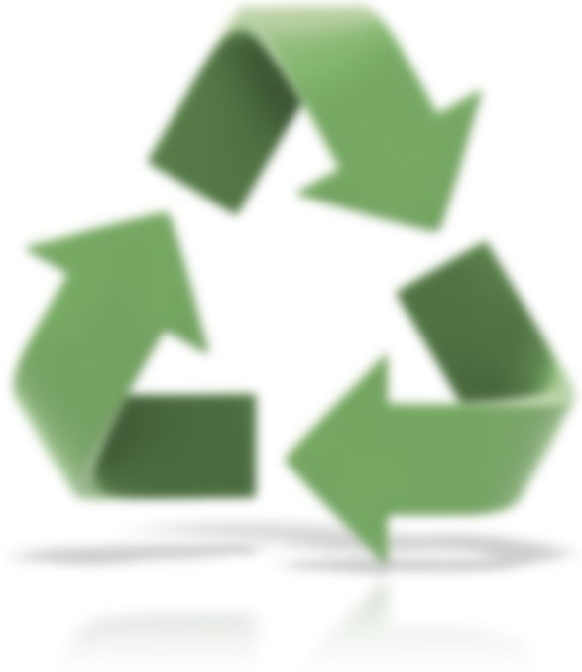
Once sorted, these materials are compressed into large cubes (i.e., bales) and sent to processors to be manufactured into new products.

Not everything placed in the recycling cart belongs there. Items that aren’t accepted at the MRF are considered contamination. Common contamination includes plastic bags and film, Styrofoam, toys, PVC, trash, green waste, and dirty items like food-filled cans or food-covered containers. These items must be removed by hand and sent to the landfill, adding time, labor, and cost to the recycling process.

This is where the Clean Recycle Rate comes in. It measures how much of the material collected is clean and recyclable. When contamination is low, more material is recycled and costs stay lower for everyone.

We’re happy to report that 2025 results show continued improvement! We ended 2025 with a clean recycle rate of 81.98% at Rocky Mountain Recycling, an improvement of 1.51% from 2024.
This continued progress is due to your support in recycling right - and it makes a real difference.
For questions about what belongs in your recycling cart, visit https://wfwrdutah.gov/how-recycle
or contact our Sustainability Coordinator on (385) 468-6337.

