 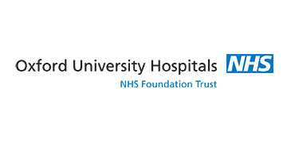

**Date:** Tuesday 14th November 2017

**Time:** 09:00 – 16:15

**Venue:** George Pickering Education Centre

**Price:** Free

Programme:

0900 – 0915 Welcome & Introduction

0915 – 1045 Critical Appraisal

1045 – 1100 Coffee Break

1100 – 1230 Paediatric respiratory problems in the ED (1) – Dr Rhiannon Furr, Consultant in Paediatrics

1230 – 1300 Lunch

1300 – 1400 Paediatric toxicology in the ED – Dr Chris Bird, Consultant in Paediatric Emergency Medicine

1400 – 1600 Practical Session

1600 – 1700 Discussion forum: GP Streaming Service – Laura Watson

1700 – 1715 Feedback and Close

The i3EM CPD Day is expected to be approved for 5 hours CPD. The exact order and timings for the day may change to accommodate external speakers. There are a limited number of places for each day so if you would like to attend or wish to find out more then please visit the website: www.i3em.yolasite.com and use the contact form.

No refreshments or meals are provided by the course organisers. The venue has several retail outlets which there will be time to use during the breaks.

Dr Adham Khalek, ED Consultant

Dr Alex Novak, GP and ED Specialty Doctor