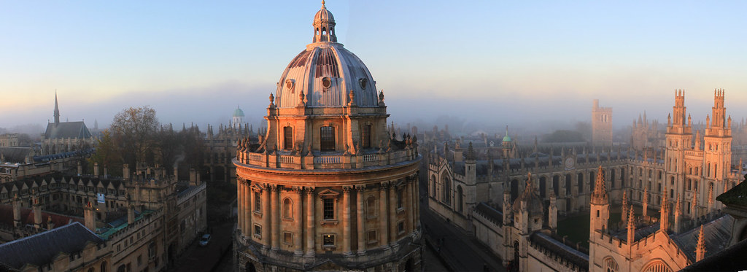
Moving to Oxford
Before the move CHECKLIST
Congratulations!
You have decided to join our Emergency Department at Oxford University Hospitals NHS Foundation Trust. Now let’s get started!

6 months Before
☐ IELTS/OET
☐ RCEM Membership
☐ RCEM Learning Membership
☐ Read information page for International Medical Graduates on GMC and RCEM websites
☐ ACLS/ALS, PALS, ATLS certification
☐ Create a Relocation Receipts Box

3 months before
☐ GMC Registration
☐ ECFMG – EPIC account
☐ Certificate of Good Standing
☐ Interview for job
☐ Finances

2 months before
☐ Tickets
☐ Accommodation
☐ Police Clearance Certificate
☐ Driving License

1 month before
☐ Tuberculosis Certificate
☐ Apply for Visa
☐ Book GMC appointment

1 week before
☐ Plan Clothing, Food & Necessities

1 day before
☐ Time well spent

Day of the move
☐ Fly to U.K.

