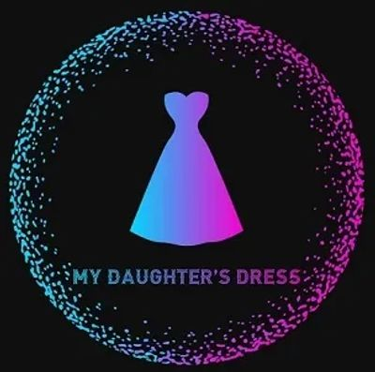
1569 Sycamore Road, Yorkville, Illinois 60560, 331.551.6332
mydaughtersdress@gmail.com

Contact Name: ____________________________________________________________________________
Address: ____________________________________________________________________________
City, State, zip ____________________________________________________________________________
Phone Number: ____________________________________________________________________________
Email Address: ____________________________________________________________________________
Financial Hardship Qualification in the last 30 Days (check all that apply):
☐ Death of a Sole Provider
☐ Loss of Job
☐ Homelessness
☐ Incarcerated Parent
☐ Referral from Outside Program:
☐Mutual Ground
☐ CASA (any county)
☐ 3:11 Project
☐ Bike Bald Group
☐ Lazarus House
☐ Hessed House

Formalwear Items Applying For
☐ Wedding Dress
☐ Quinceanera Dress
☐ Prom Dress
☐ Homecoming Dress
☐ Flower Girl
☐ Mother of the Bride/Groom
☐ Bridesmaid
☐ Little Girl/Little Boy

Please provide copy of driver’s license or state ID, 2 most current paystubs and proof of financial hardship

Signature
Date

