Blackwell's LILACS Framework for Culturally Sustainable Pedagogy: A Six-Pillar Model for Intentional, Humanizing, and Evidence-Informed Practice
Heather Blackwell, PhD
Purposeful Literacy
White Paper
August 2026
https://www.literatebecause.com

Abstract
Blackwell's LILACS Framework for Culturally Sustainable Pedagogy is a six-pillar model for designing instruction that is academically rigorous, relationally grounded, culturally accountable, and responsive to how learners engage and make meaning. The framework was developed from Heather Blackwell's doctoral inquiry into how Black teacher candidates enacted culturally sustaining practices while teaching foundational reading skills through structured word-study instruction. The study revealed a consequential distance between practice and professional language: candidates sometimes affirmed students' cultural and linguistic identities through examples, talk, relationships, feedback, and instructional choices without naming those decisions as culturally sustaining. Reflection and coursework later supplied more explicit language, stronger intentionality, and clearer rationales. The framework converts that tension into a practical proposition: culturally sustainable pedagogy cannot depend on intuition alone. It requires disciplined habits that help educators examine position and power, learn with students and communities, design accessible instruction, study effects, curate cultural connections, and reinforce learning without reducing students to compliance. This white paper defines the six interdependent pillars, identifies observable commitments, and proposes applications in K-12 systems and educator preparation. It presents a dissertation-derived conceptual model rather than a validated measurement instrument and concludes with an agenda for practitioner inquiry, construct refinement, and empirical study across contexts.
Keywords: culturally sustainable pedagogy, culturally sustaining pedagogy, teacher education, literacy, reflective practice

The Problem the Framework Addresses
Cultural responsiveness is often treated as an addition to instruction: a representative text, a familiar name in a word problem, a heritage-month activity, or a brief invitation for students to share. These choices may be valuable, but representation alone does not establish cultural accountability. A lesson can look diverse while preserving narrow assumptions about language, knowledge, ability, behavior, and whose ways of knowing count.
A second problem arises when academic rigor and cultural sustainability are positioned as competing commitments. In literacy education, for example, explicit and systematic instruction is sometimes discussed as if it were culturally neutral, while culturally sustaining practice is treated as an engagement strategy layered onto the lesson. Blackwell's research suggests a different relationship. Teacher candidates could model a sound pattern explicitly, guide practice carefully, affirm a home pronunciation, select examples grounded in students' lives, and preserve the instructional target within the same interaction. The central question is not whether educators choose evidence-based instruction or culturally sustaining pedagogy. It is how professional judgment integrates both without weakening either.
The framework therefore focuses on the quality of decisions that surround content: how educators interpret learners, establish relationships, select materials, vary pathways into learning, respond to performance, and revise practice. This emphasis is consistent with culturally relevant and sustaining scholarship that links academic success with cultural competence, critical consciousness, linguistic pluralism, and community continuity (Ladson-Billings, 1995; Paris, 2012; Paris & Alim, 2017).

Terminology: Why “Sustainable”?
Culturally sustaining pedagogy is an established scholarly tradition associated with sustaining the cultural and linguistic practices of communities (Paris, 2012). Blackwell's use of cultural sustainability is deliberate but adjacent. Sustainable names the professional conditions required for educators to maintain culturally accountable practice over time, emphasizing: humility rather than presumed authority, relationships rather than transactions, purposeful access to learning rather than novelty, reflection rather than certainty, curation rather than decoration, and feedback rather than control. The Blackwell framework is aligned with culturally sustaining pedagogy; it does not replace or rename that tradition.

Research Origins and Conceptual Status
The framework emerged through conceptual synthesis of Blackwell's 2025 doctoral research with Black teacher candidates working with Black elementary students during structured word-study instruction. The inquiry used five sources of evidence: interviews, observations, coursework, questionnaires, and researcher reflexive notes. Four rounds of qualitative coding moved from description to connection, to provisional explanation, to refinement through tension and disconfirming evidence.
Six themes informed the model: incidental cultural responsiveness, assumed cultural matching, multisensory engagement and learning, empathy-driven relationships, positive reinforcement, and reflective practice. In the present framework, two findings are intentionally reframed. Incidental cultural responsiveness becomes Intentional Cultural Humility because responsiveness must be planned, examined, and accountable to learners. Assumed cultural matching becomes Curated Cultural Responsiveness because shared racial or cultural identity does not authorize an educator to presume sameness. The remaining four findings retain their central language and become explicit practice pillars.
This transformation from themes to pillars is interpretive. The dissertation findings supply the empirical origin; the six-pillar structure is a conceptual model proposed for professional learning, instructional design, coaching, and further study. It should not yet be used to score teachers, certify programs, or make high-stakes personnel decisions.
The framework has also been operationalized in Blackwell's district facilitator materials for culturally responsive text evaluation. That application pairs the pillars with positionality inventories, evidence-based calibration, community validation, power mapping, silence and ideology analysis, and continuous improvement. These protocols clarify an important boundary: the six pillars organize professional judgment, while student, family, and community perspectives test whether that judgment is culturally accountable.

The LILACS Framework
Figure 1
Blackwell's LILACS Framework for Culturally Sustainable Pedagogy
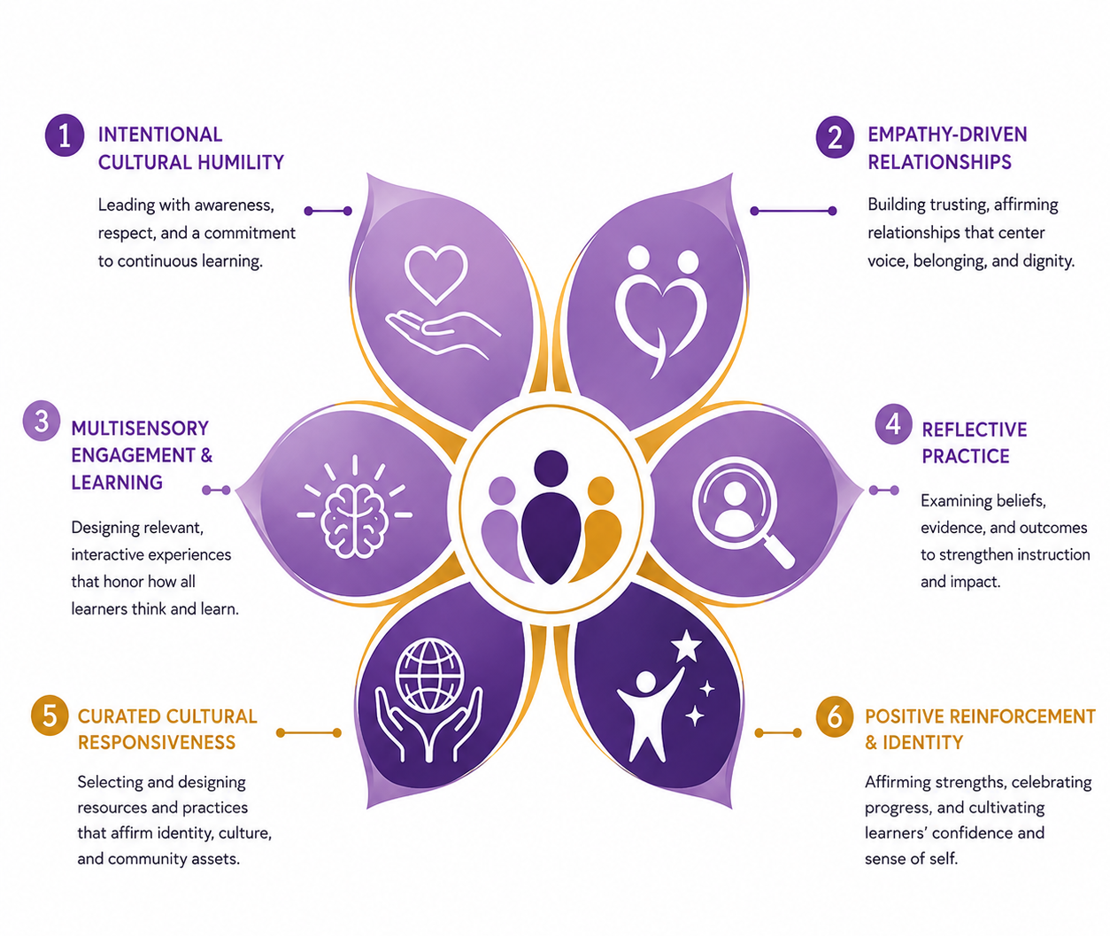
Note. The six petals represent distinct but interdependent practices. Numbering indicates a developmental sequence, not a hierarchy of value. The graphic uses “Positive Reinforcement & Identity” as an applied descriptor; Positive Reinforcement remains the formal name of the sixth pillar in this paper.
The flower represents interdependence. Each petal corresponds to one pillar, yet the six practices flourish as one system around a shared center: learner dignity, agency, and rigorous learning. The sequence begins with the educator's stance and moves through relationships, learning design, disciplined inquiry, cultural curation, and feedback. Reflection then returns the educator to humility, making the framework recursive rather than linear.
LILACS is a practice mnemonic, not a replacement for the formal pillar names:
- Learn with Cultural Humility — Intentional Cultural Humility
- Invest in Empathy-Driven Relationships — Empathy-Driven Relationships
- Layer Multisensory Engagement and Learning — Multisensory Engagement & Learning
- Analyze and Reflect on Practice — Reflective Practice
- Curate Cultural Responsiveness — Curated Cultural Responsiveness
- Strengthen Learning Through Positive Reinforcement — Positive Reinforcement

1. Intentional Cultural Humility
Intentional Cultural Humility is the continuing practice of examining one's assumptions, positionality, authority, and limits while learning with students, families, and communities. Adapted from cultural humility's emphasis on lifelong self-evaluation and attention to power (Tervalon & Murray-García, 1998), this pillar rejects the idea that an educator can become fully competent in another person's culture. Intentionality matters because goodwill and shared identity do not remove blind spots.

Practice Commitments
- Name the social and institutional positions that shape interpretation and authority.
- Seek knowledge from students and communities without requiring them to perform or represent a group.
- Treat cultural knowledge as situated, evolving, and internally diverse.
- Identify who has decision-making power, whose interpretation is privileged, and what evidence could challenge it.
Distortion interrupted. Cultural certainty, saviorism, and the assumption that familiarity equals understanding.
In practice. Before interpreting a student's language as an error or a family's participation as disengagement, the educator considers language variation, prior opportunity, communication norms, and the limits of available evidence. Questions precede conclusions.

2. Empathy-Driven Relationships
Empathy-Driven Relationships are built through disciplined perspective taking, attentive listening, reliability, and care that preserves high expectations. Empathy is not sentimentality, and relationship is not a reward students earn through compliance. Relational knowledge helps educators interpret behavior more accurately, design meaningful participation, and create conditions in which students can take intellectual risks. Research connecting teacher-child relationships with long-term academic and behavioral outcomes reinforces the instructional significance of this work (Hamre & Pianta, 2001).

Practice Commitments
- Learn how students describe their identities, strengths, interests, responsibilities, and goals.
- Use routines that communicate predictability, respect, and repair after conflict.
- Separate a learner's worth from a moment of performance or behavior.
- Pair warmth with clarity, rigor, boundaries, and honest feedback.
Distortion interrupted. Performative care, lowered expectations, and relationships used primarily to secure obedience.
In practice. A teacher notices that a student's reluctance to read aloud changes across grouping arrangements. Instead of labeling the student unmotivated, the teacher confers privately, adjusts the participation pathway, protects dignity, and continues to teach the targeted skill.

3. Multisensory Engagement & Learning
Multisensory Engagement & Learning is the purposeful coordination of visual, auditory, linguistic, tactile, movement-based, and social pathways when those pathways clarify the learning target and increase access. Multisensory design is not a claim that each learner has a fixed learning style. Its value depends on congruence: modalities should reinforce the same idea rather than add competing stimulation. Research on multisensory learning and Universal Design for Learning supports deliberate, flexible access to meaningful and challenging learning (Shams & Seitz, 2008; CAST, 2024).

Practice Commitments
- Begin with the learning goal, then select modalities that make its structure perceptible.
- Coordinate modalities so they reinforce, rather than compete for, attention.
- Offer meaningful ways to engage, access information, practice, and demonstrate learning.
- Examine whether a design increases agency and understanding or merely increases activity.
Distortion interrupted. Learning-style labels, sensory novelty, and engagement measured only by visible activity.
In practice. During word study, students hear a phoneme, articulate it, map it to a grapheme, manipulate letters, read the word in connected text, and discuss a culturally meaningful example. Each modality serves the same instructional aim.

4. Reflective Practice
Reflective Practice is the systematic examination of decisions, evidence, assumptions, and effects before, during, and after instruction. It converts experience into professional learning. Reflection is strongest when it is anchored in artifacts and disconfirming evidence, not limited to whether a lesson felt successful. This pillar draws on reflection-in-action and reflection-on-action (Schön, 1983) and on Blackwell's memo-driven approach to making interpretation visible.

Practice Commitments
- Distinguish what students said or did from the meaning assigned to it.
- Compare intended outcomes with participation, work samples, assessment evidence, and student perspectives.
- Document uncertainty, alternative explanations, and changes in reasoning.
- Revise instruction and identify the evidence that will show whether the revision helped.
Distortion interrupted. Intuition treated as proof, reflection as confession, and confirmation bias disguised as professional judgment.
In practice. After a discussion, an instructor notices that the same cultural example generated strong participation for some students and silence for others. The instructor studies the pattern, invites feedback, revises the task, and records what changed.

5. Curated Cultural Responsiveness
Curated Cultural Responsiveness is the deliberate selection, adaptation, and sequencing of texts, examples, language practices, materials, and participation structures in relation to specific learners and worthwhile academic goals. Curated signals judgment and accountability. It asks why a cultural connection is present, who authorized its meaning, how it advances learning, and what complexity it preserves. It moves beyond surface representation toward sustaining cultural and linguistic pluralism (Paris, 2012).

Practice Commitments
- Use multiple sources to learn about local histories, language practices, community knowledge, and contemporary cultural production.
- Select cultural content for authenticity, specificity, instructional relevance, and freedom from stereotype.
- Invite student contribution without making individual students representatives of a group.
- Audit whose knowledge appears as core content, whose appears as an aside, and whose is absent.
Distortion interrupted. Decorative diversity, presumed cultural matching, tokenism, and one-size-fits-all notions of relevance.
In practice. A professor redesigns a literacy methods case around a local language community, uses scholarship from that community, retains the disciplinary objective, and asks candidates to analyze both instructional access and power. A district text-review team adds student and family validation rather than treating adult consensus as sufficient evidence.

6. Positive Reinforcement
Positive Reinforcement is specific, credible, culturally attentive feedback that strengthens effective strategies, persistence, belonging, and learner agency. It is broader than praise and narrower than constant positivity. Feedback should tell learners what is working, why it matters, and what they can do next. Research shows that praise can support, undermine, or leave motivation unchanged depending on sincerity, autonomy, attribution, and expectations (Henderlong & Lepper, 2002); feedback likewise varies in impact according to its focus and use (Hattie & Timperley, 2007).

Practice Commitments
- Name the strategy, decision, growth, contribution, or evidence being recognized.
- Connect feedback to a clear goal and an actionable next step.
- Check whether recognition supports autonomy or pressures students to perform compliance.
- Examine patterns: who receives praise for intelligence, behavior, effort, leadership, creativity, or revision?
Distortion interrupted. Empty praise, public comparison, compliance-centered rewards, and feedback that communicates low expectations.
In practice. Instead of saying, “Good job, you're so smart,” an educator says, “You returned to the text, revised your claim, and used stronger evidence. That revision makes your reasoning easier to follow. Your next step is to address the counterexample.”

How the Pillars Work Together
A culturally sustainable lesson cannot be inferred from a single visible feature. A culturally familiar example may reflect careful curation, stereotype, or coincidence. A lively multisensory activity may deepen conceptual access or overload attention. Praise may communicate high expectations or subtle control. The meaning of any practice depends on its purpose, context, enactment, and effect.
The framework therefore operates as a system of checks. Cultural humility challenges the educator's first interpretation. Relationship knowledge adds context without licensing assumptions. Multisensory design widens access while preserving the learning goal. Reflection tests intention against evidence. Curation grounds cultural choices in specificity and scholarly or community knowledge. Positive reinforcement helps learners understand progress and exercise agency. When one pillar is weak, the others expose the weakness.
A practical test. Can the educator explain how a decision advances the academic goal, honors learners without presuming sameness, redistributes meaningful participation, and can be revised in response to evidence?

Uses Across Academia and K-12 Education
Table 1
Applications and Evidence Across Educational Contexts
Context | Primary use | Evidence to examine
Teacher preparation | Use the pillars to analyze lesson plans, clinical observations, cases, and candidate reflection. | Rationales, annotated plans, observation evidence, revisions, candidate memos
K-12 instruction | Use the pillars during unit design, text selection, participation planning, feedback, and assessment interpretation. | Student work, participation patterns, student and family voice, instructional adaptations, progress evidence
Coaching and professional learning | Use one pillar as an inquiry focus while preserving the full framework as a system. | Coaching notes, video or observation evidence, teacher hypotheses, next-cycle changes
Leadership and program design | Audit texts, curriculum, policy, professional learning, and resource allocation for the conditions that sustain responsive practice. | Text and curriculum audits, power and silence analyses, access data, community validation, implementation evidence
Research | Use the pillars as sensitizing concepts to guide questions while allowing findings to complicate or revise the model. | Cross-context qualitative evidence, construct studies, implementation measures, learner outcomes

A Responsible Implementation Stance
The framework is best introduced through inquiry rather than compliance. Schools and universities should resist turning the pillars immediately into a rating scale. Premature scoring would recreate the certainty the framework is designed to interrupt. A stronger entry is a focused cycle of study:
- Select a real instructional decision or learner experience, not an abstract statement of belief.
- Use the six pillars to surface assumptions, assets, missing perspectives, access barriers, and feedback patterns.
- Revise one consequential feature while preserving the academic purpose.
- Gather evidence from learners, work products, observation, and reflection.
- Document what the evidence supports, what remains uncertain, and what the next cycle should test.
This stance keeps the model developmental. It also protects against a familiar institutional pattern in which culturally responsive practice becomes a set of observable behaviors detached from community accountability, disciplinary knowledge, and student interpretation.

Research and Evaluation Agenda
Usefulness in academic and professional settings will depend on conceptual clarity and evidence. The next research phase should examine whether the pillars are distinguishable, useful across disciplines and age levels, and associated with changes in teacher reasoning, instructional design, learner participation, belonging, and academic outcomes.
- Construct refinement: Conduct cognitive interviews and expert review with students, families, teachers, teacher educators, and culturally sustaining pedagogy scholars.
- Practice-based validity: Study how educators interpret and apply each pillar to common instructional artifacts and dilemmas.
- Cross-context inquiry: Examine the model across grade bands, content areas, institutions, and cultural and linguistic communities.
- Learner-centered evidence: Center students' interpretations of relevance, respect, challenge, feedback, and agency rather than relying only on educator self-report.
- Implementation study: Identify supports, organizational conditions, and professional learning designs that help the framework influence practice over time.
- Measure development: Develop any rubric or survey only after constructs and uses are sufficiently specified; validate it for each intended inference and avoid high-stakes use during development.
The framework should remain open to revision. A culturally accountable model cannot claim finality while asking educators to practice humility, reflection, and responsiveness.

Conclusion
Blackwell's LILACS Framework for Culturally Sustainable Pedagogy names the professional disciplines that move cultural responsiveness from instinct or isolated technique toward intentional, evidence-informed practice. Its contribution is not a promise that six pillars can resolve the complexity of culture, teaching, and learning. Its contribution is a usable structure for staying accountable to that complexity.
The framework asks educators to know without presuming, care without lowering expectations, engage without distracting, reflect without self-protection, curate without reducing culture to representation, and reinforce without controlling. In combination, these commitments support instruction in which rigor and cultural sustainability are not parallel agendas. They become qualities of the same pedagogical decision.

About the Author
Heather Blackwell, PhD, is a literacy leader, university instructor, researcher, and educational consultant whose work integrates the Science of Learning, the Science of Reading, structured literacy, assessment-informed decision making, and culturally sustaining pedagogy. Her doctoral research examined Black teacher candidates' culturally sustaining practice during structured literacy instruction. She teaches literacy methods and assessment courses at Morgan State University and leads literacy technical assistance, curriculum development, and professional learning across K-12 systems and community-based programs.
Website: www.literatebecause.com

Suggested Citation
Blackwell, H. (2026). Blackwell's LILACS framework for culturally sustainable pedagogy: A six-pillar model for intentional, humanizing, and evidence-informed practice. Purposeful Literacy.

References
CAST. (2024). CAST Universal Design for Learning Guidelines, version 3.0. https://udlguidelines.cast.org/
Hamre, B. K., & Pianta, R. C. (2001). Early teacher-child relationships and the trajectory of children's school outcomes through eighth grade. Child Development, 72(2), 625-638. https://doi.org/10.1111/1467-8624.00301
Hattie, J., & Timperley, H. (2007). The power of feedback. Review of Educational Research, 77(1), 81-112. https://doi.org/10.3102/003465430298487
Henderlong, J., & Lepper, M. R. (2002). The effects of praise on children's intrinsic motivation: A review and synthesis. Psychological Bulletin, 128(5), 774-795. https://doi.org/10.1037/0033-2909.128.5.774
Ladson-Billings, G. (1995). Toward a theory of culturally relevant pedagogy. American Educational Research Journal, 32(3), 465-491. https://doi.org/10.3102/00028312032003465
Paris, D. (2012). Culturally sustaining pedagogy: A needed change in stance, terminology, and practice. Educational Researcher, 41(3), 93-97. https://doi.org/10.3102/0013189X12441244
Paris, D., & Alim, H. S. (Eds.). (2017). Culturally sustaining pedagogies: Teaching and learning for justice in a changing world. Teachers College Press. https://www.tcpress.com/culturally-sustaining-pedagogies-9780807758342
Schön, D. A. (1983). The reflective practitioner: How professionals think in action. Basic Books. https://books.google.com/books?id=E85qAAAAMAAJ
Shams, L., & Seitz, A. R. (2008). Benefits of multisensory learning. Trends in Cognitive Sciences, 12(11), 411-417. https://doi.org/10.1016/j.tics.2008.07.006
Tervalon, M., & Murray-García, J. (1998). Cultural humility versus cultural competence: A critical distinction in defining physician training outcomes in multicultural education. Journal of Health Care for the Poor and Underserved, 9(2), 117-125. https://doi.org/10.1353/hpu.2010.0233

