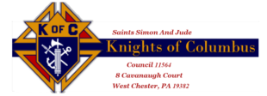
Knight’s Name
Street Address
City/State

Dear ____________, Date

The Knights of Columbus at Saints Simon & Jude support many charities. As with many charitable organizations these have been most difficult times. Our main source of revenue has been our annual golf outing historically run for 24 years. Through the event we have supported many worthy charities including:
- Our veterans at the Coatesville VA Hospital
- The Special Olympics
- The Mother’s Home in Darby, PA
- Purchase of Ultrasound equipment used to protect the unborn
- Purchase of Coats for Kids, over 500 per year
- Food for Families
- HOPE Ministry, No Family Left Behind
- Painting Camilla Hall, residence of the Sisters of The Immaculate Heart of Mary
- Parish and School improvements, just to name a few

To continue our charitable mission, we are attempting to raise the needed funds by conducting a raffle, “The 400 Club”. Only 400 tickets will be sold at a cost of $25.00 each. There will be a drawing in October, November and December. Five winning numbers will be drawn each month. The minimum award will be $50.00. The next four winners will receive an escalating award proportional to the number of tickets sold. The Grand Prize in December could be up to $1,000.00. The earlier you purchase your ticket(s), the greater the chances of winning.

Once your check for $25.00 is received a ticket(s) with your name, address, and phone number, will be filled out and the ticket with the corresponding number will be mailed to you. Your ticket will be eligible in all three monthly drawings regardless whether you won or not in the previous months still making you eligible for the main prize. So, in all you have 15 chances to win over the three-month period. We must sell 400 tickets and receive the cash/check for those tickets, to maximize the charitable contributions to those organizations most in need. Checks should be made out to Saints Simon & Jude K of C Council 11564 and sent back to me.

Please support our worthy cause and rest assured of our sincere gratitude.
Gratefully yours, 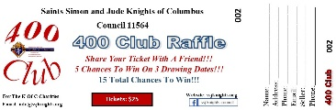

Knights of Columbus

