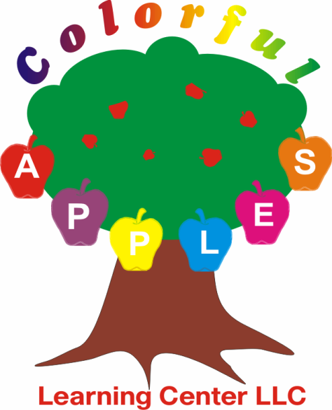

Tuition Rates:

6 Weeks-36 Months:

Full Time Care-$265.00 per week
Part Time Care:$85.00 per day

36 Months-6 Years:

Full Time Care:$200.00 per week unless not fully potty trained in that case tuition will remain at $265.00.

Part Time Care:$70.00 per day unless not fully potty trained in that case tuition will remain at $85.00.

$50.00 non refundable registration fee to hold your child’s spot in our center.This is a one time registration fee.

10% Sibling discount applied to the less amount of tuition charged.

All meals are included in the price. Breakfast, Lunch, PM Snacks, water and milk throughout the day. We also substitute for allergies and if your child doesn't like what is already being served. We belong to the NH Healthy Food Program.

*Please keep in mind, tuition is non negotiable and payment is required the first day of every week your child is enrolled.
No exceptions.

