**Roulette Payoffs**

**Paying process**

**Clear by the winning number**

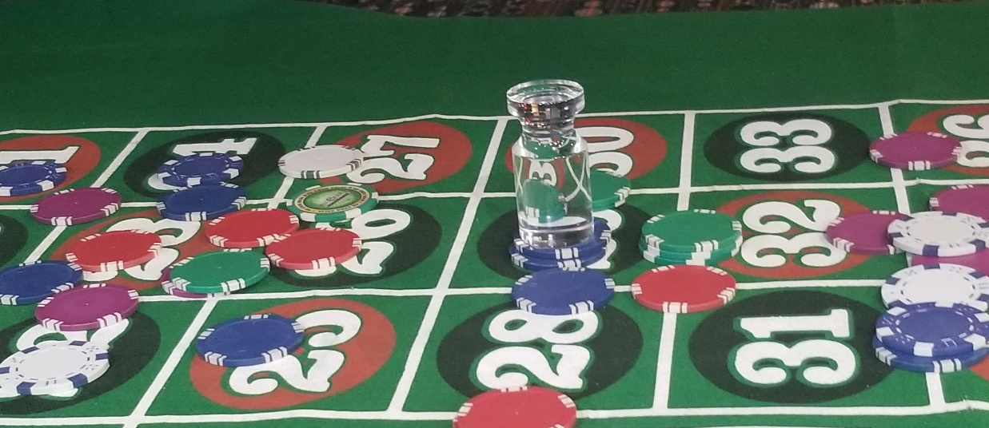

**Clear the outside**

1. **First picking up the losing bets in the columns, starting with the columns with the numbers 3 to 36, then 2 to 35 and finally 1 to 34.**
2. **2. Second picking up the outside losing bets as shown in the above diagram**
3. **Finally clear the inside board of any losing bets.**

**Paying the bets**

**Pay the outside bets**

**Pay the outside bets in the same order that you picked up the losing bets, starting with column closest to you,**

**2. The players cannot collect these until you are finished paying the inside winning bets.**

**Paying the Inside number**

**Inside paying order**

1. **Bets will be paid according the above diagram.**
2. **Different colors should be offset from each so, the dealer, customer, supervisor and surveillance can clearly ensure the proper payoff.**

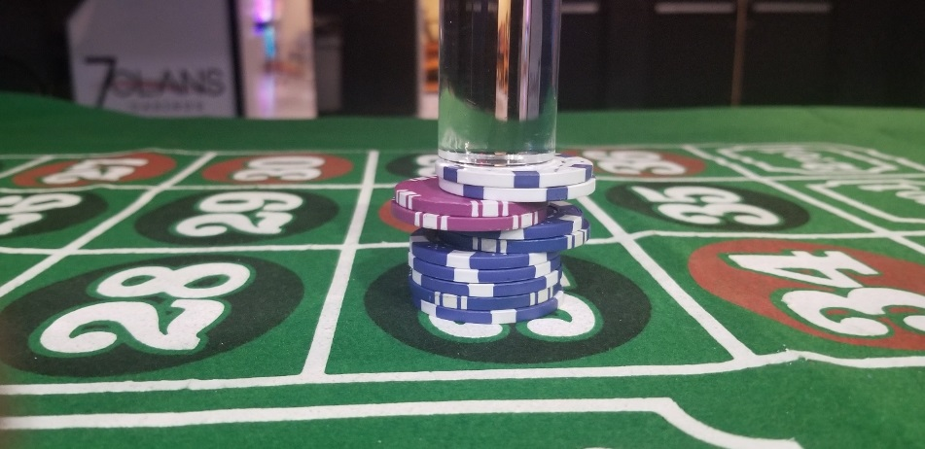

1. **Pay bets from the top down, in the above picture, pay the white than the purple, than the blue.**
2. **Colors with over 5 chips, should be offset `in 5’s, if over 20, then offset in 20.**

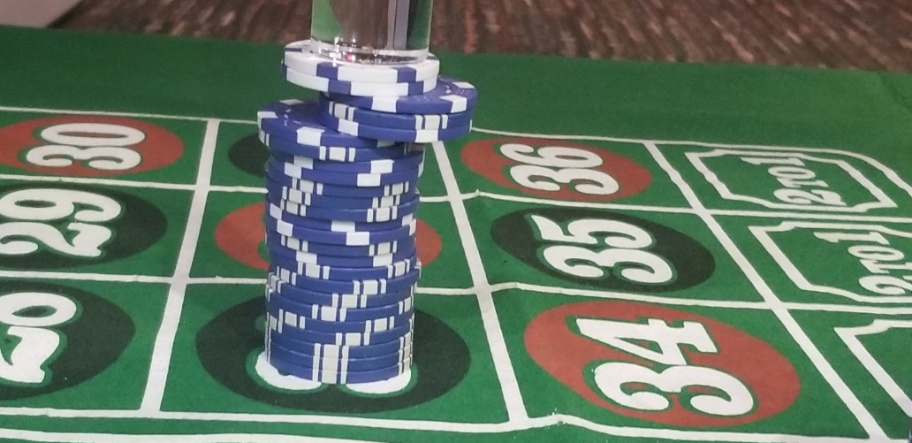

Stacks and pushing:

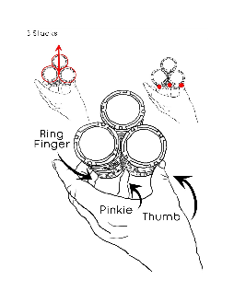 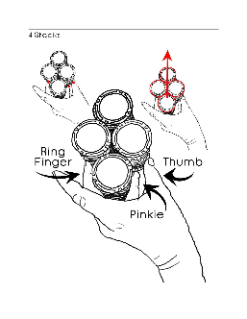 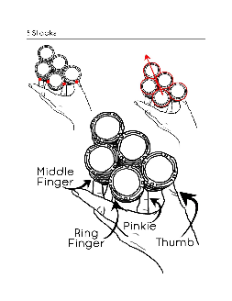

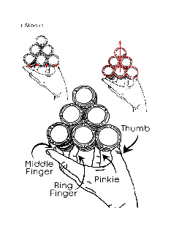 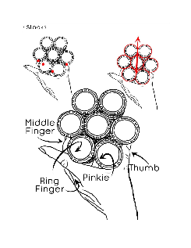 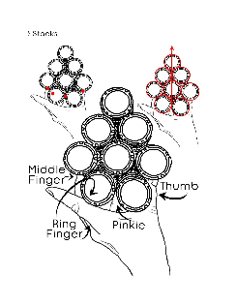 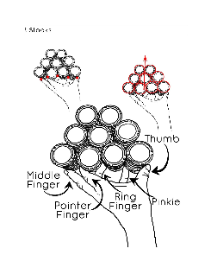 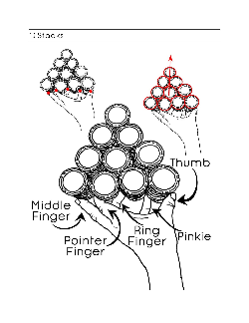

How to spin the ball:

Youtube links

[National Gaming Academy: American Roulette Video Tutorials # 6 Ball Spinning](https://www.youtube.com/watch?v=qpH7sC_if0U&t=201s)

[How to Spin the Ball in Roulette](https://www.youtube.com/watch?v=WMq8J0XBOyE)

Picture Bets:

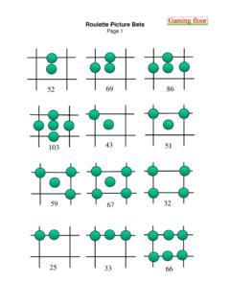

**Roulette conversion short cuts**:

**Nickels**- cut the payoff in half and add a zero.

I,e, 82 is the payoff, cut in half 41 add a zero 410. The conversion in nickels payoff is 410.

I.e. 126 is the payoff, cut in half 63 add a zero 630. The conversion in nickels payoff is 630.

**Quarters conversion**-

**Straight ups**- for every straight up quarter add 900 then subtract the actual value of quarters on the straight up bet.

i.e. 2 straight up , 2*900=1800, minus 50 = 1750.

i.e 3 straight up qtrs., 3*900= 2700 minus 75=2625

**splits**- for every split times 400 and then add the qtr value on the bet.

i.e. 4 splits, 4x400=1600+100=1700.

I,e 3 split, 3*400=1200+75=1275.

**Total bet**- dive the amount by 4 and add two zeroes at the end.

I.e. 44 qtrs, 44/4= 11add 2 oo’s , 1100.

i.e. 24 qtrs, 24/4=6 add 00;s , 600.

Odd amount divide 4 to nearest whole dollar then add the qtr value left over to the total.

i.e. 34, 32/4=8 the 800, plus 2 qtrs, 850.

**Straight Ups pay 35:1**  
Number of straight up chips divided by 2 x 7. Example 16/2=8x7=56. When dealing with larger numbers using this key, you would add a zero to the end of the number. Correct answer is 560. Whenever you have an odd number of straight ups, either round it up or down 1 number to make it even and use the key again. Remembering to add or subtract 35 from the total, to accommodate for rounding up or down 1 to make the number even.

**EVEN NUMBER OF STRAIGHT UPS AND SPLITS**;   
Example, 4 straight up and 4  
Splits  
  
Divide the straight up bet in half – 2, add 2 zero  
Then add both bets together – 8  
The bet pays 208  
  
Another example ; 8 straight up and 8 splits  
  
Divide the straight up bet in half - 4  
Add both bets together - 16  
The bet pays – 416

**Splits**

Blackjack the bet, add a zero, add double the stack to it.

14 splits

14 blacked jacked 21 , then 210 plus 28= 238

On odd amounts divide by nearest even then blackjack the bet, add a zero, add double the stack to it. Then add the leftover 17 to that.

**Split and corner**

Together they equal 25

Divide number of splits and corners by 4 and add 2 0’s.

i.e. 12 splits and 12 corners

12/4=3 then 300.

If odd amount then divide by the nearest even number then Divide number of splits and corners by 4 and add 2 0’s. then add the leftover (split corner to that) 25 to that.

i.e. 13 splits and 13 corners

12/4=3, then 300. Plus 25=325

**1 Straight up and 1 split**

Together the add up to 52

Dived the amount of chips in the straight stack in half, add 2 zero’s then add the total number of chips.

i.e. 6 straight ups and 6 splits

6/2= 3, add to zeros’ to 3= 300, plu the 12 chips bet= 312

**1 straight up and 2 corner’s, “mickey mouse”**

**Together they pay 51**

Dived the amount of chips in the straight stack in half, add 2 zero’s then add the total number of chips, in just the straight up stack.

i.e. 6 straight ups and 12 corners

6/2= 3, add to zeros’ to 3= 300, plus the 5 chips bet= 306