Double Deck

Shuffling

1. The deck will be divided into two stacks

1 A 2

B

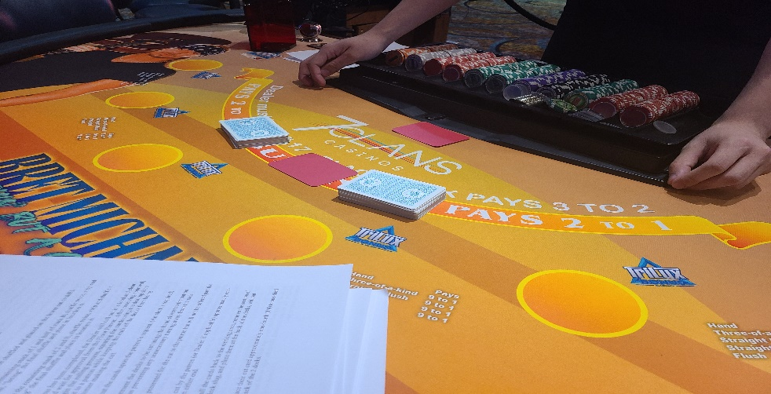

\

2. One half of each stack will be shuffled and placed on the lower cut card(B).

3. Then you take the remaining stack of 1 and half of stack B, shuffle twice, strip and shuffle a third time, “lacing” the final shuffle and place in location A.

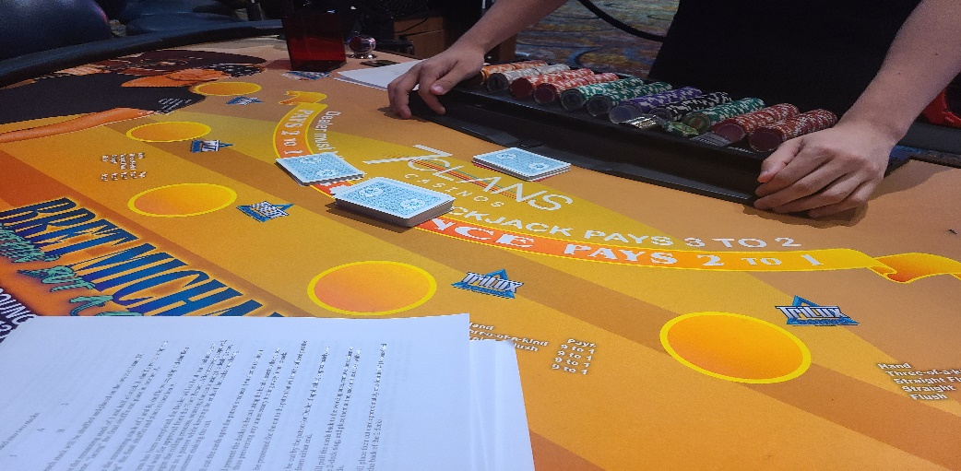

4. Then you take the remaining stack of 2 and B, shuffle twice, strip and shuffle a third time, “lacing” the final shuffle and place in location A.

5. Once this process has been completed, the Dealer will call out in a loud and clear voice “rolling” and wait for approval from the Floor Person. After receiving approval, the Dealer will begin the rolling process, squaring the cards using the dealing shoe, and offering the cut to a patron while keeping the ends of the decks from being exposed to the customer making the cut.

6. The Dealer will cut the cards upon the patron’s request. (An alert is required)

7. The Dealer will present the decks to be cut using the hand closest to the patron cutting the cards, thus preventing any unnecessary turning away from the rack.

8. The decks will be presented for the cut to the patron but will not be offered past the betting circle.

9. The cards must be cut by the patron (or Dealer if applicable) approximately one-fourth (1/4) deck from either end.

10. The Dealer will pull the cards back to the working area, remove the section of cards cut from the 2-deck slug, and place them at the back of the decks, without exposing any cards.

11. The Dealer will place their cut card approximately one-fourth (1/4) to one-third (1/3) decks from the back of the 2 decks.

Dealing

1. The 2 decks are held in the dealer's left hand, always keeping the bottom card from being exposed with the 2nd cut card.

2. The first card will be burnt.

3. Using the right hand, the dealer will “pitch" the players cards one at a time, face down, progressing clockwise around the table.

4. The dealers 1st card is dealt face up, covering the down card.

5. The dealers 2 cards are to remain squared.

6. When the layout is complete, the players may view their original 2 cards, using one hand.

7. A hit is signaled by the player either by scratching the felt with the edge of his cards, or, by the standard hit signal when a player's first 2 cards are being played faced up. When a player hits his original 2 card hand, successive cards are delivered face up.

8. A stand is signaled by the player slightly tucking their cards under their bet, face down.

9. When a player busts, his 2 cards are surrendered face up. After confirming the bust, the dealer then will collect the losing wager, rack it, and then rack the player's cards.

10. When all player's hands decisions have been completed, the dealer then exposes their down card.

11. When the dealer’s hand is complete, beginning with the first player on the dealer's right, the dealer will expose the players down cards, pay or take accordingly, and progress counterclockwise around the table.

Discarding

Unlike a 6-deck game, cards on a double deck game are to be discarded immediately after each hand is settled, and prior to proceeding to settlement of the next hand.

Pay and Take

The dealer will pay and take, from right to left, with their right hand on spots 2 through 6. The 1st spot is optional. (Either the right or left hand may be used on the 1st spot on a pay or take.)

Doubling Down

A player may double down on any first 2 cards. To double, the player will expose their original 2 cards, and the player will place an additional wager, up to equal the amount of the original bet, directly behind the original bet. Doubling for less is acceptable. The double down card will be delivered face down, and slightly tucked under the original bet.

Splitting

A player may split any pair, up to 3 times, making up to 4 hands. (Exception: See Splitting Ace's below) A split hand, excluding Ace's, may be doubled as above. To split, a player will expose their original hand, and indicate a split with 2 fingers. An amount equal to the original bet will be wagered with the 2nd card of the hand. Successive pairs are handled in the same manner.

Splitting Aces

Ace's may be split once, making 2 hands. Split Aces may not be doubled. Split aces receive one card only, delivered horizontally. A split Ace receiving a 10-value card is a natural 21, as opposed to Blackjack, and is paid even money, unless the hand is a push with the dealer.

Tap in/tap out:

1. When being tapped out, the outgoing dealer will complete all work. They should complete the hand, straighten the rack, color up the ante's, etc.

2. They will remove the cut card, gather the cards from the discard rack, then spread the cards

3. The outgoing dealer will exit the table as the incoming dealer enters.

4. The incoming dealer will immediately gather the spread cards, and quickly execute the shuffle process as described under shuffling, and then proceed with the game.

(Note: If the dealer is tapped out during the shuffle process, they will cease the shuffle, spread the decks, complete all other work, and then exit as described above.). The incoming dealer will then begin a new shuffle.)

Additional policies

Mid-Shoe entry will not be permitted.

1. Players may elect to play up to 2 hands, at the discretion of the pit staff.

2. When playing 2 hands, the dealer will slightly tuck the 2 cards of the 2nd hand under the bet.

3. The player is not permitted to view these cards until the first hand is complete. (Exception: If the dealers up card is an Ace, a person playing 2 hands is permitted to view both hands, individually, one at a time, to determine if they wish to buy insurance and/or request even money for a Blackjack.)

4. If a player begins a shoe playing 1 hand, they may not choose to play 2 hands until the next shoe. If a player begins a shoe playing 2 hands, they may choose to go back to 1 hand in mid-shoe. However, that player may not then choose to play a 2nd hand again until the next shoe.

5. Cards will be changed as needed.

6. Refer to standard 6 deck house Blackjack rules and procedures for any other situations not addressed in these procedures.