Blackjack

Training Guide

-

**Welcome Note**

Congratulations on your enrollment into the Blackjack Training! I hope you find the training a great and memorable experience, where you not only acquire skills that lead you into a new career, but that you also make a few new friends along the way.

As you begin your lessons in training, please practice. Practice the hand motions and program your muscle memory. Use your time in training wisely - even when you're playing Blackjack with other students, have a stack of cheques in your hand, constantly running them down. It is one thing to conceptualize and understand how to deal, but it requires a different skillset to actively deal. The more you practice, the more prepared you will be. At First Council Blackjack Training, we create excellent dealers. Only you, the student, can help us live up to our standards. Practice hard and make us proud!

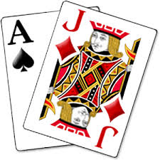

# Lesson 1

**Basics:** Blackjack is the staple game of the table games department. A player receives two cards and the dealer receives two cards - one of the dealer's cards is buried, one exposed. Numerical cards are worth their face value, face cards are 10, and aces are either 1or 11. Players decide how to play their hand and the dealer must play until he has at least 17. Whoever is closest to 21, player or dealer, without going over wins. If the player goes over 21, he automatically loses, even if the dealer exceeds 21 too.

**Card Placement Drill:** Build muscle memory by completing two shoes of blackjack and:

* Deal two cards to every spot, showing the pips
* Properly tuck the dealer hole card
* Reveal the dealer's hole card
* Sweep cards in proper order

During this drill, it is important not to play the hands as if it's a real game of blackjack. Instead, focus on the repetition and perfecting every moment. You will have plenty of opportunities to deal a full game later. Make the motions proper.

**Cheque Cutting:** Cheque handling is one of the most difficult aspects of dealing. Your instructor will show you how to cut cheques and you must practice! Grab a full stack of 20 cheques and run down stacks of 1cheque, then restack and run down cheques in stacks of 2, then restack and run down cheques in stacks of 3, etc. Complete the drill repeatedly: 1-2-3-4-5-5-4-3-2-1. Beginning today, you should practice cheque cutting for at least 20 minutes every day. Later when you're playing blackjack while another student deals, don't sit idly - run down cheques. Go to a casino and purchase $20 in $1 cheques so you may practice at home while you have downtime or are watching TV.

**Plucking:** When you take a precise number of cheques from the rack one at a time, you are plucking the cheques. Your instructor will show you the proper technique to pluck. It's a fairly messy process - and after about 6 or 7 cheques in your hand, you are better off peeling the stack rather than plucking. But plucking is great for blackjack payouts. It's not difficult; most students master plucking after 10 minutes of concentrated effort.

**Shuffling:** Shuffling is another activity you can easily practice at home. You don't need a proper felt or equipment - just a deck of cards and some free time. Your instructor will show you the proper technique for shuffling. Be sure to practice, focusing on accuracy. As with all of the drills you learn on the first day, speed will come naturally as you improve. Practice the technique.

# Lesson 2

Reading the Rack: All Cheques are in Stacks of 20

Cheque Color Denomination Full Stack Mini-Stack

Orange $0.50 $10.00 4 = $2.00

White $1.00 $20.00 5 = $5.00

Red $5.00 $100.00 5 = $25.00

Green $25.00 $500.00 4 = $100.00

Black $100.00 $2,000.00 5 = $500.00

Purple $500.00 $10,000.00 4 = $2,000.00





**Lesson 3**

**Hand Signals and Rules of the Game:** Read the guidelines below describing how to play blackjack. If you have any questions as to the appropriate hand signal for each action, ask your instructor to explain.

Stand: When a player opts not to receive another card, he stands. Hit: When the player requests an additional card, he hits.

Split: When a player has a pair (ex: 8,8), he may match his bet and split the pair into two separate hands. Note: when splitting aces, players receive only one card on each ace. When splitting, the first card and original wager always stays to the left, with additional cards and wagers moving to the right to create the new hand.

Double Down: When a player matches his bet and receives just one card, he is doubling down. This is common when a player has 11 and, in some instances, also when a player has 9, 10, or a soft hand. (Soft means hand with an ace.) Doubling is only possible on the first two cards. Players may “double for less" and bet less than their original bet as long as it meets table minimum requirements, but they may not double for more than their original bet. Also, a player may request the double down be delivered "face down," but when doubling on a hand that may potentially bust (ex: doubling on a hard 12), the card may only be given "face up."

**Soft 17:** When a hand is "soft" it means that there is an ace in the hand and taking an additional card will not bust the hand. The layout of most blackjack games will specify whether the dealer will hit or stand on soft 17. Standing on soft 17 is better for the player, so most low limit blackjack games will have the dealer hit soft 17.

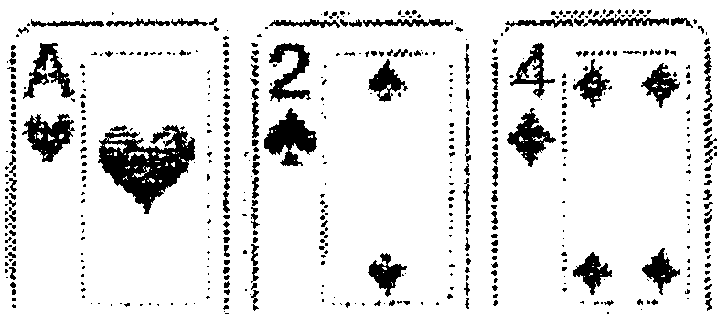**Soft 17**

Receiving a face card would not bust this hand.

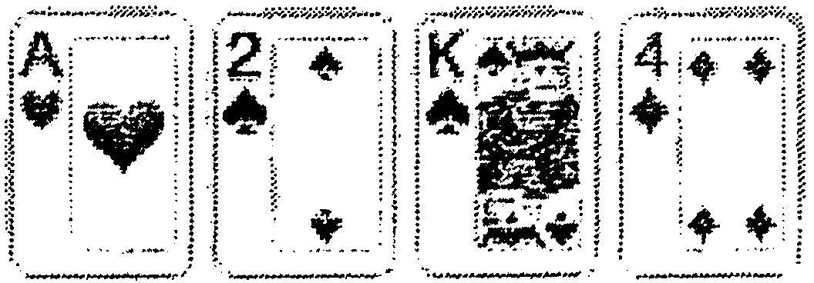**Hard 17**

Receiving a face card would bust the hand.

**Common Combinations to 21:** Look over this list of three card combinations to 21 and commit it to memory. If you remember 6-7-8 is 21, then you'll know that 6-7-9 is too many. You don't have to know what 6+7+9 totals, just that it is too many.

Note: when counting, think of aces as having a value of 1until you get to 11, 10, 9, 8, and (if the dealer doesn't hit soft 17) 7. When you get to the above totals, then the hands become 21, 20, 19, 18, and 17 respectively.

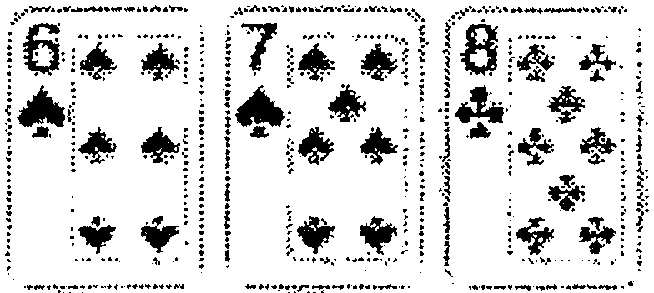 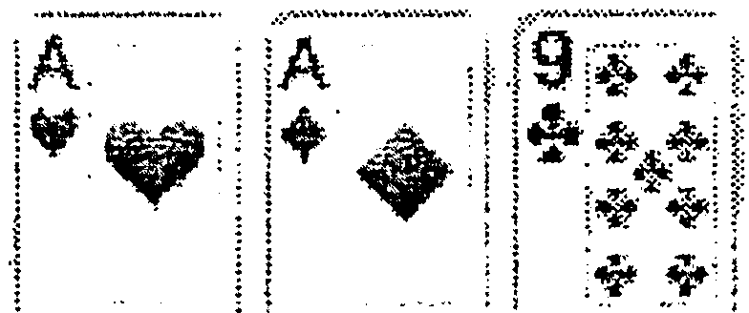 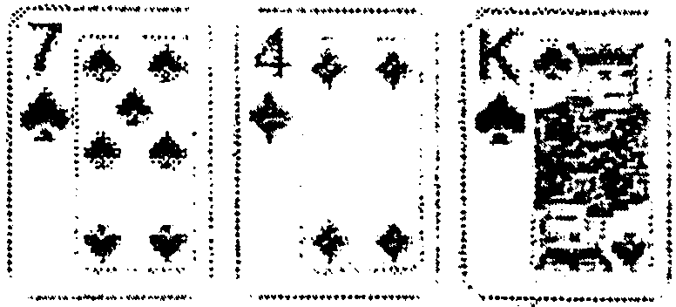

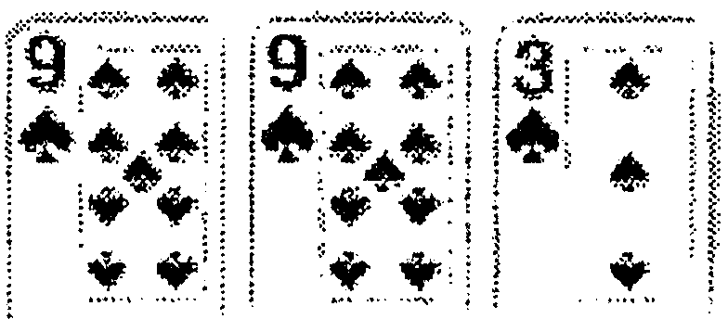 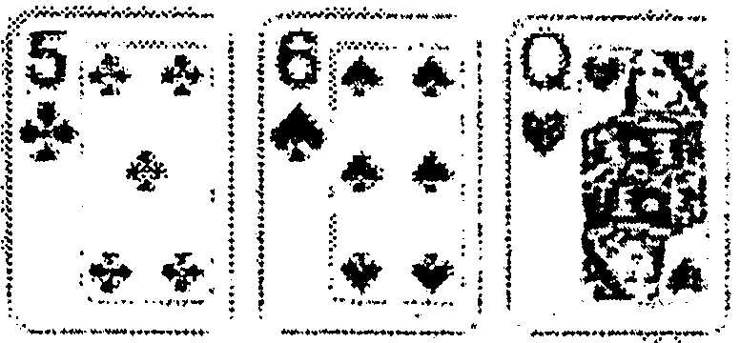 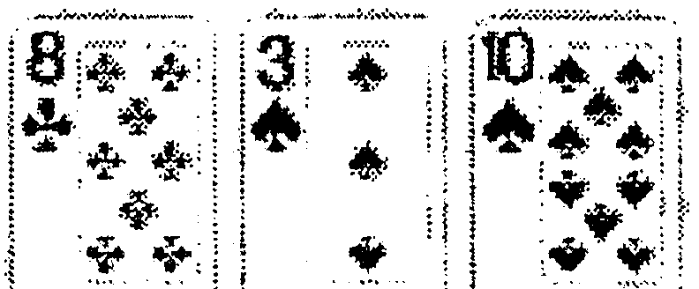

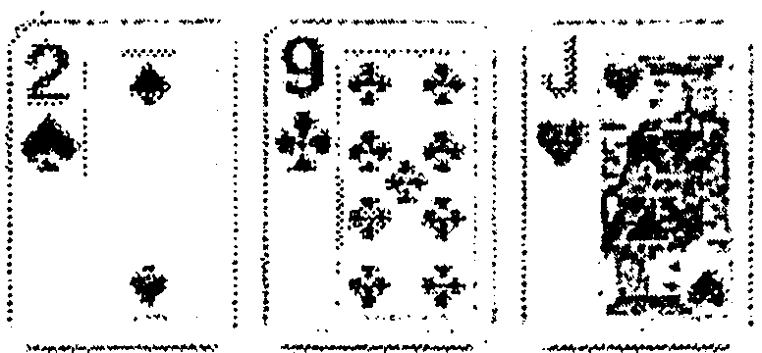 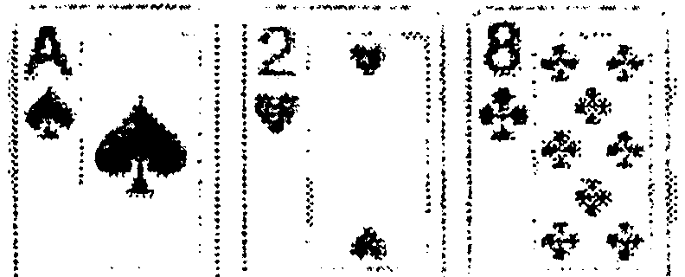 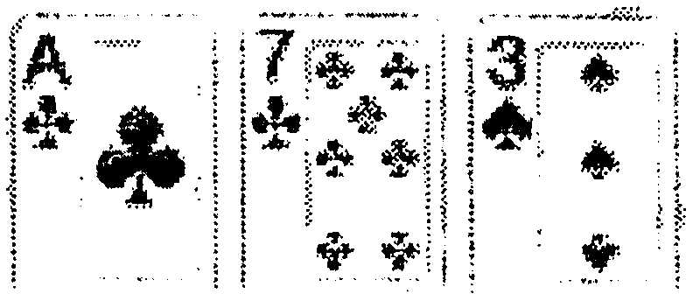

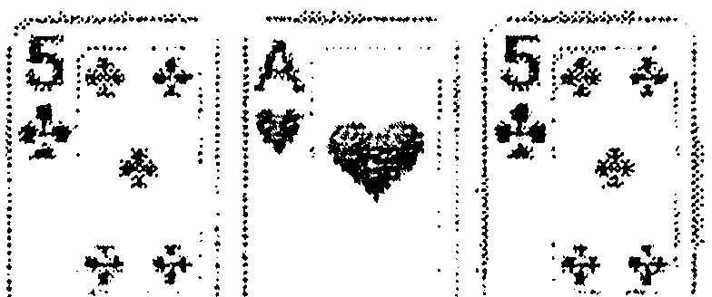 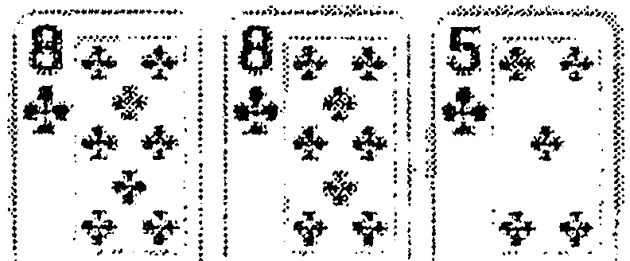 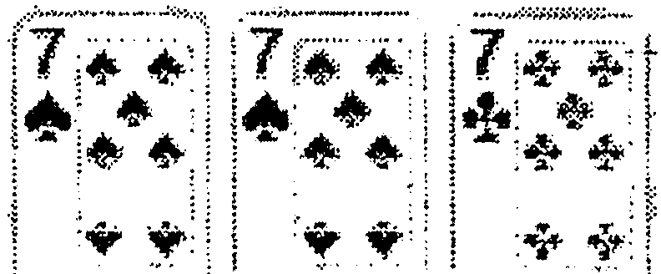



**3:2 Blackjack:** Blackjack pays 3:2 ("time and a half"). Remember, a blackjack is only possible on the first two cards. If a player receives two aces and splits them, receiving a face card on each ace, the total of each hand is 21, but it is not blackjack. The chart on the next page shows common blackjack payouts.

**PRACTICE:** Set up the following bets and pay them swiftly (answers on page 6).

1. 6 red cheques
2. 3 green cheques
3. 2 green cheques and 3 red cheques
4. 1 green cheque
5. 3 red cheques PLUS $2.50 for the dealer
6. 2 green cheques and 8 red cheques Plus 3 white cheques for the dealer

Note that a bet of $0.50 should pay $0.75 in the event of a blackjack. However, the casino does not keep quarters on the game, so when a player receives blackjack with a 50-cent piece on the bet, the house rounds down. Therefore, $0.50 pays even money.

|  |  |  |  |  |  |
| --- | --- | --- | --- | --- | --- |
| $0.50 | -7 | $0.50 | $55 | -7 | $82.50 |
| $1.00 | -7 | $1.50 | $60 | -7 | $90 |
| $1.50 | -7 | $2.00 | $65 | -7 | $97.50 |
| $2.00 | -7 | $3.00 | $70 | -7 | $105 |
| $2.50 | -7 | $3.50 | $75 | -7 | $112.50 |
| $3.00 | -7 | $4.50 | $80 | -7 | $120 |
| $4.00 | -7 | $6.00 | $85 | -7 | $127.50 |
| $5 | -7 | $7.50 | $90 | -7 | $135 |
| $10 | -7 | $15 | $95 | -7 | $142.50 |
| $15 | -7 | $22.50 | $100 | -7 | $150 |
| $20 | -7 | $30 | $200 | -7 | $300 |
| $25 | -7 | $37.50 | $300 | -7 | $450 |
| $30 | -7 | $45 | $400 | -7 | $600 |
| $35 | -7 | $52.50 | $500 | -7 | $750 |
| $40 | -7 | $60 | $1,000 -7 | | $1,500 |
| $45 | -7 | $67.50 | $2,000 -7 | | $3,000 |
| $50 | -7 | $75 | $5,000. -7 | | $7,500 |

**PRACTICE ON PAGE 5 ANSWERS**

1. 1 green cheque, 4 red cheques
2. 4 green cheques, 2 red cheques, 2 white cheques, $.50 piece
3. 3 green cheques, 4 red cheques, 2 white cheques, $.5O piece
4. 1green cheque, 2 red cheques, 2 white cheques, $.50 piece
5. 4 red cheques, 2 white cheques, $.50 piece PLUS the dealer bet should have 1 red, 1white ($3.50 pays $2.50 for a total of $6 - short cut is to leave $6)
6. 5 green cheques, 2 red cheques PLUS dealer bet paid 1red, 2 whites, $.5O piece

**Lesson 4**

**______________________________________________________________________**

**Rules of the Rack**

* Pay with the outside tubes in only. You can have one open tube of red and one tube green on each side if they are actively playing it.
* Pay and take the first two spots with your left hand all other spots are done with your right hand.
* Never pass cheques back and forth between your hands.
* In general, pay color for color. Convert after a player has two full stacks.
* When paying, size into the bet beside the original or in front if there’s no room. Never pay behind.
* No partial payments – if you don’t have enough cheques, bring it all back.
* Bets should be totem poled largest denomination on bottom to smallest on top.

**Buy-Ins**

* “Change $100” means the dealer is changing $100 cash.
* “Cheque change $100” means the dealer is making change out of $100 worth of cheques and making them a lower denomination.
* Verbalize all transactions and wait for supervisor approval on $100 or higher.
* Money/cheques going to the house belong on your left. Money/cheques going to the player belong on your right.
* Round down money in columns of five except for $50s they go in columns of 4. Don’t mix denominations – one per column.
* No more the five columns of five bills on the layout. If a buy-in is larger than 25 bills, wait for approval and place under the paddle(crisscross).
* A general rule for buy-ins is to provide players with a full stack of the table minimum cheques. On a $5 table, give a $100 buy-in a stack of red. Give a $200 buy-in a stack of red and four green. If buy-in of $500, assume the player will not bet reds and give a stack of green, (polite to ask if they would like some red).

**Color Up:** When a player has completed play, request to “Color them up” giving them a tito ticket. Money going to the house belongs on the left of the layout. Tickets going to the player belongs on the right. When you color up for a ticket, specify by saying: “Color up $500 for a ticket.”.

A general rule for coloring up while they are still playing is to “chip up” and provide players with the next cheque denomination. For instance, if the player pushes you 20 red cheques to you to color up, give him four green unless he specifically asks for black.

**Open/Close/Fill/Credit/Count:** When you open a game, close a game, complete a fill, or complete a credit, you will run down the cheques on the layout. Keep the largest denomination closest to your rack. Prove the stacks of the same color are the same size, then run down and prove one full stack. Run down and prove any partial stack too.

When it is time to close a table, bring the lid to the top of the layout so players passing by will understand you are closing. After you count the cheques and insure all information is correct, place the closer on the designated side of your rack overtop of the smallest denomination of cheques. Insure the lid is properly secured before you step away from your game.

When management does the shift count, arrange the cheques into perfect order then complete the hand you’re dealing. Wait until the count is finished before proceeding to deal another hand.



# Lesson 5

**Insurance:** When a dealer has an ace up, he offers the players insurance. Insurance is a side bet, where the player wagers that the dealer has blackjack. Players may bet up to half of their original bet. If there’s no dealer blackjack, the player loses the insurance bet. If the dealer does indeed have a blackjack, the insurance bet is pa id 2:1.

Example: a player has a $10 bet and takes full insurance of $5. If the dealer has a blackjack, the player wins 2:1 on the insurance ($10) but loses the original bet (-$10), so essentially the player “pushes” and does not lose any money in the transaction. M any dealers simply push the insurance bet back to the player as payment, but the proper procedure is to take the losing bet then pay 2:1on the insurance line. Th is makes sense when you consider this next example.

Example two: a player has a $10 bet and takes partial insurance {let’s say $2 insurance bet in this case). If the dealer has a blackjack, the original bet loses (-$10) but the insurance line pays 2:1 ($4). It’s proper procedure to take the original bet then pay the insurance line.

**Even Money:** Even money is a shortcut for insurance that’s available when the player has blackjack and the dealer is showing a n ace. Even money is available in a standard blackjack game where blackjacks pay 3:2, but not I n a 6:5 game.

Example: player bets $10, receives a blackjack, the dealer shows an ace, and the player requests “even money.” The math works out exactly the same as an insurance bet. Full insurance would be $5. If the dealer doesn’t have a blackjack, the player would lose the insurance bet (-$5) but win 3:2 on the blackjack ($15), betting $10. If the dealer has a blackjack, the player would win 2:1 on the insurance bet ($10) and push the blackjack ($0), again betting $10. In either scenario, the player wins even money ($10)

**Lesson 6**

**Basic Strategy:** Basic strategy, often referred to as “The Book,” is the mathematically best way to play a hand of blackjack without knowledge about the distribution of the rest of the cards in the deck. It is important for a dealer to have a working knowledge of basic strategy, as well as to understand the misconceptions.

There are many variations of the basic strategy chart. Any rule change (such as not allowing double after split) and any variation on the number of decks changes the strategy. For instance, on a six-deck shoe if a player has 7-7 vs. a dealer’s 10, basic strategy dictates the player should draw, but on a single deck, it’s proper to stand.

Every situation is different, but a general rule to remember is that you, as the dealer, are providing a service to players. You’re there not only to deal cards, but to assist them in having fun at the table. Instigating a fight by telling someone they are wrong is not fun for anyone. Here’s an example of what you can say to give the player options: “16 vs. a 10 is tough. Basic strategy as I know says to **hit,** but a lot of players don’t like to. Either way, it’s not looking good.” If you can turn it into a joke, you’re easing the pressure.

Aside from getting basic strategy wrong (most players do), the biggest misconception a player makes is when he believes another player’s actions affect his hand. Players often have a selective memory and remember that time when a player stood on his 14 vs. the dealer’s 6 and “took the dealer’s bust card,” but mathematically, another player’s decision has equal chance of hurting or helping. Basic strategy is not written as a collective strategy for the entire table - that is simply superstition.

The easiest way to think of basic strategy is in terms of weak or strong dealer hands. If a player assumes the dealer's hole card is 10, a 7, 8, 9, 10, or A as the upcard gives the dealer a pat hand. If the dealer's hole card is 2, 3, 4, 5, or 6, it's a very weak hand for the dealer. No matter what card is underneath, the dealer will have to draw. Drawing another card increases the dealer's chances of busting.

Here are some easy pointers to basic strategy:

* + If a dealer shows a strong upcard (7 through A), the player should hit until 17.
  + If the dealer shows a weak upcard (2-6), the player should stand if they can bust (with the exception of a 12 vs. a 2 or 3).
  + Split and double down on soft hands often against weak deaer's_upcard card. If a player has 11, he should double down
  + If the player has 10, he should double down against every card except a 10 or A. If the player has 9, he should double down against a weak dealer upcard of 3-6. If the player has A-A or 8-8, he should split.
  + If the player has 9-9, he should split against everything except 7, 10, A.

This chart below shows the basic strategy for the most common blackjack game in Vegas multiple deck, dealer hits soft 17. Read the chart by finding the player's hand on the left column and matching it with the corresponding cell for the dealer's upcard

|  |  |  |  |  |  |  |  |  |  |  |
| --- | --- | --- | --- | --- | --- | --- | --- | --- | --- | --- |
| 6 Decks, H 17, DAS, No Surrender, Peek | | | | | | | | | | |
| Estimated casino edge for these rules: 0.66% | | | | | | | | | | |
| Your | Dealers Upcard | | | | | | | | | |
| Hand | 2 | 3 | 4 | 5 | 6 | 7 | 8 | 9 | 10 | A |
| 7 | H | H | H | H | H | H | H | H | H | H |
| 8 | H | H | H | H | H | H | H | H | H | H |
| 9 | H | D | D | D | D | H | H | H | H | H |
| 10 | D | D | D | D | D | D | D | D | H | H |
| 11 | D | D | D | D | D | D | D | D | D | D |
| 12 | H | H | S | S | S | H | H | H | H | H |
| 13 | S | S | S | S | S | H | H | H | H | H |
| 14 | S | S | S | S | S | H | H | H | H | H |
| 15 | S | S | S | S | S | H | H | H | H | H |
| 16 | S | S | S | S | S | H | H | H | H | H |
| 17 | S | S | S | S | S | S | S | S | S | S |
| A,2 | H | H | H | D | D | H | H | H | H | H |
| A,3 | H | H | H | D | D | H | H | H | H | H |
| A,4 | H | H | D | D | D | H | H | H | H | H |
| A,5 | H | H | D | D | D | H | H | H | H | H |
| A,6 | H | D | D | D | D | H | H | H | H | H |
| A,7 | DS | DS | DS | DS | DS | S | S | H | H | H |
| A,8 | S | S | S | S | DS | S | S | S | S | S |
| A,9 | S | S | S | S | S | S | S | S | S | S |
| 2,2 | P | P | P | P | P | P | H | H | H | H |
| 3,3 | P | P | P | P | P | P | H | H | H | H |
| 4,4 | H | H | H | P | P | H | H | H | H | H |
| 5,5 | D | D | D | D | D | D | D | D | H | H |
| 6,6 | P | P | P | P | P | H | H | H | H | H |
| 7,7 | P | P | P | P | P | P | H | H | H | H |
| 8,8 | P | P | P | P | P | P | P | P | P | P |
| 9,9 | P | P | P | P | P | S | P | P | S | S |
| T,T | S | S | S | S | S | S | S | S | S | S |
| A,A | P | P | P | P | P | P | P | P | P | P |
| Dlr: | 2 | 3 | 4 | 5 | 6 | 7 | 8 | 9 | 10 | A |
| Key: | H= | HIT | | S= | STAND | | P= | SPLIT | |  |
|  | D = | DOUBLE (Hit if not allowed) | | | | | | |  |  |
|  | DS= | DOUBLE (Stand if not allowed) | | | | | | | |  |

**Side Bets:** Think of these bets as you would think of candy bars in the checkout isle of a grocery store - they're meant to lure people into impulsively adding one item to their shopping cart. The good news for you is that side bets have all the information you need to know printed on the layout, making the bet easy to understand.

The important thing to know about side bets are as follows:

* Players must place a wager on the blackjack hand in order to bet on the side bet.
* Pay attention to minimums and maximums. No matter the bet of the blackjack hand, side bets typically have lower limits - usually $1-50
* Unless the side -bet has something-to do with the final outcome of the player's hand (which is rare), the side bet should be paid or taken immediately. Proper procedure when paying the bet is to pay then push the entire amount - original wager and payout away from the betting circle and back toward the player. This is a procedural precaution to make sure you do not pay the bet twice.

**Lesson 7**

**Pitch Black jack:** Your instructor will show you the proper technique to pitch cards. Begin pitching to a single spot on the table and as you improve your accuracy, pitch to multiple spots.

* Only one player may touch the cards
* The player may hold card in only one hand and may not bend/mark the cards.
* Players betting two spots must make decision on their first hand and set it down before picking up cards to the other hand.
* Players must be seated while playing.

##### Table Games General Rules:

* Clap and clear your hands whenever you approach the table, clear your hands whenever you touch your body, hair or clothing. You should clear your hands constantly.
* Never take anything directly from a player's hand.
* No eating, photographs, cell phones, or electronic devices at the table.
* Only casino cheques, money, player cards, basic strategy cards, smokes, ashtrays, and drinks may be placed on the table.
* Players betting two hands must bet double the minimum of the table.
* Players betting three hands must bet five times the minimum.
* Ask for a player's card or ID card on all new players coming to your table.
* Never argue with your floor supervisor in front of guest - even if you know they are telling you something that is incorrect. Approach on your break time to discuss.
* Walk your game. Move constantly to allow your peripheral vision to assist you.
* Be keenly aware of the bets first spot (first base) and last spot (third base).
* No matter whom you're speaking with or what you're doing, your torso should face your cheque rack.
* Don't leave yourself open to vulnerabilities, such as paying the first base with your right hand and leaving the right side of your rack exposed.
* On a shoe blackjack game, cover the mouth of the shoe with your left hand when there are pauses in your dealing (such as waiting for a player to make a decision).
* Players may not cover their bet with their hand, body, cards or other instrument; surveillance must always have a clear view of the bet.
* Be suspicious of a player who makes hand gestures or movements close to the betting circle or cards.

**Customer Service:** Dealing in a casino is a blend of game knowledge, procedure, and personal skills. Customers are playing at your table to have a good time. Show them a good time. Be friendly and positive. Enjoy your job and they'll enjoy playing with you.

* Greet players when they approach your table.
* Invite players to sit down. If you're in the middle of dealing a hand, tell them you'll be with them as soon as you finish.
* Some casinos prefer you to address players by their first name. Others insist on using their last name. In general, "sir" and "miss" are good substitutes.
* Use complete phrases and avoid slang.
* Say a genuine 'thank you' with eye contact when a player makes a bet for you.
* Wish players luck when you make change for them, when they make a large bet, when they double down, and when they leave your table.
* Be engaged in the conversation.

**Things Not To Do:** Do not do the following at work:

* Do not complain about your personal life to players. Be positive.
* Do not deal to friends or family members.
* Your hair should be a natural color and you should never have a bad hair day.
* Do not offer unsolicited advice. Allow players to play their hand their own way.
* Do not be insulted if a player is rude to you. Let it roll of your back.
* Do not sign the E.O. List for another person.
* Do not take breaks in a public area of the casino. Go to the back of the house.
* Do not smoke anywhere other than the designated employee smoking area.
* Do not chew gum on the casino floor.

**Break Time:** When you get tapped off for break, take a step to the side and allow the incoming dealer to step in. At that time, relay vital information to the incoming dealer. If you're in the middle of a shuffle or buy-in or some other task, complete it before going on break. Provide guests with a warm farewell before you leave. Pause for a moment, giving the players one last chance to tip you.

**Appendix: Casino Lingo**

**Bankroll:** (1) The player's available funds. (2) The cheque rack.

**Book:** "The Book" is the basic strategy chart in blackjack. And 'to book' as in 'to book a bet' is to accept that bet.

**Break-In:** An inexperienced dealer.

**Burn:** Taking a card from the top of the deck and placing it in the discard rack.

**Breaker:** The dealer who sends other dealers on break.

**Cage:** Casino cashier.

**Cans:** The drop boxes on the gaming tables that hold the money.

**Case Bet:** The last bet a player makes because he's run out of cheques.

**Cheque:** A casino token that has value.

**Chip:** A casino token without a specified value on a roulette game.

**Color for Color:** Paying a bet with the same value cheques the player bet with.

**Comp:** A complimentary "gift" from the casino to a player in the form of a dining credit, hotel room, show tickets, etc.

**Credit:** Removing casino cheques from a table (opposite of fill).

**Cut:** When a player places a solid colored card into freshly shuffled cards to cut the deck

**Dead Game:** A gaming table that is open but does not have any players.

**Dirty Money:** Cheques in a losing bet that have not been returned to the rack and are used to pay other winning bets.

**Drop, The:** The amount of money a casino (or a table in the casino) takes in during a given day (or shift). 'To drop' is to put the money into the drop box.

**Edge:** The casino's mathematical advantage in a particular game.

**E.D.R.:** Employee Dining Room

**Eighty-Six:** To 86 a player is to bar him from playing.

**E.O.:** Early Out

**E.O. List:** The list a dealer signs to receive an Early Out

**Eye, The:** Surveillance

**Fill:** Extra cheques brought to a table game by a security officer.

**Foreign Cheque:** A cheque from another casino.

**Friday, My:** The last day of a person's five-day work week

**George:** A customer who tips well.

**George, King Kong:** A customer who tips exceptionally well.

**Grandfathered In:** A player gambling at a table prior to the table minimum being raised who is allowed to bet the previous minimum is "grandfathered in."

**High Roller:** A player with a large bankroll.

**Hole Card:** The dealer's unexposed card in a blackjack game.

**Lace:** Riffling the cards without pushing them together.

**Lammer:** A valueless token denoting a dollar amount, used primarily to issue markers.

**Lay and Pay:** Opposite of "pick and pay" and predominantly used in Pai Gow Poker. The dealer first lays every players hand on the layout, removing the losers and tie hands. Then the dealer returns to remaining hands on the layout and pays the bets.

**Let It Ride:** To take the winnings from a bet and wager it along with the original.

**Lock:** A hand that cannot lose. 'Lock it up' means to put cheques into the rack.

**Muck:** The act of restacking roulette chips. Typically, one mucks for a roulette dealer when the

Casino is overstaffed or needs to maintain an extra dealer in case of emergency.

**Mucker:** One who mucks.

**Paddle:** The clear piece of plastic used to push money or casino paperwork through the slot on the drop box.

**Player's Card:** Reward card for customers where high average bets and time spent at the gaming table translate into prizes, similar to the frequent flyer program of major airlines.

**Push:** A premature break given to your string by an extra dealer.

**Stiff:** A customer who does not tip at all.

**String:** The name for the 3-5 dealers that follow one another

**Take and Pay:** After all players at the table make a decision, pick and pay is when the dealer picks up the cards of each hand to determine whether or not they are a winner, then immediately pays, takes, or pushes before moving to the next player.

**Tapped Off:** When Dealer A taps Dealer B's shoulder and A replaces B on a game.

**Toke:** A tip given to an employee.

**Totem Pole:** A bet with several different cheque denominations. (Also called barber pole)

**Wash:** Throwing all of the cards onto the table and mixing them up with both hands.