Mini Baccarat Rules

Following are the rules of baccarat. The terminology can be a little confusing. To try to minimize this, when referring to a particular bet or hand, I will use capital letters. In particular Player and Banker refer to bets as well as particular sets of two or three cards each.
- Usually eight decks of cards are used.
- Cards are given point values as follows: Ace = 1, 2-9 = pip value, 10 and face cards = 0.
- Play begins by all players betting either on the Player or Banker. There is also a side bet on a Tie. At some tables there are also side bets on a Player Pair and/or Banker Pair. There are lots of other newer side bets, which I go into in my baccarat appendix 5.
- After all bets are down, the dealer gives two cards each to the Player and Banker hands.
- The maximum number of points in both the Player and Banker hands is 9. The way to arrive at the points per hand is to take the total points of each individual card in the hand. If the sum is more than 9, then drop the first digit. For example, if either hand had a 9 and 7, then you would drop the 1 from the total of 16, for a 6-point hand.
- A third card may or may not be dealt to either the Player or Banker hands, depending on the following rules.
- If either the Player or Banker have 8 or 9 points, it is referred to as a "natural." If there is at least one natural, then both hands will stand.
- Otherwise, if the Player's total is 5 or less, then the Player hand will draw one more card, otherwise, with 6 or 7 points, the Player hand stands.
- If the Player hand stands with 6 or 7 points, then the Banker hand will draw a third card on a total of 5 or less. Otherwise, with 6 or 7 points, the Banker will stand.
- If the Player does draw a third card, then use the Banker will use his positional advantage to decide whether to take a third card according to his total and the third card drawn to the Player,
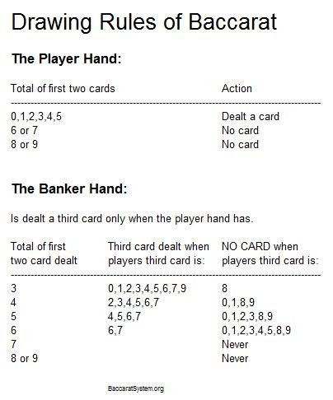

- The score of the Player and Banker hands are compared; the winner is the one that is greater. In an event of a tie, the Player and Banker bets push.
- The Tie bet wins if the Player and Banker hands tie. All other outcomes lose.
- The Player Pair bet wins if the first two cards in the Player hand are of the same rank. All other outcomes lose.
- The Banker Pair bet wins if the first two cards in the Banker hand are of the same rank. All other outcomes lose.
- Following is how to pay each bet:
  - Player: Wins pay even money.
  - Banker: Wins pay 19 to 20, which is equivalent to even money less a 5% commission.
  - Tie: Almost all casinos pay 8 to 1 on a tie, which is often expressed as the equivalent to 9 for 1.
  - Player Pair and Banker pairs: Wins pay 10 to 1.

The reason the Banker gets paid less than the Player is the Banker enjoys a positional advantage, with more information available to make the decision on drawing a third card.
Following are some rules on dealing procedures. The beginner can skip this part.
- At the start of a new shoe, the dealer will turn over one card. This will determine how many cards the dealer will burn, according to the baccarat value, except a 10 or face card will result in 10 cards burned.
- The cut card will be placed 16 cards from the bottom of the shoe. When the cut card appears, the dealer will finish that hand, play one more hand, and then start a new shoe. If the cut card comes out instead of the first card, the dealer will finish that hand, and then start a new shoe.
- To speed up the game, the dealer will keep track of commissions owed on winning Banker bets using small laminated markers. He will collect all commissions owed at the end of the shoe.

Dragon Bonus rules and payouts
At its core, the Dragon Bonus is just like the standard baccarat bets: you can either side with the banker, or with the player. If you bet on the banker, you win if the banker has the highest score; and if you bet on the player, you win if the player has the highest score.
What separates the Dragon bet from regular baccarat wagers is the extended payout table. The higher the margin of victory, the bigger the payoff – except in the case of naturals. If the winning hand has a score of eight or nine points on the initial deal, the return is 1 to 1. If both hands draw a natural and the result is a tie, the bonus bet is pushed.
For all other outcomes (i.e. any non-natural hands), a winning margin of four points or more earns a payout. For example: if the player has six points and the banker has one, the player wins the bonus bet by a margin of five points. If the hands are tied, or if the margin is three points or less, the bet loses.
Winning hands are paid out like so:
- Four points pays even money
- Five points pays 2 to 1
- Six points pays 4 to 1
- Seven points pays 6 to 1
- Eight points pays 10 to 1
- Nine points pays 30 to 1
These odds apply to both the banker bonus and the player bonus.

