Prop bet payoffs
3 way bets
ex. 6's (5-1, 4-2, 3-3)
one way (3-3) pays 30 to 1 two ways (4-2,5-1) pay 15 to 1
9x bet plus 1/3 4x bet plus 1/3
9xbet plus in the box. 4x bet plus whats in the box
9.33 per $1 4.33 per$1

any 7 pays 4 to 1
yo 11 pays 15 to 1
any craps. Pays 7 to 1
c&e pays 3 to 1 on crap/ 7 to 1 on the 11

2 way bets
on a 30 to 1 -key is blackjack the bet add a zero to back number and subtract half the original bet. Ex. 10 hi-lo, 10 blackjacked is 15, 150 with zero, 145 payoff after bet subtracted
on 15 to1- 7 times bet
horns or 4 way bets
2 |  | 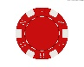  12
pay 30 to 1 |  | pays 30 to 1
7 times the bet - 1/4 the bet |  | 7 times the bet - 1/4 the bet
6.75 per $1 |  | 6.75 per $1
3 |  | 11
pays 15 to 1 |  | pays 15 to 1
3 times the bet |  | 3 times the bet
$3 per $1 |  | $3 per $1
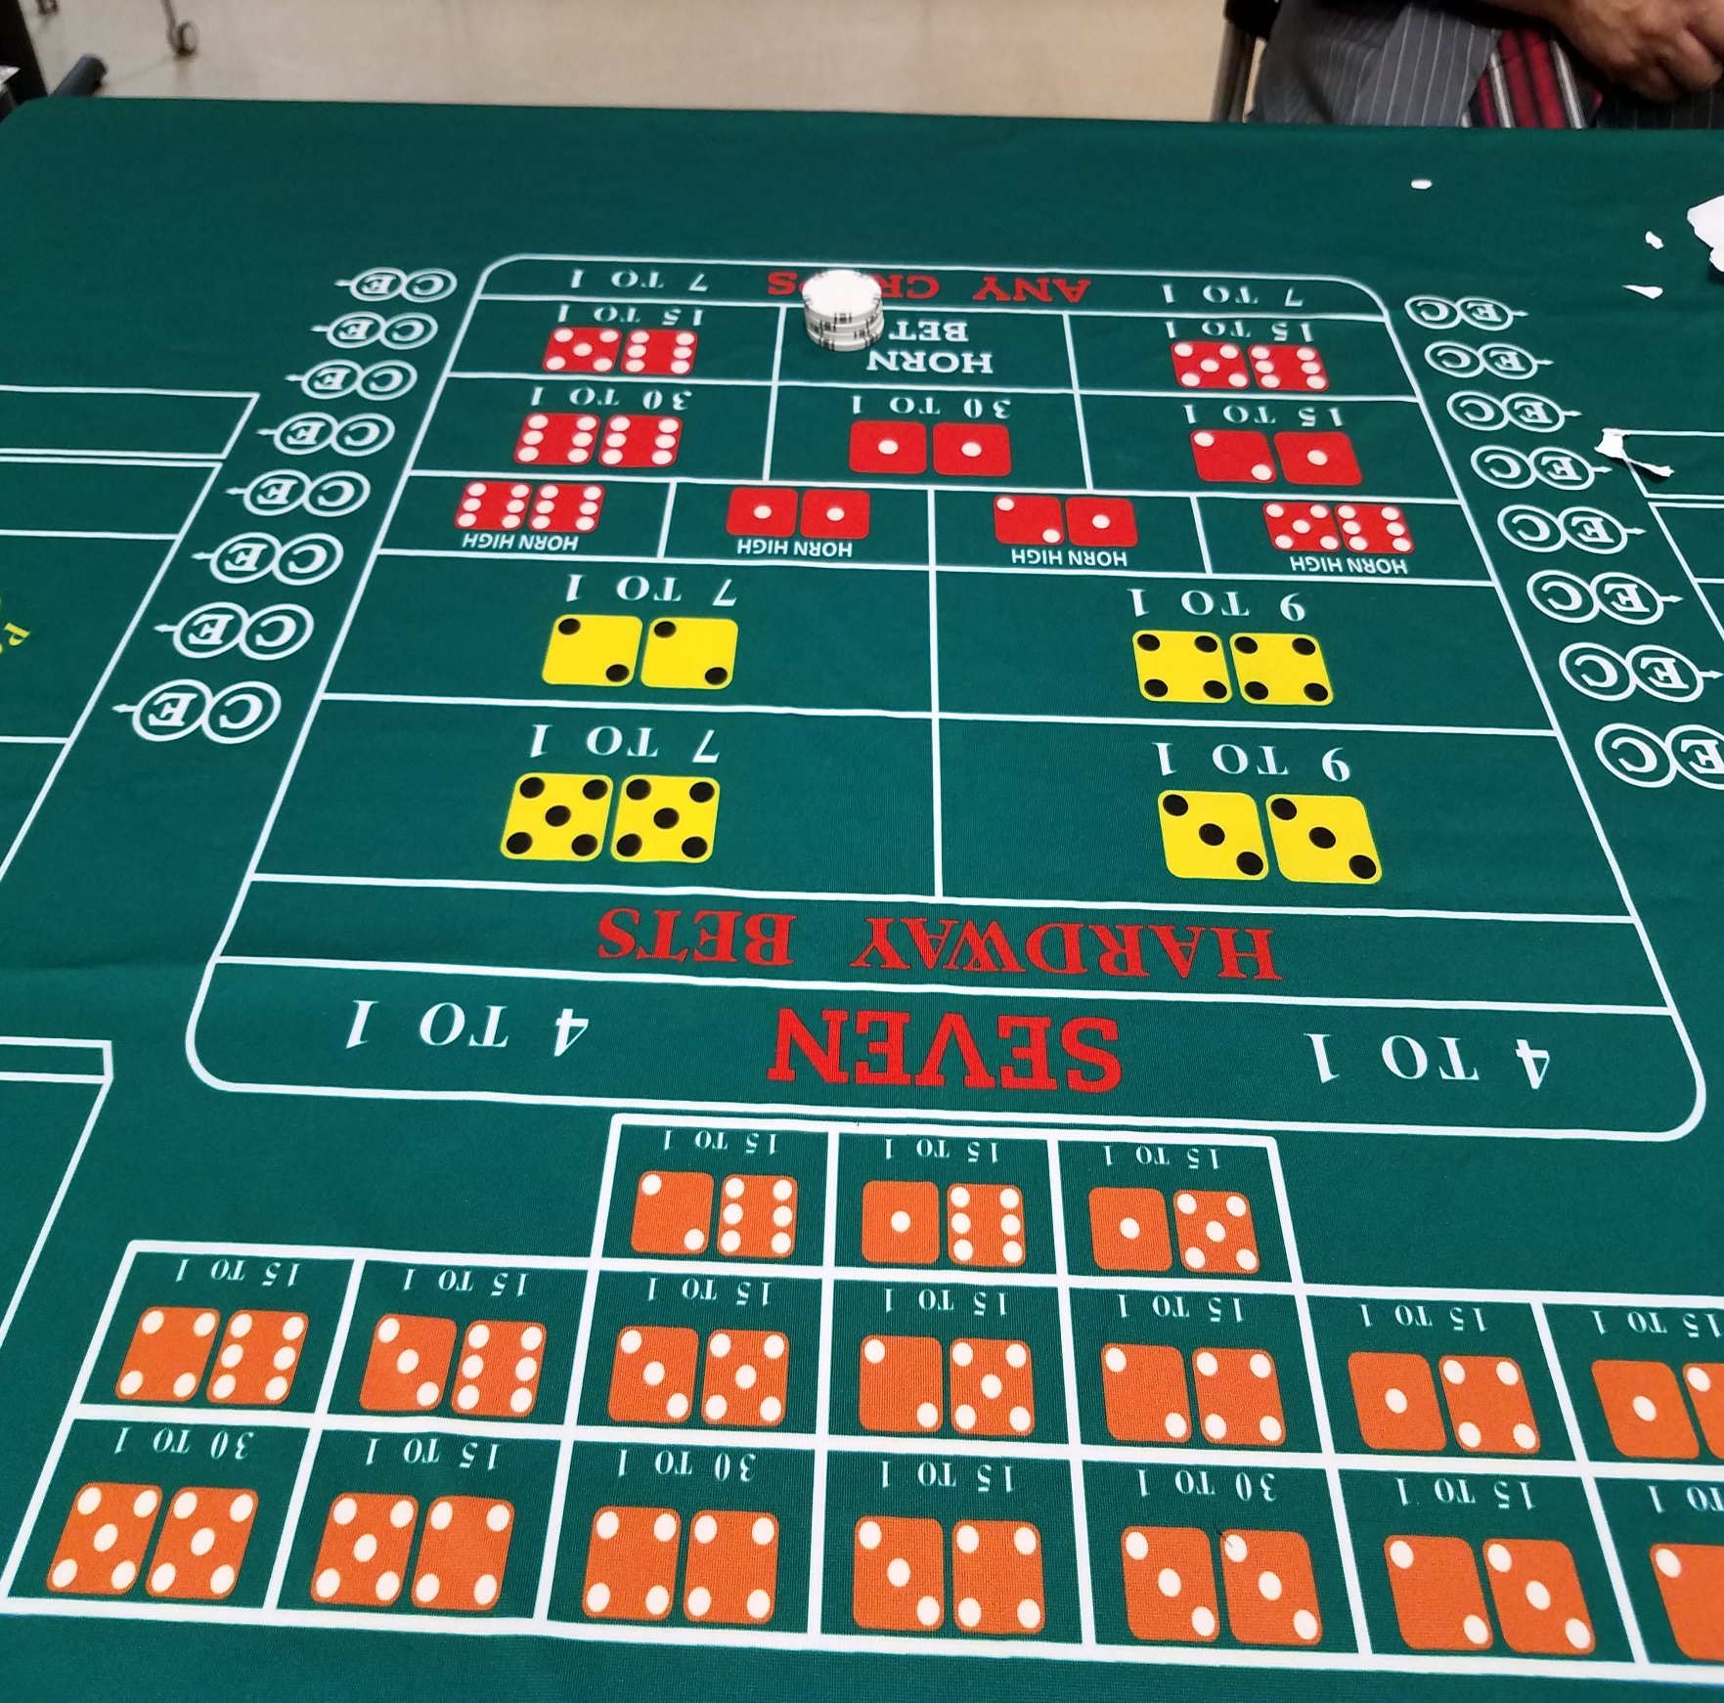
Bets are placed in the position that the customer is playing on the table.
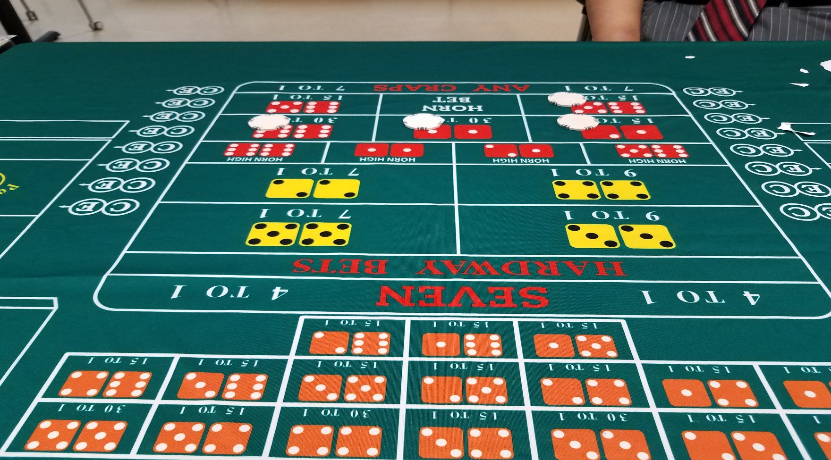
Dealer may also place them with ¼ of the bet in each spot, if it is easier for them to calculate win.

5 way whirl or world bets
Low side every red gets $11, high side every red gets a green and a white

Any 7

pays push
2 | 12
pay 30 to 1 | pays 30 to 1
5x bet plus 1x in box | 5x bet plus 1x in box
$5.20 per $1 | $5.20 per $1
3 | 11
pays 15 to 1 | pays 15 to 1
2x bet plus 1x in box | 2x bet plus 1x in box
2.20 per $1 | 2.20 per $1

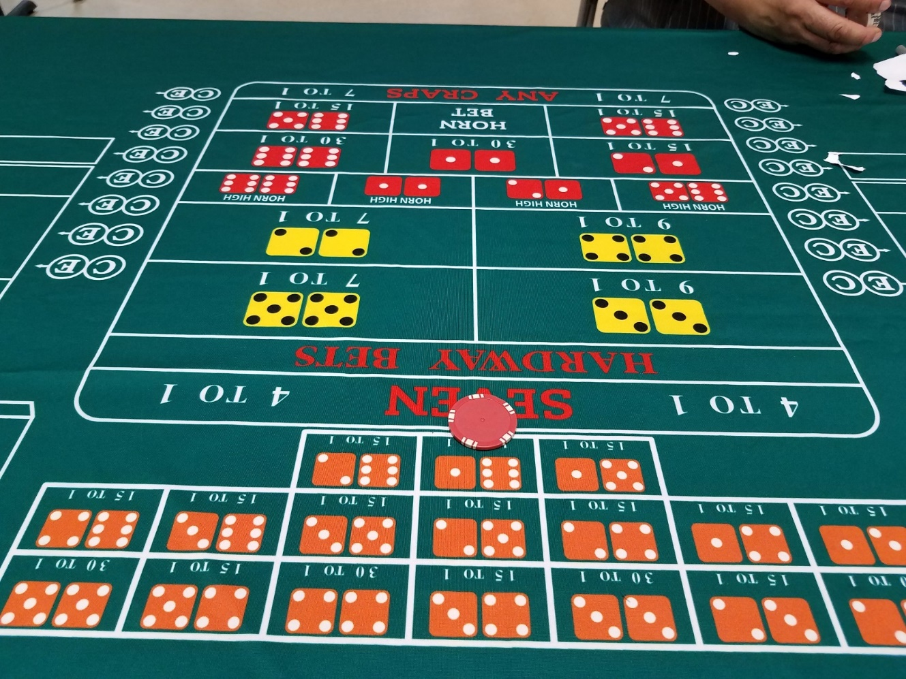
Bet is placed on the top line above the any 7 box, on a whirl bet.

 |  |  | Horn Highs
 |  |  | 2 |  | 12
 |  |  | 30 to1 |  | 30 to1
high side |  |  |     11x bet plus 1x in the box |  | 11x bet plus 1x in the box
 |  |  | 11.40 per $1 |  | 11.40 per $1
 |  |  | 5x bet plus 1x in box |  | 5x bet plus 1x in box
 |  |  | $5.20 per $1 |  | $5.20 per $1
 |  |  | 3 |  | 11
Low side |  |  | 15 to 1 |  | 15 to 1
 |  |  | 5x bet plus 1x in the box |  | 5x bet plus 1x in the box
 |  |  | 5.40 per $1 |  | 5.40 per $1
 |  |  | 2x bet plus 1x in box |  | 2x bet plus 1x in box
 |  |  | 2.20 per $1 |  | 2.20 per $1

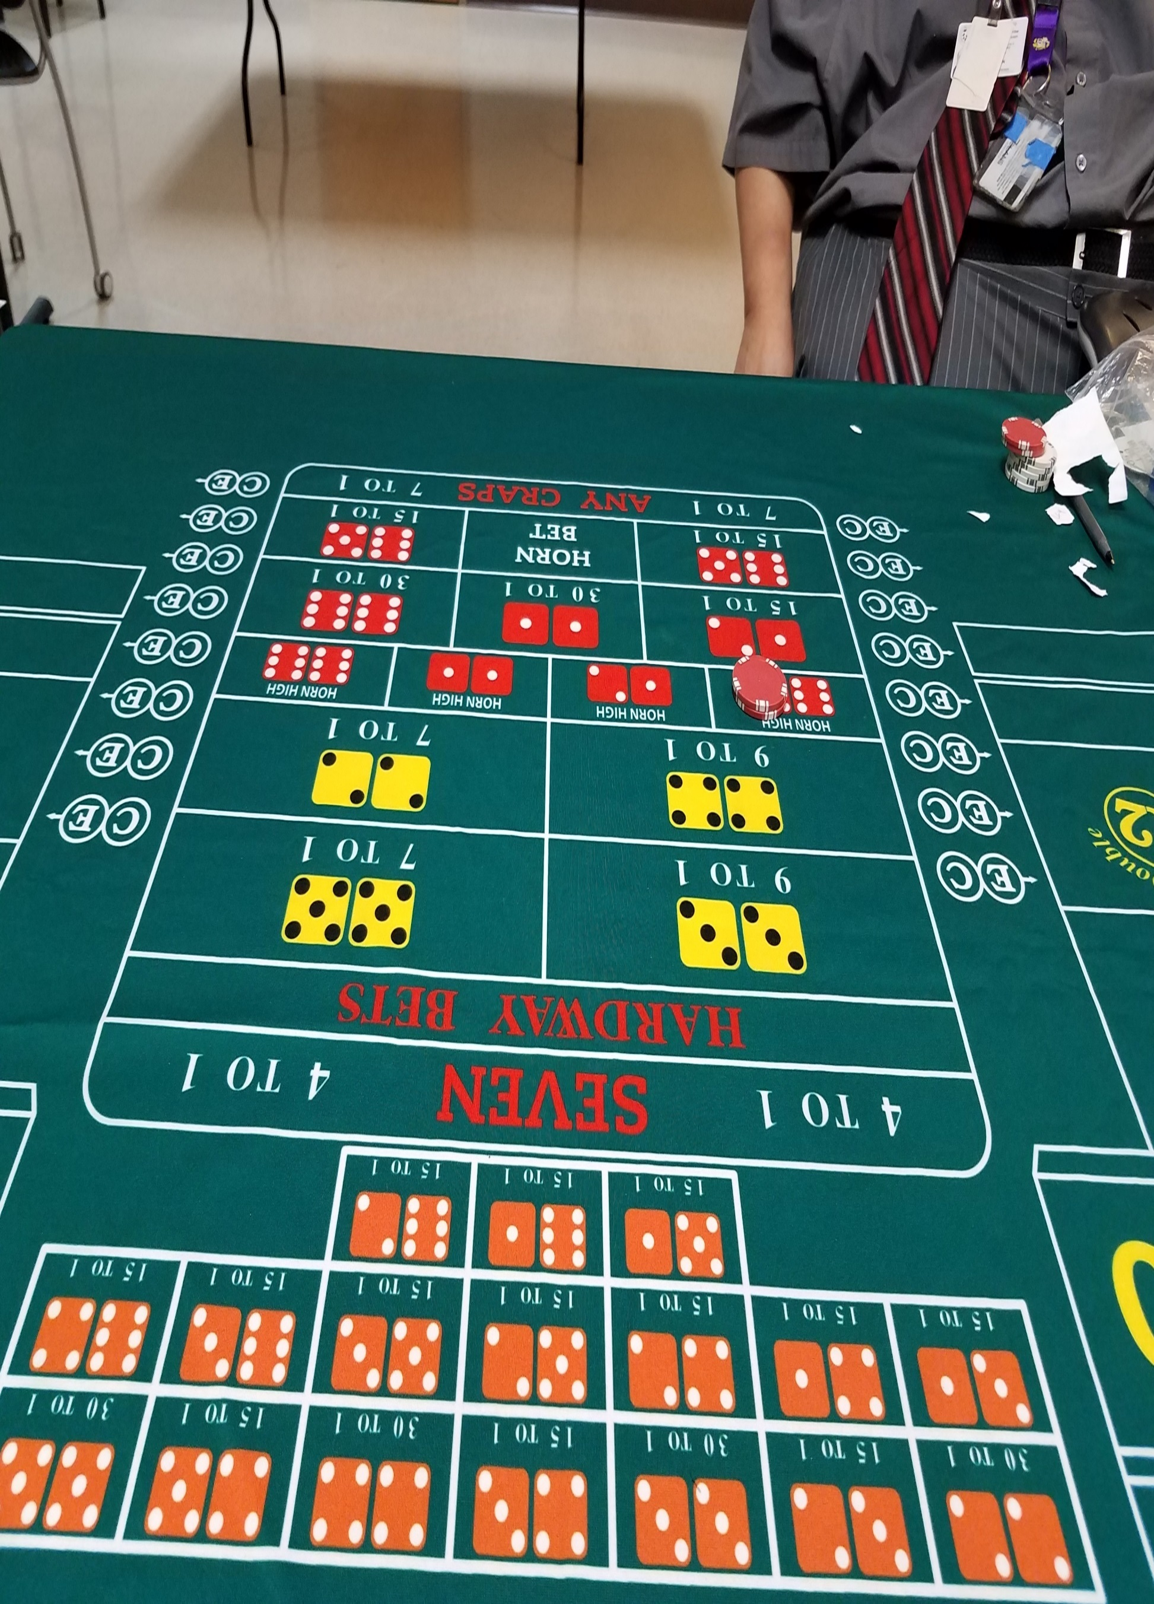
Bets are placed in the box which the horn high is high on. Above is a horn high yo.

Hardways
Hard 4 and 10 7 to 1
Hard 6 and 8 9 to 1
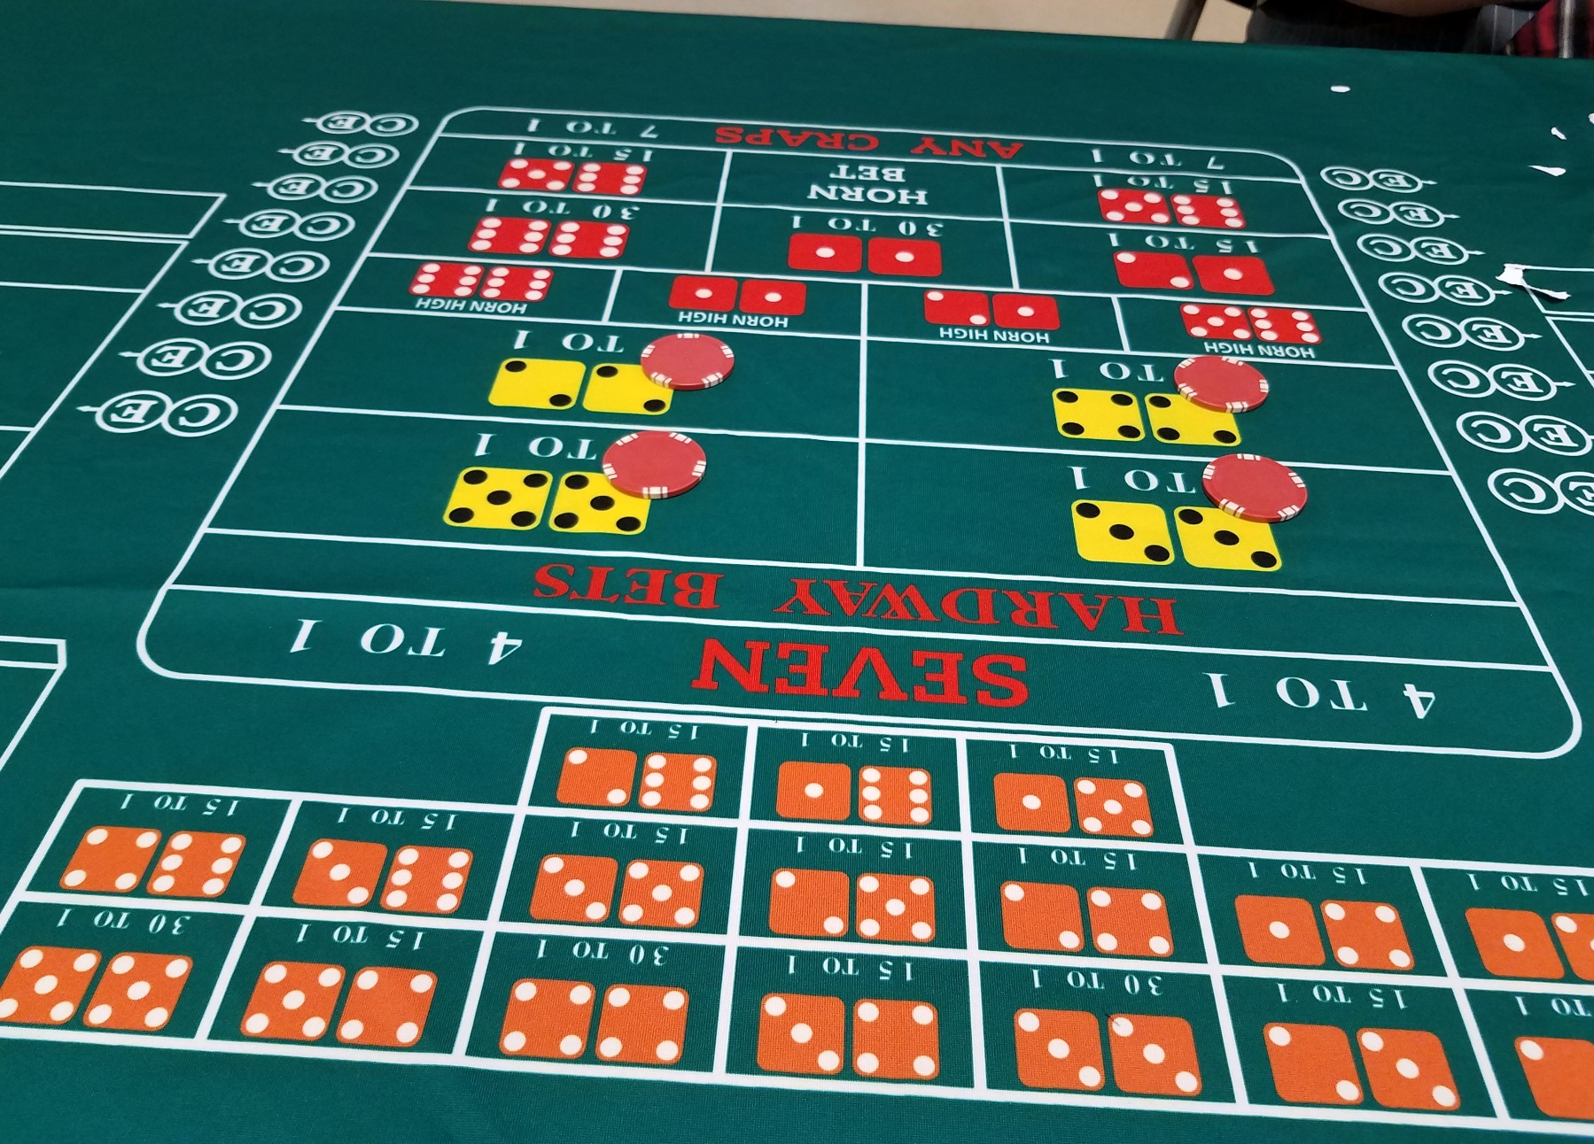
Bets are placed in the position that the customer is playing on the table.

