Info on www.fcctraining.org

**RULES OF PLAY**

Free Bet Blackjack is a variation of the standard game of blackjack. Free Bet Blackjack offers an optional Pot of Gold and a Push 22 side bet. To receive cards you must make the standard blackjack wager. To play against the Pot of Gold pay table you must also make the Pot of Gold wager. Both the standard and Pot of Gold wagers must be made prior to receiving cards. Free Bet Blackjack follows the basic rules of our standard blackjack games, with the following features:

1. “Free” double-down on first two-card hard total of 9, 10, or 11
2. “Free” splits on all pairs *except 10 value cards (10-10, J-J, Q-Q or K-K)*
3. “Free” double-down allowed after split on a two-card hard total of 9, 10, or 11
4. “Free” re-splits allowed up to four hands (following standard Free Bet BJ rules)
5. All normal splits allowed,
6. Regular doubles allowed on two-card hands,
7. Dealer pushes on 22

If a player makes a Push 22 bonus wager and they bust their original blackjack hand, the dealer must leave the player’s cards on the table until the Push 22 wager is reconciled.

Note: Player blackjacks are paid before the dealer hits out their hand, so they are not affected by the Push 22 rule. In the event that all players’ hands bust or have Blackjacks, the dealer will draw cards in order to settle the Push 22 wager.

**FREE SPLIT**

Players may split any pairs except 10 value cards (10-10, J-J, Q-Q or K-K) without making an additional wager. The dealer will place a “Free Bet” token to the right (dealer’s view) of the player’s original bet and deal the game normally. There are three possible outcomes:

1. The player beats the dealer. a. The dealer will pay the player for his original bet and an equivalent amount for his free split. If the player has made a Pot of Gold wager, the token would be moved by the dealer to a spot in front of the player’s Pot of Gold wager. If the player didn’t make the Pot of Gold wager, the dealer would collect the token.

2. The player loses to the dealer. a. The dealer will collect the player’s original bet. If the player has made a Pot of Gold wager, the token would be moved by the dealer to a spot in front of the player’s Pot of Gold wager. If the player didn’t make the Pot of Gold wager, the dealer would collect the token.

3. The player and the dealer tie. a. The dealer will push the player’s original bet. If the player has made a Pot of Gold wager, the token would be moved by the dealer to a spot in front of the player’s Pot of Gold wager. If the player didn’t make the Pot of Gold wager, the dealer would collect the token.

**FREE DOUBLE**

Players may double a two-card hard count of 9, 10 or 11 without making an additional wager. The dealer will place a “Free Bet” token to the right (dealer’s view) of the player’s original bet and deal the game normally. There are three possible outcomes:

1. The player beats the dealer. a. The dealer will pay the player for their original bet and an equivalent amount for their free double. If the player has made a Pot of Gold wager, the token would be moved by the dealer to a spot in front of the player’s Pot of Gold wager. If the player didn’t make the Pot of Gold wager, the dealer would collect the token.

2. The player loses to the dealer. a. The dealer will collect the player’s original bet. If the player has made a Pot of Gold wager, the token would be moved by the dealer to a spot in front of the player’s Pot of Gold wager. If the player didn’t make the Pot of Gold wager, the dealer would collect the token.

3. The player and the dealer tie. a. The dealer will push the player’s original bet. If the player has made a Pot of Gold wager, the token would be moved by the dealer to a spot in front of the player’s Pot of Gold wager. If the player didn’t make the Pot of Gold wager, the dealer would collect the token. Free doubling after splitting is allowed, provided the player’s point total is a two card hard total of 9, 10 or 11.

**Tokes:**

If the player makes a bet for the dealer, the dealer is also eligible for the Free Split and Free Double along with the player. The same game rules apply to the dealers bet.

**Dealing procedure**

After each hand and the dealer all have 2 cards:

1. The dealer checks each hand, from right to left, and picks up the pot of gold bet from any hand which does not qualify for a free bet coin.
2. The dealer will check any 10 value cards to see if they have blackjack. If they do all pot of gold and push 22 hands lose, as well as any customer hands that don't have a blackjack.
3. If the dealer has an ace up, they will turn the card sideways and offer insurance. This will be handled as we are currently. If the dealer has a blackjack all losers are picked up and any insurance is then paid. All pot of gold and push 22 bets will lose as well.
4. If the dealer does not have blackjack, any customer hands that have blackjack are then paid. If they have a push 22 bet, the cards will be tucked under the push 22 side bet, , to signify that the hand still has a bet to be finalized.
5. The rest of hands will be played from left to right starting on the dealers left.
6. If a player has a ***hard*** 9, 10, or 11 or any pairs, *with the exception* *of ten cards*, the player may ask for a free bet. This is done *by pointing to the pot of gold bet, whether they bet this side bet or not, and then pointing to their main bet (a split with be done with 2 fingers spread forming a v and a double with 1 finger.)*

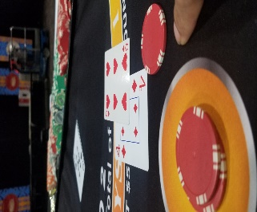

1. If a player does not wish to create a free bet hand and had a pot of gold bet, then the pot of gold bet will be picked up immediately.
2. If a player bust, but still has a push 22 bet, the cards will be *tucked under the push 22 bet.* If the payer did not have a push 22 bet, since there is no bet to resolve, the losing wager and the cards will be immediately locked up.

1. If a player has a split hand with a free bet and the player busts on the hand with initial wager. The losing cards will be squared up, turned sideways and the losing wager will be placed on top of them. If the player busts on the free bet split hand the free bet is picked up and either locked up in the dealer’s tray, if they do not have a pot of gold bet, or placed in front of the pot gold bet, if they have a pot of gold bet. The cards are put in the discard rack. If their original hand had busted and there is no push 22 or pot of gold bet to finalize than that losing wager can now be locked up and the cards put in the discard rack. Otherwise leave it out until the hand is finalized.

Resolving free bet hands

If a player has a double down with a free bet:

1. It wins, size into the original bet twice *(once for the regular bet and once for the free bet*) and pick up the free bet coin. Lock it up if no pot of gold bet had been bet, place the coins, in front of the pot of gold bet if it had been bet. Resolve the pot of gold payoff, by comparing the number of free bet tokens earned and multiply by the multiplier. Then lock up the free bet token.

1. It pushes, pick up the free bet coin. Lock it up if no pot of gold bet had been bet, place the coins, in front of the pot of gold bet if it had been bet. Resolve the pot of gold payoff, by comparing the number of free bet tokens earned and multiply by the multiplier. Then lock up the free bet token.

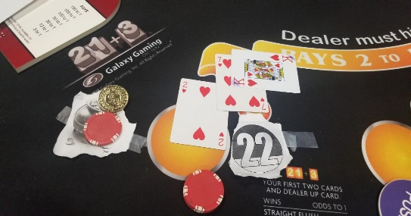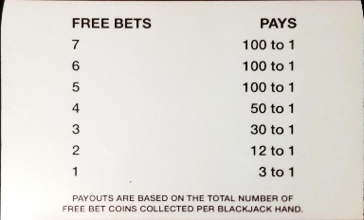 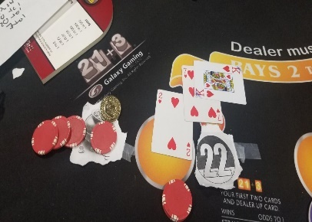 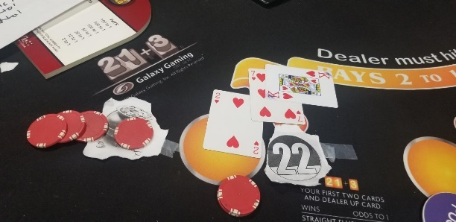

1. It loses, pick up the losing wager and pick up the free bet coin. Lock it up if no pot of gold bet had been bet, place the coins, in front of the pot of gold bet if it had been bet. Resolve the pot of gold payoff, by comparing the number of free bet tokens earned and multiply by the multiplier. Then lock up the free bet token.

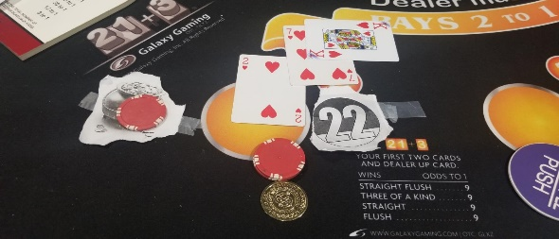 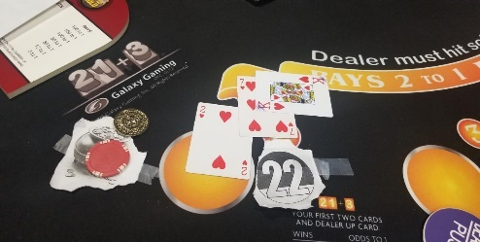 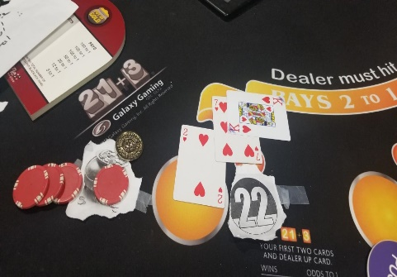 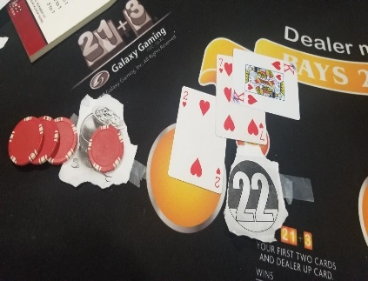

**Pot of Gold side bet:**

The Pot of Gold wager payouts *are based on the total number of gold Free Bet tokens the player collects for each individual blackjack hand*. See payouts for odds. Note: All Pot of Gold wagers lose to a dealer blackjack.

**5 + tokens pay 100 to 1**

**4+ tokens pay 50 to 1**

**3+tokens pay 30 to 1**

**2+ tokens pay 12 to 1**

**1+tokens pay 3 to 1**

**Push 22 side bet:**

***If the dealer draws a point total of 22, all active player blackjack bets in action are pushes****.* **Inactive hand wagers will be locked up**, (*ones that had already busted but are turned sideways on the insurance line, with the original bet on it*, *because an active free bet hand Is still in play*)

The Push 22 bonus wager wins if the dealer ***draws a total of 22***, and the players hand does not exceed a point total of 29. **All push 22 side bets pay 11 to 1**.

Note: Player blackjacks are paid before the dealer hits out their hand, so they are not affected by the Push 22 rule. In the event that all players’ hands bust or have Blackjacks, the dealer will draw cards in order to settle the Push 22 wager.

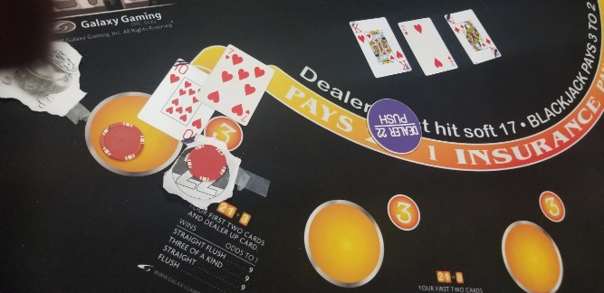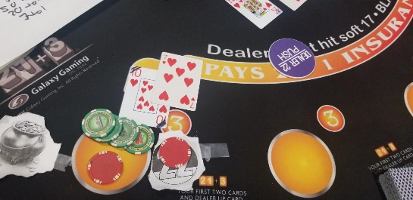

***Approvals***: to be decided

**Pay and take orde**r:

Pay and take each hand from the dealers right to left, Take losers first, otherwise, 1. the main bet, 2. pot of gold and then 3. push 22, order is not necessarily specific at all times.

**Layout**

