Protecting your hand after you have pitched the initial cards
Hold the cards at a 45 degree angle when giving players additional cards


Hole Card Delivery
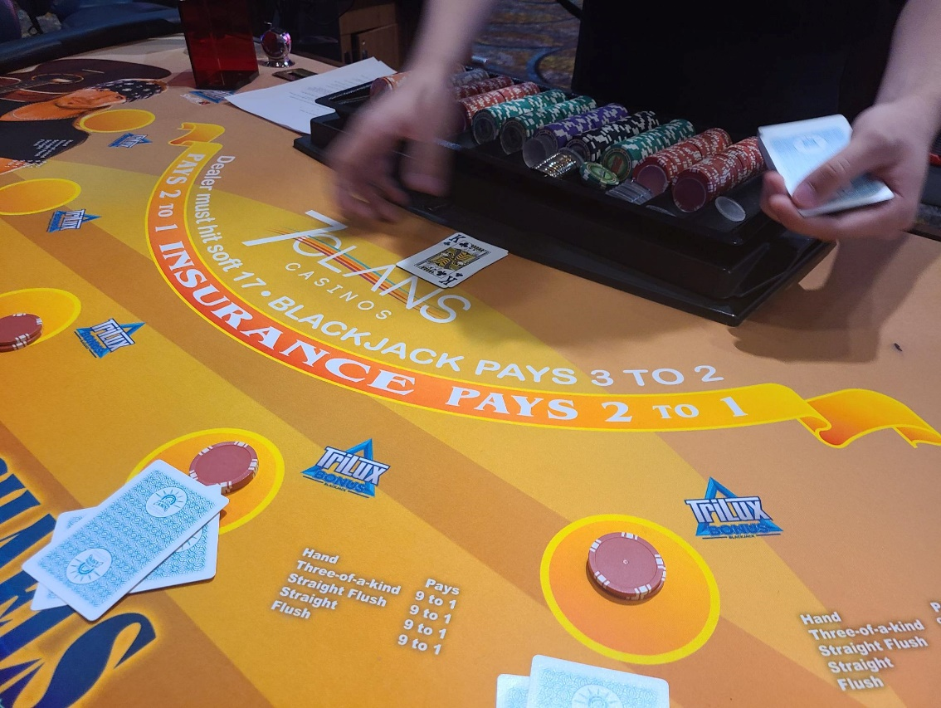
Lower your hand with the cards and move it towards the exposed up card
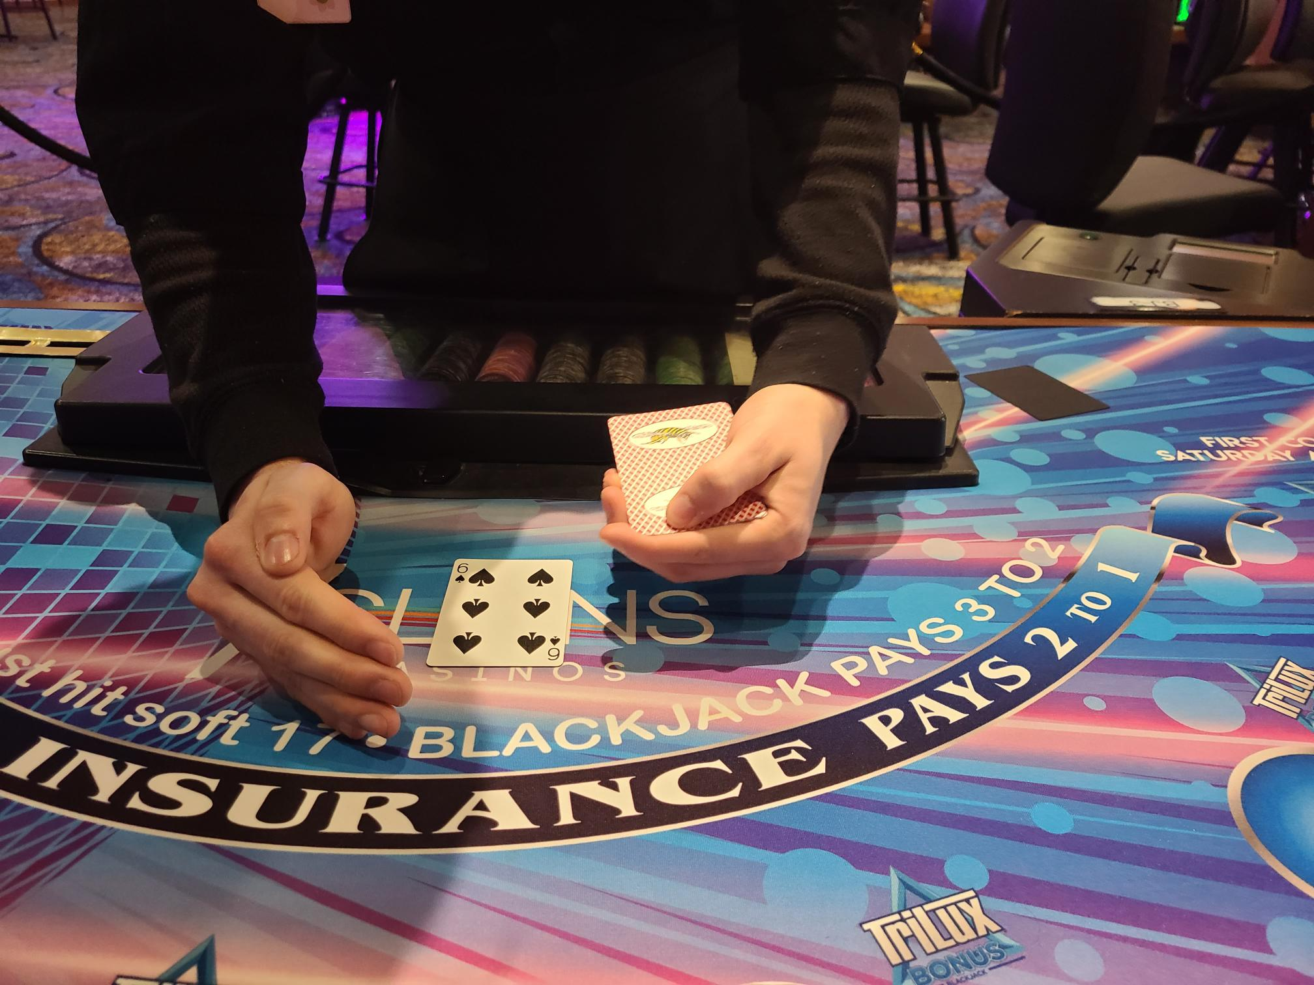
Place your free hand on the layout to the right of the exposed-up card.

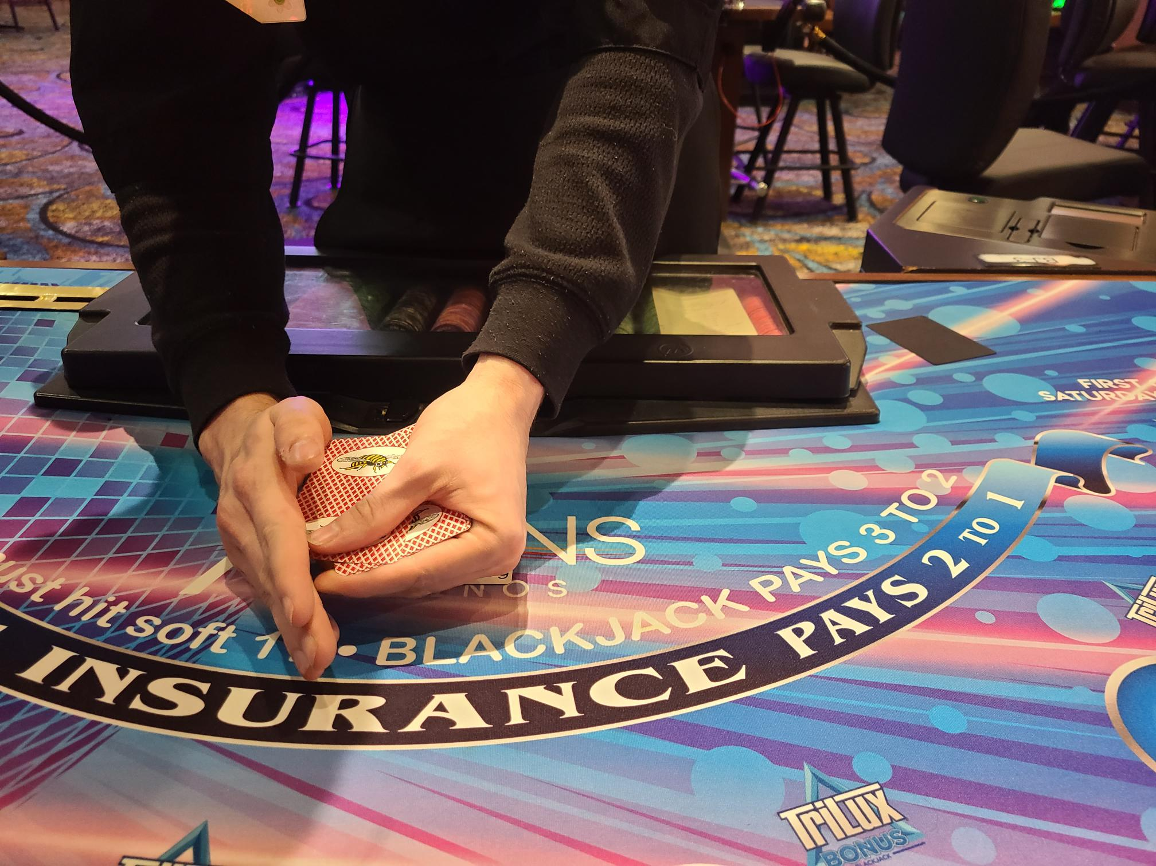
Move your hand with the cards into the free hand and place between the fingers


Another view

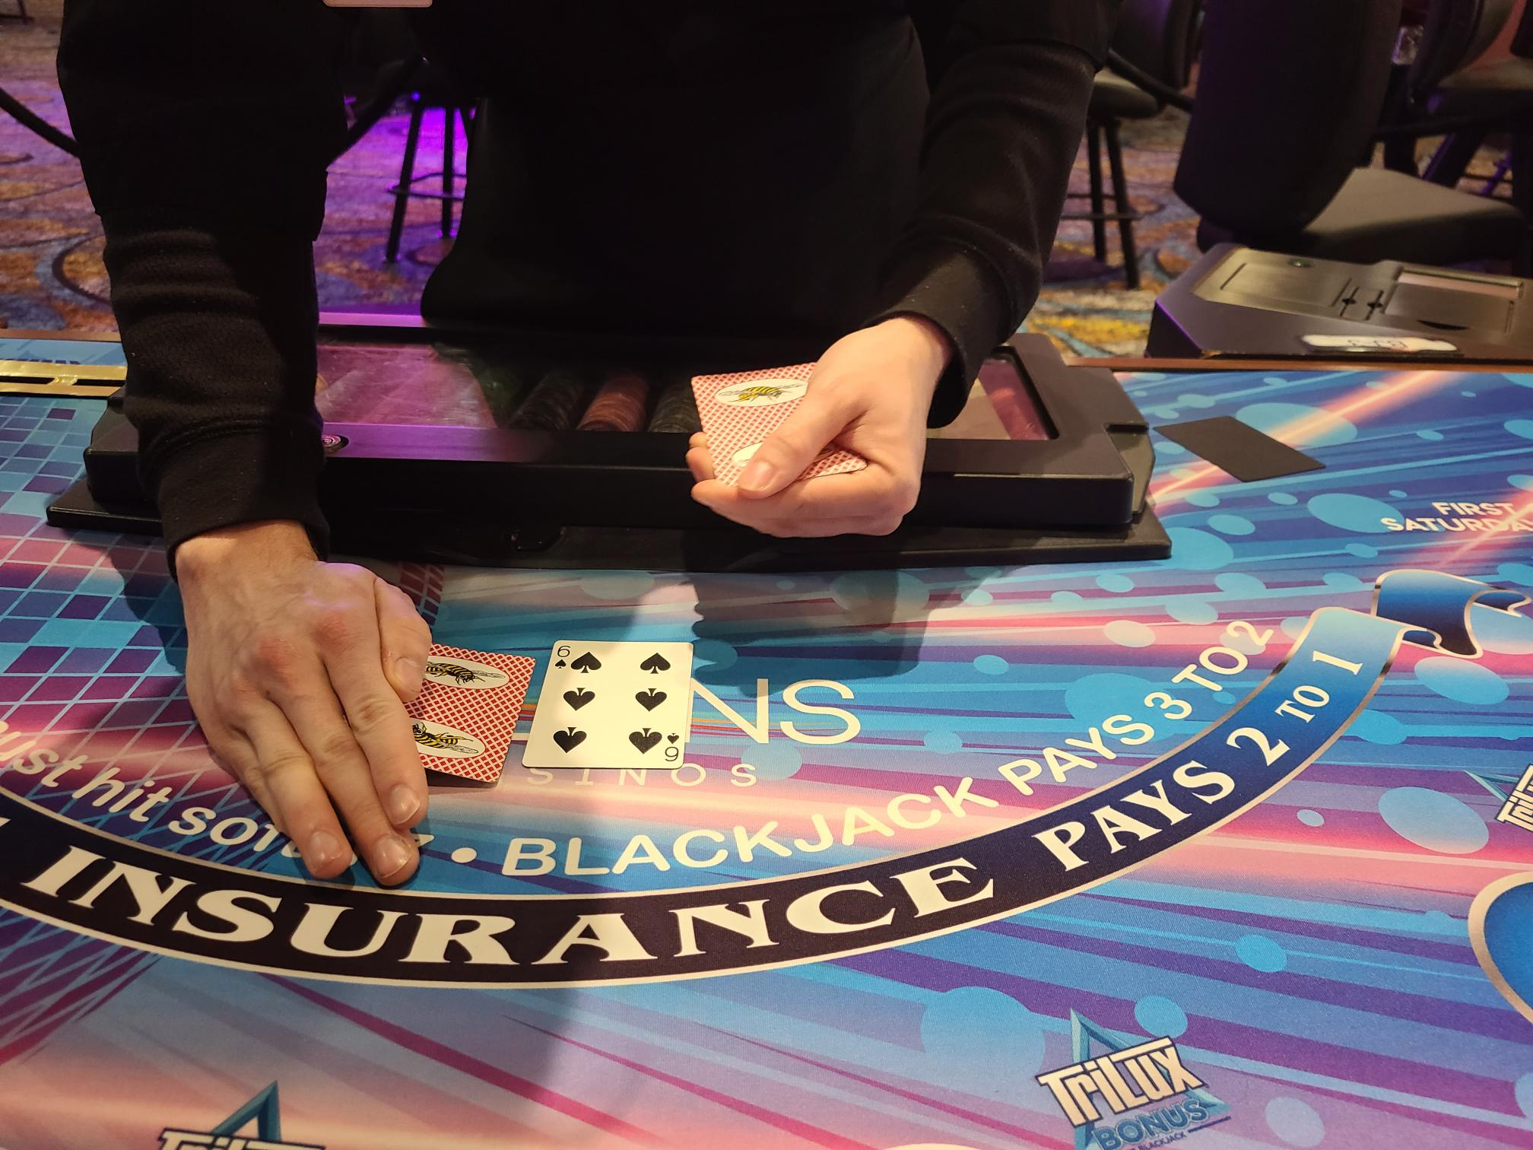
Then tuck the hole card under the up card
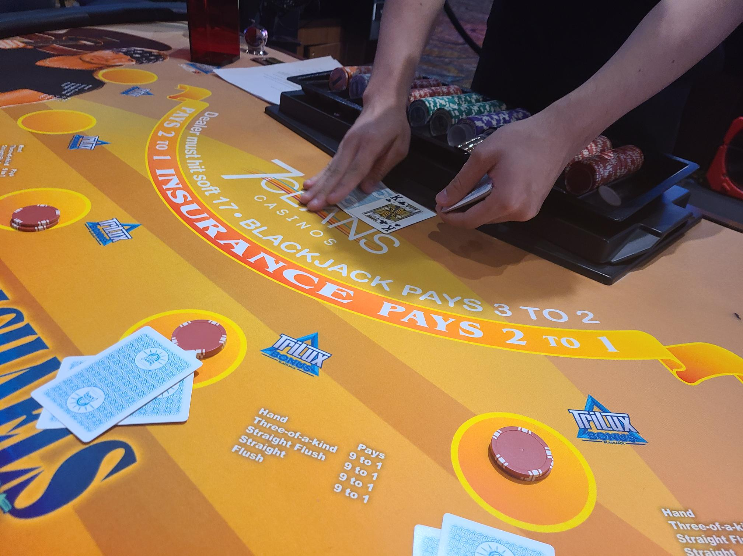
Another view
