**Roulette Payoffs**

**Paying process**

**Clear by the winning number**

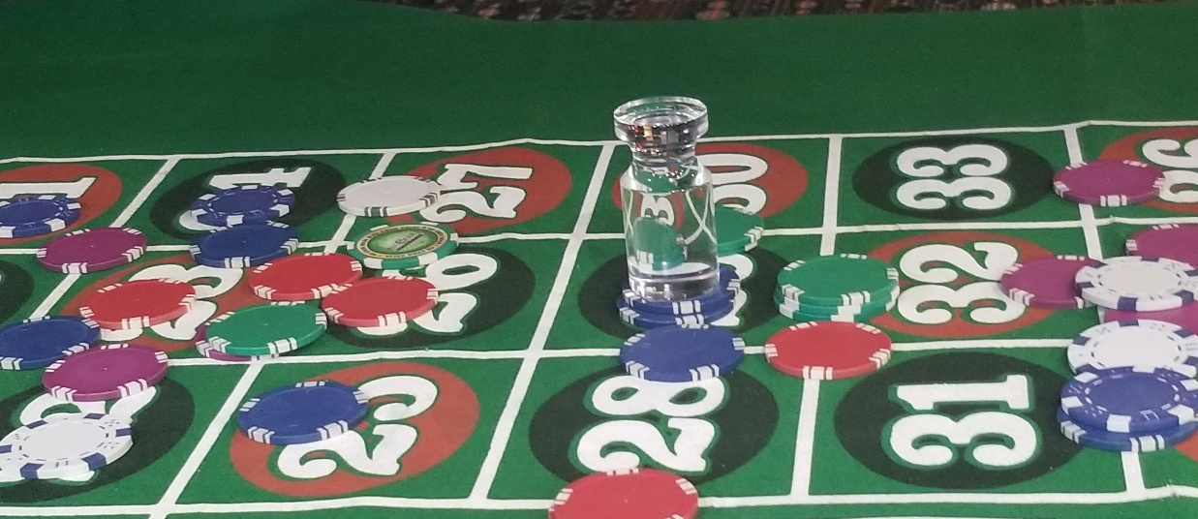

**Clear the outside**

1. **First picking up the losing bets in the columns, starting with the columns with the numbers 3 to 36, then 2 to 35 and finally 1 to 34.**
2. **2. Second picking up the outside losing bets as shown in the above diagram**
3. **Finally clear the inside board of any losing bets.**

**Paying the bets**

**Pay the outside bets**

**Pay the outside bets in the same order that you picked up the losing bets, starting with column closest to you,**

**2. The players cannot collect these until you are finished paying the inside winning bets.**

**Paying the Inside number**

**Inside paying order**

1. **Bets will be paid according the above diagram.**
2. **Different colors should be offset from each so, the dealer, customer, supervisor and surveillance can clearly ensure the proper payoff.**

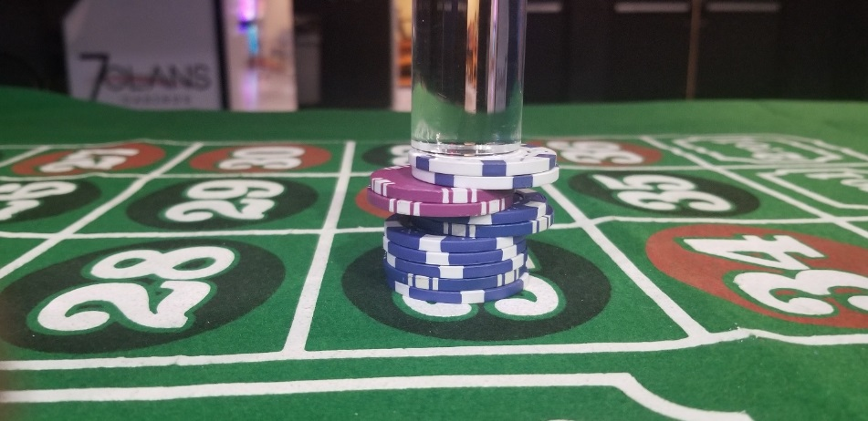

1. **Pay bets from the top down, in the above picture, pay the white than the purple, than the blue.**
2. **Colors with over 5 chips, should be offset `in 5’s, if over 20, then offset in 20.**

