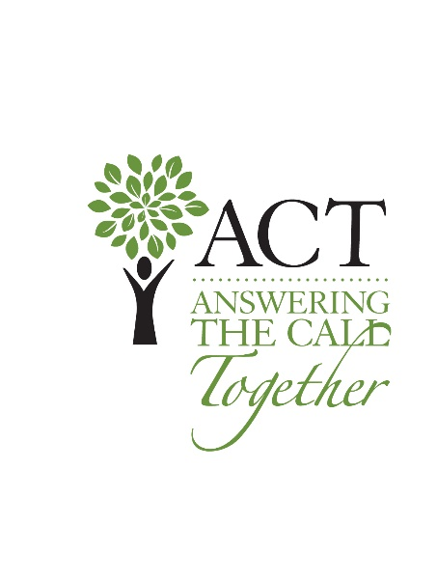

**Golden Isles ACT Grant Application***Must be received by January 22*

*Thank you for applying for the Golden Isles ACT grant. Please complete the following application and submit it, along with the required appendices, as ONE single document (PDF format).*

**ORGANIZATION CONTACT INFORMATION**

Organization Name: EIN:

Address:

City/State/Zip: Phone:

Primary Contact Person & Title:

E-Mail Address:

Person responsible for this project: Phone:

**ORGANIZATION INFORAMTION**

Date of Incorporation Date fiscal year begins:

Are you part of a larger organization? □ YES □ NO

Are you required to pay a percentage of revenue to a parent organization? □ YES □ NO

**ORGANIZATION FUNDING**

Total Organization Budget: $

Principal sources of support for the entire organization:  
*Total should equal 100%*

% United Way % Government Contracts

% Earned Income % Individual Contributions

% Foundations/Corporations % Special Events

% Other

**PROJECT INFORMATION**

Project Name:

Total Project Budget: $ Start Date:

Amount Requested: $ Percentage of Annual Budget: %

Administrative Costs for Project: $ Percentage of Project Budget: %

**TYPE OF REQUEST:**

□ Start-Up Cost □ Project Support

□ Capital Expenditures □ Technical Assistance

□ Other

**ORGANIZATION DESCRIPTION***Provide a brief description of the organization, its purpose, history, service to the community, and how the organization aligns with Golden Isles ACT Areas of Focus. (Limited to 2,000 characters)*

**PROJECT DESCRIPTION***Provide a brief description of the project, how it is unique, the population it serves, define how the project aligns with the organization’s long-term strategies and objectives, and, If the project is larger than the requested funding from Golden Isles ACT, outline where additional funds will come from to complete the project. (Limited to 3,000 characters)*

**REQUIRED ATTACHMENTS***Below is a list of required attachments that should be incorporated into your application and submitted as one PDF file.*

Appendix A: Organization’s current annual operating budget (include any narrative you deem appropriate to highlight the organization’s financial situation – optional)

Appendix B: Current audited financial statements

Appendix C: Current list of Board of Directors, including business address, occupations, length of tenure, and engagement level

Appendix D: List of any grants applied for in the past 12 months, including the name of the organization, amount requested, purpose of the request, and funding status

Appendix E: Separate cost estimates for each part of the proposed project

Appendix F. Copy of the Organization’s IRS Determination Letter

**AUTHORIZATION***By signing this grant request, you certify that you are authorized to submit grants on behalf of  
this organization.*

Signature: Title:

Print Name: Date:

*This grant request must be fully completed to be considered. Please print legibly if being completed by hand. Applications are only accepted by email and only between December 1 and January 22. Grant applications must be received by Golden Isles ACT by January 22 at 4:00 p.m. Eastern Time for consideration. Email grant applications to* [*info@GoldenIslesACT.org*](mailto:info@GoldenIslesACT.org)*. Your email subject line should read, “ACT GRANT – your organization name.”*