
Technical Data Sheet
NECAL 9170 PRESSURE SENSITIVE ADHESIVE

DESCRIPTION

NECAL 9170 is an unsupported film of pressure sensitive adhesive displaying excellent bond characteristics, high clarity, and good initial tack. It is an excellent option for decals, membrane switches, overlays, industrial transfer tapes, multi-purpose laminations. This adhesive is used in Appliance, Automotive, Transportation, Industrial Equipment, Recreational Equipment, and Electronic Applications.

FEATURES

NECAL 9170 will adhere to many substrates including aluminum, brass, steel, glass, enamels, and plastics such as polystyrene, ABS, and acrylic. Because of its thickness NECAL 9170 is recommended for use on rough surfaces.

PHYSICAL PROPERTIES

Thickness (without liner): 2.0 mils acrylic adhesive
Release Liner: Available with P, W, H, J, HD, VF, P1, HD-2 or W1 liners
180° Peel from Stainless Steel: >3 lbs. after 16-hour dwell (PSTC-101)
Loop tack from Stainless Steel >3 lbs. (PSTC-16)
Shear Adhesion: >7 days (1-inch x 1-inch x 1000 g @ 72°F)
Temperature Range: Application: 50°F. Minimum
Service: -20°F. Minimum
Short Term (minutes/hours): 400°F.
Long Term (days/weeks): 300°F.
All tests conducted with a 2 mil PET backing

BONDING INSTRUCTIONS
Remove the release liner and apply to a clean, dry substrate. Use firm pressure to obtain maximum contact. Increasing application force will optimize bond strength to surface. The adhesive will reach maximum bond after 72 hours.

STORAGE DATA
The shelf life of this material is at least two years when stored at 72°F and 50% relative humidity. Increased temperatures and/or humidity will affect performance characteristics.

NOTICE
The information shown here represents typical values, which may vary with each application. The values are not intended to be a performance guarantee and are not intended to be utilized for setting specifications. Users should determine, prior to use, the suitability of this material for their application.


Standard UL 969
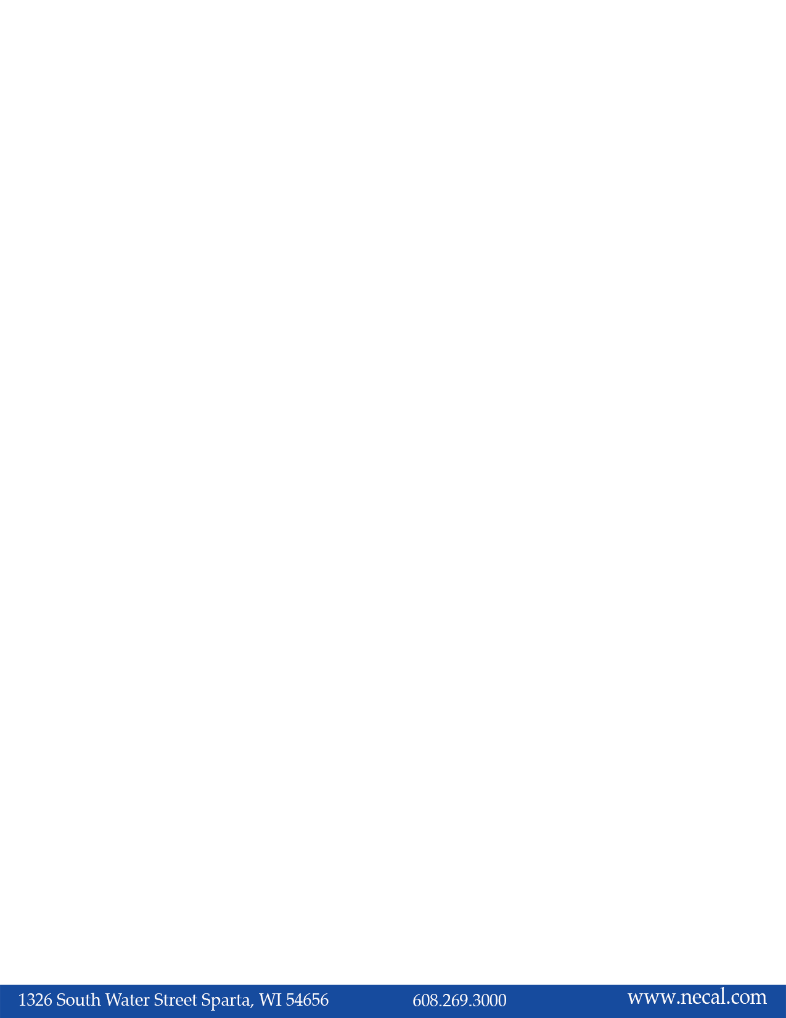
System Materials (PGGU2). Oct. 2020

