*TB Vented ROOF (all versions) – Installation Instructions*

1. PRODUCT

TB Vented ROOF is a nailable composite roof insulation panel for sloped roof applications (minimum 2:12 pitch with BHT approval, consult BHT for recommendations for pitch under 3:12) made with Iso or XPS foam with a built-in space for roof ventilation. Panel size is a nominal 4’ x 8’ (actual coverage approx. 47-1/4” x 95-1/4”). CHECK LOCAL BUILDING CODES for any applicable requirements.

2. STORAGE

TB Vented ROOF products are shipped in units covered with a plastic bag which is intended to temporarily protect the material while in transit only. On the jobsite the units should be covered with a breathable waterproof tarpaulin. The plastic bag should be removed if moisture accumulates inside it.

3. PRODUCT APPLICATION

TB Vented ROOF is designed to allow air flow through the air space below the top sheathing. To do this it must have the following:

a. Adequate air entry flow at the eave. Use eave edge vents or eave soffit vents which allow approximately 9 square inches of air entry per foot run of eave. Where edges blocking is used at the eave, do not cover the entrance to the air space.

b. The TB Vented ROOF air spaces must not be closed off. If you need a smaller panel it is usually best to cut off the side or end with the tongue on it. Support the cut edge with spacer blocks running up the slope. Extra spacers are supplied with every shipment.

c. A ridge vent with approximately 10 square inches of open area per foot run the ridge should be used. Warm moist air leaking from the inside of the building can cause condensation at the ridge, at the end walls or at any other opening. Seal off these openings by cutting the foam insulation at a suitable angle and filling any gaps with spray foam or caulking. Do not use combustible spray foam around chimneys.

4. INSTALLATION

a. If specified, install a vapor retarder on the supporting roof deck. We recommend one over high humidity areas such as swimming pools. In this case particular care should be taken to seal all openings on the deck around lighting fixtures, skylights, end walls, and at the ridge, etc. On any building where conduit is installed above the structural deck, a separate layer of 1-1/2” thick foam insulation is recommended.

b. Fire safety precautions should be observed when TB Vented ROOF is installed. Protect foam from flame cutting and welding operations, etc. Around chimneys provide suitable fire protection.

c. Install wood nailers/blocking at the eave and rake edge of the roof. Before installing the first row of insulation at the eave check how the eave vent or the sheathing over the roof overhang will be supported. Check the supporting roof deck is smooth and even without bumps or depressions.

d. Lay panels with the wood side up and the 8’ long side parallel to the ridge. Note: If using a base foam layer first secure it to the deck. Panels are square edged and require a 1/8” gap at the sheathing juncture for expansion. This gap may be created by the use of ‘H’ Clips or an alternate method. Creating a two-layer system using a base foam layer with staggered joints relative to the TB Vented Roof upper panel is desirable and required with thicker configurations. Field cut panels should be kerf cut to maintain a 1/8” minimum gap between the sheathing on adjacent panels. Stagger end joints in succeeding panel rows.

e. Place screws directly through the panel into the structural deck, use insulation fasteners as shown on the next page. Do not over-torque the screws and compress the insulation too much. Do not fasten through the wood spacers.

f. Check the insulation top surface for uneven edges BEFORE covering. Grind off any uneven edges with a sander or grinder.

g. Roofing should be applied over dry insulation as soon as possible. Apply roofing felt/underlayment and shingles to TB Vented ROOF using shingle nails placed according to shingle manufacturers’ recommendations. For best results use barbed or ring shank shingle nails and premium or laminated shingles.

h. Install eave and ridge vents as described under Product Application. 10 in/ln ft open area minimum.

TBVR Inst 0623 Page 1

*TB Vented ROOF (all versions) – Installation Instructions Page 2*

5. INSULATION FASTENERS—Use SIP Fasteners

a. Number –Minimum of 15 SIP Fasteners per 4’ x 8’ panel to meet standard inland load requirements. Apply fasteners at the approximate position of the internal spacers as shown in drawing below. There are lines on the sheathing (OSB only) at 24” and 48” from the panel ends which will assist in locating the fasteners. Ignore the lines at 16” and 32. Use additional screws at the rakes, eaves ridge as shown. If high wind load requirements exist, contact Blue Hills Tech or fastener manufacturer.

b. Wood deck -Use SIP Fasteners 1-1/4” to 1-1/2” longer than the overall depth of the TB Vented ROOF insulation panel. If the wood deck is less than 2” actual thickness, use fasteners with a minimum of 1” penetration and install 4 extra fasteners on the horizontal center line of the panel. On plywood use fasteners that protrude through the deck at least ¼”. If exposed fastener tips are not acceptable, contact BHT for suggestions.

c. Steel Deck – Use SIP Fasteners with a minimum of 1” penetration into the steel deck; 1” longer than TB Vented ROOF panel thickness

d. Concrete Deck – use Tapcon screws or equal. Advance testing is recommended.

e. Special Applications – Contact us for special applications not shown here.

6. FASTENER PATTERN

a. Use 15 screws per panel (5 across-parallel to the ridge & 3 up the slope) as the standard fastening pattern for panel assemblies up to 5” thick (1-90 uplift requirements), add additional fasteners as shown below. For insulation panel assemblies over 5” thick and/or high wind load requirements exist, contact fastener manufacturer or Blue Hills Tech for recommendations. Do not fasten through wood spacers.

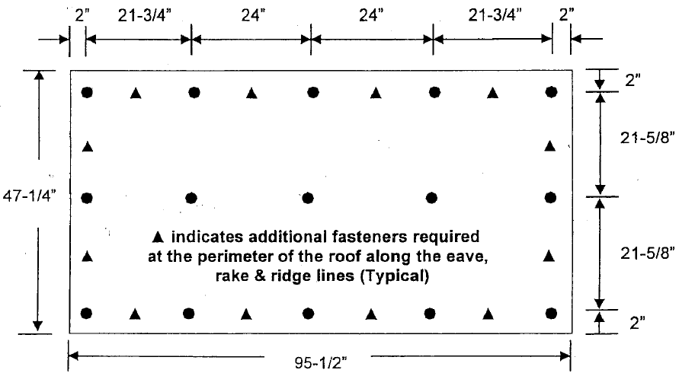

1. When installing heavy material such as natural slate or tile on a pitch greater than 4/12 but less than 8/12, install 4 additional fasteners on each panel along the center of the panel (aligned along the 8’ length) parallel with the ridge line. For roof pitch 8/12 or greater contact Blue Hills Tech for recommended fastener patterns.
2. NOTE: For panels of overall thickness 6” or more, add 4 additional fasteners per panel; SEE 19 COUNT PATTERN.

Visit our website/contact Blue Hills Tech for additional details or consult your architect.

**BLUE HILLS TECH LLC**

28592 263rd St, Holcombe WI 54745

(715) 828-0578

[www.bluehillstech.net](http://www.bluehillstech.net)

info@bluehillstech.net

TBVR inst 0623 page 2