
TB ROOF—Ventilated Roof Insulation Panel--Spacer Pattern
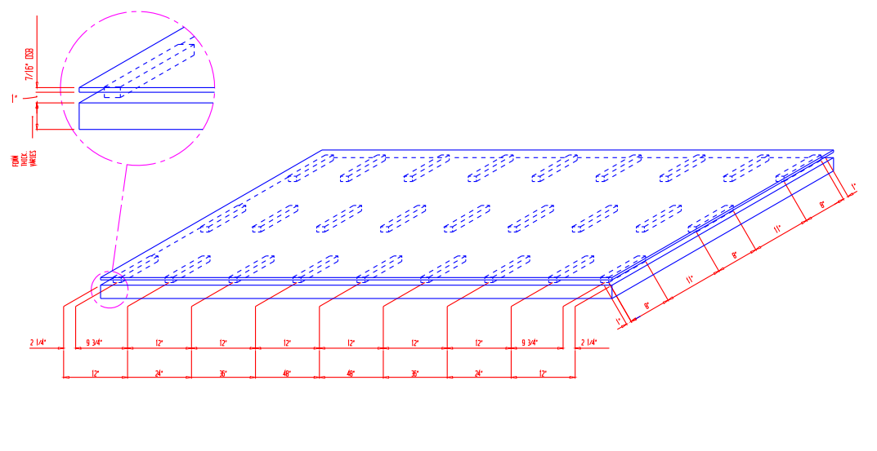
92% Open Area On Panel----85% Vent Space Open Along 8” Dimension
Over 10 Sq In Open Area Per Lineal Foot Vent Opening—Best in Class!

Office: www.bluehillstech.net
13064 Taylor St NE Blaine MN 55434 info@bluehillstech.net
715-828-0578 mikec@bluehillstech.net

