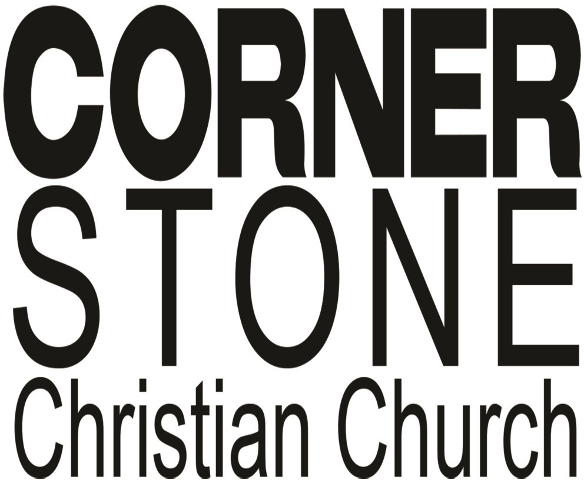

Big Challenges and a God of Great Power

February 2019
Job 26:7-14
We recently accepted and moved forward on the plan to do some major repair on the building occupied by Cornerstone Christian Church. Some pretty major issues, some of which have been brewing for several years, have come to the point that action must be taken. The decision was made to proceed with the needed work.
For a relatively small group, this represents a big challenge. Job declared the awesome power of God (Job 26:7-14) and indi- cated that it is beyond the comprehension of man to fully under- stand it (14). There is no doubt that God has whatever resource is needed for us to do His work (2 Corinthians 9:8, 9). Three things to keep in mind:
- Big challenges will stretch us beyond what we can do on our own. Many examples in scripture of the people of God following Him include a point at which the issue gets bigger than what they can do on their own. The Israelites surviving in the desert and conquering the promised land; David facing Goliath; the he- roes of faith in Hebrews 11; the early church taking the gospel message into their culture…the examples are plentiful.
- Our focus must be on doing what God wants us to do. The great commission (Matthew 28:18-20) was a call to make and grow disciples. Material things like buildings have value only as tools to accomplish that work. The Cornerstone building is a place used by many people for many purposes during a week. But at the root of it all is the opportunity for individuals to have contact with folks who can introduce them to Jesus. Pray that contact may be made with those seeking answers for life, or un- churched believers needing an excited group to fellowship and grow with. Winning folks to the Lord is the priority!
- Optimism and victory are realities when your trust is in God. The Lord never promised an easy way or a life devoid of chal- lenges. He has promised His presence (Matthew 28:20) and His strength (2 Corinthians 3:4-6). When we have success, it is be- cause of God’s power, not ours. When we stumble along the way, it is God’s love that picks us up, dusts us off, and sends us forward to fruitful service. We can expect some knocks, but al- ways ultimate victory, when our focus is on God’s purposes.
Keep your eyes on what a big God can do through people who love to serve Him. Commit yourself to being one of those peo- ple!
Blessed to be serving with you,
Jay
Serving in February Communion Meditation: 2/3– Mike McBride
2/10– Video
2/17– Ken Crook 2/24– Larry McKemey

Nursery:
2/3 –Dianna Stover 2/10 –Charis Walker 2/17 –Tonya Generally 2/24 –Dianna Stover

Greeters:
2/3– Loyd & Gladys
McBride/Mike & Blake McBride
2/10– Loyd & Gladys
McBride/Ken & Carolyn Crook
2/17– Loyd & Gladys
McBride/Charlie Grider
2/24– Loyd & Gladys
McBride/Tonya Generally

AWANA! Here’s what’s happening:
Feb.6– Regular club night! Wear your uniform and bring your Bible!
Feb. 13– Valentine Spirit! Come dressed in Valen- tine colors/clothing (red, pink, white/hearts)!
Feb. 20– Regular club night! Wear your uniform and bring your Bible!
Feb. 27– Mustache or Ti- ara Night! Wear either a tiara or a mustache!
February 3– WEAR RED DAY! Our Cornerstone health ministry, “Your Body, God’s Temple,” will be active checking blood pressure for any who so desire. Plan to come get a health-minded orientation to life!

February 4- @ 4PM-Elder’s- If anyone desires to meet with the elders please see Jay or Larry in advance to arrange a time during the meeting.

February 15-16 - Ladies Retreat! Time to be announced.

February 24 - Cornerstone Talent Night- Join us for a fellowship meal beginning at 5PM. Bring items for the meal and then enjoy an evening of Cornerstone Talent. If you wish to be a part of our talent line-up please see Andrea in advance and let her know what your will be doing. This will allow us the opportunity to make sure we have music tracks lined up, if needed, etc. This year the talent will encompass not only singing, playing an instrument, reading a poem, etc., but if you paint, make quilts, sew, create sculptures, anything that can be displayed, please partici-
pate. We will have an area set up to display the items. Again, please see Andrea as
she will coordinate the evening’s lineup and setting up of displays.

February 9 - Men’s Breakfast- Men, join us at 8:30AM as we meet, enjoy a great breakfast and then a time fellowship. We will also have a program following the meal.

February 10– Keenagers pot luck after AM Worship. Larry McKemey will bring the devotion.

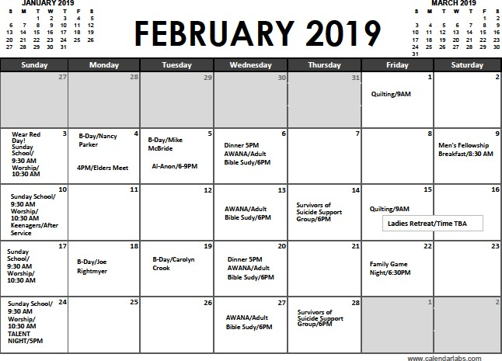

YOUR BODY, GOD’S TEMPLE
A Ministry of Cornerstone Christian Church
Joe Rightmyer, DNP, FNP-BC & Melanie Rightmyer, DNP, RN

“Do you not know that your body is a temple of the Holy Spirit who is in you, whom you have received from God?”1Cor.6:19

FEBRUARY HEART AWARENESS MONTH

So now that it is February, how have you done so far fulfilling those New Year’s res- olutions? I haven’t given up on mine quite yet, but I have had to alter them a time or two. Exercise to lose weight is at the heart of my annual New Year’s resolutions.
This has been interrupted though because I have been falling a lot lately. These falls are happening without any dizziness or warnings at all. If you ask my husband, Joe, he would tell you that I am one of the most klutziest people he knows. Howev- er, these “spells” could be related to my mitral valve prolapse. What I do know is that I had to buy a new blood pressure monitor so I could keep track of my num- bers. I can always tell my mitral valve is prolapsing because I get this “lump in my throat” feeling. Sometimes I get a feeling like one can have when you are scared to death and your stomach leaps into your throat. That’s exactly what it feels like when my mitral valve isn’t working correctly and causes my heart to skip a beat or two. Now that this is happening more frequently, I am needing to check my “numbers” daily and document any times I feel my heart skipping a beat.

This is something I should be doing any way and have just gotten away from check- ing my blood pressure. High blood pressure can damage the cells of your arteries; damage your heart through coronary artery disease, cause an enlarged heart from over working, cause damage to the brain leading to mini-stroke, or stroke, and damage to the kidneys. Hypertension is called the silent killer because it can affect people without any warning signs. While not everyone may a have a stroke or heart attack right away, untreated it can shave ten years or more off your life. Heart dis- ease is the leading cause of death in both men and women. Every 34 seconds someone has a heart attack and every minute someone dies from a heart disease- related event. In fact, we have had several friends and/or colleagues die in the past two to four weeks from heart attacks. I always say, “None of us are guaranteed our next breath.”

So, in celebration of Heart Awareness Month, we will be setting up a Your Body, God’s Temple Booth to check blood pressure readings and learn the ABCs to heart health.

A = Aspirin Use
  - Ask your provider about taking an aspirin

B = Blood Pressure
Normal blood pressure should be at or below 120/80 Reduce your sodium consumption

C = Cholesterol
Ask your provider about how often to check your cholesterol
  - Goals: Total Cholesterol <200 LDL (bad cholesterol) <100
  - Read the nutrition label: select foods with 0 grams of trans fat
Read the nutrition label: choose foods lowest in saturated fat and cholesterol

S = Smoking Cessation
  - Talk to your healthcare provider about smoking cessation
Call 1-800-QUITNOW or go to www.alabamaquitnow.com for free tobacco coun- seling

ACTIVITY: Come by the Your Body, God’s Temple table, and have your blood pres- sure checked, learn warning signs of heart attack, and find out how to best take care of Your Body, God’s Temple.

