**Does It Make a Difference?**

Cornerstone Christian Church February 2025

Seeking to glorify God in all things!

(2 Peter 3:17, 18)

**1 Corinthians 15:58**

In 1 Corinthians 15, Paul discusses the future resurrection of the Christian’s body, how, as he puts it, “…this perishable must put on the imperishable, and this mortal must put on immor- tality” (v. 53). The last verse of the chapter encourages his readers (and us) to “be firm, im- movable, always excelling in the work of the Lord, knowing that your labor is not in vain in the Lord” (v. 58). The word translated as “labor” (NASB 2020) means “intense work, toil.” It is sometimes translated “efforts, hard work,” and used for the weariness that results from work.

There are few things more discouraging than feeling like time and resources poured into an effort have been wasted. But…what a blessing it is to be assured that what we do in serving

Christ is “not in vain”- a metaphor of endeavors, labors, or acts which result in nothing, with- out effect. We pray with fervor- count on God’s strength- and dive in with discernment and de- termination!

What we do for Christ has value. Whether it is physically hard labor, working to help someone, or emotionally and intellectually exhausting. Or all of the above- take a look at the Corner-

stone crowd on the last night of VBS, for example. That’s a tired bunch!

Individually and as a church Body, may we never slack off or settle for half-efforts. We live in times when the world needs to see the distinct and full commitment of Christians serving

their Lord with excitement, effort, and confidence. The choice to do so, as always, lies with us!

Happy to be serving with you, Jay

# Communion Meditation:

**2/2– Jay Thompson 2/9– Jack Jackson 2/16– Ken Crook**

**2/23– Wayne Nickols**

# Greeters:

**2/2– Loyd & Gladys McBride 2/9– Paul & Wanda Reynolds 2/16– Jack & Linda Jackson 2/23– Mike & Dianna Stover**

**February at CCC...**

Friday 2/7, at 9 AM– **Cornerstone Quilters**. Come enjoy quilting with a purpose.

Monday 2/10, at 4 PM- **Elder’s Meeting**- If you have a business for them to discuss or want to meet with the group, see Jay, Jack & Larry in advance.

Wednesday 2/12, at 5 PM- **Wednesday Meal**. Anyone planning on joining us, please make a reservation, as we need a count to have enough for everyone. Bible study following at 6!

Menu- Pizza, salad, dessert, and beverage.

Friday and Saturday, 2/14-2/15, **CCC Ladies’ Retreat**. Starts at on Friday at 6 PM, and runs till noon on Saturday. For more information contact Rhianna Gentry, Andrea Ingram, or Kelley Thompson.

Sunday 2/16– **HEART SUNDAY**! The Rightmyer’s ministry, “Your Body- God’s Temple” will be

available for blood pressure checks, as well as medical discussion. Wear Red! Friday 2/21, 9 AM– **Cornerstone Quilters**. Quilting as a ministry. Come join in!

Saturday 2/22 at 8 AM– **Men’s Breakfast**– Sharing in food, fellowship, spiritual growth, and en- couraging Christian men to be just that!

Wednesday 2/26, at 5 PM- **Wednesday Meal**- Anyone planning on joining us, please make a reservation, as we need a count to have enough for everyone. Bible Study following at 6!

Menu- Tacos with all the fixings, dessert, and beverage.

Friday 2/28, at Noon– **Keenagers** meet, at the CCC Building.

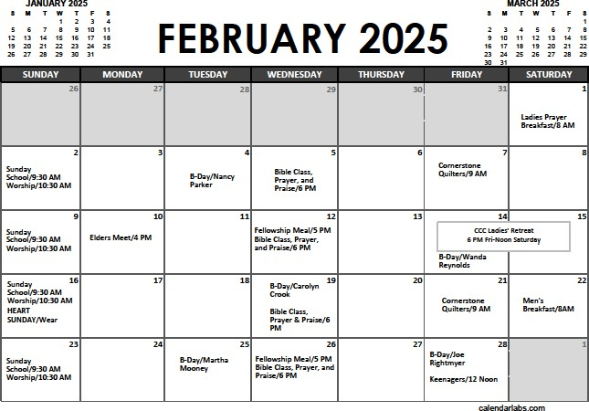

A Note from Melanie Rightmyer: **\*\*Heart Awareness Sunday: Go Red for Women\*\***

As we gather for Heart Awareness Sunday, February 16th, we are reminded of the critical im-

portance of heart health, particularly for women. This special day, supported by the American

Heart Association's Go Red for Women campaign, serves as a call to action for our community to prioritize cardiovascular wellness. Heart disease remains the leading cause of death for women, and it's essential that we raise awareness and educate ourselves about the risks and prevention

strategies. By wearing red today, we not only show our support but also spark conversations about heart health that can save lives. Throughout the day, we encourage everyone to take part in various activities aimed at promoting heart health. **Stop by the Your Body God's Temple booth for your blood pressure check**. Do you know your numbers? Start checking today. Remember, small changes can lead to significant impacts, and by supporting one another, we can create a healthier future for ourselves and our loved ones. Join us in celebrating Heart Awareness Sunday and let's continue to spread the message of heart health throughout our community.

**A Missions Report from Melanie regarding the work of GIJAPA (“God Is Just A Prayer Away,” the radio ministry of Ed Bousman):**

GOD IS JUST A PRAYER AWAY

It was early on Sunday morning in Lynchburg, Ohio, when Ed challenged the congregation at the First Christian Church to go home and pray for something impossible. He prayed for a na-

tionwide radio broadcast. Life changed from then on for Ed Bousman and he left life of being a minister of a small country church behind and became a well-known radio evangelist.

Then Peter said unto them, “Repent and be baptized every one of you in the name of Jesus Christ for the remission of sins, and ye shall receive the gift of the Holy Spirit.” Acts 2:38 ASV. Ed decided he wanted to include the scripture Acts 2:38, which outlined the plan of salvation, in every one of his sermons. He said that way no matter whether a listener was receiving the true Word of God from their own ministry at home they would have heard the plan of salvation consistently from him.

We are thankful for the faithful contributors of this ministry. Cornerstone Christian Church have been faithful for the past 33 years in providing monetary support. We presently have 36

Churches of Christ and Christian Churches, and 182 individuals contributing. This compares to 50 Churches of Christ and Christian Churches and 293 individuals in 2023 and 78 Churches of Christ and Christian Churches.

GIJAPA can be heard on the following radio stations for $10,875 per month: (1) WHAS, Louis- ville, Kentucky, (2) WIBC, Indianapolis, Indiana, (3) WRVA, Richmond, Virginia, and (4) WDOC,

Prestonburg, Kentucky. Shortwave radio is back…..during COVID-19 we had to say good-bye to shortwave, but PRAISE GOD, we began broadcasting again on July 1, 2024. Shortwave radio stations include Radio Africa, WRMI Europe, WRMI India, WRMI North America, and

WRMI Ukraine. People have asked about why bother broadcasting overseas. There are a poten- tial of 1.4 billion souls being reached through broadcasting into India alone which reaches In- dia, Pakastan and Nepal. Over 80% of the individuals living in India practice Hinduism. The ra- dio station broadcasting GIJAPA into the Ukraine also reaches part of Russia. For WRMI Africa, they reach over 140 million English-speaking people in three former British Colonies: Nigeria, Ghana and Cameroons. We received the following email from Pan American staff in Africa . . . “Incredible Carmen, this is a wonderful blessing to have GIJAPA radio ministry back on our Ra- dio Africa Network, just a miracle...I am so very excited GIJAPA is back on the air. Hallelujah!

Please let the family know how thankful we all are to hear the GIJAPA program once again on Radio Africa. To God be the glory! Samuel Ajayi.” In addition, we recently received the following written letters from Africa listeners for example, Brother Oku wrote, “So glad to listen to your program once again on Radio Africa. I used to listen some time ago. May God bless you as you continue to bring your pure inspirational message for my spiritual upliftment and growth. In Christ our Lord. Accra, Ghana.”

Truly God is able to bring things about which we think are impossible.