October…Time to Think Ahead!
Cornerstone Christian Church October 2026
Spreading the Light of Jesus!
( John 1:9)
Psalm 111
In years past, I’ve been the kind of guy that was out searching for gifts in the week, and sometimes the very days, just before Christmas. I’ve matured since then, and as a focused, responsible, mature male adult, I now do my seasonal holiday shopping the right way-
Kelley does it all for me!

Yes, procrastination is a disease…and sometimes it sweeps over me! As we come into October, we’re on the cusp of the blessed, and sometimes overly stressed, Thanksgiving/
Christmas/New Year blast. All occasions that should help us focus on the great blessings of our Heavenly Father, and how we can walk a bit closer to Him in the days to come. Pray that this year’s celebrations will truly be worship times for you and yours- times of remembering and praising God for His greatness and love, and for simply being who He is. How richly He deals with us, and with what grace He shepherds us!

How can we be channels of God’s blessing to others this season? Remember our missions-we’ll make pledges to support them the weekend of October 24th at the Mission Rally and Chili Cookoff. Don’t forget the annual event at Friendship Mission, and the blessing God brings to that special group of women and children. And certainly, we are blessed to serve them. And be looking for “God sightings,” those times when He works and we get the opportunity, often spontaneously, to be used to make a difference in the lives of others. This is no time to procrastinate…but to look for the work of the Lord and joyfully participate!
Very, very blessed to serve Christ with you-Jay

Communion Meditation:
10/4– Larry McKemey 10/11– Jay Thompson 10/18– Joe Rightmyer 10/25– Jack Jackson

Greeters:

10/4– Larry & Sarah McKemey 10/11– Victor & Sharon Clark 10/18– Jack & Linda Jackson
10/25– Paul & Wanda Reynolds

Join Us For OCTOBER!
⇒ Friday 10/2, 9 AM- Cornerstone Quilters.
⇒ Saturday 10/3, 8 AM- Ladies Prayer Breakfast.
⇒ Wednesday 10/7, 6 PM – Prayer, Praise, and Bible Class.
⇒ Tuesday 10/13, 6 PM-Elders’ Meeting- If you have a business for them to discuss or want to meet with the group, see Jay, Jack & Larry in advance.
⇒ Tuesday 10/13, 6 PM- Ladies’ Bible Study
⇒ Wednesday 10/14, 5 PM- Wednesday Meal– Hoagie Sandwiches, Calico Beans, dessert, beverage. Cost is $6 per person, or $18/family max. Prayer, Praise, and Bible Class follows at 6!
⇒ Friday 10/16, 9 AM- Cornerstone Quilters.
⇒ Saturday 10/17, 8 AM- Men’s Prayer Breakfast- Join us for a breakfast, a time of prayer, and a devotional.
⇒ Wednesday 10/21– at 5 PM – Prayer, Praise, and Bible Class.
⇒ Friday 10/23, 12 Noon- Keenagers Luncheon. Joe Rightmyer speaking. Contact Melanie Rightmyer for more details.
⇒ Saturday, 10/24– CCC’s annual Chili Cookoff, and Mission Rally! Join in to learn more about Cornerstone’s direct support missions involvement. Pledge day is Sunday 10/25. Be in prayer about your commitment!
⇒ Wednesday 10/28, 6 PM– Prayer, Praise, and Bible Class.

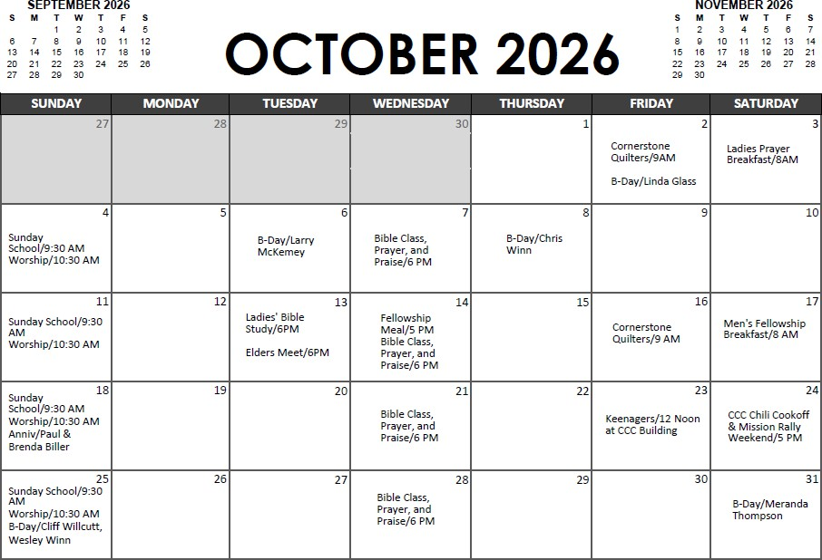

Your Body God’s Temple
A Cornerstone Christian Church Ministry
Joe Rightmyer, FNP, DNP and Melanie Rightmyer, DNP Breast Cancer Awareness

October is Breast Cancer Awareness Month. This has hit close to home this year because my sister-in-law Catherine told us during our trip to Family Camp in Ohio that she was fighting breast cancer. She is presently receiving chemotherapy. I know everyone in our con-gregation knows someone who has had breast cancer. To learn more about Breast Cancer we have summarized a few interesting facts:

*Breast Cancer is the most common cancer for women worldwide
*1 out of 8 women will develop breast cancer in their lifetime
*On average every 2 minutes a woman is diagnosed with breast cancer
*There’s a 99% survival rate to early detection
*Men can get breast cancer too
*There are over 4 million breast cancer survivors in the United States

Please join us in bringing awareness to Breast Cancer by wearing PINK on our WORSHIP IN PINK SUNDAY, OCTOBER 18TH! Stop by the Your Body God’s Temple pink table for more de-tails that Sunday.

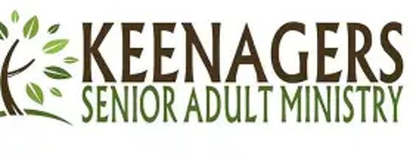
OCTOBER 23, 2026 at 11:30 AM
LOCATION: Church Fellowship Hall SPEAKER: Joe Rightmyer

An electronic sign-up will be designed soon for veggies and desserts. Con-tact Melanie Rightmyer or Gini Woods for details.

