Stages
Cornerstone Christian Church September 2026
Spreading the Light of Jesus!
( John 1:9)
2 Peter 1:5-8

It’s not hard to recognize that all believers are at differing levels of spiritual growth and ma-turity. Just like a baby is newborn, progresses to shallow levels of function, and then on to adolescence and adulthood, the comparison is true spiritually. So, the following hold true as well:
Maturing Christians should strive to represent and model Jesus so that others will want to be “born again”- Matthew 28:18-20.

We should bear with each other, recognizing the different levels of development eve-ry individual has reached, as well as their potential to continue on toward a more ma-ture reality- Romans 15:1-7.

2 Peter 1:5-8 gives us a list of qualities that we can look for and add to as we grow in our faith. In fact, the term “supply” in verse 5 is a command to grow these qualities as we live
out our faith. They are marks of progress, as well as warnings, if we’re not realizing any pro-gress in our walk with Jesus.

It is a great joy to be a helper in someone’s spiritual growth. To watch as folks gain
knowledge and then put that knowledge to work in serving Christ. It is also a great challenge to keep growing ourselves, and to see the difference it makes in our attitudes toward others, and toward Christ!

Blessed to serve Him with you-
Jay

Communion Meditation:
9/6– Larry McKemey 9/13– Jay Thompson 9/20– Joe Rightmyer 9/27– Jack Jackson

Greeters:
9/6– Larry & Sarah McKemey 9/13– Victor & Sharon Clark 9/20– Jack & Linda Jackson
8/27– Paul & Wanda Reynolds

SEPTEMBER is happening!
⇒ Wednesday 9/2, 6 PM – Wednesday Bible Study.
⇒ Friday 9/4, 9 AM- Cornerstone Quilters.
⇒ Saturday 9/5, 8 AM- Ladies Prayer Breakfast.
⇒ Tuesday 9/8, 6 PM-Elders’ Meeting- If you have a business for them to discuss or want to meet with the group, see Jay, Jack & Larry in advance.
⇒ Tuesday 9/8, 6 PM- Ladies’ Bible Study
⇒ Wednesday 9/9, 5 PM- Wednesday Meal- Chicken Strips, Mashed Potatoes, Green Beans, roll, dessert, beverage. Cost is $6 per person, or $18/family max. Bible class follows at 6!
⇒ Wednesday 9/9, 6 PM- Wednesday Bible Study
⇒ Friday 9/14, 9 AM- Cornerstone Quilters.
⇒ Wednesday 9/16, 6 PM- Wednesday Bible Study
⇒ Saturday 9/19, 8 AM- Men’s Prayer Breakfast- Join us for a breakfast, a time of prayer, and a devotional.
⇒ Wednesday 9/23- @ 5 PM – Wednesday Meal- Menu: Pizza, salad, dessert & beverage.
Bible Study follows at 6!
⇒ Friday 9/25, 12N- Keenagers Luncheon.
⇒ Saturday, 9/26- Cornerstone Handcraft Market- 8 AM-1 PM. We will serve as ambassa-dors for Jesus and CCC!
⇒ Wednesday 9/30, 6 PM- Wednesday Bible Study.

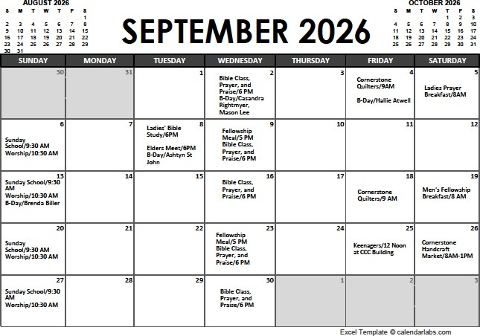

Your Body God’s Temple
A Cornerstone Christian Church Ministry
Joe Rightmyer, FNP, DNP and Melanie Rightmyer, DNP Healthy Aging Month – September 2026
THE FLU VACCINES ARE AVAILABLE NOW!

People often ask me, “Can you get the flu from the flu shot?” No, you cannot. The shot is made from the dead flu virus that can’t cause influenza infection. You can however get brief flu-like symptoms which may feel like you have the flu.

I have had asthma all my life, was born with it and never outgrew it. Because of my asthma it puts me at a higher risk of catching the flu and then it is leading into pneu-
monia. Now that I am 63 years old, I have a naturally declining immune response that just comes with aging. That’s why it’s especially important that I get a yearly flu vac-cine.

I found this statistic frightening this year. . . The flu and pneumonia were the 8th lead-ing cause of death in the U.S. in 2025, up from 11th only a year ago. While each flu
season differs in severity, during most seasons, people 65 and older bear the greatest
burden of disease. CDC estimates that between 70-85% of seasonal flu-related deaths and between 50-70% of seasonal flu-related hospitalizations occur in older adults.

By the way, Publix is providing free flu vaccines and if you get one from them, they will hand you an electronic gift certificate for $5.00. I usually wait until October to get my vaccine, but I am going ahead and getting it now. Another reason to get your vaccine asap is because it will take up to two weeks in your system before it begins to help provide immunity.

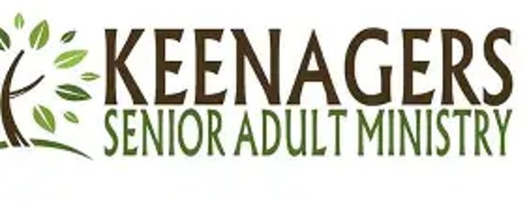
SEPTEMBER 25, 2026 at 11:30 AM
LOCATION: Church Fellowship Hall SPEAKER: To Be Determined

Gini Woods will be cooking “Cubed Steak” from Gladys McBride’s recipe. An electronic sign-up will be designed soon for vegees and desserts. Contact Melanie Rightmyer or Gini Woods for details.

