Documentation of Vision, Scope, Staffing, and Budget Meeting held on 07/20/22.

Future Vision
- Authority owns equipment required to support Fire/EMS services for our area
- Authority pays personnel directly
- Contracting with Fire/EMS agencies would only be short-term until Authority is going
- Personnel will consist of cross-trained Fire/EMS personnel and those who are only Fire or EMT
- Long-term, we would like full-time staff 24x7 at multiple locations, combined with additional personnel available for multiple calls at the same time and/or large scenes.
- Short-Term: due to budget constraints, we will need to find the right blend of staffing to best serve the needs of our community.

Scope - Services
- FIRE PROTECTION (EXTINGUISH STRUCTURE AND GRASS/BRUSH FIRES)
- FIRE INVESTIGATION/FIRE PREVENTION
- BASIC AMBULANCE TRANSPORT SERVICE
- MOTOR VEHICLE ACCIDENTS / VEHICLE EXTRICATION
- INDUSTRIAL INCIDENT RESPONSE (GAS/OIL FACILITIES, POWER LINE ISSUES)
- WATER/ICE RESCUE
- HAZ MAT
- COMMUNITY CPR TRAINING
- LOCATIONS:
  - MESICK/SPRINGVILLE
  - BUCKLEY

Scope – Service Area
- Immediate – Antioch, Hanover, Springville, and Wexford
  - Obtain approval from Medical Control
  - EMS Note: Mesick Rescue current coverage area includes Slagle and Harrietta (they are charged a base of $850 plus services rendered and mileage per run)
  - FIRE Note: Buckley is providing fire services to Grant and Mayfield
- Future:
  - Traverse County – Grant and Mayfield still interested in contracting with the Authority for Fire/EMS coverage
  - Other Wexford Townships – Slagle and others

Staffing/Command Structure

Thought Starters:
- Think what would be the ideal staffing?
- Think about what is right for our community – how much do we need for our volume?
- Don’t limit to current funding - other opportunities may be available:
- Other Townships – Grant, Mayfield, Slagle are interested in contracting for NWEA services
- Grants – primarily for equipment so our other funds could be for personnel
- State Funding – Governor recently approved funding for Fire/EMS support
- Property Tax – with inflation, property taxes will increase, but so will wages…

Thought Starters: Previous Proposal and Email of Job Descriptions:
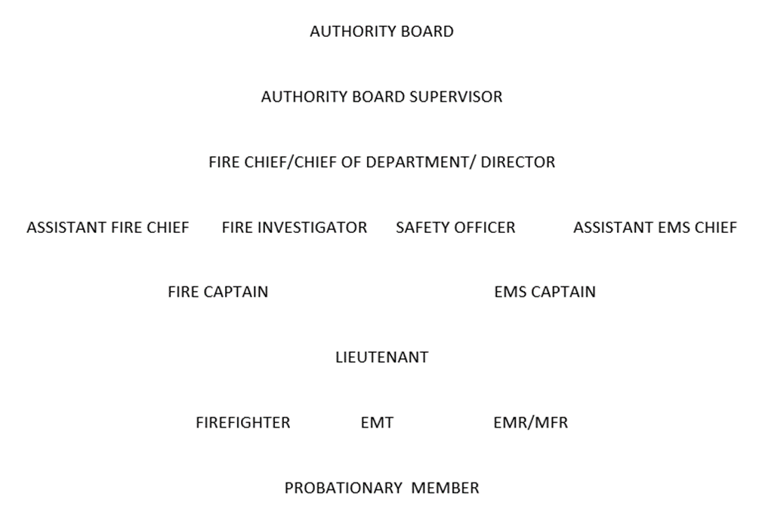 | Descriptions Emailed 7/18/22:  - Director  - EMS Chief  - Fire Chief  - Captains  - Duty Crews  - Paid On Call  - Training Instructor (Fire and EMS)  - Training Coordinator (EMS)  - Fire Investigator  - Health and Safety Officer

Staffing/Command Structure

Future Staffing Goals: (Agreed to)
- Long-Term Goal: 24x7 staffing in 2 locations (Buckley and Springville/Mesick area)
  - Minimum of 2 trained personnel staffed full-time at each station with enough back-up to mobilize back-up units for larger scenes
  - Provide our personnel with a sustainable pay to make a professional career, including benefits
- Make it easy to be “on-call”, sign-up, etc. (electronic scheduling, tablets for billing, etc.)
- We want/need a blend of those who are willing to be Fire/EMT cross-trained and those who just want to be Firefighters or those who just want to be EMT.
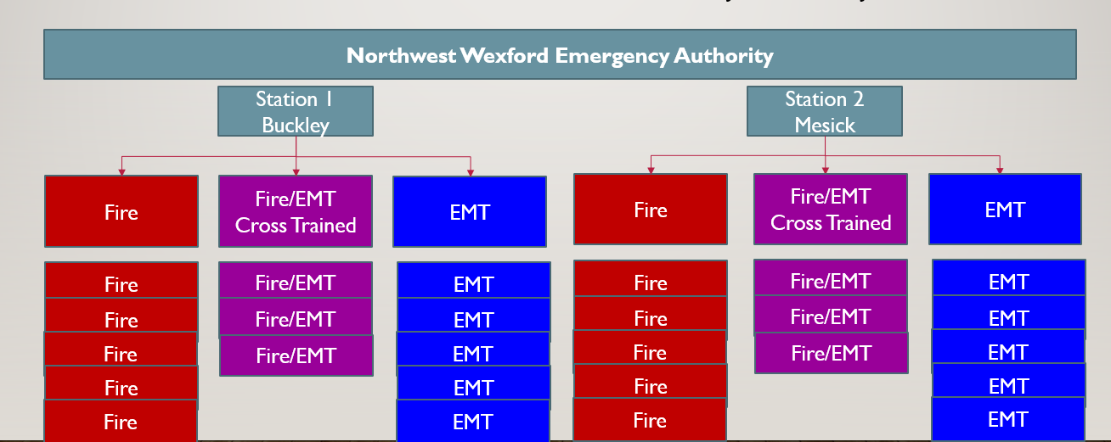

Future Command Structure: (Agreed to)
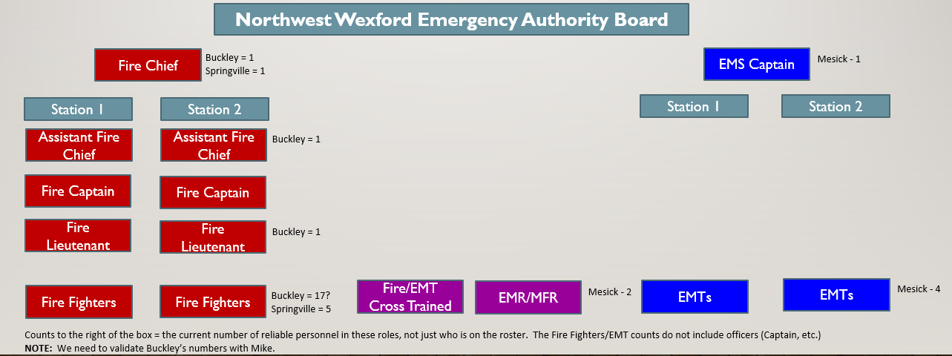
- The command structure was defined without regard to budget, but rather what would be a good command structure for the size/scope of our townships in the Authority
- Generally, a Fire Officer manages approximately 5-7 firefighters
- Each location really needs an Assistant Fire Chief. However, as we start up, the Fire Chief may act as the Assistant Fire Chief for one of the locations.
- For EMS, the Captain and/or the most senior person at the location is in charge.
- We want to be sure that the teams cross-staff and train together so we operate as “one Authority”, not two separate departments within the Authority.

Staffing/Command Structure

Roles Out of Scope: (Agreed To)
At this time, the team does not currently see the need for the following roles. However, as we grow, the need for additional roles may change over time.
- Fire/EMS Director – we could talk to Eric Somsel (Blair) or Darryl Case (Green Lake) to ask when they determined the need for this position; typically found in larger organizations
- EMS Chief – just need Captain
- Training Instructor – currently the Fire Chief/EMS Captain and other officers do this or it can be contracted as required
- Training Coordinator – combination of Chief/Captain and personal responsibility
- Fire Investigator
- Health and Safety Officer

Immediate Roles Needed: (Agreed To)
- Roles: Fire Captain (with Firefighters) and EMS Captain (with EMT personnel)
- Medical Control Recommendations – if we have staffing in Mesick, then we should at a minimum have first responders in the Buckley area

Current Staffing – EMS:
- Mesick Rescue is currently 24x7
  - 12 hours at the station during the day 7am-7pm
  - 12 hours at home or at the station at night
  - When a second crew is needed (first ambulance is out), they are paid hourly for each call with a minimum of 2 hours pay
  - Note: a second crew is needed about 2x/week lately
- Buckley Area
  - We at least need first responders, but ideally staff at the station 2 people during the day
  - Issue: first responders don’t want to use their personal vehicle – leasing a vehicle would alleviate this concern. A crash truck could be a first response unit – the license determines if a vehicle is a first response or a transport vehicle (ambulance).
  - Buckley used to staff on-call during the day 9am-9pm; evenings were dependent on who responded
  - On-call (2 people) would receive $5/hr

