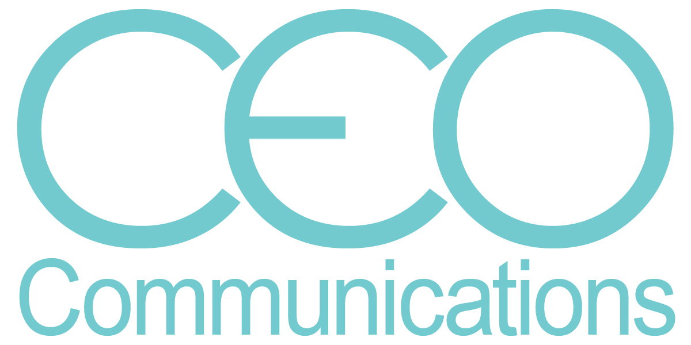
717•917•6299 carol.everett.oliver@gmail.com 11266 Royal Tee Circle • Cape Coral, FL 33991

Carol Everett Oliver, RCDD, DCDC, ESS

ICT Consultant

CEO Communications is an industry marketing organization producing technical white papers, case studies, blogs, press releases and newsletters. See complete information at: www.ceocomm.com
Industry Accomplishments
- BICSI Global Organization:
    - President, BICSI Board of Directors (2022-24)
    - Chair, BICSI Intelligent Building Standards’ Subcommittee (2015-2020)
    - Vice Chair, BICSI ESS Standards’ Subcommittee (2012-Present)
    - Established the Women in BICSI Group (2013)
    - BICSI Northeast Region Director (2012-2016), Secretary (2017-2020), President Elect (2020-2022)
    - Awarded David K. Blythe BICSI Outstanding Member of the Year (2011)
    - Recognized as an Industry "Changemaker" by BICSI Organization (2009)
    - Obtained RCDD (Registered Communications Distribution Designer) in 2003 and ESS (Electronic Safety and Security) in 2009 and DCDC (Data Center Design Consultant) in 2019
    - Established the Exhibitor Advisory Committee for vendors and was first chair and standing member (2003-2016)
    - BICSI Nominating Committee (2008-2012)
  - Global Industry Presenter on Infrastructure (IoT, Intelligent Buildings, Healthcare, Security,
Data Center)
  - Published Writer: industry articles and cover stories (over 100 articles)
  - Business Owner: 10 years success in marketing and marketing communications planning and execution for numerous global telecommunications companies
  - ASIS Physical Infrastructure Council (Education Sub-committee): the first structured cabling expert accepted on the educational sub-committee (2009)

Previous Professional Experience

SIEMON COMPANY, 101 SIEMON DRIVE, WATERTOWN, CT – 2018-2019
Southeast and Mid Atlantic Network Cabling Specialist based in Cape Coral, FL
Optical fiber and copper best practices training instructor for certified installers. Local meeting and national conference new standards and technology presenter for customers/end users and installers. Marketing technologist and article and blogs writer focusing on market trends. Build and maintain the integration of industry manufacturers that complement the Siemons’ structured cabling system solutions portfolio.

LEGRAND DATA COMMUNICATIONS DIVISION, 60 WOODLAND ST.,
WEST HARTFORD, CT – 2015-2018
Training and Technology Manager
  - Network infrastructure trainer for end users, contractor managers and technicians including optical fiber and copper standards updates, best practices and hands-on termination and testing. Manage and maintain all online and face-to-face module updates.
  - Global industry technologist for emerging markets (i.e. IoT, Intelligent Buildings, PON, Healthcare, AV) to include proving market research and education through customer presentations, webinars and technical articles. Maintain partner manufacturers relationships.
BERK-TEK, A NEXANS COMPANY, 132 WHITE OAK RD., NEW HOLLAND PA – 2006-2015
Channel Marketing Manager (2013-2015)
  - Coordinated and produced all channel/distribution promotional programs and events (Graybar, Anixter, Accu-tech and CSC/Wesco).
  - Industry association liaison responsible for public relations, technical articles, technical presentations and trade show messaging and logistics.
Marketing Analyst (2006-2013):
  - Researched and defined new and emerging markets, such as security, healthcare, IP/BAS, government, and green initiative for structured cabling.
  - Industry presenter for national trade shows, workshops and customer and other events.
  - Supported communications by writing technical and other industry articles.
EVERETT COMMUNICATIONS, HOLLISTON, MA 01746 – 1996-2006
Owner
Marketing communications, public relations and advertising plans, budgets and campaigns for structured cabling and other related technical national companies.
BERKLEY ADVERTISING, FRAMINGHAM, MA – 1990-1996
Vice President, Account Services
Oversaw and orchestrated the design and production of marketing communications projects
for two optical fiber and copper cabling manufacturers.

Education
SAN JOSE STATE UNIVERSITY, SAN JOSE, CA
B.A. Advertising/Public Relations/Marketing

