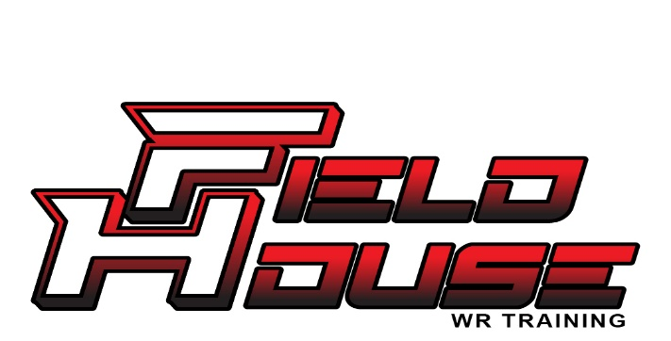
THE FIELDHOUSE CODE

By training at Fieldhouse, I agree to the following:
- I will train with intent and effort.
- I will be coachable and open to correction.
- I will respect my coaches, teammates, and the process.
- I will focus on development over hype.
- I will take pride in mastering the craft of wide receiver.
- I understand improvement takes time, discipline, and consistency.
- I represent Fieldhouse by how I train and how I play.

I don’t chase shortcuts. I build skill. I uphold the Fieldhouse Standard.

Athlete Name: __________________________________________________
Signature: ______________________________________________________
Date: ___________________________________________________________

