|  |  |  |  |
| --- | --- | --- | --- |
|  |  |  |  |
|  | | |

|  |
| --- |
| **Spring Branch Civic Association**  **P.O.Box 430574, Houston TX 77243-0574** |
| **Winter 2024 Newsletter**  **Spring Branch Civic Association**  **Website: www.springbranchcivic.com**  **Email: sbcivicassn@gmail.com**  Christmas Forest Fragrance Oil - Trial ... |

OCTOBER YARD OF THE MONTH WINNERS:

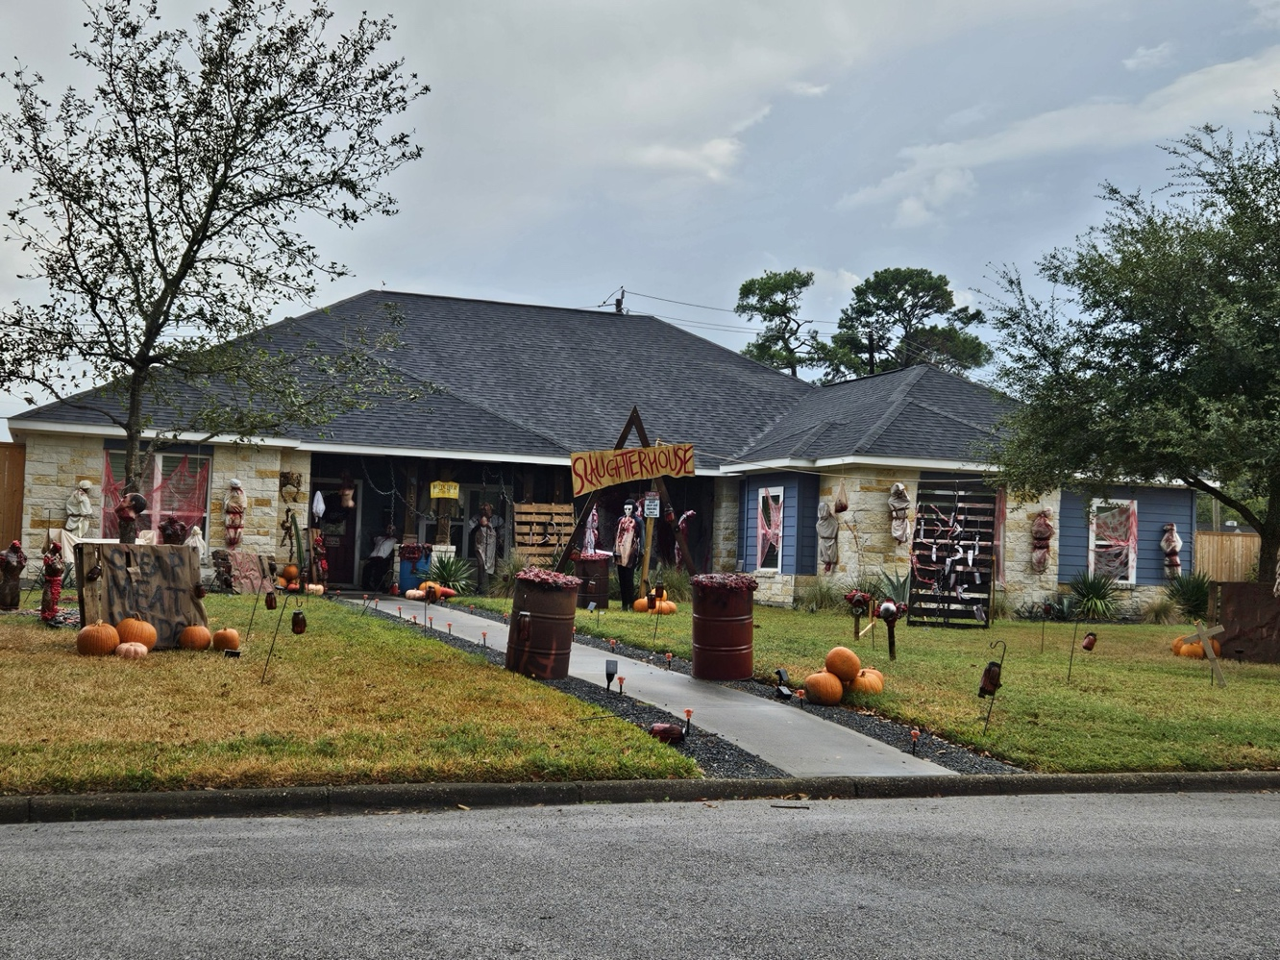

**MOST GRUESOME**

1329 Centennial

Designed by:

Courtney McGuire &

Nolen Baker

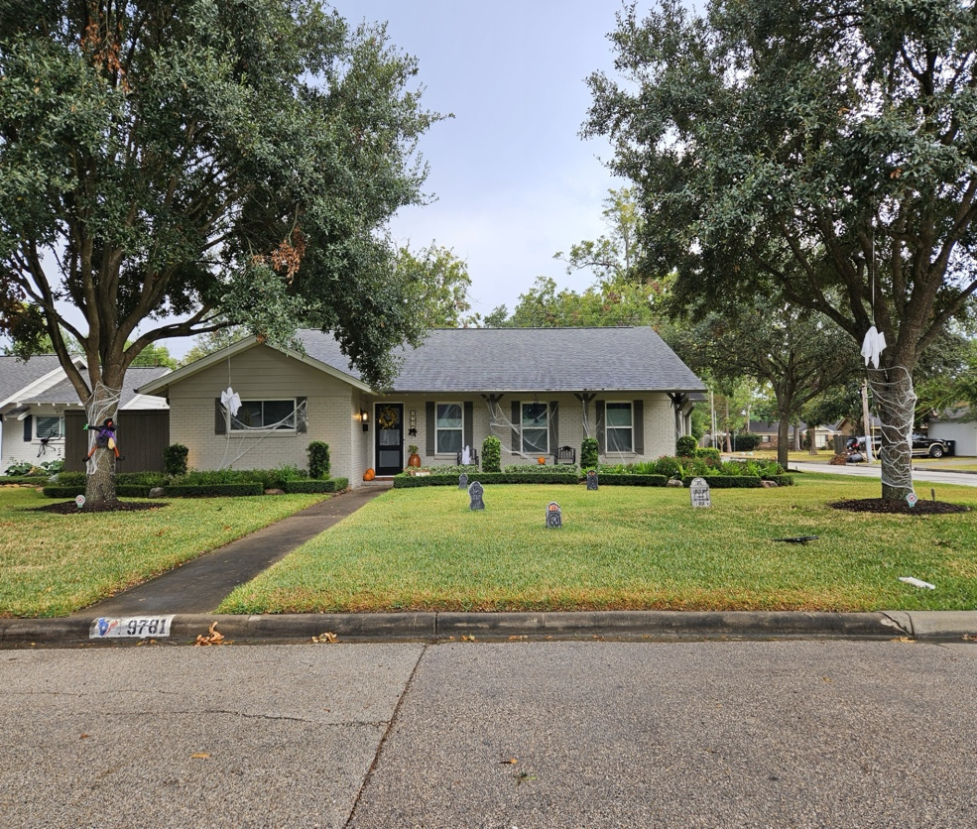

**SPOOKY!**

9781 CEDARDALE

**YARD OF THE MONTH**

Calling all yard decorators!!! We will be selecting yard of the month for **DECEMBER!**

Get ready to decorate again for CHRISTMAS! Awards will be given for MOST FESTIVE and BEST OVERALL!



**NEIGHBORHOOD FINDS:**  Spring Branch is full of great places!  Here are a few of the Board's favorite spots around town.  Reply to this email with your favorite spot and you could win a $20 gift card to one of our local faves!

* [Lazy Oaks Beer Garden](https://lazyoaksbeergarden.com/) - "outdoor perfection." "dog-friendly." "gameday fun!"
* [Buzz & Bites](https://buzznbites.com/home) – a “must stop by local coffee shop” 1444 Blalock Rd
* Under Belly Burgers -Burgers from locally sourced beef and more!
* Decoy Bar & Sand Volleyball – volleyball, cornhole, large screens, hang-out.
* Pickle Ball Social – indoor & outdoor courts, bar, live music, lessons, and more!
* [Warren-T Fitness](http://www.warrentfitness.com/)- Tell Callie we sent you! New to Spring Branch, this place is an affordable choice for staying healthy all year long.
* <https://saigonhustle.com>– Vietnamese food1223 Witte Rd.

**SAVE THE DATE:**



CHRISTMAS HOLIDAY PARTY

DECEMBER 8TH FROM 3:00-5:00

9775 CEDARDALE DRIVE

**ISSUES IN THE NEIGHBORHOOD:**   Everyone can help preserve our neighborhood just by following deed restrictions and City ordinances and respecting your neighbors.  If you see a violation, please report it to 311. If you are not sure whether it is a violation or not sure how to report it, send an email to this address and we'll help.  You can find deed restrictions [here](https://springbranchcivic.com/), on our neighborhood website.

**[](http://houston311.org/)**  
  
Your [City of Houston 311](http://houston311.org/) is proud to announce its new and improved Houston 311 mobile app, powered by SeeClickFix, to report non-emergency issues.  
  
The Houston 311 mobile app features dynamic upgrades and an easy-to-use interface with features like:  
  
• Create service requests on the go.  
• Submit cases with pictures and details.  
• Cases are routed to a team, instead of an individual.  
• Set up your own "watch areas".  
• Receive notifications about your reported issues as well as issues in your community.  
The new Houston 311 mobile app is available for download on Android and iPhone.

**HEAVY TRASH SCHEDULE:** Houston Solid Waste Management has launched HTX Collects, a mobile app that will allow residents to stay better connected with the City's waste and recycling collection programs.  This app is available for download on Android and iPhone.

[Click here](https://houstontx.gov/solidwaste/htxcollects.html) for more HTX Collects info.

**REMINDER:**

Want to get involved and serve with us?  Just reply to this email if you'd like to join the Board, volunteer with special events, or help with the upkeep of our park.  Everyone is welcome!

SBCA Annual Dues are only $20.  Thank you to everyone who has paid their dues. If you still need to pay your 2024 dues, just [click here](https://springbranchcivic.com/paypal)to pay via PayPal. Or, you can mail your $20 check payable to SBCA to:

SBCA

P. O. Box 430574

Houston TX 77243-0574  
  
It's always a pleasure to serve you and the Spring Branch community.   
  
Regards,  
SBCA Board Members

Caroline Horsley, President

Jonathan St. Romain, Vice-President

Charmaine Bixler, Secretary

Frank Dunstatter, Treasurer

Carla Quine, at large

Jennifer St. Romain; at large

***If you no longer wish to receive these emails, send an email back to this address asking to be removed from the mailing list.***

**IMPORTANT CONTACTS:**

**HPD Northwest Substation**

6000 Teague

832-394-5500

**District A Office - CM Amy Peck**

[**districta@houstontx.gov**](mailto:districta@houstontx.gov)

[832-393-3010](tel:832-393-3010)

**State Senator – Joan Huffman, District 17**

(281) 497-2450

senatorjoanhuffman@gmail.com

**State Representative – Lacey Hull**

512-463-0727

<http://www.house.state.tx.us/members/member-page/?district=138>

|  |
| --- |
|  |