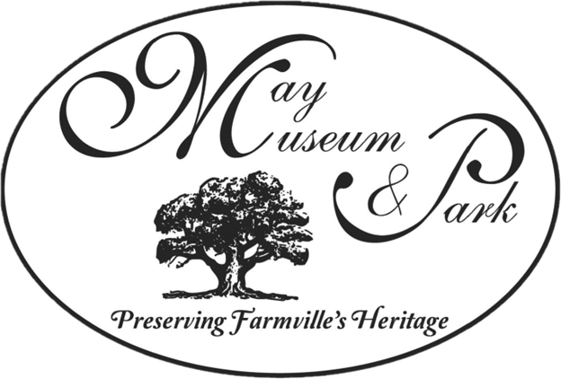

**The Friends of The May Museum, Inc.** is a non-profit 501(c)(3) organization. It is a core group of

contributors and volunteers who work alongside The May Museum and Park Advisory Board. The members

aid in the promotion of the museum, serve as volunteers at scheduled events, and assist with fund-raising

to meet the needs of acquisitions for the collection or for enhancement of the building and grounds.

*We need your help in our efforts to preserve Farmville’s rich heritage.*

*Please consider becoming a member of the* ***Friends of The May Museum****.*

***Membership Prices Have Changed***

**Type of Membership Included With Form**

**Student - $20.00 $ ____________**

**Individual - $30.00 $ ___________**

**Family (Household and Dependent Children) - $50.00 $ ____________**

**Civic Organization/Non-Profit - $75.00 $ ____________**

**Business - $125.00 $ ____________**

**TOTAL AMOUNT INCLUDED $ ____________**

Name(s): ___________________________________________________

Address: ___________________________________________________

City, State, Zip: _____________________________________________

Telephone: _________________________________________________

E-mail address: ______________________________________________

Today’s Date: ______________________________________________

Please return this completed form with your remittance to:

**Friends of the May Museum**

**Post Office Box 623**

**Farmville, NC 27828**

**Contact Roger Kammerer @ (252) 758-6882 With Questions**

***Thank you for your support!***