Dear Main Street Waterbury Supporter,

Main Street Waterbury is proud to announce phase IV of our Downtown Banner Program! Businesses will have the opportunity to take advantage of this inexpensive advertising medium by sponsoring these attractive new banners. Banners are durably made with long lasting, fade resistant Sunbrella fabric.

Banner sponsors enjoy:
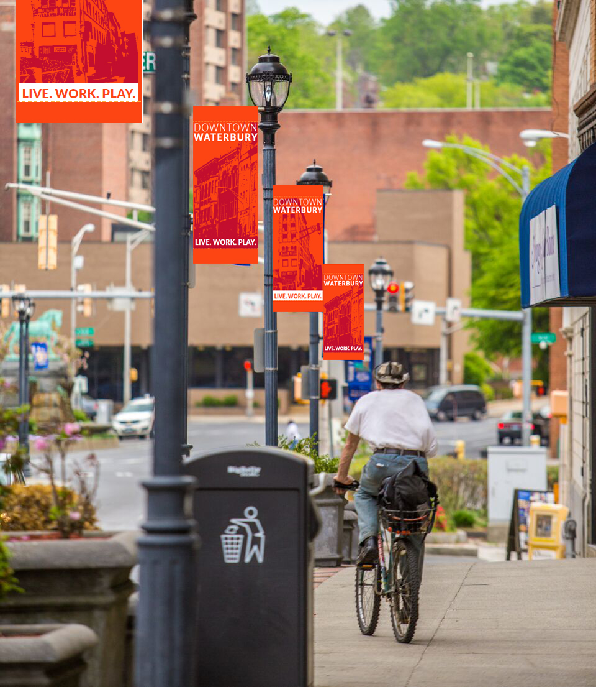
Low cost signage at just:
- $0.55 per day for a slice holding up to 3 lines of text and attached to a new full banner ($600 for 3 years)
- $500 for 3 years on purchases of two or more banners.
Constant Visibility:
- Banners are on display 24/7 – 365 days per year
- High volume traffic locations
Attractive Presentation:
- Rich colorful artwork with images of downtown buildings emblazoned with the words: Downtown Waterbury “Live. Work. Play”.
Demonstrated Community Involvement:
- Participation and display of your business name demonstrate your involvement in Waterbury and the enrichment of our downtown.

Please consider banner sponsorship for your business. Presently, there are still a great variety of pole locations throughout downtown and discounts are available for multiple banner locations.
Main Street Waterbury is taking sponsorship orders through March 31, 2021. Banners & slices will be hung in the Spring of 2021!
Please complete the attached order form. For any questions, please contact Main Street Waterbury at (203) 757-0701 x302.
Each selected light pole features sponsor recognition on a large tag attached to the bottom of the banner. Sponsors select among the available locations on a first-come, first serve basis and discounts are available for multiple banners.
Banners will be mounted at locations on Bank Street, Grand Street, East, West , and South Main Streets, plus other downtown locations where applicable.


Sponsorship Copy:
Please write copy as you wish for it to appear on the sponsor tag.

Sponsor Name
Address
Contact
Phone
Email
(New Single Banner Sponsorship - $600 for 3 years) ______
Two or more - $500/each _________________ QTY

Remit Payment To:
Main Street Waterbury
83 Bank Street
P O Box 1469
Waterbury, CT 06721
Village Cleaners

Please write copy as you wish for it to appear on the sponsor tag
that sits at the bottom of the banner (see photo).


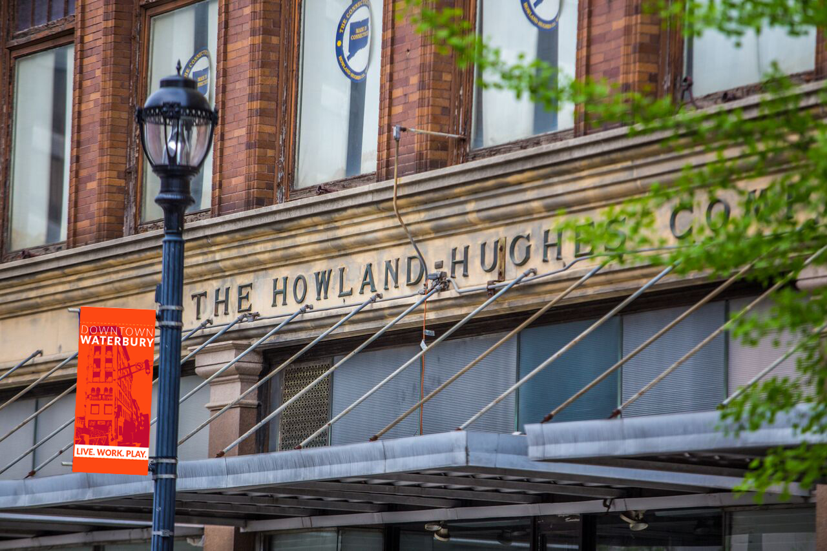
Sponsorship Copy:
Please write copy as you wish for it to appear on the sponsor tag.

________________________

