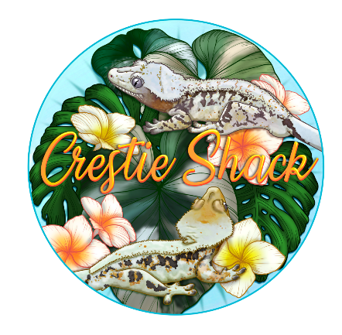
Crested Gecko Care sheet
  - All wording used in this care sheet is written by Crestie Shack.
The crested gecko or eyelash gecko (Correlophus Ciliatus) is a species of gecko native to southern New Caledonia (France). In 1866, the crested gecko was described by French zoologist Alphonse Guichenot. This species was thought to be extinct until it was rediscovered in 1994 during an expedition led by Robert Seipp. Along with several other New Caledonian gecko species, it is being considered for protected status by the Convention on the International Trade in Endangered Species of Wild Flora and Fauna.
The species was first described in 1866 as Correlophus Ciliatus by the Alphone Guichenot in an article entitled "Notice sur un nouveau genre de sauriens de la famille des geckotiens du Muséum de Paris" ("Notes on a new species of lizard in the gecko family") in the Mémoires de la Société Scientifique Naturelle de Chérbourg.
It was later renamed Rhacodactylus Ciliatus. Recent phylogenetic analysis indicates that R. Ciliatus and R. sarasinorum are not closely related to the other fat, so these 55 species have been reclassified from Rhacodactylus back to the genus Correlophus.
The specific name, Ciliatus, is Latin, from cilia ("fringe" or "eyelashes") and refers to the crest of skin over the animal's eyes that resembles eyelashes.

Housing
Crested geckos are an arboreal species and require height more than width and depth. Fully grown cresties should be in at least a 45cm tall glass terrarium thick with foliage and ledges. If you think it's too much green cover, then you've got the perfect amount. Crested geckos love to hide to feel safe.
Acrylic and plastic are a good alternative to glass, so long as they are ventilated adequately.
Feeding ledges are great for this species as they would find their food up higher in the wild, but this doesn't mean that they won’t eat on the ground, it’s all down to your individual gecko.
Crested geckos should never be cohabbed, as male x male will fight until one of them is severely injured or unfortunately passes away. male x female will result in your female being constantly bred without any kind of break, this causes her to lay eggs throughout the year, losing weight and calcium which can lead to calcium crashes. Some more experienced breeders cohab female x female successfully but it isn't recommended to the novice keeper. Experienced keepers are able to keep an eye and recognise any behaviours which could lead to fighting, injury or death.
UVB lighting is very beneficial to your crestie but isn't essential for your gecko to thrive. If UVB is something you'd like to provide, we recommend the Arcadia T5 shade dweller. If you do not provide UVB, you will need to supplement but dusting live food with calcium + D3.
Baby crested geckos we recommend keeping in an exo terra nano sized tank with kitchen roll on the floor so to keep an eye out for defecation. Defecation = eating.
Juveniles (8-20g) we keep in either 20/30ltr tubs. You can keep in a 30x30x45cm exo terras if they are eating consistently and gaining weight at a good average.
Really useful boxes are also a cheap and effective way to keep your geckos. They would manually need venting with a decent size of mesh on at least one size to ensure correct humidity is achieved.
Don’t be discouraged if your gecko isn’t putting on weight well or not eating much, we’ve found downsizing the tub/enclosure they are in gets them eating on a regular basis again, after a around a month otherwise two of regular eating and weight gain we will upside their enclosure size again and keep an eye on their eating.
Crested geckos can take over 3 months to fully settle in a new space, so always leave a good while to settle before worrying and changing enclosures.
Humidity – Rule of thumb is that humidity should raise to over 80% after spraying and then allowed to naturally dry out to 30/40% during the day. We find one mist in the evenings is sufficient enough to cause this.
Heat – We find that our geckos are happiest at 20/22⁰c. Anything higher than 29⁰c can cause harm to your gecko. We have an air conditioning unit for our reptiles in the summer to keep them cool, but other tricks are:
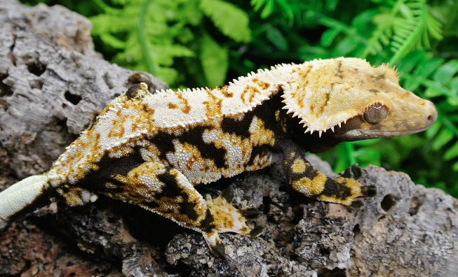
Keep curtains and blinds shut.
Spray down a little more often.
Fans oscillating
Moving your gecko to a cooler room in the house e.g., bathroom or kitchen
Turn off any lighting/UVB you have over/in their enclosure.
Equally, you don’t want to let them get too cold over the winter months. Although this isn’t fatal to them with UK temperatures, it will slow down their growth and how much they eat. There are a few options for heating such as
Ceramic heat lamps (Outside the tank or inside in a guard cage)
Heat mats (most reptile keepers find these don’t keep consistent overall temperature and only end up heating the side they are placed on)
Heat cable (we used this in our shelving racks but found it did not heat adequately)
Heat lamps/Coloured lights are not generally used for geckos as they need a day and night light cycle, so they would need to be switched off in the evening which would mean they are not providing heat to your gecko at the coldest point of the day.
Radiator with a built-in thermostat (We use this method in our reptile room to heat the entire room)
IMPORTANT – ANY HEAT SORCE MUST BE PLUGGED INTO A THERMOSTAT. NOT USING ONE RISKS BURNING/KILLING YOUR GECKO AND HOUSE FIRES.
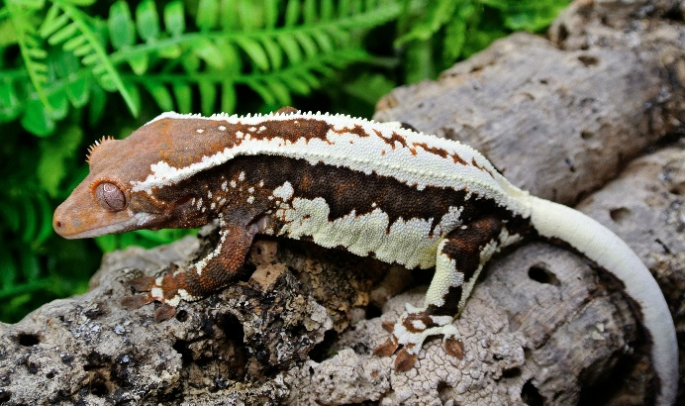
Heat rocks are also something we never recommend; they are known to burn animals as they have no thermostat built into them.

Feeding
The base of any crested gecko diet is a complete powered fruit diet such as Pangea or Repashy, Mixed with water to a ketchup like consistency. Nothing else needs to be added as it already has everything your gecko needs.
Live food should be offered 1-2 times a week dusted with calcium power. if you are not providing UVB lighting then you will need calcium with added D3 so they can absorb it correctly. Staple live foods are crickets, locusts and roaches. Wax worms should only be given as a rare treat, being very fatty they can cause liver issues if fed too often.
We feed on a schedule of Monday - CGD, Tuesday - No food, Wednesday – No food, Thursday - Live food, Friday – No food, Saturday - No food, Sunday - CGD
Live food should also be gut loaded at least 24 hours before feeding. We gut load ours with left over Pangea and fresh fruit and veg. We also find adding a little honey to our Pangea mix encourages our geckos to eat.
Jelly pots are something we will never recommend feeding to any animal including live food. They are full of sugar and e numbers including citric acid which is toxic to geckos. Don’t worry if your gecko doesn’t eat immediately, it can take up to a month for your gecko to settle into their new environment. As long as you see poo, your gecko is eating. Babies eat such a small amount that sometimes it isn’t very noticeable. Live food shouldn’t be offered until your gecko is eating their complete diet regularly. Newly hatched geckos shouldn’t be offered live food until at least 2 weeks of age.
Baby food is also never recommended, even as a treat. Back when crested geckos were first discovered, baby food was the only food available to feed them while in captivity. Complete diets were formulated as keepers noticed the bad effects from baby food being fed over time. Most baby foods contain preservatives and even organic baby food contains lemon juice which is toxic to cresties.
For our adult females we also leave a capful of calcium + D3 so they can self-regulate their calcium stores. Many females over 30g will lay infertile eggs on occasion, especially during the warmer months, so providing calcium is always beneficial to them.

Troubleshooting
  - Shedding
Shedding can be a very stressful time for owners. Most of the time you won’t actually notice when your gecko sheds as they eat it, so there may be no evidence. You can sometimes tell when your gecko is going into shed. Signs are:
- Feeling rough/dry to the touch
- Not being able to stick to things as well.
- Looking paler than usual
Most geckos will not need any assistance while shedding if your humidity is on point and they should be left alone to shed peacefully. If your gecko still has some shed left after 2 days, it may be time to intervene (most of the time they leave some on toes). The best thing to do is to give your gecko a sauna and then gently remove the shed with a dry Q-Tip. Now, when we say sauna, we don’t mean an actual steam room, here’s a step by step on how to do it.
- First, get a small, ventilated tub with a lid.
- Place a piece of kitchen roll in the bottom.
- Spray down the tub and towel with water.
- Place your gecko inside and shut the lid.
- Leave for at least 20 minutes.
- Gently try to roll off the stuck shed with a dry q tip.
- If you can, use a set of tweezers to gently remove any bits that are close to coming off.
- If your gecko starts shaking their tail, making noises or biting, give them a break. They will only put up with so much!
  - Tail Drops
Tail drops can be very scary and upsetting, but they happen all too often and most of the time, for no reason. If your gecko drops his tail, be aware the tail will wriggle for a little while afterwards as it is their only defence mechanism to escape from predators. If your gecko has dropped his tail, its best to change out any lose substrate you have for kitchen roll while he heals up. It can take a few weeks before the wound is fully healed, but we do not recommend using any creams or ointment on the wound. It will heal itself up naturally. If the wound does get substrate etc in it, it’s best to clean with just sterile water (Although your gecko probably won’t appreciate your efforts). He may be a little more flighty or wobbly while he gets used to not having it around, but being tailless does not affect your gecko in any way and they will continue to live happily without it.
  - Floppy Tail Syndrome
Floppy tail syndrome or FTS as its commonly known is unfortunately all too common and easily avoided. FTS is caused by sleeping facing downwards when there isn’t enough foliage available, so the tail starts tipping back over until the nerves at the base of the tail die off. Adding lots of vertical leges and bundles of foliage can stop FTS getting any worse, but once your gecko has it, it won’t ever get better. Some keepers will actually force a tail drop on geckos that have severe FTS to stop it getting any worse. This is not something I suggest unless absolutely necessary.

Tail Rot
Tail rot can easily be identified when the end of the tail turns black and usually shrivels up. I would always recommend visiting your exotic vet if you suspect tail rot. This may mean that they perform a partial amputation of the tail, but it stops any infection spreading.

Metabolic Bone Disease – MBD
MBD is a very painful and irreversible disease and is caused by owner error and a lack of calcium being absorbed. Not providing a complete diet or adding D3 to calcium supplements if you’re not providing UVB lighting are the most common causes. Jelly pots and baby food are also a big factor in causing MBD as they are not balanced, contain e numbers and usually preservatives such as citric acid and lemon juice which is toxic to geckos. Feeding fresh fruit very rarely as a treat isn’t a cause of MBD, but feeding regularly can cause it to happen. Some fruits inhibit the absorbing of calcium such as bananas. Crested geckos do not actually understand treats and are not necessary. But if fresh fruit is something you want to do on a rare occasion, stay away from anything citric. Papaya, melon, figs and apricots are appropriate, but please do this rarely. Complete diets have everything your geckos need and also contain fruit.
Main signs of MBD;
- Swollen limbs
- Rocking/shaking.
- Rubbery jaw
- Deformed back/limbs.
Unfortunately, if you have noticed any of these, your gecko already has it severely and needs an exotic vet visit. Checking your gecko’s calcium sacks is a good way to keep an eye on their stores. Crested geckos have two pockets of calcium stores inside their mouth on the roof towards the back, using a lolly stick type tool, try and get your gecko to open their mouth without causing too much stress to check.

Females Laying Eggs
We briefly approached this subject in the feeding section of this care sheet, but we feel covering it a little more would be beneficial to prepare you for when or if this happens. Over 25/30g females can often lay infertile eggs, especially during the warmer months of the year. If they do, there is nothing to worry about and it is completely natural. They will also lose some weight when they lay. We always supply a capful of Calcium + D3 (if not using UVB lighting) in our female’s enclosures so they are able to self-regulate their calcium stores, as these can be depleted when laying. Keeping females at cooler temperatures will help reduce the number of times they lay infertile eggs.
Most of the time, any eggs a female lay will be infertile if they haven’t come into contact with a male, but there have been incidents of pathogenic eggs being laid. 99% of the time these eggs won’t reach hatching stage but there are some cases where they have actually hatched.
If your female has come into contact with a male and laid eggs, the best course of action is to check if they are fertile. Fertile eggs when candled will have a red cheerio shape on one side.
Candling is when a light is shined through the egg.
If a cheerio is present, mark the top of the egg (Cheerio facing up) with a nontoxic marker or pencil, as the eggs will need to stay this way up. Get a small tub, preferably with little to no ventilation, add something like moss, coco fibre or vermiculite to the base, dampen whichever you have to hand, make a thumb print shape and place the egg in it with the mark you made earlier facing up, Close the lid and leave them be. If you have no ventilation, opening the tub once a week is sufficient enough to ventilate enough.
Typically, eggs take between 70 – 130 days depending on the temperature they are incubated at. Hotter = faster hatch. Faster hatching is definitely not something you want as it usually means smaller hatching sizes. The longer they take to hatch the better size baby you will end up with.
Signs an egg has gone bad are, turning orange, growing mould or ‘sweating’. Sweating before 50 days usually means the egg has failed and should be disposed of. After 50 days could mean the baby is trying to hatch but having difficulty.

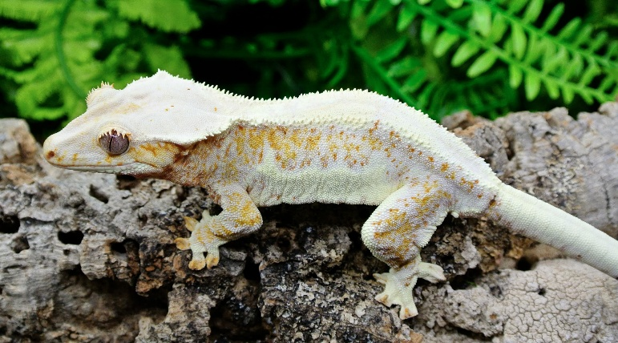
Escaping
One of the worst things that can happen to a keeper is losing one of them, but it does happen. The best thing to do if this happens is check all over the room they are being kept in, focusing up high. Check behind picture frames and behind appliances as they are sometimes attracted to the warmth they emit. If you still haven’t found them after checking everywhere, set up their tanks with some food in the centre of the room if possible as well as multiple pots of food around the room and bowls of water. Check the food bowls for any signs of them coming out to eat so you know they are still around in the room. Another trick is to sit in the room once its dark and wait to see if they appear. Geckos feel safer to move around once the lights go out. Keep all doors and windows shut to the room so that if you do ever have an escapee, you know they will still be in the room somewhere, so it narrows your search.

Eye Trouble
Eyes can be one of the most common issues with crested geckos. Not having eyelids, they can get injured very easily. Any issues with eyes should be seen by an exotic vet asap. Many issues include, stuck eye caps, ulcers, swollen/fluidy eyes and cloudiness. All of these need vet treatment immediately.

Prolapse
In some cases, males can prolapse their Hemipene, this can happen even without the presence of a female, and there are different steps on what to do;
- When you first notice the Hemipene exposed, make a note of the time.
- Leave them for at least an hour to try and retract it themselves, they do this but licking and biting the hemipene.
- If it still has not retracted after an hour, line a clean tub with kitchen roll and spray with de-chlorinated water. Place your gecko inside and leave for another hour. The best thing to do is to keep the area hydrated.
- If this still doesn’t work, apply some honey or sugar paste directly to the hemipene, Honey and sugar naturally reduce swelling and Adema’s. This method also encourages him to lick the area to retract it.
- If the previous steps still haven’t worked, then you may need to resort to more drastic measures. Get two Q-Tip’s, apply some KY jelly and try to roll the hemipene back into place, you want to do this gently, but firmly to have any chance of it resolving. Having someone hold the gecko while you try to manipulate it back into place will help, but this cannot always be done with geckos who do not tolerate handling.
- If none of the above step’s work, it’s time to call the exotic vet. They may be able to manipulate the area back in once pain killers and anti-inflammatories are administered, but in some cases, it will require amputation.
In my case, I noticed my male like this at 9am, I tried everything in the steps above but by 1pm, nothing had improved. We went to the exotic vet at 3pm, where we tried for a long time to manipulate it back, but to no avail. The vet sent us home after administering pain killers and anti-inflammatories to see if once the swelling reduced, he could get it back himself. But the next morning, he was the same. So he went back into the vets at 1pm. The vet tried while under general anaesthetic to manipulate it again, but no luck. We then decided that amputation was the only thing we could do. We were then sent home with pain killers and he recovered well. Luckily, crested geckos have two hemipenes, so he is still about to breed when he is fully recovered, and they do not use their hemipene to toilet, so amputating has little affect.
Cost breakdown
- Vet visit one – consultation, pain killers & anti-inflammatories = £103
- Vet visit two – Consultation, surgery & aftercare = £206
It’s always advised to keep a rainy day fund for situations just like this, and to know your closest exotic vet in case of an emergency.

Thank you for reading our care sheet. We are always here for any questions you might have about your crested gecko, so please don’t hesitate to get in touch !

