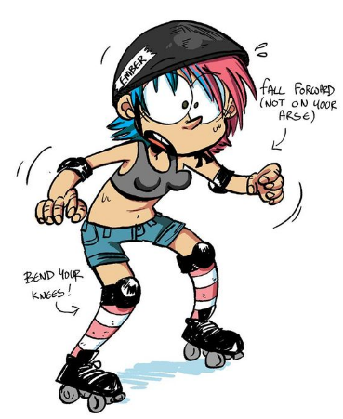
WHO AM I?

Name:
DOB:
Phone Number:
Email Address:
Mailing Address:

How to find you on Facebook:
What brought me to derby:
What I hope to gain from derby:
Previous skating experience:
Other hobbies:
Other skills: (marketing Organizing, etc.…

