
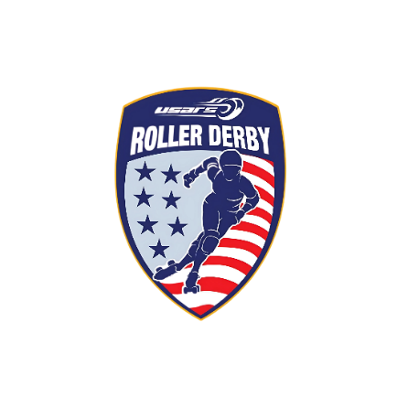
USARS Junior Charter
Skills assessment
Under 18 years of age

"The USARS skills guidelines serve as a vital resource for leagues and coaching staff, empowering them to effectively evaluate athletes' core skating skills, game-critical movements, and tactical intelligence. These guidelines ensure consistent standards while fostering growth, performance, and strategic excellence within the sport."
All USARS chartered league and its members that enter any USARS sanctioned events must meet minimal skills requirement. Each Charter is responsible for determining skaters’ experience, skill level, and frequency of re-assessment.
New skaters: Basic Skills
- Fundamental skating skills:
  - Posture: Low, stable stance with bent knees and hips back
  - Stride: strong, steady, controlled strides.
  - Balance: maintaining stability while skating and maneuvering.
  - Stopping: Demonstrate the ability to stop, using proper form and without losing balance.
  - Crossovers and turns: perform smooth crossovers, efficiently changing direction while maintaining speed.
  - Endurance: Working to build stamina for games and advance skating performance.
Intermediate skaters: open to scrimmage
- Fundamental skating skills:
  - Posture: Low, stable stance with bent knees and hips back
  - Stride: Strong, steady, controlled strides.
  - Balance: Maintaining stability while skating and maneuvering.
  - Stopping: Demonstrate the ability to stop, using proper form and without losing balance.
  - Crossovers and turns: Perform smooth crossovers, efficiently changing direction while maintaining speed.

- Physical Endurance and Strength:
  - Endurance: Working to build stamina for games and advance skating performance. Skates at least 27 laps around regulation track within five minutes
  - Strength: focus on strength training exercises that target glutes, adductors, and abductors for improving lower body strength, stability, and overall athletic performance.
  - Recovery Tactics: Learning how to recover quickly from a fall and maintain your position on the track.
- Game - Specific skills:
- Jammer/Pivot (Active Scorer) Skills:
  - Knowledge: Ability to navigate blockers and score points.
  - Pivot skills: Understanding both jammer vs pivot roles.
  - Speed and agility: Quick acceleration and maneuvering through traffic.
- Blocker skills:
    - Positioning: Maintaining a strong position to block opponents.
    - Blocking Techniques: Using body positioning and skating skills to stop jammers.
    - Teamwork: Communicating with and supporting teammates.

Advanced skaters: Competitive game play

- Advanced footwork:
  - One-Foot Glides: Long gliding strides on one foot with good balance.
  - Jumps: Ability to jump and land safely.
  - Weaving: Ability to weave through a pack of skaters forward and backwards with constant speed.
- Physical Endurance and Strength:
  - Endurance: Able to maintain stamina for long games and intense skating.
  - Strength: Ability to maintain form when making contact or embracing contact.
  - Recovery Tactics: Capable recovering quickly from falls and maintaining your position on the track.
- Game-Specific Skills:
  - Jammer/Pivot Skills:
    - Knowledge: Ability to navigate blockers and score points.
    - Pivot Skills: Understanding both Jammer and Pivot roles.
    - Speed and Agility: Quick acceleration and maneuvering through traffic.

- Blocker Skills:
  - Positioning: Maintaining a strong position to block opponents.
  - Blocking Techniques: Using body positioning and skating skills to stop jammers.
- Communication: Learn to communicate effectively with teammates on track.

- Strategic Awareness:
  - Track Awareness: Understanding track positioning and traffic flow.
  - Game Situations: Recognizing and reacting to different game situations.
  - Rules of Gameplay: Understand the rules of roller derby and how to play within them.

Design Assessment Drills and Scenarios:
- Posture and Stride:
  - Drill: Have skaters skate at an easy pace, then lower into a low skating form and stride for a set time, followed by an upright stance.
- Stopping and Maneuvering:
  - Drill: Have skaters practice T-stops, plows, and stopping techniques at varying speeds.
  - Scenario: Set up cones or markers for skaters to practice weaving and changing direction.
- Jammer Skills:
  - Drill: Have skaters practice passing drills with a stationary blocker, then progress to dynamic scenarios with multiple blockers.
  - Scenario: Set up a “jammer lane” with multiple blockers and have skaters practice passing and scoring.
- Blocker Skills:
  - Drill: Have skaters practice blocking techniques against a stationary jammer, then progress to dynamic scenarios with multiple jammers.
  - Scenario: Set up a “blocking zone” and have skaters practice blocking and defending.
- Strategic Awareness:
  - Scenario: Present skaters with different game situations and have them explain their strategies.

