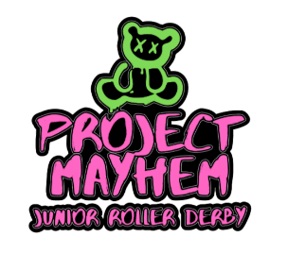

ARIZONA SKATE CLUB INC

"
Name: ______________________________________________________ Age: ________ Date of Birth: _____________

Parent's Name(s) (if under 18): _______________________________________________________________________

Address: _________________________________________________________________________________________

Phone (H) _________________________ Phone(C) _______________________ Text Y/N

Email: ___________________________________________________________________________________________

Condition of Health: Excellent Good Fair Poor. Allergies: _________________________

Any known medical conditions you would like to make us aware of: ________________________________________________________________________________________________________________________________________________________________________________________________________________________

SKATER ENROLLMENT AGREEMENT

- I understand that under the terms of this agreement, the AZ SKATE CLUB shall provide me training and Instruction any required safety gear is the responsibility of myself or my parent/guardian

- It is understood that my failure to attend weekly practices will not relieve me of my obligations to pay the monthly tuition herein agreed upon.

    - I agree that all exercises and workouts shall be undertaken by me at my own risk, and I will not hold AZ SKATE CLUB responsible for any injuries that may result. I understand the AZ SKATE CLUB coaches and trainers are not licensed medical practitioners but are able to and will perform Basic First Aid and CPR if necessary.

    - For Consideration herein acknowledged as received, and by signing this release I hereby give the AZ SKATE CLUB my permission to license the Content (Pictures)and to use the Content in any Media for any purpose (except slanderous or defamatory) which may include, advertising, promotion, marketing and packaging for any product or service. I agree that the Content may be combined with other images, text, graphics, film, audio, audiovisual works, and may be cropped, altered, or modified.

Skater Signature: _____________________________________________________________________ Date: _____________

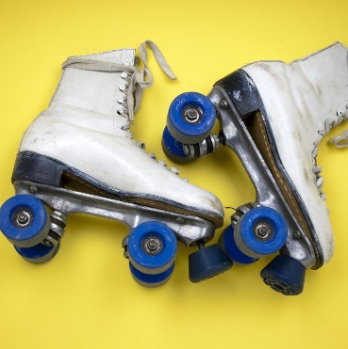
Parent/Guardian Signature (if under 18): ________________________________ Printed: _______________________________
MONTHLY DUES:
$ 35 per student per month ($25 -Junior League)
FEES ARE DUE AT THE BEGINNING OF EACH MONTH
*ZELLE * PAYPAL*VENMO*CASH
START DATE: _____/_____/_____

