To be completed when MAD of 10 feet is not practical to complete the work

Date:_______________ Crew__________________ Foreman_________________________________________________
Location: ____________________________________________________________________________________________
Qualified Incidental Line Clearance Arborist on Site _____________________________________________________
Secondary Qualified Person if Applicable________________________________________________________________
Designated Spotter___________________________________________________________________________________
Does it make sense to call the power company to ground the hazard?______________________________________
(You can find which power company by looking at the pole or finding the nearest meter on a building.)
County Gas & Electric (521) 989-6247 or (800) 873-3374 California Power (800) 888-2726 or (800) 245-2345
City Utilities (215) 999-2000 Good Enough Power (310) 555-1234 Government Power & Light (306) 947-1111

Type of Electrical Hazard (Communication, Service Drop, Primary Wire, etc.) ____________________________ _
Voltage of Line(s)_____________________________________________________________________________________
Minimum Approach Distance According to Table Below__________________________________________________
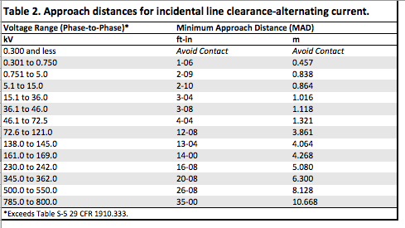
Remember, if you are working within 10 feet of an electrical hazard you must use CLEAN, UNDAMAGED, DRY, NON-CONDUCTIVE tools. Which non-conductive tools will be used to perform work?
- Dielectric Polesaw
- Fiberglass Pruning Pole
Potential Hazards to discuss Remember to never turn your back to an electrical hazard if
- Backfeed you are within 10 feet. Take your time and be extra cautious!
- Bad Weather If climbing, be sure that your climbing line will pull you
- Step-potential away during a swing.

Other Crew Members Present:
____________________________________________ ________________________________________
____________________________________________ ________________________________________
____________________________________________ ________________________________________

