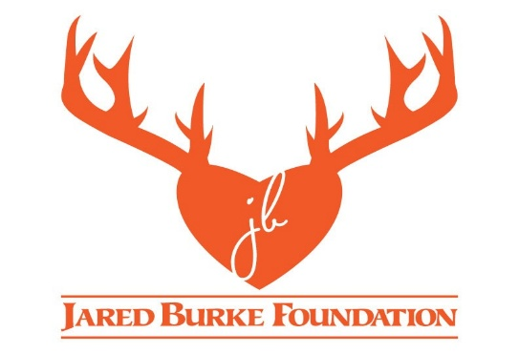

The past year has been a tapestry woven with threads of joy and sorrow for JBF - a journey marked by moments of celebration and times of quiet reflection. The individuals who have experienced the many healing events make up the heart of JBF and why the foundation exists.
Here is a look back at what has been happening:

September 2024 – Swamp Masters Air Boat Service – Louisiana Alligator Hunt - Preston Rowe
Preston Rowe is an amazing young man who has some special needs, but he doesn’t let that stop him from staying busy attending school, working at Wal-Mart, and owning his own lawn care business. Preston went to the swamps of Louisiana and was able take 3 gators measured at 9’5”, 9’11”, and 7’6”!!

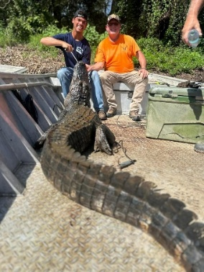

September 2024 – Shoot for the Vets – Winchester’s Nilo Farms
The Jared Burke Foundation had the Title Sponsorship for the “Shoot for the Vets” outing at Winchester’s Nilo Farms Shooting Complex in Brighton, Illinois.
Chris Burke smoked several pork butts to compliment Carlyle IGA’s catering.
This is our 6th year providing the food for over 150 veterans as they roll out onto this awesome complex to shoot some clays and come together for some camaraderie. Mark Johnson with the St. Louis Chapter of Safari Club International and their crew put this event on every year, and JBF was the “Title Sponsor” this year.
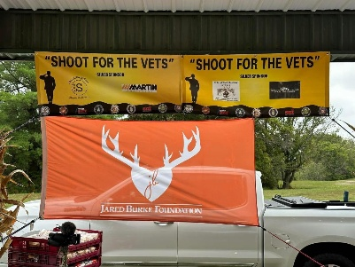

September 2024 – 13th Annual Aaron Hurst Youth Waterfowl Education Day
The 13th Annual Aaron Hurst Waterfowl and Conservation Education Day was a raging success! Jared Burke Foundation has been a major sponsor of this event for the past several years and it is an awesome event!
Bob and Chris Hurst lost their son Aaron in an ATV accident in 2012 and created the Aaron Hurst Foundation. Aaron was an avid outdoorsman and waterfowl hunter much like Jared, so naturally, you can see the connection the Burke and Hurst families share - a connection based on the foundation of sorrow that, over the years, has blossomed into two wonderful foundations doing great things for our youth! We share the passion to create a legacy of education and fun for our young conservationists in honor and memory of Jared and Aaron.

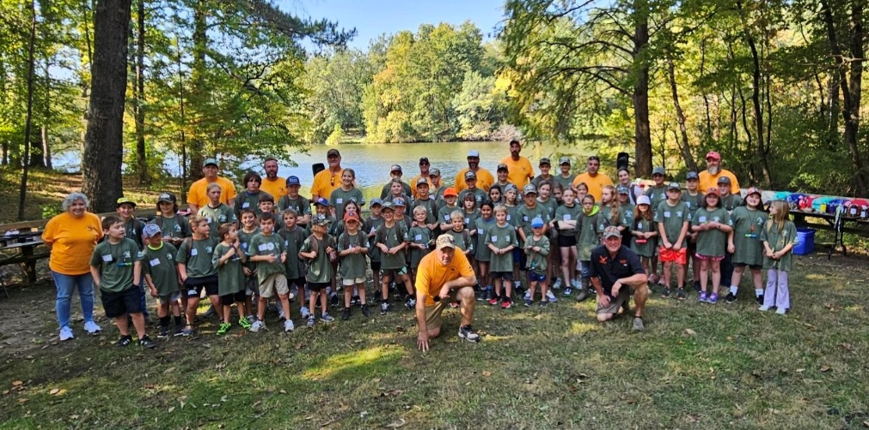

October 2024 – Youth Shotgun Deer Season
Sophia and Peyton Kessel were joined by their mother, Brandi, on our youth deer hunt this past year at Lakeside Lodge near Iuka, IL. They had an awesome time fishing in the lake and eating some great food prepared by Don and Kori Voss. These two girls did a fantastic job, each of them harvesting an impressive buck. Youth season is a great time to get the kids out that may not normally get to hunt.

October 2024 and May 2025 – Bennett Springs, Missouri
The fly fishing outings for veterans at Bennett Springs offer our veterans an opportunity to find a calming and peaceful pastime. There is something about being in a stream casting a fly for some nice trout that calms the mind and soul!
Special thanks to Joe Rensing and Gerald Vahlkamp for getting this event together for us a few times per year and to Ken Pierson who works hard to get the veterans together for the outings through John Schmeink at Jefferson Barracks VA.
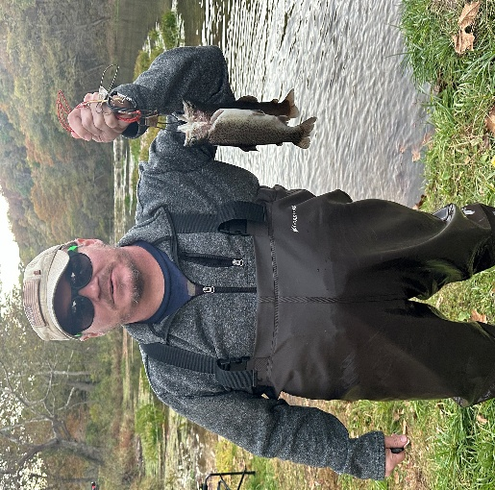

October 2024 – Specimen Creek Outfitters – Montana Elk/Mule Deet Hunt – Joe Santel
Jared Burke Foundation is blessed to be a part of our hero’s lives - Our heroes that put it all out there for our freedom! This year’s Elk/Mule Deer hunt at our “Happy Place” was one to remember with Marine Corps Veteran, Joe Santel, and his good friend, Colin Kuhn.
Lloyd Johnson from The North Fork guided these guys, navigating through the mountains of Montana in search of some nice elk and mule deer. Our good friend Lloyd can always find the good animals in his own “backyard” - the Gallatin National Forest (over 950,000 acres). Joe started off with a nice mule deer up off Bear Creek and followed up with his elk out on Eagle Creek drainage. Everyone got to witness his shots and assist in dragging those beautiful animals out of the field.
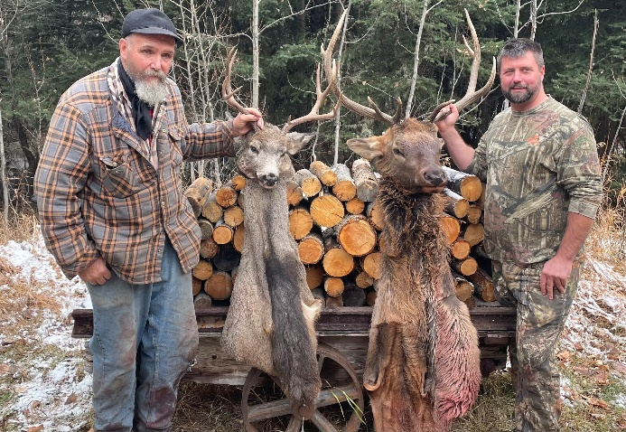

December 2024 – Aaron Hurst Veteran Duck Hunt – Mud Lake Waterfowl Club – Vandalia, IL
The Aaron Hurst Memorial Veteran Duck Hunt at Mud Lake Hunting Club with Bob Hurst and the Aaron Hurst Foundation is a highlight each year. It was slow going but just being out with these guys and 30 plus other veterans makes for one heck of a good time! God bless all the veterans, and a special thanks to Bob Brinker and Tim Berry for giving these veterans a day in the field!

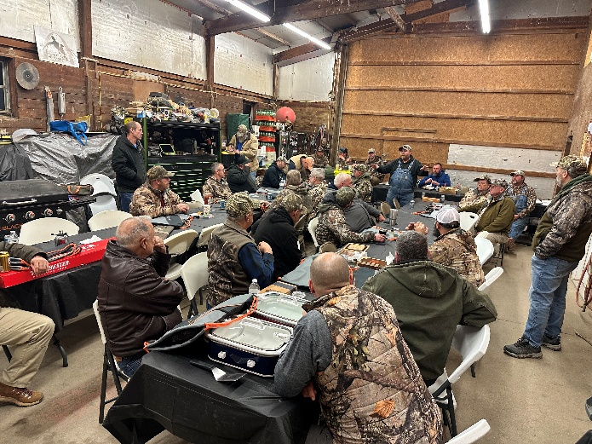

January 2025 –Whitetail Hunt – Illinois Dominant Bucks– Grant Beckemeyer & Dameyn Rakers
Folks, we came out of the gate rolling this year with a great deer hunt at Illinois Dominant Bucks!
Grant Beckemeyer and Dameyn Rakers took to the woods to hopefully get on some good bucks.
Grant started it off with a unique and awesome 14-point buck on day one. Dameyn hunted hard the first day, seeing some decent bucks, but they never presented a shot for this great young man! Dameyn made it count on day two and put a good shot on his warrior buck! Both young men were able to share the experience with the family members accompanying them!!

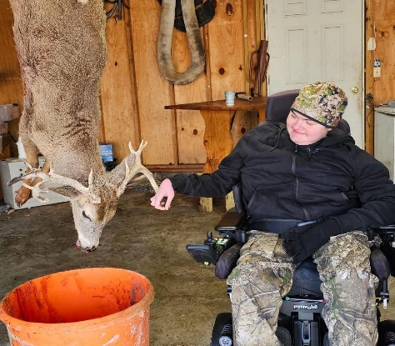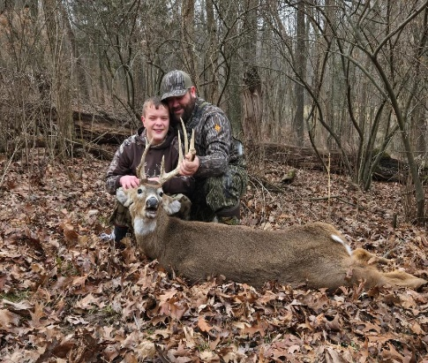

January 2025 – Dalton Newkirk Family Donation
John Burke and Laura Beckmann joined the Dalton Newkirk family to officially accept a check from the First Annual Copper Classic golf outing. The golf outing was a day of reflection, memories, sharing and giving. Just as JFB was founded on a tragic loss, so was the Copper Classic golf outing. We want to extend our heartfelt thanks to the Newkirk family and friends for their donation in memory of Dalton to help JBF to continue our mission.

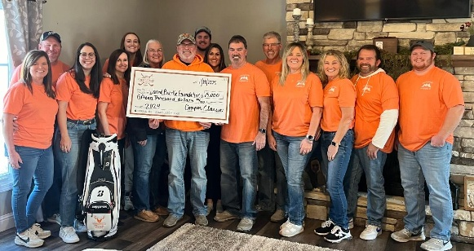

March 2025 – PTSD Course for Veterans – Breese, Illinois
The Jared Burke Foundation believes our veterans are the foundation of all our freedoms! “Serving those who served” is one cornerstone of our very existence. The course navigates through the reality of PTSD & Moral Injury and helps veterans to start their healing journey with important information, support, compassion and understanding.

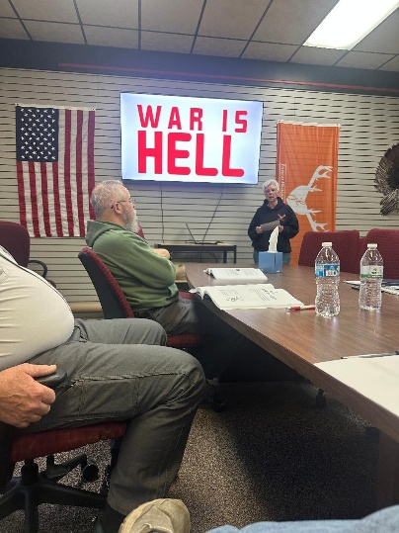

March 2025 – Youth Turkey Hunt – Marion County, Illinois
We kicked off the Illinois Turkey season with three youth hunters. Olivia Wiegmann, Delaney Wiegmann and Brody Brinkmann hit the woods of Marion County. We went 2 for 3 with Brody Brinkmann taking a nice bird on Don and Kori Voss’ property.
Olivia Wiegmann harvested a good bird with an unofficial NWTF rough score 78.22 “limbhanger”! Congratulations young lady on a dandy bird! Mark Kreke guided the hunt for this record bird on his property for a great start to the JBF Turkey Season!
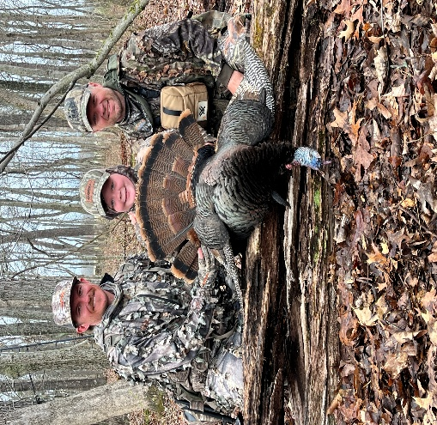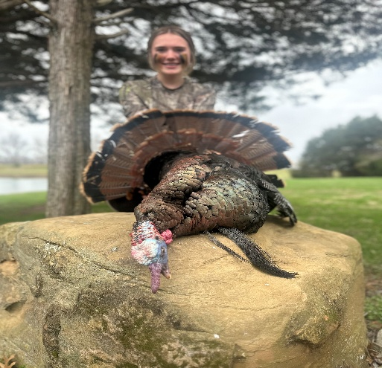

March 2025 - Veteran Fishing - Johnny McLaughlin – Carlyle Lake, Illinois
The Jared Burke Foundation had the pleasure of spending the day chasing catfish with 95-year-old army veteran, Johnny McLaughlin, yesterday on Carlyle Lake. The biggest channel cat caught by Johnny tipped the scales at 12lbs! Joan from Highland Cedarhurst nominated Johnny for the outing. Thank you, Cedarhurst for nominating this amazing veteran and for donating to JBF. Johnny’s son, Bruce, was able to join us on the outing. Also, a big thank you to Captain Jake Nalley at Precision Fishing Guide Service for taking us out and donating the trip.

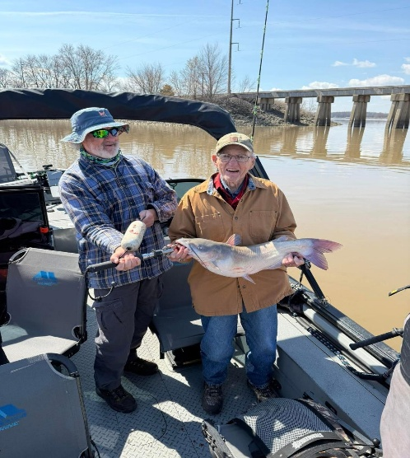

April 2025 – Discussion Group for Families of Veterans that suffer from PTSD and Moral Injury
This group has provided valuable insights and strategies to help a spouse/significant other understand what a loved one who is suffering from PTSD or Moral Injury is going through, and to help them help the rest of the family to understand.

April 2025 – Veteran Turkey Hunt – Mud Lake LLC
Mud Lake once again hosted a Veteran Turkey Hunt for veterans Gerald Barton and Anthony Sanders. It is always a great time to go out with these guys at Mud Lake! We ended up getting skunked due to the wild rains and rising river. We had to abandon one of the blinds because it was underwater after heavy rain north of Vandalia, but that didn’t deter these gents from having fun. What an impressive experience these warriors had with us and our friends at Mud Lake! I want to offer a resounding thank you to John Cripe who went above and beyond making some excellent food and providing support during the hunt. God bless all the folks from Mud Lake that make this an awesome experience.
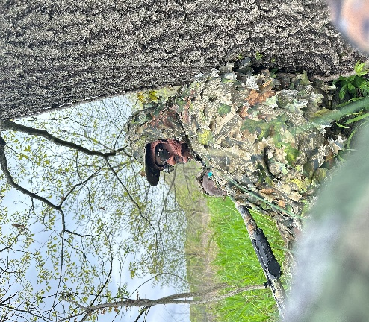

April 2024 –First Responder Turkey Hunt –Torstenson Conservation Center –Pecatonica, IL
What a great first hunt with our friends from Illinois Conservation Foundation!! Their awesome Torstenson Conservation Center and Lodge was the setting for our First Responder Turkey Hunt. We had Nathan Lakenburges and Brandon Price out on this hunt. Nathan is a firefighter for Germantown Fire Department and Brandon works as an EMT for several departments throughout the area. Nathan led off with a nice bird while hunting with Scott Rakers. Brandon was hunting with John Burke and took a nice bird a few days later.

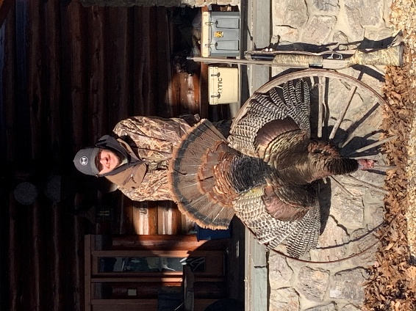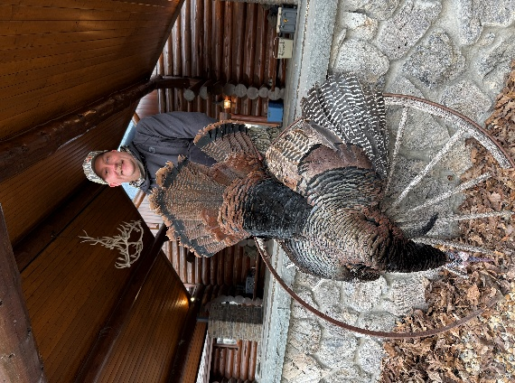

April 2024 – Mark and Jenna Laurnidsen – Veteran Turkey Hunt – Bainbridge Property, MO
A wonderful veteran couple, Mark and Jenna Lauridsen, headed down to the Bainbridge Property north of Cape Girardeau, Missouri to hunt turkey. Allen and Laura Beckmann accompanied them for JBF.
Although the birds weren't the most cooperative, they still got to see a few, and Jenna got to take a shot but didn’t connect. Thanks to Tim Buchheit for the use of the property and John Jordan and Allen Beckmann for the guide and calling service. And speaking of service, I would like to take this opportunity to thank both Mark and Jenna for their service to the great United States of America.

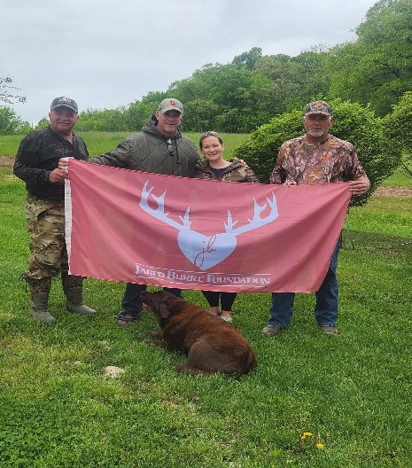

May 2025 – Josh Schniers – Turkey Hunt – Marion County, Illinois
Well, folks, we rounded off the 2024 Turkey Season with Army Veteran Josh Schniers! Josh took his bird on Dave Mahlandt’s property in Marion County. Dave Mahlandt and John Burke were along for all the action. The birds didn’t cooperate early – those turkeys made us wait until almost noon before this one presented himself for the shot. Special thanks to Dave Mahlandt, who is always willing to get JBF out with one of our heroes. God bless our veterans for their commitment to our freedoms!

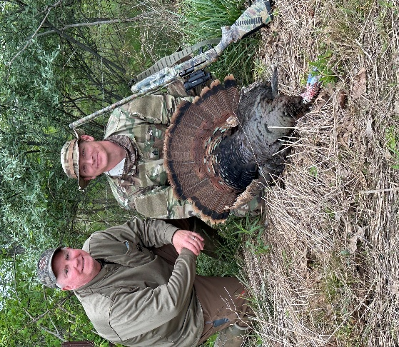

April 2025 - Dwayne and Chase Edgar – Turkey Hunt – Craig Roman Property – Missouri
Air Force Veteran, Dwayne Edgar, and his grandson, Chase, hit the woods on the Craig Roman property just across the Mighty Mississippi from Chester, Illinois. They were accompanied by BJ Robert and gave it a good try, but to no avail. The turkeys had other plans, but the guys had a great time none the less. This was a special hunt as Dwayne was able to hunt with his grandson and share some lifetime memories.

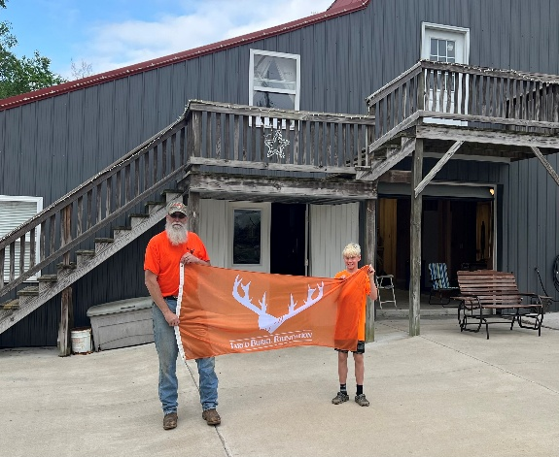

May 2025 – Veterans Dale Richter and Rocky Ratermann – Catfishing – Kentucky Lake
Scott Rakers and Rich Litteken accompanied Dale Richter and Ron “Rocky” Ratermann to Kentucky Lake for a day of catfishing. Jason Alexander provided the boat and knowledge of the lake to allow them to catch some nice fish.
Rich is a Vietnam Veteran who loves to fish and was more than happy to accompany his fellow veterans on this trip.

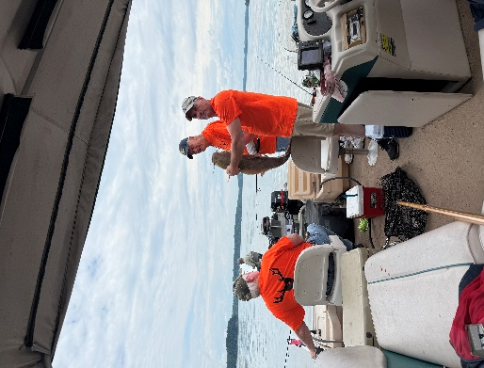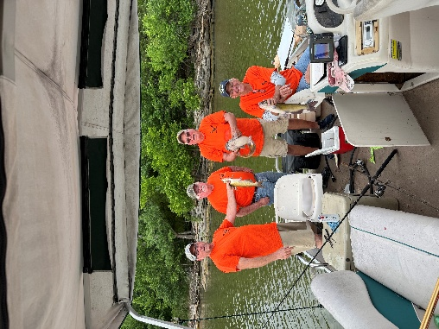

June 2025 – Oak Creek Whitetails – Veteran Ram Hunt – Bland, Missouri
During the week of June 16-19, 2025, Jared Burke Foundation members Mark & Hunter O’Laughlin and Ken Pierson took three US Veterans on an outdoor adventure to Oak Creek Whitetail Ranch in Bland, MO. Each hunter was successful in harvesting an exotic ram. The hunters were Gerald Barton, US Army, Don Davenport, US Navy, and James Poggi, US Marine Corps. JBF would like to thank Don Hill and Jesse Fisher of Oak Creek for providing such an awesome place to stay and enjoy making new friends and outdoor memories. Heroes helping Heroes by Serving those who Served!
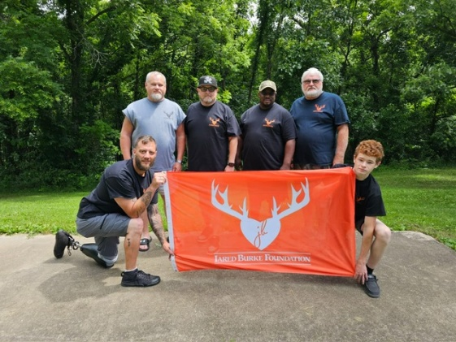

June 2025 – Specimen Creek Outfitters – Veterans Trip – Jardine, Montana
We took 5 veterans, 3 of them Vietnam vets, out to Montana - Bernie Goebel, Jerry Hoffman, Gervase Hemker were joined by Dusty Sampson and Michael Linsky! The guys took the time to reflect on their service and those they lost when they served. We had a ceremony at the “Healing Wall”, where they laid their stones with all those from the past. It is a very healing moment as they salute the memory of those they lost! To say we had fun would be an understatement, my friends. The laughter was over the top as these gentlemen offered up their own unique stories of the good times in service! Mark Kreke joined John Burke on the trip as we worked with our mountain friend, Lloyd Johnson, to provide these heroes with an awesome experience. All this fun while healing in nature is second to none. We had a day trip into Yellowstone and saw some awesome sites at Old Faithful, the Lower Falls and Upper Falls. Rowdy and Kristen Yates opened the doors to Shooting Star Ranch for an ATV ride through the mountains that offers some majestic views. We topped it off with a visit to the OTO Ranch showcasing the history of this area. God bless our heroes dealing with the demons of the past! It is because of your generosity that we can provide these healing trips!
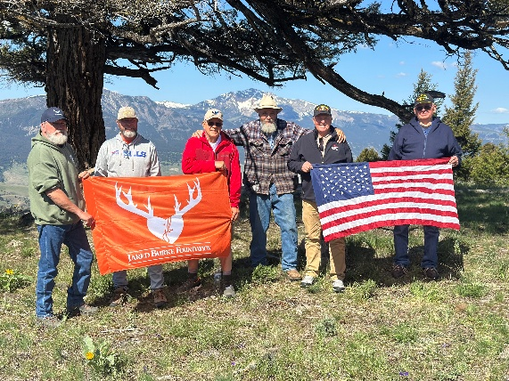

June 2025 - Specimen Creek Outfitters – Women Veterans Trip – Jardine, Montana
June is the time of year to enjoy the mountains of Montana. It is even more special when you get to share the beauty and solemn majesty with a group of female Veteran and First Responders! Deb Bullen (Retired Air Force) joined Melinda Buhl (veteran), Connie Hoffman (St. Louis Police Officer) and Robin Goebel on the trip. To witness the healing properties of the mountains, one can merely watch them as they take in the serenity of nature. This is healing in its most perfect sense! The ladies enjoyed a day in Yellowstone, took hikes, visited the OTO Ranch, settled in at dusk for some campfires and dispatched their thoughts through a small ceremony at the “Healing Wall”! This was a great trip for all of us and to be a part of something bigger is second to none! Special thanks go out to Lloyd Johnson, Rowdy and Kristen Yates (ATV Ride), and to all our sponsors and donors who make these trips possible! Thank you, ladies, for your sacrifices through your service to this country and communities!

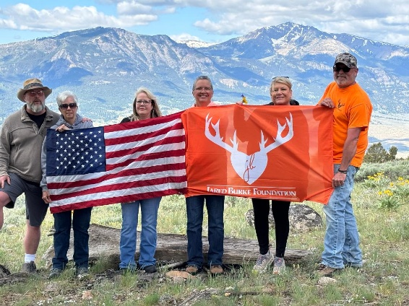

July 2025 – Huey Helicopter Dedication – Missouri’s National Veterans’ Memorial
Thank you, Vietnam Veterans
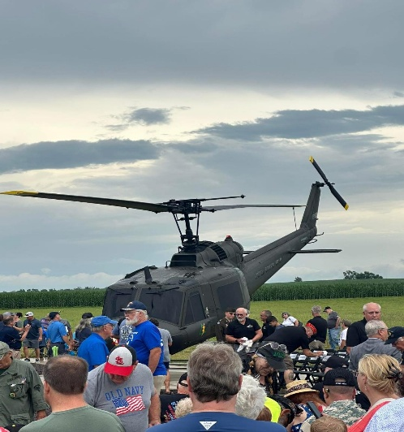

July 2025 – Greg Raterman Memorial Fishing Derby
The rain came early the day of the event, but it didn’t dampen the great turn out for the 6th Annual Greg Ratermann Fishing Derby. This event keeps getting bigger each year with 97 registered youth anglers this year. 76 kiddos showed up to fish and had a great morning at Whispering Pines. Thanks to all the great sponsors and volunteers, they made this an incredible day for all the participants!
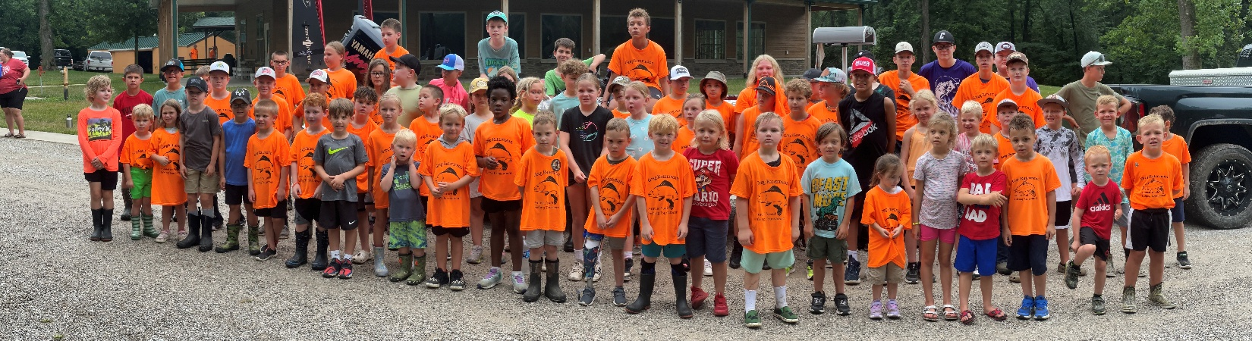

July 2025 – Josh Toennies Annual Memorial Golf Scramble – Okawville, IL

August 2025 – Luke and Tessa Beckmann – Crappie & Lake Trout Fishing Trip – Lake Michigan
Luke and Tessa Beckmann joined Scott Rakers of JBF on a crappie fishing trip to Shobona and Heidecke Lakes. Their uncle, Brad Beckmann, and grandma, Trish Beckmann, tagged along to enjoy the trip with Jim “The Crappie Professor” Kopjo where they had two successful days of fishing. They also were able to visit a go-cart track and gaming place for kids. Luke and Tessa lost their father, Brian Beckmann, several years ago, and he is missed dearly.
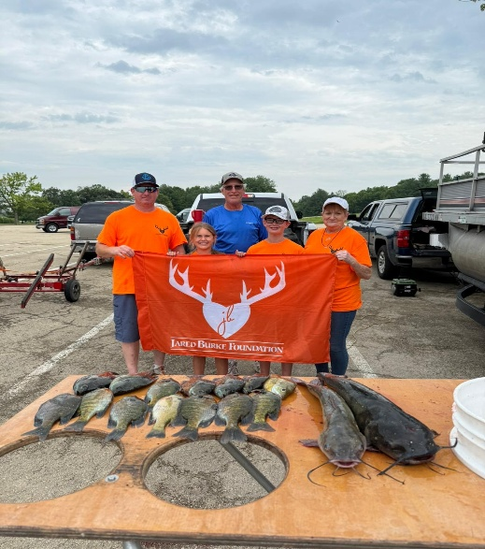

Fall 2025 Outdoor Adventures
Stay tuned to our JBF Facebook page for this Fall’s Outdoor Adventures, it promises to be exciting!!!!

Memorials
“Having started and managed the Jared Burke Foundation since 2014 is one of the most rewarding things I have ever done in my life”, stated John Burke. “Unfortunately doing the things we do inevitably ends up in us losing our friends that have been fighting an illness or disability. We will honor their memories forever and hold dear the time we spent with each of them.”
This past year we lost Vietnam Veteran Eugene “Slim” Trame, our Honorary Committee Member and sweetheart Macy Haar, and FDNY Firefighter LT Gregory “Mickey” Hansen. These kindred souls will remain in the thoughts and minds of all that loved them. May God wrap them in his loving arms and leave only good thoughts and memories in the minds of those they left behind!

JBF Organization
Officers of JBF are John Burke - president, Chris Burke - vice president, Shannon Kluemke - secretary, Brian Fuehne – treasurer. Committee members are Alex Burke, Nick Jondro, Randall Malone, Colby Haar, BJ Robert, Kenny Pierson, Laura Beckmann, Scott Rakers and Mark O’Laughlin.
“These are the folks that make this foundation run smoothly along with their spouses and families who volunteer,” John Burke said.
The JBF Committee invites everyone to view the smiling faces and see the awesome memories created this past year by visiting their Facebook Page, Jared Burke Foundation, or the group’s website www.thejaredburkefoundation.com.
“Once again, I cannot thank everyone enough for honoring my brother Jared’s memory through your donations and volunteer efforts. I am forever grateful!” – John Burke

Upcoming Board Meetings
September 15, 2025
October 20, 2025
November 17, 2025
December 15, 2025

