BUFFALO JR. JILLS CHEERLEADING PROGRAM WAIVER FORM
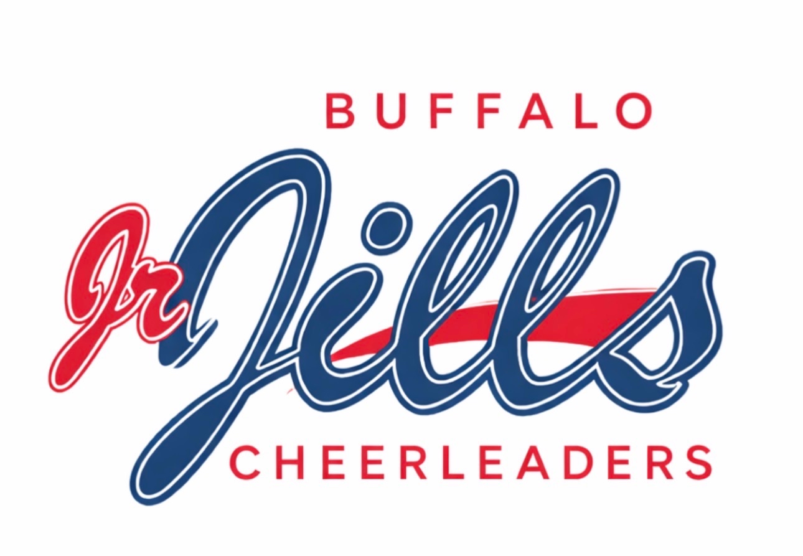
Participant & Contact Information
PROGRAM: Jr. Jills Cheerleading Program
PROGRAM DATES: 7/25/26, 7/26/26, 8/15/26, 8/16/26, 8/19/26, 8/23/26
PARTICIPANT’S NAME___________________________________________________________________
BIRTHDATE______________ GRADE__________
_______________________________________________________________________________________ ADDRESS STREET CITY STATE ZIP
PHONE # __________________________________ E-mail _____________________________________
#1 EMERGENCY CONTACT____________________________________________ RELATIONSHIP_________________________ CELL PHONE ____________________________________
#2 EMERGENCY CONTACT______________________________________________ RELATIONSHIP_________________________ CELL # ______________________________________

PLEASE ANSWER THE FOLLOWING QUESTIONS
1. LIST ANY MEDICATION WHICH PARTICIPANT IS CURRENTLY TAKING
___________________________________________________________________________________2. LIST ALLERGIES__________________________________________________________________
___________________________________________________________________________________
BUFFALO JR. JILLS CHEERLEADING PROGRAM WAIVER FORM
Insurance Provider Information
4. LIST NAME AND ADDRESS OF INSURANCE COMPANY THAT COVERS PARTICIPANT

INSURANCE PROVIDER____________________________________________________________ ADDRESS______________________________________________ PHONE #_________________ CITY___________________________________STATE______________ ZIP___________________
NAME OF SUBSCRIBER_________________________________ POLICY #___________________
________Please check if participant is not covered under any insurance policy. By signing below, I hereby acknowledge and agree that I am the responsible party for any and all medical bills associated with any injury or medical treatment my child may receive. All bills will be sent directly to the Parent/Legal Guardian listed on this waiver.
I ACKNOWLEDGE THAT MY CHILD HAS NO MEDICAL OR HEALTH RELATED PROBLEMS THAT WOULD PROHIBIT THEM FROM PARTICIPATING IN THIS CHEERLEADING PROGRAM.
______________________________________________________ Parent/Guardian Signature
____________________________________ Date
RELEASE/WAIVER FORM
TERMS AND CONDITIONS OF PARTICIPATION
MEDICAL AUTHORITY STATEMENT:
THIS IS A LEGAL LIABILITY DOCUMENT
I, the undersigned parent/guardian, do hereby grant permission for daughter/son/participant to attend cheerleading practices and events sponsored by and conducted by Buffalo Jills Alumni Association. In order for daughter/son/participant to receive the necessary medical treatment in the event of an injury or illness, I hereby authorize the Buffalo Jills Alumni Association Staff Members to obtain medical treatment for my daughter/son/participant for such injury or illness during any practice and/or event, and I hereby hold the Buffalo Jills Alumni Association, including but not limited to, Sports Performance Park or The Sahlen Stadium Buffalo Bisons organization and their representatives harmless in the exercise of the authority. I further acknowledge, understand and agree that in participating in this program there is a possibility of physical injury or illness and that my daughter/son/participant and I am assuming the risk of such injury or illness by her/his participation.
PARENT/LEGAL GUARDIAN______________________________________DATE_____________________
BUFFALO JR. JILLS CHEERLEADING PROGRAM WAIVER FORM
RELEASE/WAIVER FORM
TERMS AND CONDITIONS OF PARTICIPATION
WAIVER & RELEASE FORM:
THIS IS A LEGAL LIABILITY DOCUMENT
I, the undersigned parent/guardian, do hereby give permission for my daughter/son/participant to attend and to participate in cheerleading program practices and events sponsored by the Buffalo Jills Alumni Association. I hereby acknowledge that by attending and participating in cheerleading events that there is a possibility of physical injury or illness to my daughter/son/participant and I do hereby for myself and all others who might have a similar claim waive, release and forever discharge any and all rights and claims for damages, which may arise now or in the future against the Buffalo Jills Alumni Association, including but not limited to, its owners, operators, officers, agents, or representatives, for any and all damages which my daughter/son/participant may sustain or suffer while attending and participating in the program and events.
It is expressly understood that I agree to reimburse, indemnify and hold harmless Buffalo Jills Alumni Association, for any claim, interest or subrogation by any person, company, corporation, or association that may arise regarding this event or waiver. It is also understood that I will be responsible to Buffalo Jills Alumni Association for counsel fees and costs related thereto.
PARENT/LEGAL GUARDIAN______________________________________DATE________________
APPEARANCE AGREEMENT
THIS IS A LEGAL LIABILITY DOCUMENT
I understand Buffalo Jills Alumni Association produces promotional and publicity material about its programs. I understand that as a Participant I may be included in videotaping, photographs and digital film taken during the event. I hereby freely and irrevocably grant Buffalo Jills Alumni Association and Buffalo Bisons Organization, its successors, assignees, licensees, sponsors, television networks, and all other exhibitors, the exclusive right to copy, exhibit, use, take, distribute and/or publish Participant’s name, face, likeness, voice, and appearance as part of its advertising, promotions and publicity including but not limited to art, print, web, social media, film, telecast and any other lawful purpose without reservation or limitation. In granting this license, I understand Buffalo Jills Alumni Association is under no obligation to exercise any of its rights, licenses, and privileges herein granted by the Participant.
PARENT/LEGAL GUARDIAN______________________________________DATE_____________________
No one can be admitted to the program or events held by Buffalo Jills Alumni Association unless this form has been properly filled out and signed by a parent or legal guardian.

