Please note that the steps below may or may not apply to other eMR builds/ Districts.

Step 1. Select Patient Access List
Note. This may be called Rounds List for some users.

Step 2. Right-click on the grey banner and select Change Patient List
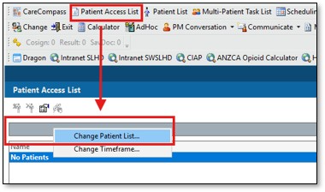

Step 3. Select the patient list you have set up and want to use
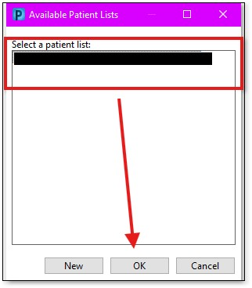

Step 4. Establish relationships with the patients you are reviewing
This window will appear immediately after you select a patient list.
Ensure the relationship type is set to “Assigned” and you tick the patients you want to establish a relationship with then select OK.
If you do not have an assigned relationship with a patient, you will not be able to see their data.
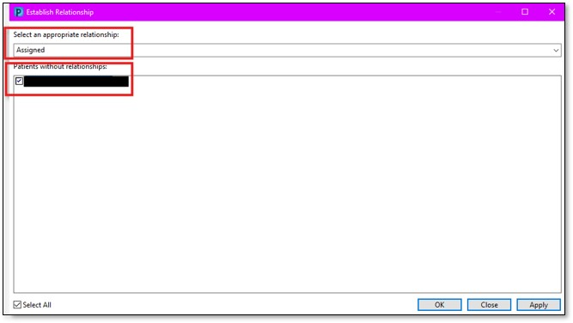

Step 5. Right-click on the column heading and Insert Column
This is done in the 4th column group on our eMR build.
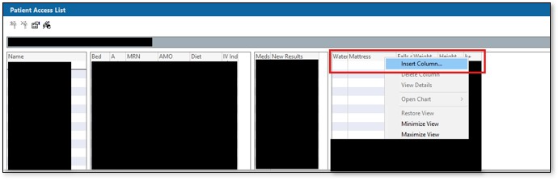

Step 6. Select the eGFR folder and then Select Next
Our eMR build has it under ALLOCFSETS > ALLRESLTSECT > ALLSERVSECTS > LABORATORY > Blood Chemistry > Estimated Glomerular Filtration Rate
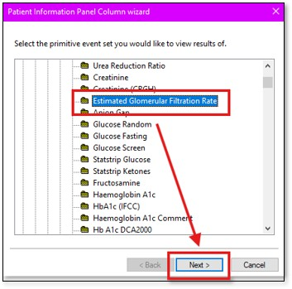

Step 7. Select the length of time to look back for results and then Select Next
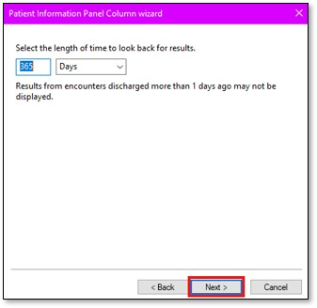

Step 8. Configure columns settings such as column width and column name and then Select Next
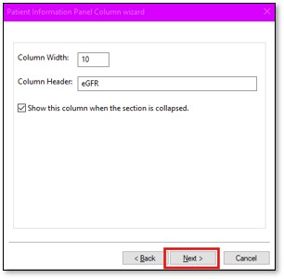

Step 9. Confirm column details and select Finish
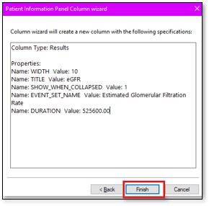

Step 10. You will now see the new eGFR column with eGFR results for your patients
You can sort the column in ascending or descending order by clicking the column heading
