Identification of Sides of a Structure and Floor Designation Procedure
Adopted: September 2018 Updated:

Purpose: The purpose of the SOG is to clearly identify the four primary sides of a structure and how floors are designated in multiple story buildings above and below grade. In Multijurisdictional and Unified Command incidents the IC will clarify with other agencies how the building sides and floors are defined to eliminate any confusion or potential problems.
Guideline: The structure will normally be divided into four basic sides as follows:

A / Alpha Side – The front of the structure, usually the side facing the street. In the event the front of the structure is not obvious the IC will determine and announce the location of the Alpha Side.

B / Bravo Side – The first side proceeding clockwise from the Alpha Side. Facing the structure from the Alpha Side, Bravo is to the left.

C / Charlie Side – The second side proceeding clockwise from the Alpha Side. Facing the structure from the Alpha Side, Charlie is the rear.

D / Delta Side – The third side proceeding clockwise from the Alpha Side. Facing the structure from the Alpha Side, Delta is to the right.
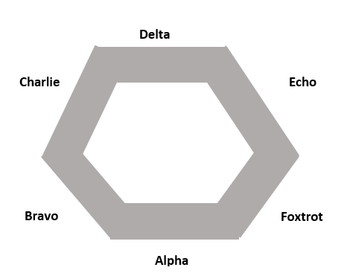
For buildings with an unusual configuration, side Alpha will be identified by the first arriving unit, utilizing a suitable landmark such as the parking lot, swimming pool, boiler room, etc. Additional sides will follow the clockwise rotation around the building
Charlie
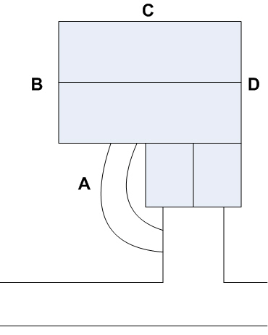
Bravo
Delta
Alpha
STREET

Guidelines | In multi-story occupancies, Divisions will be designated by floor number (Division 6 indicates the 6th floor). In some cases the floor division identification may be subdivided into geographic areas such as "Division 6 West" or "Division 2 North" depending on stairwell and floor access. When operating in levels below grade such as basements the use of Basement is appropriate.
 |  | Division 6 = 6th Floor
 |  | Division 5 = 5th Floor
 |  | Division 4 = 4th Floor
 |  | Division 3 = 3rd Floor
 |  | Division 2 = 2nd Floor
 | Ground Level | Division 1 = 1st Floor | Ground Level
 |  | Basement 1 = 1st Basement Level
 |  | Basement 2 = 2nd Basement Level
 | For Garden Level Apartments (or similar split grade floors), the Alpha Side will be considered Division 1 (i.e. 1st Floor).
ALPHA
Division 2 = 2nd Floor
Division 1 = 1st Floor
Basement 1 = 1st Basement Level
Ground Level
Ground Level

