Search Markings Guide
Adopted October 2019 Updated: March 2020

Purpose: Establish a consistent guideline for the use of search markings during Search Operations. Proper markings identify operational priorities, and assist with their overall assessment of the event.

Process: The Assessment marking procedures are designed to identify specific information pertinent to each affected building.

Orange peel and stick forms will be used to mark structures.

A permanent marker should be used to write additional information on the form itself.

Search Assessment Marking Guidelines:

Orange peel and stick forms will be used to mark structures. A permanent marker should be used to write additional information on the form itself using these guidelines. Form instructions are also printed on the back of the form – see sample below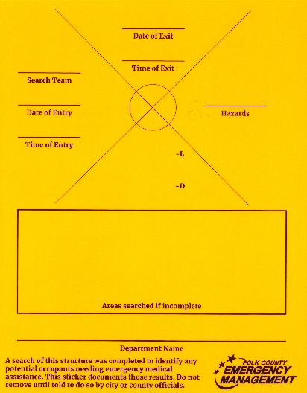 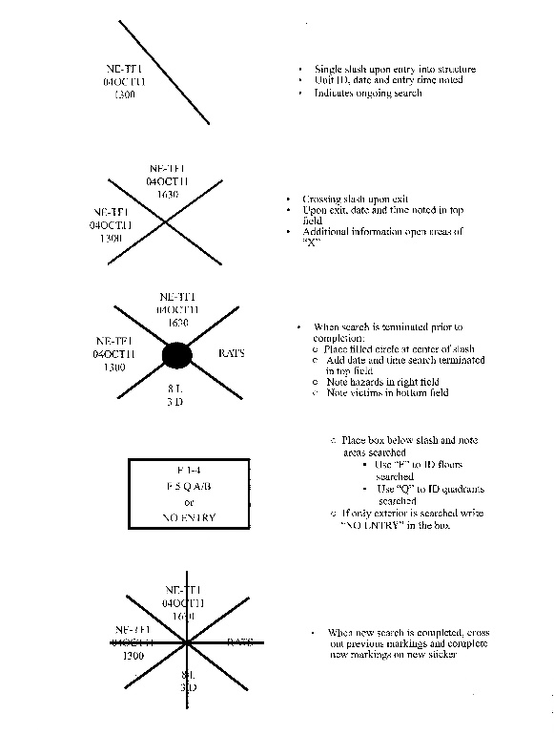
Process
Forms will be fixed on the address side of the structure. An X on the form will be constructed in two operations - one slash drawn upon entry into the structure (or room, hallway, etc.) and a second crossing slash drawn upon exit.
Entry
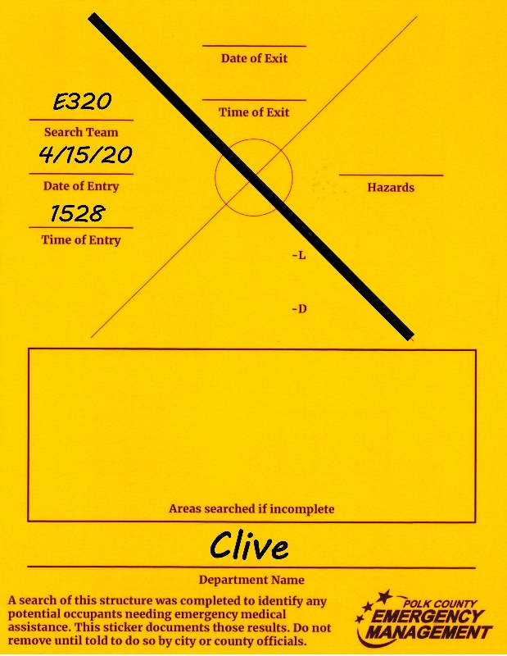
- Single slash upon entry into
structure
- Company ID, department
abbreviation, date and entry time
noted
- Indicates ongoing search
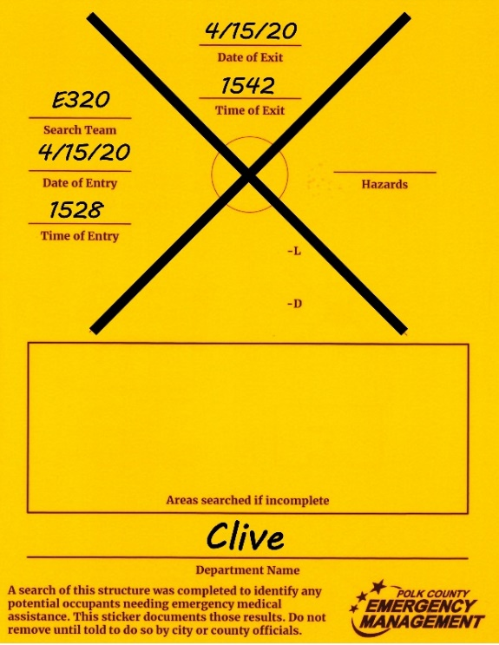
Exit
- Crossing slash upon exit
- Upon exit, date and time noted in top
field
- Additional information open areas of “X”

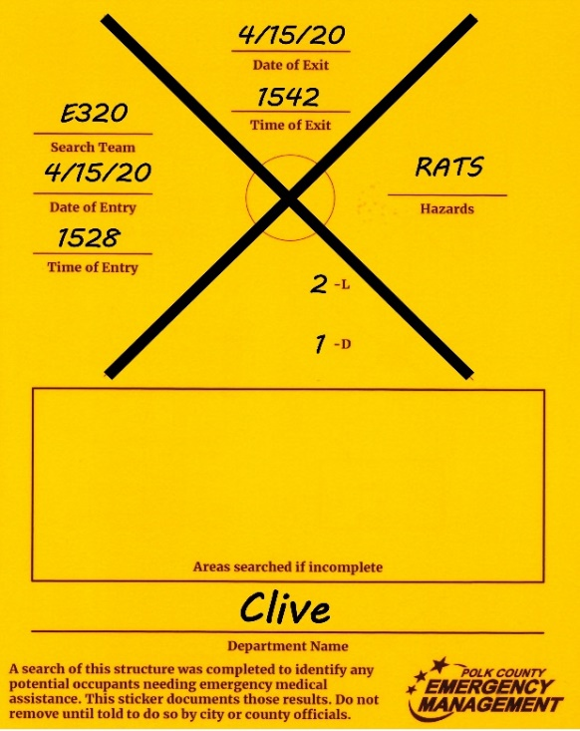
Findings/Hazards
- Right Field- Hazards
- Bottom Field- Number of Victims
needing rescue or recovery (that
you were unable to assist)
  - L for live victims needing rescued
(your search team was unable to
rescue them)
              - If no live victims needing rescue assistance, indicate
with a “0”.
- D for deceased victims needing
recovered from the building
              - If no deceased victims needing
recovered, indicate with a “0”
Note: This form represents the Search Operations and your findings. If you find live victims that you are able to rescue, the form should indicate “0 – L” because there is no-one needing Rescue Operations after your departure.
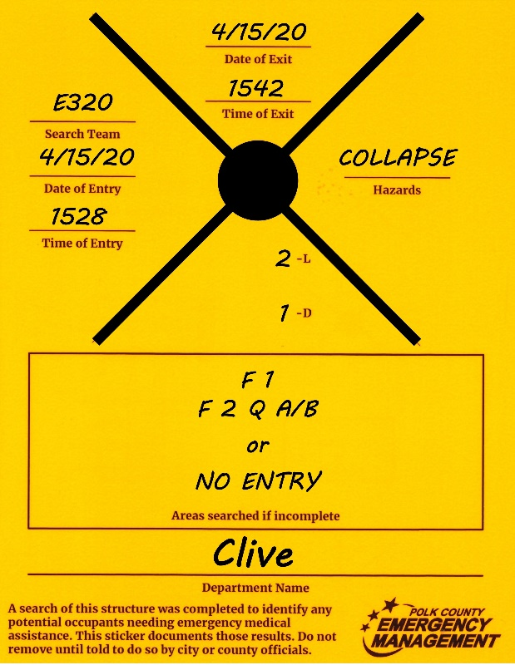
Terminated Prior to Completion
- When a search is terminated prior to
completion:
  - Place filled circle at center of slash
  - Add date and time search was terminated
at top
  - Note hazards in right field
  - Note areas searched in box at bottom
  - use “F” to identify floors searched
  - use “Q” to identify quadrants searched
if only exterior was searched, write “No
Entry” in box
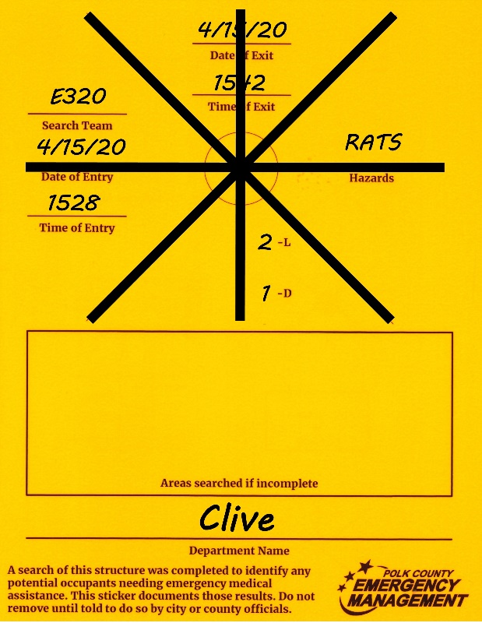
New Search
- When new search is completed, cross out
previous markings and complete new
markings on a new sticker
- Do not cover original sticker

