TIERED EMERGENCY ASSET MANAGEMENT SYSTEM

T.E.A.M.S.

GENERAL OPERATING PROCEDURES

Adopted: May 10, 2004
Revised: June 2019

TIERED EMERGENCY ASSETS MANAGEMENT SYSTEM
GENERAL OPERATING PROCEDURES

I. PURPOSE

The primary purpose of the Tiered Emergency Assets Management System (TEAMS) is to coordinate the effective and efficient provision of mutual aid during emergencies, natural disasters, or manmade catastrophes. TEAMS is not intended to relieve a community of their responsibilities of providing adequate emergency services for all local emergencies, since all communities should have their own first line of defense. When a community exhausts its resources, TEAMS can be activated by the affected community, and through a systematic plan, TEAMS will provide:

- Immediate assistance of personnel and equipment at the scene of an emergency or disaster

- Response teams of: Firefighters, EMS, Hazardous Materials, Technical Rescue (TRT), Divers, etc.

- Access to specialized equipment

- A contractual agreement covering responsibilities and liabilities for all its members

- Standardized policies and procedures for mutual aid responses

- Organization comprised of Fire Departments from Des Moines Metro.

- Standardize the minimum response for an assignment (Working Structural Fire) level as a minimum of 2 Engines, 1 Truck, 1 Ambulance and 1 Chief Officer. Departments can exceed this minimum but should not list less.

III. RESPONSIBILITY

It shall be the responsibility of all departments that are members of Polk County Fire Chief’s to follow the recommendations of this system to help ensure sufficient resources are deployed in a timely and effective manner to provide an Effective Response Force to mitigate hazards. It is also the responsibility of units responding to an incident to adhere to the policies and procedures of TEAMS as adopted by the Polk County Fire Chiefs.

IV. AUTHORITY

The Polk County Fire Chief’s Association shall have the authority and responsibility to ensure that all members adhere to the policies and procedures of the TEAMS agreement.

Variances to the TEAMS procedures are not generally recommended, but under certain circumstances, a individual department will find it necessary to make minimal modifications. The goal is to ensure an Effective Response Force (ERF) is dispatched to each type of assignment. Any modification must be consistent with the existing procedures. All modifications must be agreed upon by two-thirds majority of the Polk County Chief’s membership.

ALARM PROCEDURE

The following from the affected town must be obtained when the alarm is requested:

- The name of the requesting Fire Department

- The type of Alarm (i.e. Fire, EMS, Haz-Mat, Rural Water-etc.)
- The level of the Alarm requested

- The location of the incident, address and the name of the building (hospital-school-factory-etc.)

- Staging location

It shall be the responsibility of all responding Departments to individually, upon receipt of a
TEAMS, notify the TEAMS Dispatch Center (Polk County) that the Department has received the TEAMS
Alarm information and the equipment requested will or will not be sent. If unable to fill the request they must notify Dispatch immediately. All vehicles shall inform the TEAMS Dispatch Center over the designated operational channel (Fire East, Fire Central or Fire West):

- (Department Name-Type of Apparatus-Vehicle Number) to (Dispatching Town)

- Responding to the 2nd (Number of 2nd Alarm and Name of Stricken Town) (Address of the Emergency).

- EXAMPLE: "Ankeny 1131 to Polk County, we’re responding to Johnston’s 2nd Alarm, 6400 Merle Hay Road".

RESPONSE CARDS

UNIFORM RESPONSE CARD PROCEDURE

- Even though the other types of Response Cards have merit, the Polk County Fire Chiefs agree the standard use of a fixed format for Response Cards used in the TEAMS General Operating Procedures, with certain allowable modifications.

- The Polk County Fire Chiefs will make available a computer-based format to any Department or Division that wishes to use that option. This format will be provided in Microsoft Excel format.

- The area between Assignment and 2ND Alarm on the TEAMS Response Card may be used for additional responses that are not intended to activate the TEAMS system.

- All Response Cards must show an effective date or revised date in the Header.

- Departments placed on a card must be given the opportunity to approve/disapprove their assignment before the Response Card goes into effect.

- Response Cards sent out for comment/approval, and not intended for implementation, must be stamped DRAFT across the face of the 2nd Card.

DESIGNATED RESPONSE CARDS

As TEAMS modified itself, it became necessary to address specific emergency situations that warrant special equipment, therefore, designated Response Cards are used for: underwater rescue, medical emergencies, hazardous materials, special high-rise rescue, tankers, etc.

SAMPLE TEAMS MUTUAL AID RESPONSE CARD
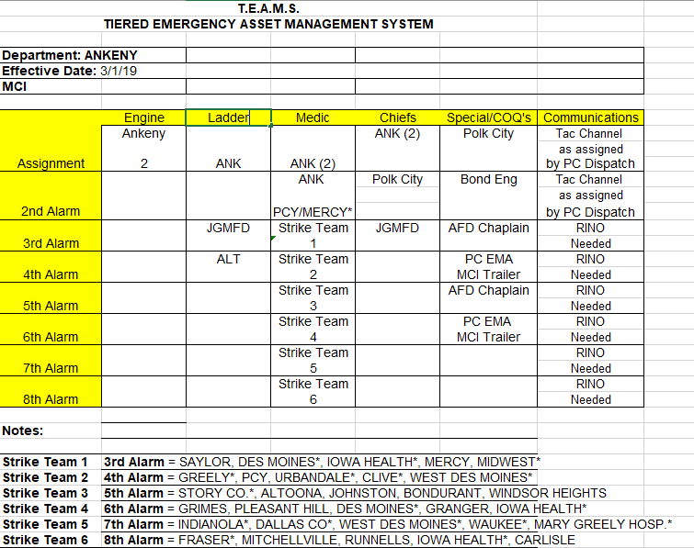

The above is a sample Response Card in use by the Ankeny Fire Department in which you will see the different towns, how they are marked and where they go on the TEAMS Alarm.

Special instructions for a specific town or piece of equipment would be done as follows:

Special/COQ box. List the special resources that should be requested/dispatched at each assignment or alarm level

ll special instructions must be marked on all Response Cards along with addresses of stations to be filled on change of quarters.

VII. INCIDENT COMMAND SYSTEM

In order to establish a standardized system of incident command, the Polk County Fire Chiefs has adopted the National Incident Management System (NIMS) as the standard operating procedure for all TEAMS members.

