Water Emergency Team

Adopted: January of 2020 Updated:

The Polk County Fire Chief’s Association has adopted a standardized procedure for Swift Water Rescues. The intent is to have each fire department respond in a like manner for the safety purposes of all personnel in the event of a mutual aid call. In order to ensure smooth incident operations, this procedure will identify minimum training requirements that water rescue capable department should meet. This procedure will also provide common terminology and common signals that will be utilized for a water rescue related incident.

Common Terminology & Hazards

River Orientation
Upstream/Downstream – Everything on the river is either upstream or downstream; not “north of here” or “south of there”.
River Right/River Left (as you are looking downstream) – Everything is on river right or river left; no “west bank” or “east shore”.
Hydraulic Effects
Helical Flow (Effects) – The circular, rolling flow of water near the banks which forces water midstream, caused by friction between water flow and bank composition.
Helical Flow (Features) – Spiral shape of flow, moves along the banks of both sides, carries objects out from bank towards laminar flow. When helical flow meets laminar flow, helical “dives down” and returns to shore along the river bottom
Laminar Flow – Layered flows of water which are slower on the bottom and faster towards the surface (the surface is slightly slower because of air resistance); faster layers are usually found midstream and outside of curves.
Eddy –The horizontal reversal of water flow where the pressure of the current along an obstacle (such as a rock) causes the water behind the obstacle to reverse and flow upstream.
Eddy Fence – An obvious line in the river where the current moves in the opposite direction at each side. It can range from a gentle surface line to a wall of water.
Downstream V - A hydraulic effect in the form of a V pointing downstream. It is caused by convergence of downstream water flow in the channel of least resistance. The largest series of V’s pointing downstream indicates the location of the main channel. The main channel may not be midstream.
Upstream V – A hydraulic effect in the form of V’s pointing upstream. It is caused by downstream water flow around an obstacle. Objects just below the surface that cause the V can be hazardous.
Haystack, Standing Wave – A rhythmic series of waves caused by large volumes of water flowing over a fixed object. The first wave is the largest, each successive wave is smaller and represents a dissipation of energy.
Hole, Stopper, Keeper – A vertical reversal of water flow where the pressure of the current falling over a gradient (dam) causes the channel water at the base of the gradient to be forced downward into a loop-style reversal and back to the surface. At this point, part of the water continues downstream and part reverses back upstream to the base of the gradient. This reverse tends to be hazardous because it can cause an object to be re-circulated (stopped or kept) in the hydraulically churning white water, which consists of 40% to 60% air.

Hazards of Swift Water

Loads
Top Load – Things that float on the surface or are lighter than water –positively buoyant.
Suspended Load – Heavy objects that can’t float but can move with the current. They are dangerous because they cannot be seen – neutrally buoyant.
Bottom Load – Objects which are on the bottom of the river because they are stuck in the mud or are too heavy to move with the current. They are very dangerous because they can cause foot entrapment –negatively buoyant.
Stationary Objects
Rocks – If a victim or rescuer in the water strikes a rock or other obstacle, there is a possibility for severe injury.
Bridge Abutments – These can be hazardous if a victim or rescuer should strike them.
Obstacles – Any other fixed object in the water that presents a danger to the victim or the rescuer.
Holes
Reversals – A vertical reversal of water flow where the pressure of the current falling over a gradient causes the water at the base to flow downward into a loop-style reversal and back to the surface, at which point part of the water continues downstream and part reverses back upstream to the base of the gradient. This is very hazardous to victim or rescuer in the water because they will tend to hold person in that hole.
Low Head Dam – VERY DANGEROUS! Built for irrigation, hydroelectric, flood control and sometimes to protect underground power lines that cross a river, “Reaction Wave”, “Face”, “Backwash”, “Boil”, and “Outwash”, are all terms which describe the action of the water. The Center Street and Scott Ave dams are local examples of such. Here is a picture of the body of the Center Street dam with no water flow. You can see its recessed, clam shell design and voids. There are also many potential snagging points as debris tends to gather at the base.
Escape Action
- Dive to the base of the dam;
- Cover face and head with one arm, extend the other arm to probe for obstructions;
- Forcefully kick away from the dam, staying as close to the river bed as possible.
Strainers – A strainer is a buildup of debris such as trees and logs which restrict the downstream flow. It is dangerous due to the undertow which may cause entrapment and drowning. Fallen and submerged trees are primary killers during floods.
Horizon – The person in the water must constantly watch the horizon line. If it appears to disappear downstream, it is certain there is a drop-off ahead. The person in the water must exit immediately.
Hypothermia – Hypothermia is considered to be a personal safety hazard, especially considering that most flood problems occur during the winter and spring months when ambient temperatures are low and water temperatures are even lower because of melting snow.
The following information is a general guideline to show how quickly hypothermia induced stability can occur for victims submerged in cold water:
Temperature Useful Work Unconscious
40 Degrees 7.5 Minutes 30 Minutes
50 Degrees 15 Minutes 60 Minutes
60 Degrees 30 Minutes 120 Minutes (2 hours)

Rescue Team

- Incident Commander
- Safety Officer
- Rescue Group Supervisor
- Primary Boat Operator
- Primary Rescuer
- Primary Backup
- Secondary Boat Operator
- Secondary Rescuer
- Secondary Backup

IC - In charge of the overall scene.
Rescue Group Supervisor (RGS) - In charge of the water rescue operation to observe, evaluate, communicate, and direct operations.
Safety Officer – In charge of ensuring overall incident safety practices for all emergency responders on scene. While the Safety Officer is responsible for ensuring safety of the incident, they are not expected to have subject matter expertise.
Primary Boat Operator (PBO) - Maintains and organizes equipment, possess good river reading skills and operates primary boat with direction from RSG.
Primary Rescuer (PR) - Responsible for victim contact and rescue. In addition, will attach rope to anchor and moveable control harness to static line.
Primary Backup (PBU) - Provides primary communication with RSG and safety outlet on shore for the team.
Secondary Boat Operator (SBO) - Maintains and organizes equipment, possess good river reading skills, and responsible for operation of backup boat or secondary boat in the two boat tether operation.
Secondary Rescuer (SR) - Backup to primary rescuer.
Secondary Backup (SBU) - Provides a safety outlet on shore and assists as needed.

Team Member Qualification

All fire department members who perform swift water rescue must receive initial training that provide orientation to swift water rescue equipment, with a focus given to competent use of all equipment.

Swim Test
It is recommended that all departments utilize the NFPA defined swim test. At a minimum, all fire department members considered to be certified to perform swift water rescue should pass the following minimum swimming standard on an annual basis:
- In under 10 minutes, firefighter shall swim 150 yards without stopping or grabbing the sides of the pool.
- After a 1-minute break from the swimming portion of the test, the firefighter shall tread water in a straight up and down position for five minutes without stopping or touching the sides of a pool.
To ensure the safety of all personnel performing the swim test, the test shall be administered in a pool that has adequate personnel to monitor all performing the test.

Training
Due to the dynamic and dangerous nature of swift water rescues, all fire department members certified to perform swift water rescue shall complete all department Job Performance Requirements annually. To ensure high efficacy of mutual aid responses, each department that performs swift water rescue shall participate in a joint training, per shift, at least one time per calendar year.
Departments shall perform, at a minimum, water rescue committee approved JPRs.

Affecting the Rescue

First, Second, Third Rule!! - A swift water environment is inherently dangerous. Rescuers should place priority on personal safety and other teammates’ safety.
- Personal Safety first - As a rescuer, YOUR personal safety comes first. The rescuers should take all precautions necessary to avoid becoming another victim.
- Teammate Safety second - Once your personal safety is assured, the safety of your teammates should be verified.
- Victim Rescue third - After all rescuers’ safety is assured, then attention should be placed on victims.
Upon making visual and verbal contact with a victim, talking them in to enacting a self-rescue should be the first option in considering a rescue plan. If this is not possible, the rescue intervention should be determined starting with low risk operations and moving towards high risk operations.

Methods

The following methods are considered options for a rescue situation but not considered be a sequence that must be followed for every situation. If a situation requires a rescuer to advance to a different method, that is acceptable.
Reach - If possible, reach for victim with whatever is possible from shore. A long pike pole, branch, stick, or anything else that may reach the victim without the rescuer getting into the water is acceptable. If water and current conditions allow, a human chain can be used but with extreme caution.
Throw - If possible, throw the victim a rescue ring or rope. For throw bag technique, throw rope at 45 degrees upstream to victim. It’s better if the bag lands slightly upstream than downstream. The bag and rope will move faster than victim in water because of laminar flow. If the first attempt at victim misses, gather (coil) in rope as rescuer moves downstream with eye on victim. When enough rope is gathered in to reach victim, throw to victim at no more than 45 degrees downstream.

As victim grabs rope, instruct victim to put throw bag rope in to opposite hand of the rescue river bank. For example, a river-left rescue victim should put the throw bag rope in their right hand. Allow the victim to complete natural pendulum motion towards the river bank. If the rope is completely paid out, and victim has not completed pendulum to bank, then the rescuer must move downstream with the victim. This will allow a little slack in line, which will allow for completion of pendulum motion.
Throw Bag Rescue
- Position self on stable shore in full sight of the party to be rescued, with rescue bag in throwing hand and standing end of the line held in the opposite hand.
- Aim and plan to land bag directly at the swimmer. Throw underhand with a smooth, steady action.
- Brace yourself! Belay swimmer to shore as you would land a 20-lb. fish on a 5-lb. test line.
- Pendulum swimmer to shore. Position rescuers downstream to either retrieve the swimmer or repeat a rescue throw. Always maintain visual and audible contact between swimmer and rescuers.
Boat – The use of boat, with or without motor for propulsion, to affect rescue of victim in water.
GO - The rescuer actually gets into the water to affect the rescue. This is extremely dangerous for rescuers. This can be used if victim is floating downstream. Rescuer should never enter water without proper equipment (PFD and helmet). Immediately the rescuer must assume proper swimming position. Rescuer positions him/herself on their back, facing downstream. Feet should be downstream with heels slightly lower than the buttocks to fend off any obstacles. There is only one exception to this when approaching a strainer.
Ferry Angle - While in the water, rescuer should work with the current. This is done by setting the body at 45 degrees to the downstream flow of the current. Head should face the desired direction of travel. This will allow current to push swimmer to the desired direction.
Eddy Out - After ferry angle has been set, swimmer moves to the bank. When swimmer nears an eddy fence, he rolls over the eddy fence on to his stomach and swims upstream into the eddy. Swimmer moves in calm eddy to the bank and climbs out of water.
Tethered Swimmer Rescue - The rescuer will enter the water when the victim floats almost even to the rescuer’s entry point. The rescuer must be a very strong swimmer; he/she will swim a “hard” front crawl stroke directly at the victim. This is a free swim with a slack line that provides a means of retrieval when the rescuer captures the victim. When the victim is captured, the rescuer will signal to the shore team for retrieval by lifting one hand.
Maneuvering with the Victim
Ferry angle - Hold the victim (as stated before) and set proper ferry angle that would allow for movement to desired shore.
Ditching - If the rescuer, while moving downstream with a victim, sees a life threatening situation ahead (such as a strainer, low head dam, etc.), the rescuer must make the decision to ditch the victim. If this decision is made, the rescuer should push the victim far enough away to prevent the victim from grabbing onto the rescuer. If possible, continue with the rescue after safely negotiating the hazard.
Extracting the victim from the water - If the rescuer suspects a C-spine injury, he should act accordingly. The rescuer should keep his hold on the victim and not let him enter back into the current.

WET Designation:
In order to obtain the “WET” designation, all departments must meet the following criteria:
- Minimum staffing of three (3) trained personnel
- Completion of all initial training requirements
- Adherence to all requirements as set in this document

Standardized Hand Signal Guide

Stop

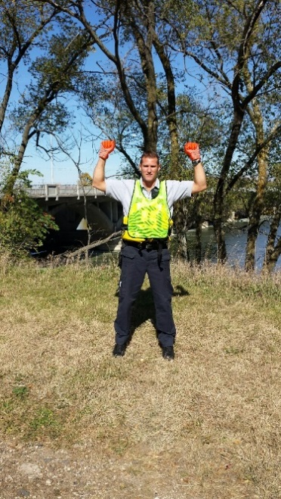

Hookup (Two Boat Tether)

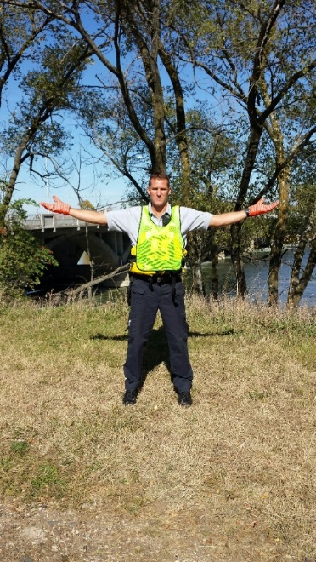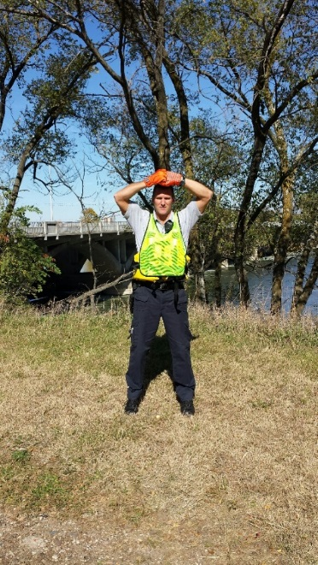

Both Boats Forward

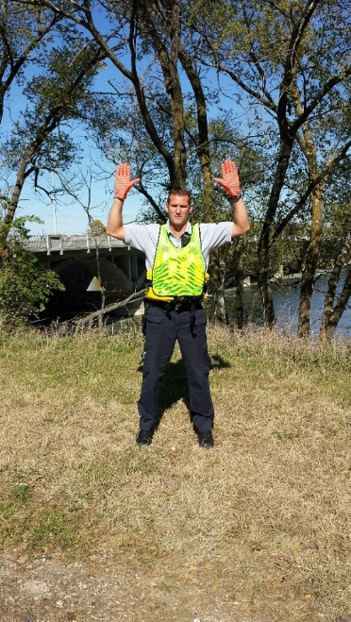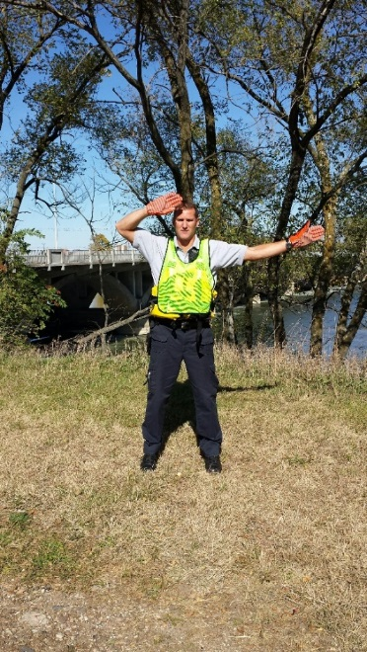

Both Boats Back

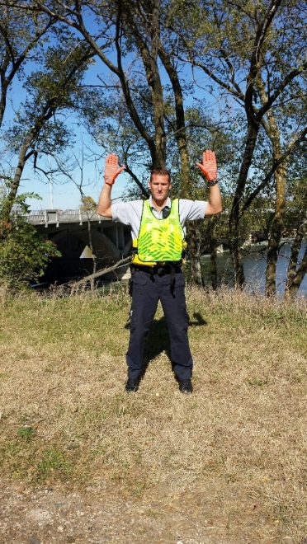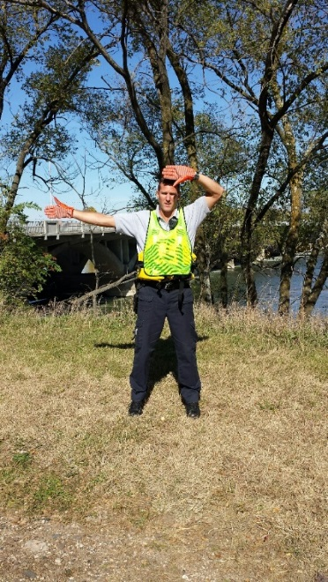

Secondary Boat Forward

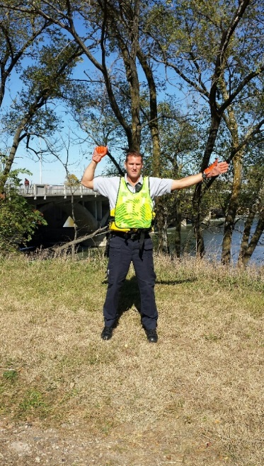

Secondary Boat Back

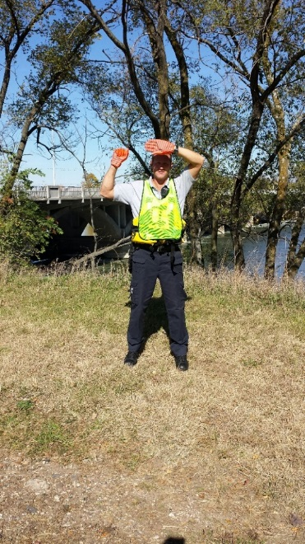

Near Shore

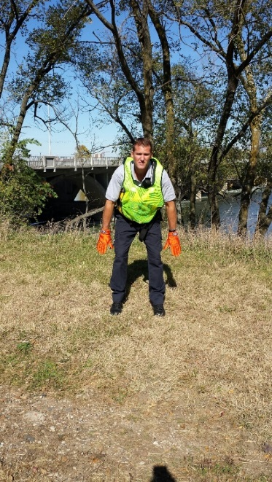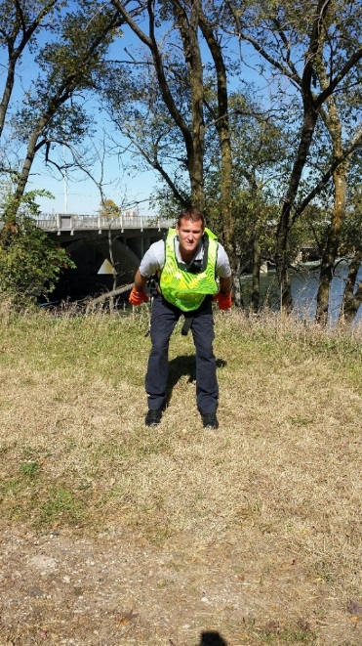

Far Shore

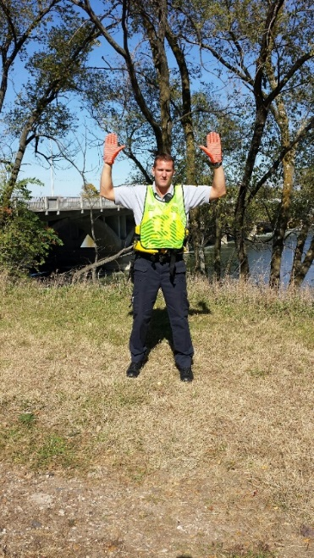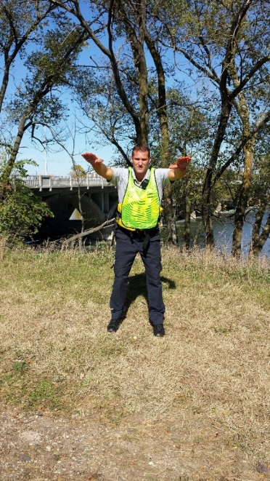

Victim in Boat

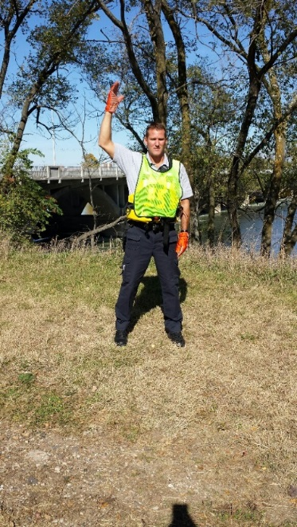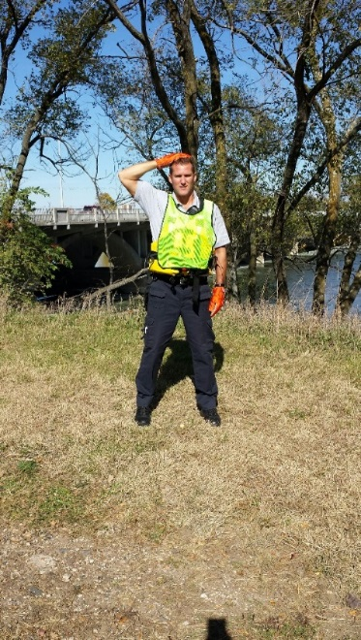

Deploy Throw Bag

