COGGINS GEOTOOLS DOCUMENTATION
Version 1

About

Coggins Geotools is a set of tools developed for the author’s personal use. They include PREMIUM BLEND, which calculates fluid properties given input parameters, GASSMANNAGER, which does Gassmann substitution using the output fluids from FD for a given reservoir, and OBLIQUE, which calculates Amplitude Variation with Offset responses for bounding shales and the rock property cases output from GassMannager. The tools are made available as open software for use by other geoscientists. The user operates at his/her own risk when using these tools; there is no warrantly, either explicit or implied, that the output values from this software are correct. The author makes no promises to maintain, develop, or correct this software upon request. However, users may contact the author by sending email messages who’s title begins with ‘GEOTOOLS’ to JLC@CogginsGeosciences.com .
Geotools are written in Python 2.7, mainly because I had just completed Python classes in 2.7. They were converted to Python 3 using the script ‘2to3’ and tested in Python 3.5. The tools use only text-based menus, since that was easiest and will likely guarantee compatibility across most platforms. The tools are invoked using the command line from the Anaconda Python Distribution or other distribution . For development, I used the Spyder Python Development Environment.
The technical underpinning for this software can be found in: The Rock Physics Handbook, Mavko,Mukerji,Dvorkin, Cambridge Press, 2013.

Contents
About 1
PREMIUM BLEND 2
Starting 2
Main Menu 2
1 Set PRESSURE and TEMPERTURE values 3
2 Calculate BRINE Properties 4
3 Calculate OIL Properties 5
4 Calculate GAS Properties 6
m Calculate a Fluid Mixture 7
p PRINT the current FLUID PROPERTIES 8
s SAVE the current FLUID PROPERTIES to a FILE 9
L LOAD the FLUID PROPERTIES from a FILE 10
x EXIT PREMIUM BLEND 11
Summary 11
GASSMANNAGER 12
Starting 12
Main Menu 12
1 Set Reservoir Rock Properties 14
2 LOAD FLUID PROPERTIES From FILE 16
f PRINT FLUID PROPERTIES to Screen 16
3 Set IN-SITU FLUID PROPERTIES 17
4 Calculate the DRY ROCK MODULUS 18
5 Calculate FLUID SUBSTITUTION PROPERTIES 19
p PRINT the RESERVOIR MODEL to the Screen 20
s SAVE the RESERVOIR MODEL to FILE 22
l LOAD the RESERVOIR MODEL from a FILE 23
* PLOT a Bar Chart of Reflection Coefficients 24
Summary 26
OBLIQUE 27
Starting 27
Main Menu 27
1 Load a RESERVOIR/AVA MODEL from a File 29
2 SET the BOUNDING SHALE(S) PROPERTIES 30
3 SELECT THE PORE FLUIDS TO MODEL 31
4 Calculate AMPLITUDE VARIATION WITH ANGLE 32
p PRINT the RESERVOIR/AVA Model Parameters to the Screen 33
s SAVE the RESERVOIR/AVA MODEL to FILE 34
* PLOT the AVA Models 35
x EXIT OBLIQUE 37
Summary 37

PREMIUM BLEND
PREMIUM BLEND is a tool to calculate fluid properties for use in Gassmann substitution.

Starting

Start PREMIUM BLEND by changing to the directory containing the software, then type ‘python premiumblendv1.py. (Your particular Python distribution or hardware may require a different command.)

Main Menu

PREMIUM BLEND’s Main Menu is shown below:
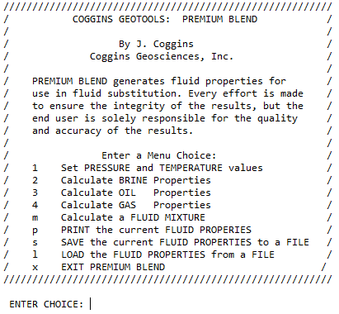

The menu is designed to be used sequentially. To create fluid properties from parameter input requires items ‘1’-‘4’. To create mixtures, such as an oil with 20% water saturation, item ‘m’ is used.
To view the parameters, use option ‘p’ to list them to the screen.
To save or load the fluid properties, use the ‘s’ or ‘l’ options.
Each Menu Item is described in more detail below:

1 Set PRESSURE and TEMPERTURE values
The use of this choice is shown below. Note that pressure and temperature must be in MPa and Degrees Centigrade. These are important parameters that must match the pressure/temperature of the reservoir rocks used for fluid substitutions and AVA modeling later.
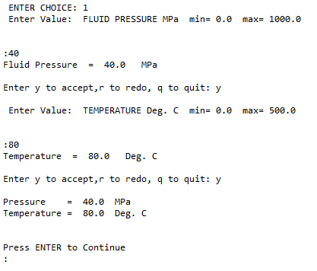

2 Calculate BRINE Properties
Brine property calculation requires the salinity in ppm in addition to the global pressure and temperature values entered previously. Properties for water at these conditions are also calculated.
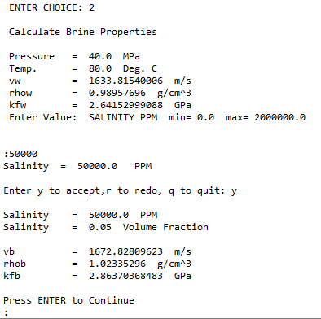

3 Calculate OIL Properties
Oil properties require the API number, gas gravity of dissolved gas, and the gas-oil ratio. Note that GOR is unit-less, and not Mcf / bbl or some other unit, but rather gas volume divided by oil volume in the same units of volume. This of course refers to standard temperature and pressure. Refer to the book by Mavko described in the ‘About’ section of this document if additional clarification is needed.
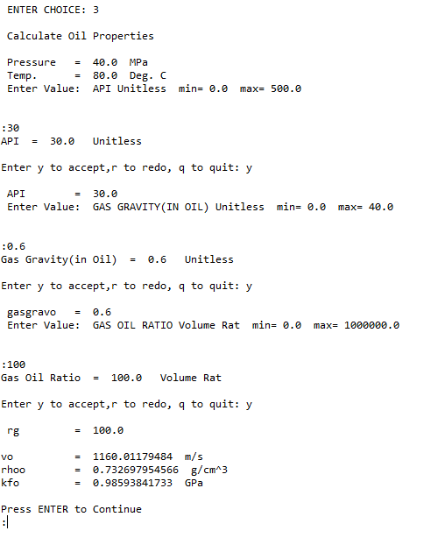

4 Calculate GAS Properties
Gas properties require only the gas gravity, in addition to the Pressure and Temperature. Note that this parameter is not constrained to be the same as the gravity for the gas dissolved in the oil case.
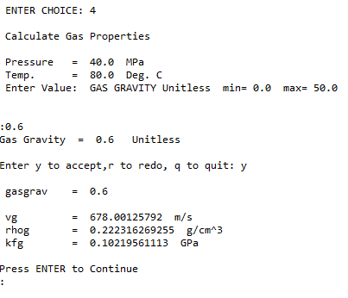

m Calculate a Fluid Mixture
The Fluid Mixture menu item creates fluid mixtures using Brine and Gas or Oil. This menu choice will allow the user to create one mixture, so creating multiple cases requires multiple menu choices. Note that the water saturation (actually, this is brine) is entered as a FRACTION, not as a percent. Be sure to use a fluid description without spaces!
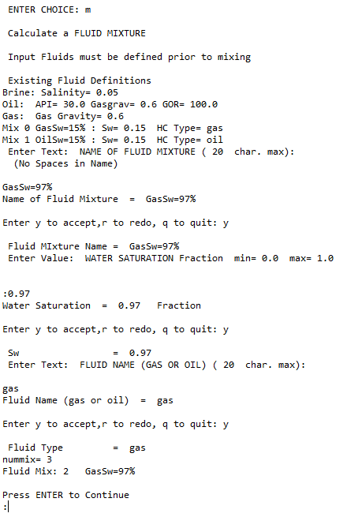

p PRINT the current FLUID PROPERTIES
This menu item prints the fluid properties to the screen.
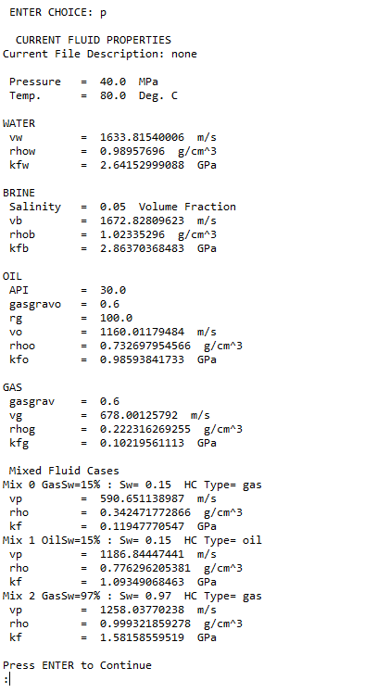

s SAVE the current FLUID PROPERTIES to a FILE
This does just what it says it does. There is no directory control in the program, so the file gets saved to the current directory at startup of PREMIUM BLEND.
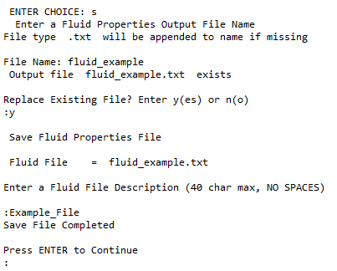

L LOAD the FLUID PROPERTIES from a FILE
This loads a fluid file that was previously saved. Note that the file must reside in the same working directory as when the program was started. This is a text file, and I think the format is self-explanatory.
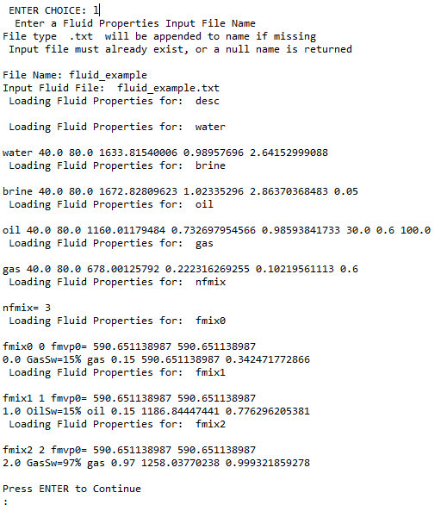

x EXIT PREMIUM BLEND
Exits after checking with user.
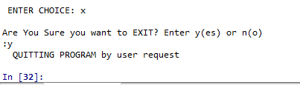

Summary

PREMIUM BLEND was the first module of the Coggins GeoTools Series. When visiting data rooms at other companies, the inputs to this program could be obtained, but the fluid properties were needed to do additional modeling.

GASSMANNAGER
GASSMANNAGER does fluid substitution, given input fluids and reservoir properties. As an option, it makes a reflection coefficient plot for each fluid type, given bounding shale values.

Starting
Start GASSMANNAGER by changing to the directory containing the software, then type ‘python gassmannagerv1.py. (Your particular Python distribution or hardware may require a different command.)

Main Menu
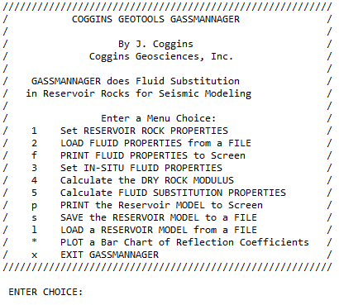
GASSMANNAGER’s Main Menu is shown below:

The menu is designed to be used sequentially. To create fluid substitution cases for a given reservoir, complete steps 1-5.
To view the fluid parameters, use option ‘f’ to list them to the screen.
To view the model parameters, use option ‘p’ to list them to the screen.
To save or load the model properties, use the ‘s’ or ‘l’ option.
The ‘*’ menu item plots a bar graph of Reflection Coefficients.
Each Menu Item is described in more detail below:

1 Set Reservoir Rock Properties
The use of this choice is shown below. The first set of parameters are text, and must be entered without any spaces (_ can be used). Note that the reservoir depth is only for the user’s benefit, and is not used in any calculations. These are shown below:
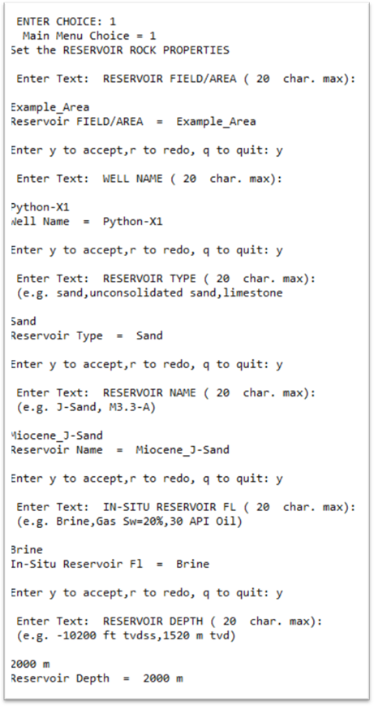

The remainder of the inputs is floating point numbers used for calculations. Note the required units.
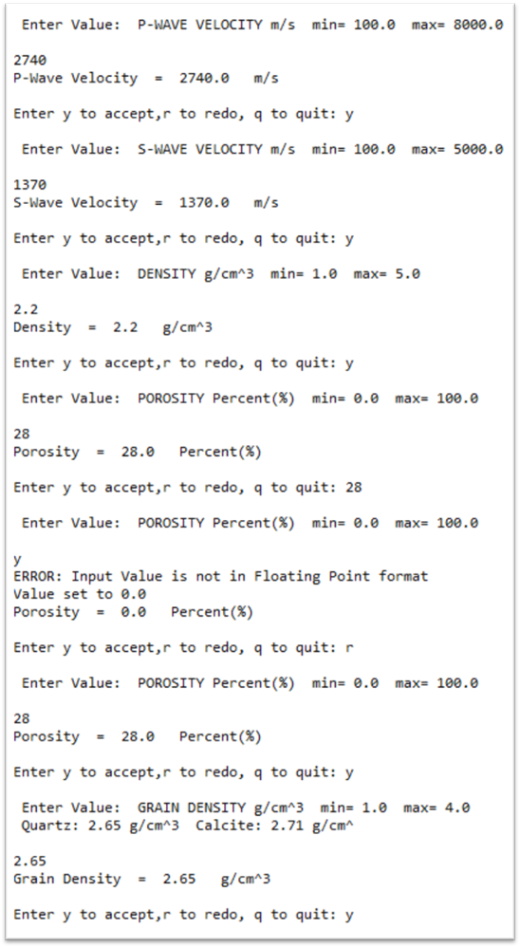

2 LOAD FLUID PROPERTIES From FILE
The menu choice loads a fluid file that is output from the PREMIUM BLEND tool. The file must be in the current directory and have the .txt suffix.
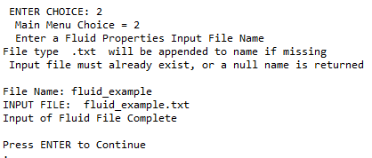

f PRINT FLUID PROPERTIES to Screen
This menu item lists the fluid properties to the screen. It has exactly the same output as the ‘p’ command in the PREMIUM BLEND tool.

3 Set IN-SITU FLUID PROPERTIES
This menu item sets the set of fluid properties for the in-situ fluid type. This is the fluid in reservoir that corresponds to the reservoir properties entered in item 1. It is typically Brine, but can be any of the fluids already defined. The program lists the existing fluids, and the user enters the number corresponding to the proper choice.
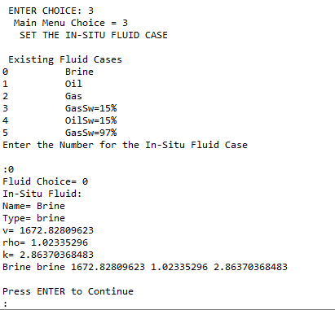

4 Calculate the DRY ROCK MODULUS
In order to accomplish Gassmann substitution, the ‘dry bulk modulus’ or the reservoir must be calculated. The bulk modulus of the rock matrix mineral is required. Use one of the listed numbers, or another value calculated externally for a mixed mineral case. (Note that the grain density input in Item 1 and this number must be consistent.) The resulting Dry Bulk Modulus must be a positive number. As a rule of thumb, this number will be similar to the reservoir’s Shear Modulus. (The Shear Modulus can be viewed using the ‘p’ menu choice to print the existing reservoir model to the screen.)
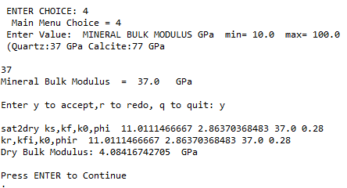

5 Calculate FLUID SUBSTITUTION PROPERTIES
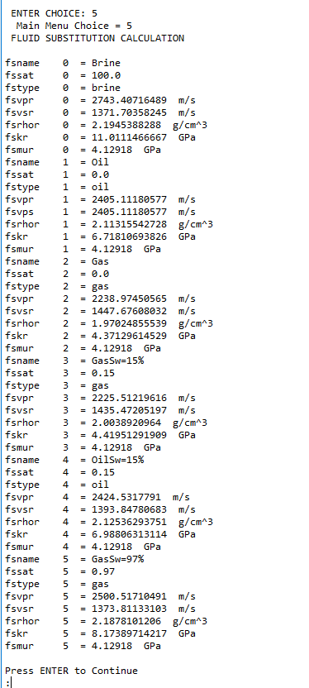
This calculates the reservoir rock properties for all the fluid cases using Gassmann Substitution. The in-situ fluid rock properties are recalculated. These should be identical to the input reservoir rock properties.

p PRINT the RESERVOIR MODEL to the Screen
This menu item prints the Reservoir Model to the screen. The model includes the reservoir rock properties, the input parameters for Gassmann Substitution, and the rock properties output from the substitution. The user is given the option of printing the Fluid Parameters as well.
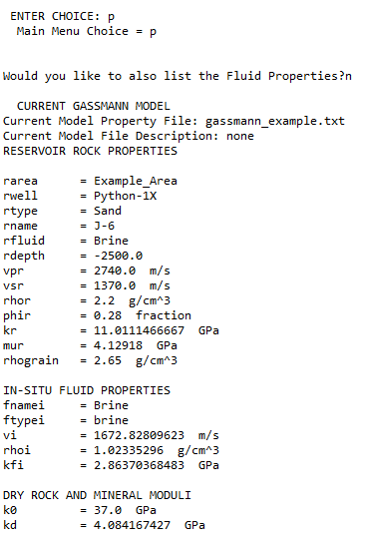

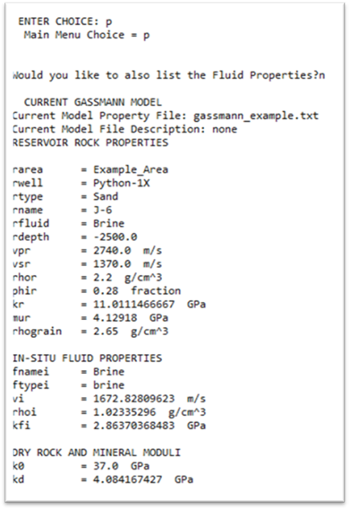

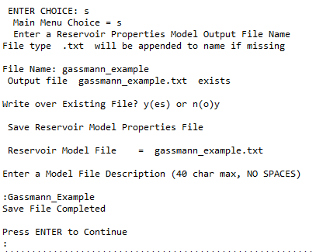

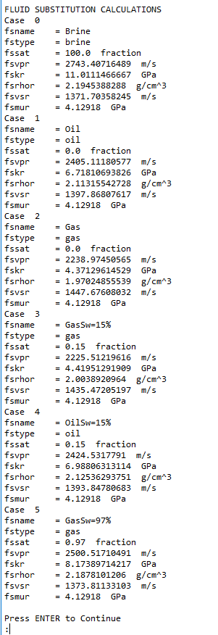

s SAVE the RESERVOIR MODEL to FILE
This does just what it says it does. Everything is saved, including the fluid parameters. By loading this file (next item), GASSMANNAGER can be restored to a previous session.
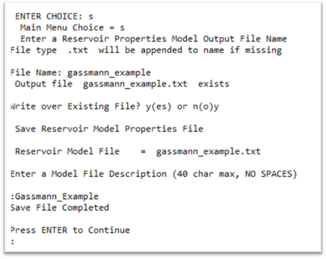

l LOAD the RESERVOIR MODEL from a FILE
This loads a RESERVOIR MODEL that was previously saved using the step above. This restores the GASSMANNAGER to a previous session. The user can choose not to load the fluid parameters from the file, so as not to write over any fluid information already present. Note that the file must reside in the same working directory as when the program was started. This is a text file, and I think the format is self-explanatory.
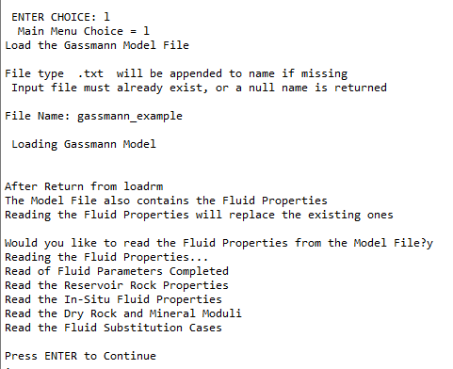

* PLOT a Bar Chart of Reflection Coefficients
This menu item plots a chart of the reflection coefficients between a bounding shale and the reservoir. The user enters bounding shale properties and then chooses the fluid cases to plot.
Entering the number of a fluid case toggles it off or on (marked with an *). After the fluids are selected for plotting, enter a ‘*’ to make the plot. The plot is color-coded for brine, oil, and gas (blue,green, red).

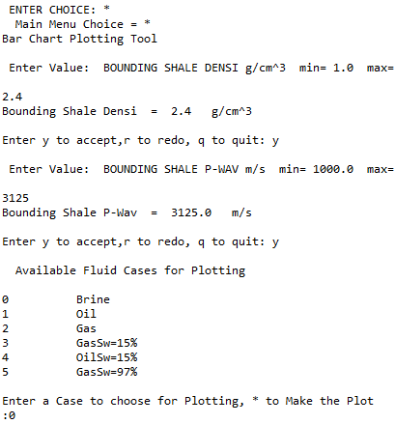

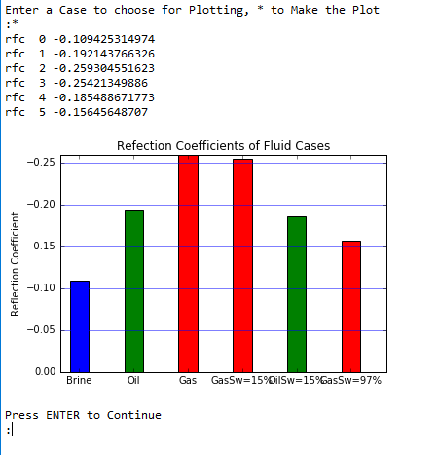

x EXIT GASSMANNAGER
Exits after checking with user.

Summary

GASSMANNAGER was the second module of the Coggins GeoTools Series. When visiting data rooms at other companies, this module can use the fluids from PREMIUM BLEND and GASSMANAGER to understand the impact of fluids on the reservoir reflection coefficients. Should we expect ‘bright spots’ in this reservoir?

OBLIQUE
OBLIQUE models the amplitude variation with angle (AVA) of reservoir rocks with a variety of pore fluids, using the output reservoir properties from GASSMANNAGER.

Starting
Start OBLIQUE by changing to the directory containing the software, then type ‘python obliquev1.py. (Your particular Python distribution or hardware may require a different command.)

Main Menu
OBLIQUES’s Main Menu is shown below:
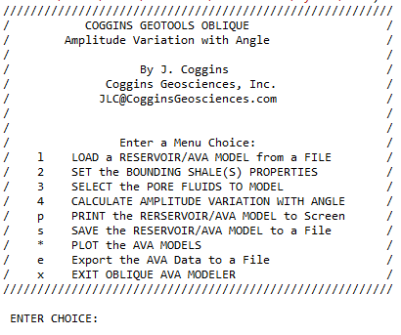

The menu is designed to be used sequentially. To create AVA responses for reservoir/pore fluid pairs, use menu items 1-4 . The remaining menu items are utilities that provide: Model File Input/Output, Listing Parameters to Screen, Plotting AVA responses, and Exporting the AVA data for use in other programs.
Each Menu Item is described in more detail below:

1 Load a RESERVOIR/AVA MODEL from a File
Menu item ‘1’ can be used to load a model file output from GASSMANNAGER or OBLIQUE. In the initial AVA model building, the input will be a GASSMANNAGER file. The OBLIQUE model file can be used when re-entering the program to restore a previous session.
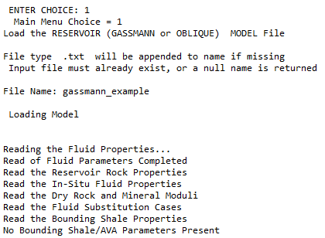

No Bounding Shale or AVA Parameters were found in this file, because it is a GASSMANNAGER output file.

2 SET the BOUNDING SHALE(S) PROPERTIES
Menu item ‘2’ is used to enter the bounding shale rock properties. If the properties have already been entered, they are listed, and the user can accept those values.
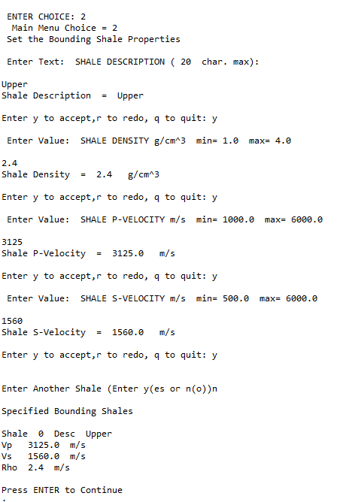

3 SELECT THE PORE FLUIDS TO MODEL
This menu item lists the existing pore fluids to the screen, and allows the user to select which ones to model. Normally all the fluids are selected. If any of the cases are not applicable or undefined, they can be excluded from the calculation.
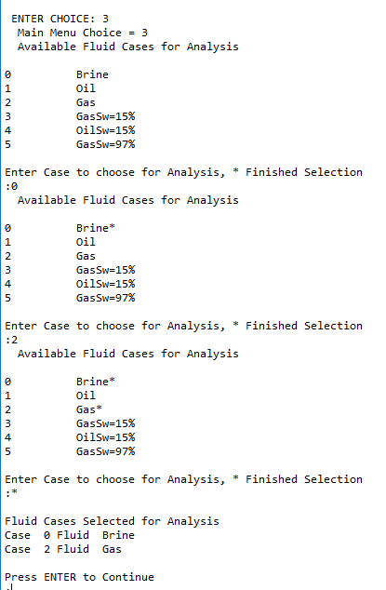
The input manner is the multi-case toggle menu, as seen previously in GASSMANNAGER. In the example below, only the Brine and Gas cases have been selected to illustrate the menu operation.

4 Calculate AMPLITUDE VARIATION WITH ANGLE
Menu choice ‘4’ calculates the Amplitude Variation with Angle, using the Zoeppritz solution. The user enters the beginning offset angle (normally zero) and the ending offset angle (typically 40-50 Degrees). For the time being, the angle increment is fixed at 1 degree. (If the angle specification already exists, the user is prompted to optionally accept the existing values.)
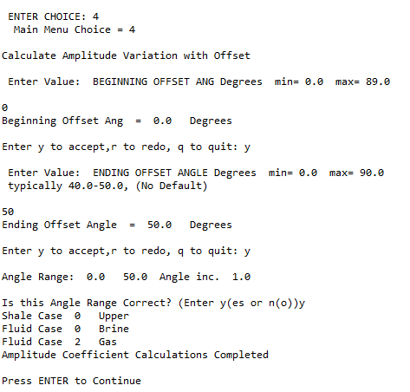

In a very short time, the AVA calculations are completed.

p PRINT the RESERVOIR/AVA Model Parameters to the Screen
This item prints all the parameters to the screen. For the sake of space, only the additional parameters specified in OBLIQUE are listed below. (The PREMIUM BLEND and GASSMANNAGER parameters are also listed.)
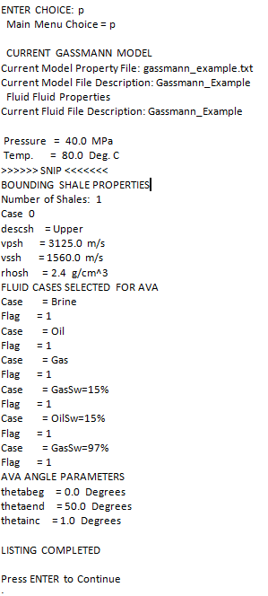

s SAVE the RESERVOIR/AVA MODEL to FILE
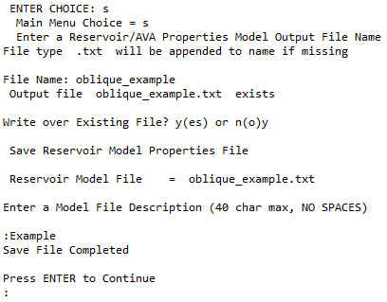
This does just what it says it does. Everything is saved, including the fluid and Gassmann parameters. By loading this file (next item), OBLIQUE can be restored to a previous session.

* PLOT the AVA Models
Pretty obvious what this does. If multiple bounding shales are defined, the user is prompted to select the shale for this plot. The fluid cases are selected with the now-familiar toggle menu, and entering ‘*’ at the end generates the plot. (For the sake of space, only Brine and Gas are selected below, while the plot shows all the cases.)
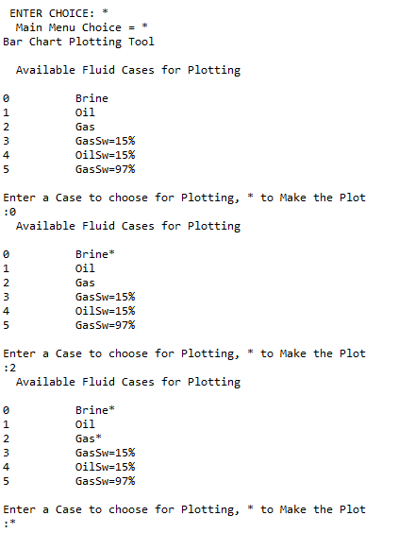

The plot of Amplitude Vs Angle is shown below:
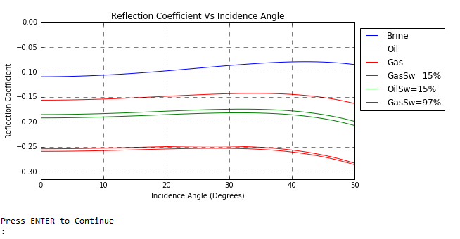

For the current version, all brine, oil, and gas cases are blue, green, and red, respectively. The savvy user should be able to match the case to the curve.
Now, besides knowing the normal incidence reflection coefficients for our reservoir, we also have an AVA model. In this case, we see that most of the information is in the normal incident (Angle=0) response. This is a classic bright-spot response. Given the uncertainties in the modeling and data quality, it may be difficult to distinguish between oil and residual gas.

e EXPORT the AVA Data to a File

x EXIT OBLIQUE
Exits after checking with user.

Summary

OBLIQUE was the third module of the Coggins GeoTools Series. In addition to understanding the normal incidence (Angle=0) reflection coefficients we got from GASSMANNAGER, we can look at the expected amplitude behavior in the offset domain. Does Ampltude Variation with Angle (Offset) contained additional information about the pore fluid? (or other reservoir properties…)

REVISION HISTORY
13sep2016 Began Documentation
14sep2016 Completed PREMIUM BLEND documentation
14sep2016 Completed GASSMANNAGER documentation

ENTER CHOICE: p
Main Menu Choice = p

CURRENT GASSMANN MODEL
Current Model Property File: gassmann_example.txt
Current Model File Description: Gassmann_Example
Fluid Fluid Properties
Current Fluid File Description: Gassmann_Example

Pressure = 40.0 MPa
Temp. = 80.0 Deg. C
>>>>>> SNIP <<<<<<<
BOUNDING SHALE PROPERTIES
Number of Shales: 1
Case 0
descsh = Upper
vpsh = 3125.0 m/s
vssh = 1560.0 m/s
rhosh = 2.4 g/cm^3
FLUID CASES SELECTED FOR AVA
Case = Brine
Flag = 1
Case = Oil
Flag = 1
Case = Gas
Flag = 1
Case = GasSw=15%
Flag = 1
Case = OilSw=15%
Flag = 1
Case = GasSw=97%
Flag = 1
AVA ANGLE PARAMETERS
thetabeg = 0.0 Degrees
thetaend = 50.0 Degrees
thetainc = 1.0 Degrees

LISTING COMPLETED

Press ENTER to Continue
:

