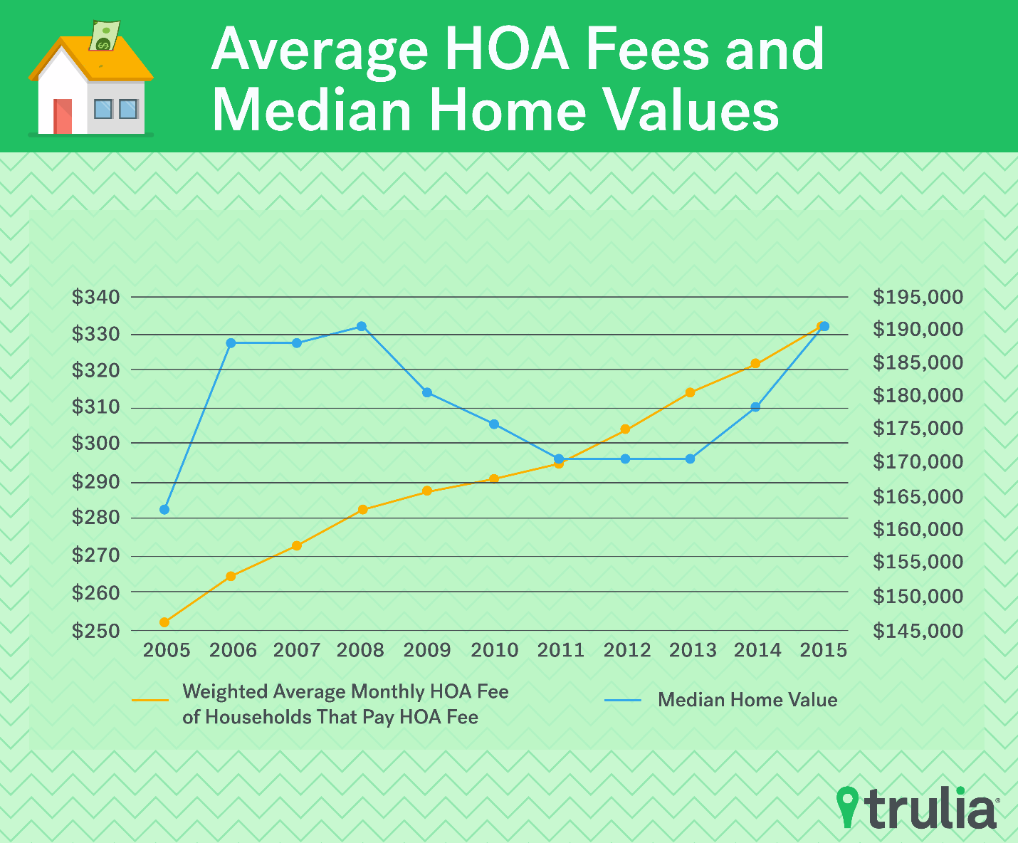

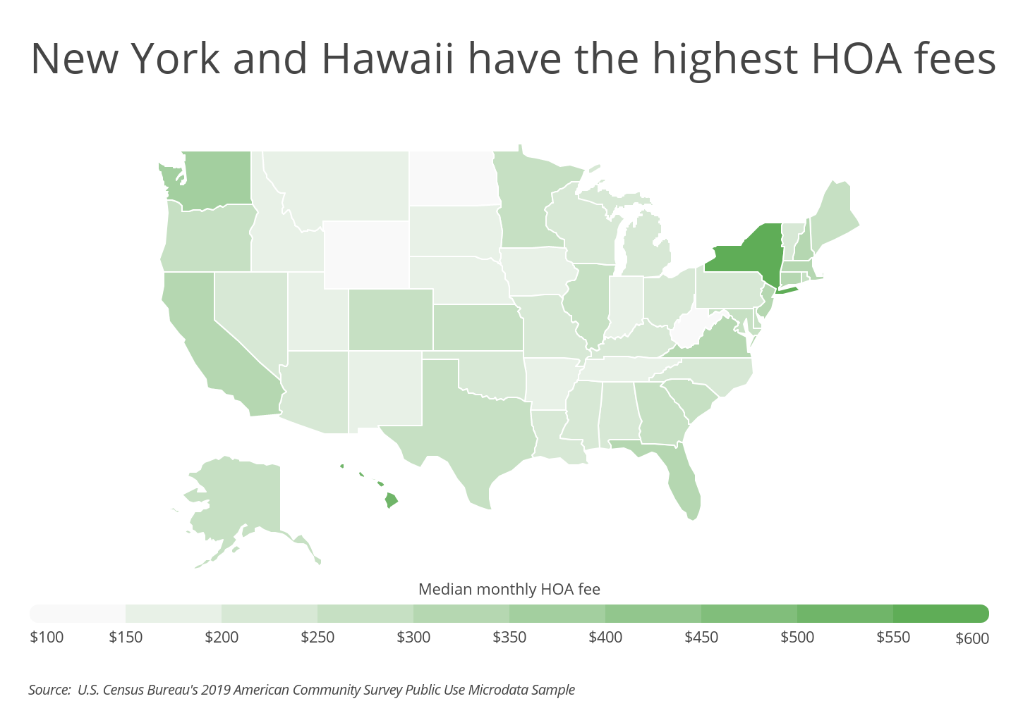

# HOA Statistics

Last Updated: October 9, 2022

**Report Highlights.** Homeowners’ associations in the United States manage **355,000** communities, with an average of 22 new associations forming daily.

* **82.4%** of newly constructed homes sold in 2021 were part of HOA communities.
* **53%** of all homeowners live in HOA communities.
* **$250** is the average monthly HOA membership fee for a single-family home.
* **40 million** housing units are part of HOA communities.
* Roughly **8,000** new HOA communities form each year.

An estimated 7,500 HOAs are large-scale, meaning they have at least 1,000 lots or homes and a $2 million annual budget

**Nevada**

Nevada HOAs have a membership rate above the national average.

* There are 3,460 HOAs in Nevada.
* Roughly 518,000 people in Nevada live in HOA communities.
* Each HOA in Nevada has an average of 150 residents.
* 16.6% of Nevada’s population lives in HOA communities.
* 10.5% of Nevada homeowners are part of HOAs.
* An estimated 199,231 homes in Nevada are part of HOA communities.
* Homeownership statewide is 61.2%.