Step: 1 – 10 SCA Pay scale
Date Est.: May 18, 2020
Last Rev.: November 19, 2021
FLSA: Non-Exempt
Probation: 30 Days
Schedule: 40 hours per week
Department: Buildings & Grounds
Position Title: B&G Laborer Maintenance Tech I.
Reports To: B&G Superintendent/B&G Parks Director: Based on Assignment.
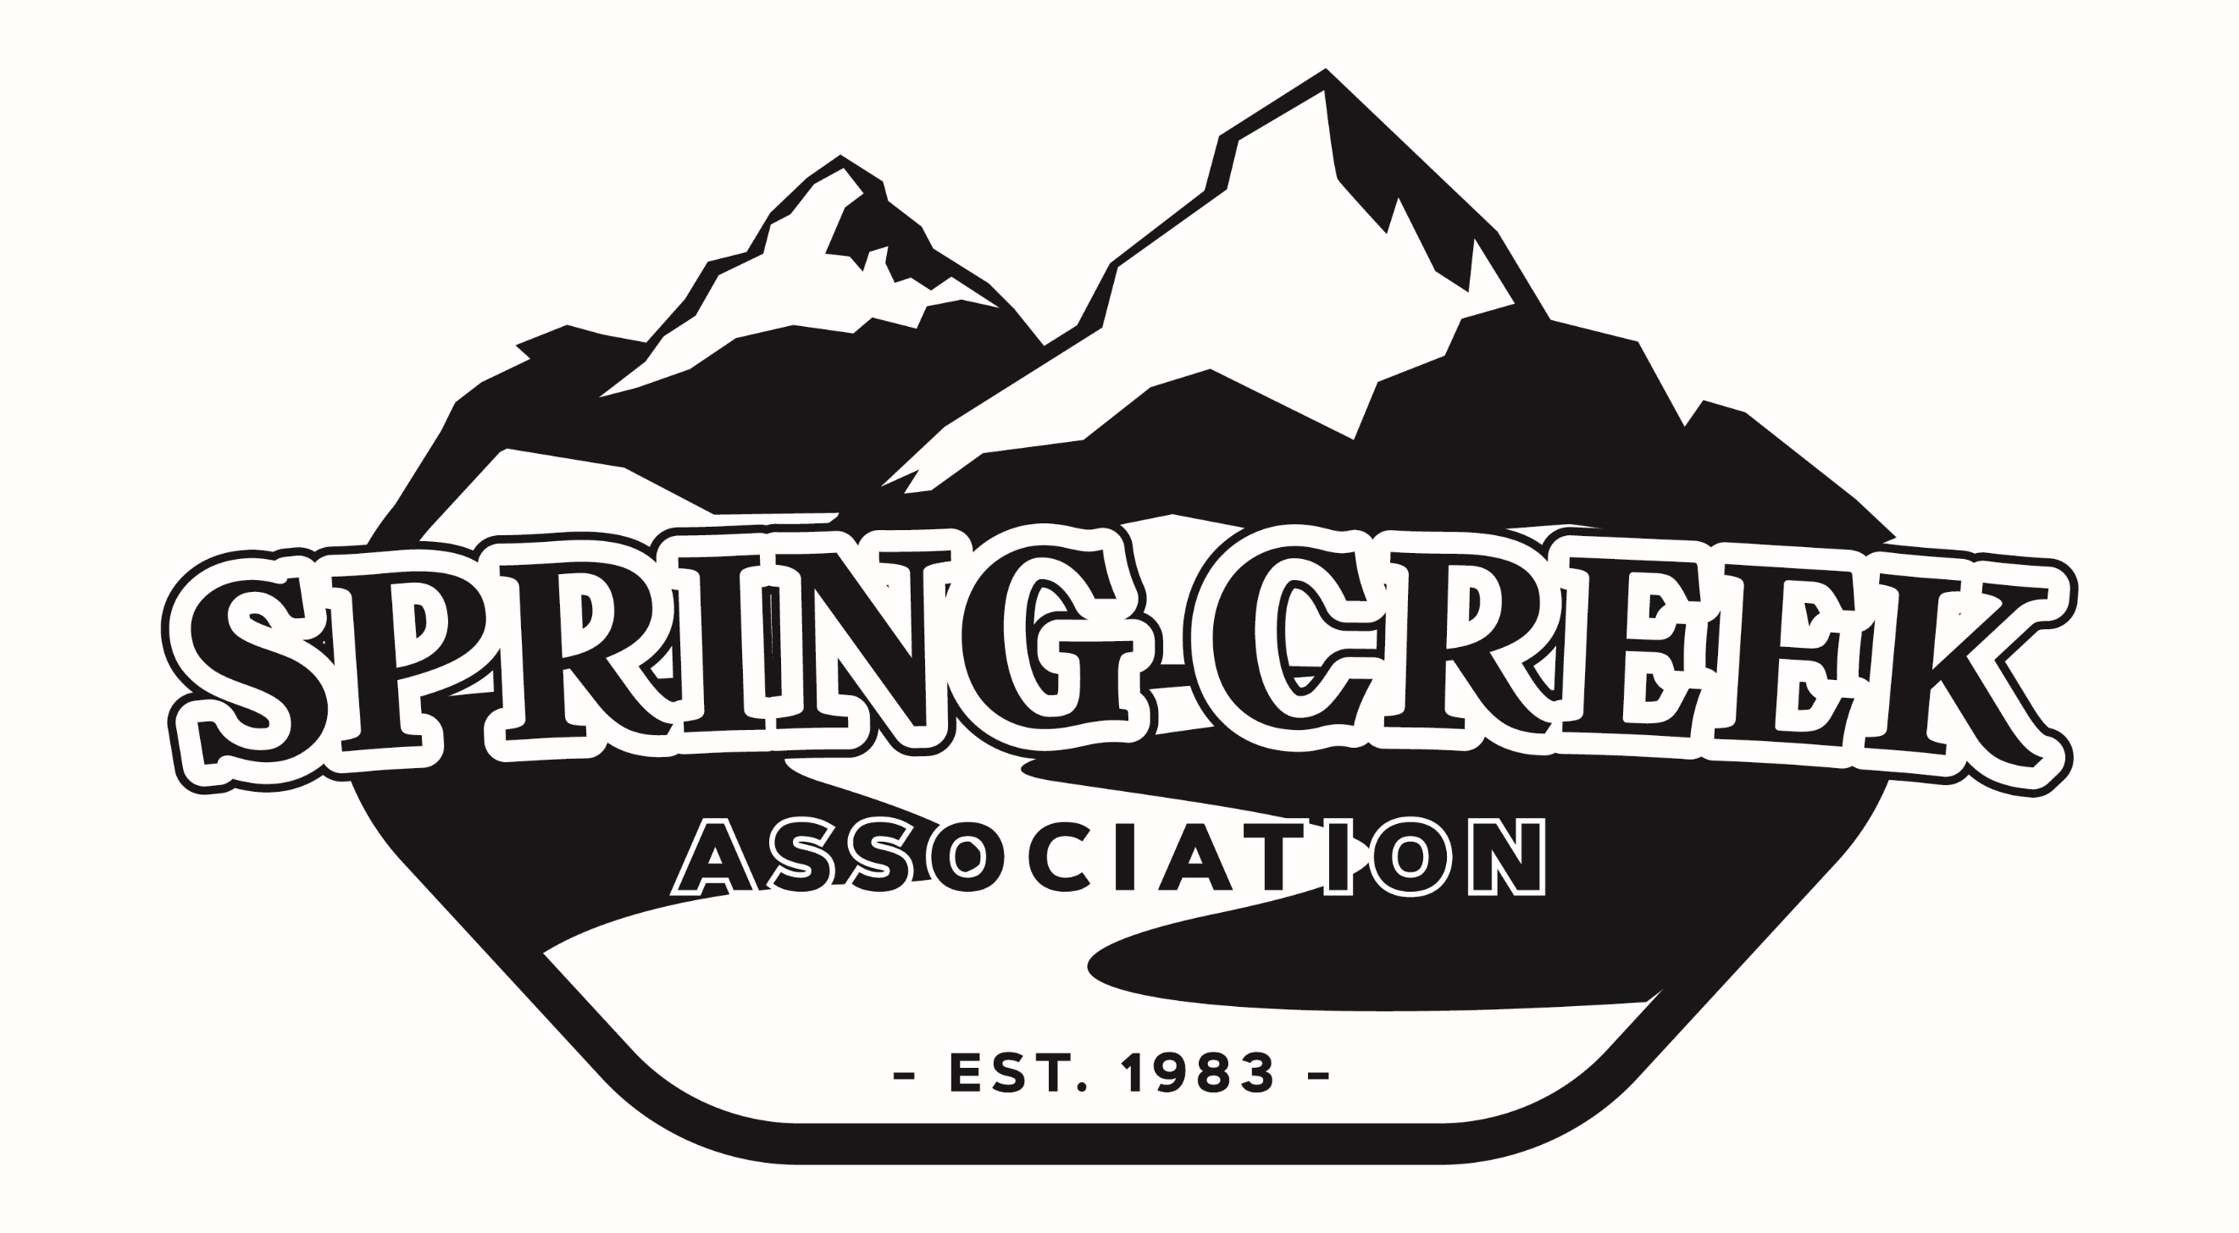SPRING CREEK ASSOCIATION
401 Fairway Blvd
Spring Creek, NV 89815
775.753.6295
775.753.9539

DEFINITION FUNCTION:
Under the direction of the Buildings & Grounds Department; this position may be assigned to general maintenance and/or parks and grounds.

This position will report to the Supervisors which is responsible for general regular maintenance and large-scale in either areas of buildings and grounds maintenance or parks and grounds encompassing such projects involved with buildings, amenities, parks, park facilities, ballfields, lawns, grounds, and other cultivated areas in the Association; assures that safe and clean facilities are provided for residents.

The incumbent is responsible for providing member service through caring, honest, respectful, and responsible actions and interactions that contribute to the relationship between the member and the Association.

SUPERVISION RECEIVED AND EXERCISED:
Receives general direction from the B & G Superintendent or B & G Parks Director based on assignment.

DUTIES AND RESPONSIBILITIES:
The following duties are typical for this position. Incumbents may not perform all of the listed duties and/or may be required to perform additional or different duties from those set forth below to address business needs and changing business practices.
- Performs maintenance of landscape and grounds in assigned buildings, amenities, parks, recreation centers, facilities, campground, and playgrounds, including inspection, maintenance, management and improvement of parks and grounds areas; evaluates maintenance issues, and recommends and implements solutions to provide safe, clean and aesthetically pleasing facilities.
- Monitors work sites to assure that safety rules and regulations are adhered to, and that the work zones and all equipment are in safe operating condition.
- Perform non-peak season maintenance including snow removal as required by supervisor, and helping in other department projects.
- Communicate effectively with all staff and volunteers in working as a team to produce expected results in assuring clean, safe and well-maintained facilities.
- Assist other staff and departments with duties that may require additional help or attention.
- Occasionally attend prescribed training sessions, staff meetings and seminars as required by supervisor.
- Carries out other duties as assigned by the Association.

JOB RELATED AND ESSENTIAL QUALIFICATINS:

KNOWLEDGE OF:
- Knowledge of the safe operation practices and maintenance of various tools, turf equipment, and motor vehicles
- Some knowledge of plumbing, masonry, electrical, painting, and HVAC as well as light construction
- Familiar with basic OSHA standards and safety practices
- Planting and caring for trees, shrubs, and flowers.
- Safe operation practices and maintenance of various tools, including motor vehicles.
- SCA policies and procedures.
- Methods, materials, tools, and equipment used in parks maintenance.
- County and State safety rules and regulations.
- Occupational hazards and safety precautions.

ABILITY TO:
- Manage tasks insuring their successful completion.
- Work independently and prioritize daily work duties
- Effectively communicate his or her thoughts and plans both verbally and in writing
- Make sound judgments and decisions.
- Model expected behavior, motivating fellow staff and volunteers, and be capable of working with diverse groups
- Follow all SCA safety policies at all times
- Work flexible hours with some evening, weekends, and holiday shifts as required.
- Assist other staff and departments with duties that may require additional help or attention
- Read and write to effectively communicate expectations in completing tasks through crew.
- Read, understand, and communicate implications of product warning and instruction labels.

ESSENTIAL SKILLS:
- Punctual, dependable, trustworthy, sound reasoning skills, strong work ethic, and initiative-taking.
- Initiative-taking with sound reasoning skills; able to follow and administer directions.
- Experience in parks and recreation and/or maintenance certifications desirable.
- Mechanical ability; skilled in the use of small power hand tools; ability to maintain small power and hand tools .
- Operate motor vehicles, tractors, mowers, other large equipment as assigned.

EDUCATION AND EXPERIENCE:
Education: Minimum of a high school diploma or GED.

Experience: Minimum of 1-year prior experience in related field.

LICENSES OR CERTIFICATES:
Continued employment is contingent upon all required licenses and certificates being maintained in an active status without suspension or revocation, including completing all required continuing education credits, and renewal requirements by the licensing agency.

- Possession of, or ability to obtain, a valid Nevada Driver’s License.
- Provide a copy of DMV record prior to offer of employment.

OTHER REQUIREMENTS:

PHYSICAL DEMANDS:
The physical and mental requirements described here are representative of those that must be met by an employee to successfully perform the essential functions of the job.
- Strength, dexterity, coordination, and vision to perform inspections, and use various equipment, sometimes for prolonged periods.
- Flexibility, dexterity, coordination, and physically able to climb into equipment and vehicles.
- Needs to be energetic and physically able to walk and stand for prolonged periods.
- Dexterity and coordination to manage multiple types of tools, boxes, pipes, materials; occasionally lifting of items weighing up to 100 pounds with two hands to a minimum height of 54 inches (4.5’).
- Ability to climb ladders to a minimum of ten feet, to walk, bend, twist reach overhead regularly. The employee is frequently required to walk, reach with hands and arms, climb or balance, stoop, kneel, and crouch or crawl. The employee may be exposed to moving mechanical parts.
- Ensure established protocols are followed, and report staff/program concerns to supervisor on timely basis.

In compliance with applicable disability laws, reasonable accommodations may be provided for qualified individuals with a disability who require and request such accommodations. Incumbents and individuals who have been offered employment are encouraged to discuss potential accommodations with the employer.

WORKING CONDITIONS:
- Significant amount of time spent working outdoors, and in inclement weather (within reason and safety), to include, but not limited to hot, humid, wind, cold, rain and snow.
- Able to work around chemicals and hazardous materials for use and application.
- Exposure to dust, fumes, odors, or noise. Worksite performance and/or inspections may or will include time in all types of work environmental factors possible or likely.
- Readiness to perform activities under adverse conditions as required.
- Required to drive alone, and with others, for extended periods of time throughout SCA on a regular basis and as situations may dictate.

EFFECT ON END RESULT:
This position has a direct impact on the overall effectiveness with which the organization accomplishes its mission in service to members and the community.

Member satisfaction will improve through maintaining the integrity of the several types of equipment needed to maintain the Spring Creek Golf Course and surrounding areas.

Decrease in number of accidents and claims through regular, documented inspections.

Improved public perception as a quality organization demonstrated by a well-maintained infrastructure.

This job description is not intended and should not be construed to be an exhaustive list of all responsibilities, skills, efforts or working conditions associated with the job. It is intended to reflect those principal job elements essential for recruitment and selection, for making fair job evaluations, and for establishing performance standards. The incumbent shall perform all other functions and/or be cross trained as shall be determined at the sole discretion of management, who has the right to amend, modify, or terminate this job in part or in whole. Incumbent must be able to perform all job functions safely.

_______________________________ _______________________________

Incumbent Printed Name Supervisor Printed Name

_______________________________ _______________________________

Incumbent Signature Supervisor Signature

________________________________ ________________________________
Date Signed Date Signed

