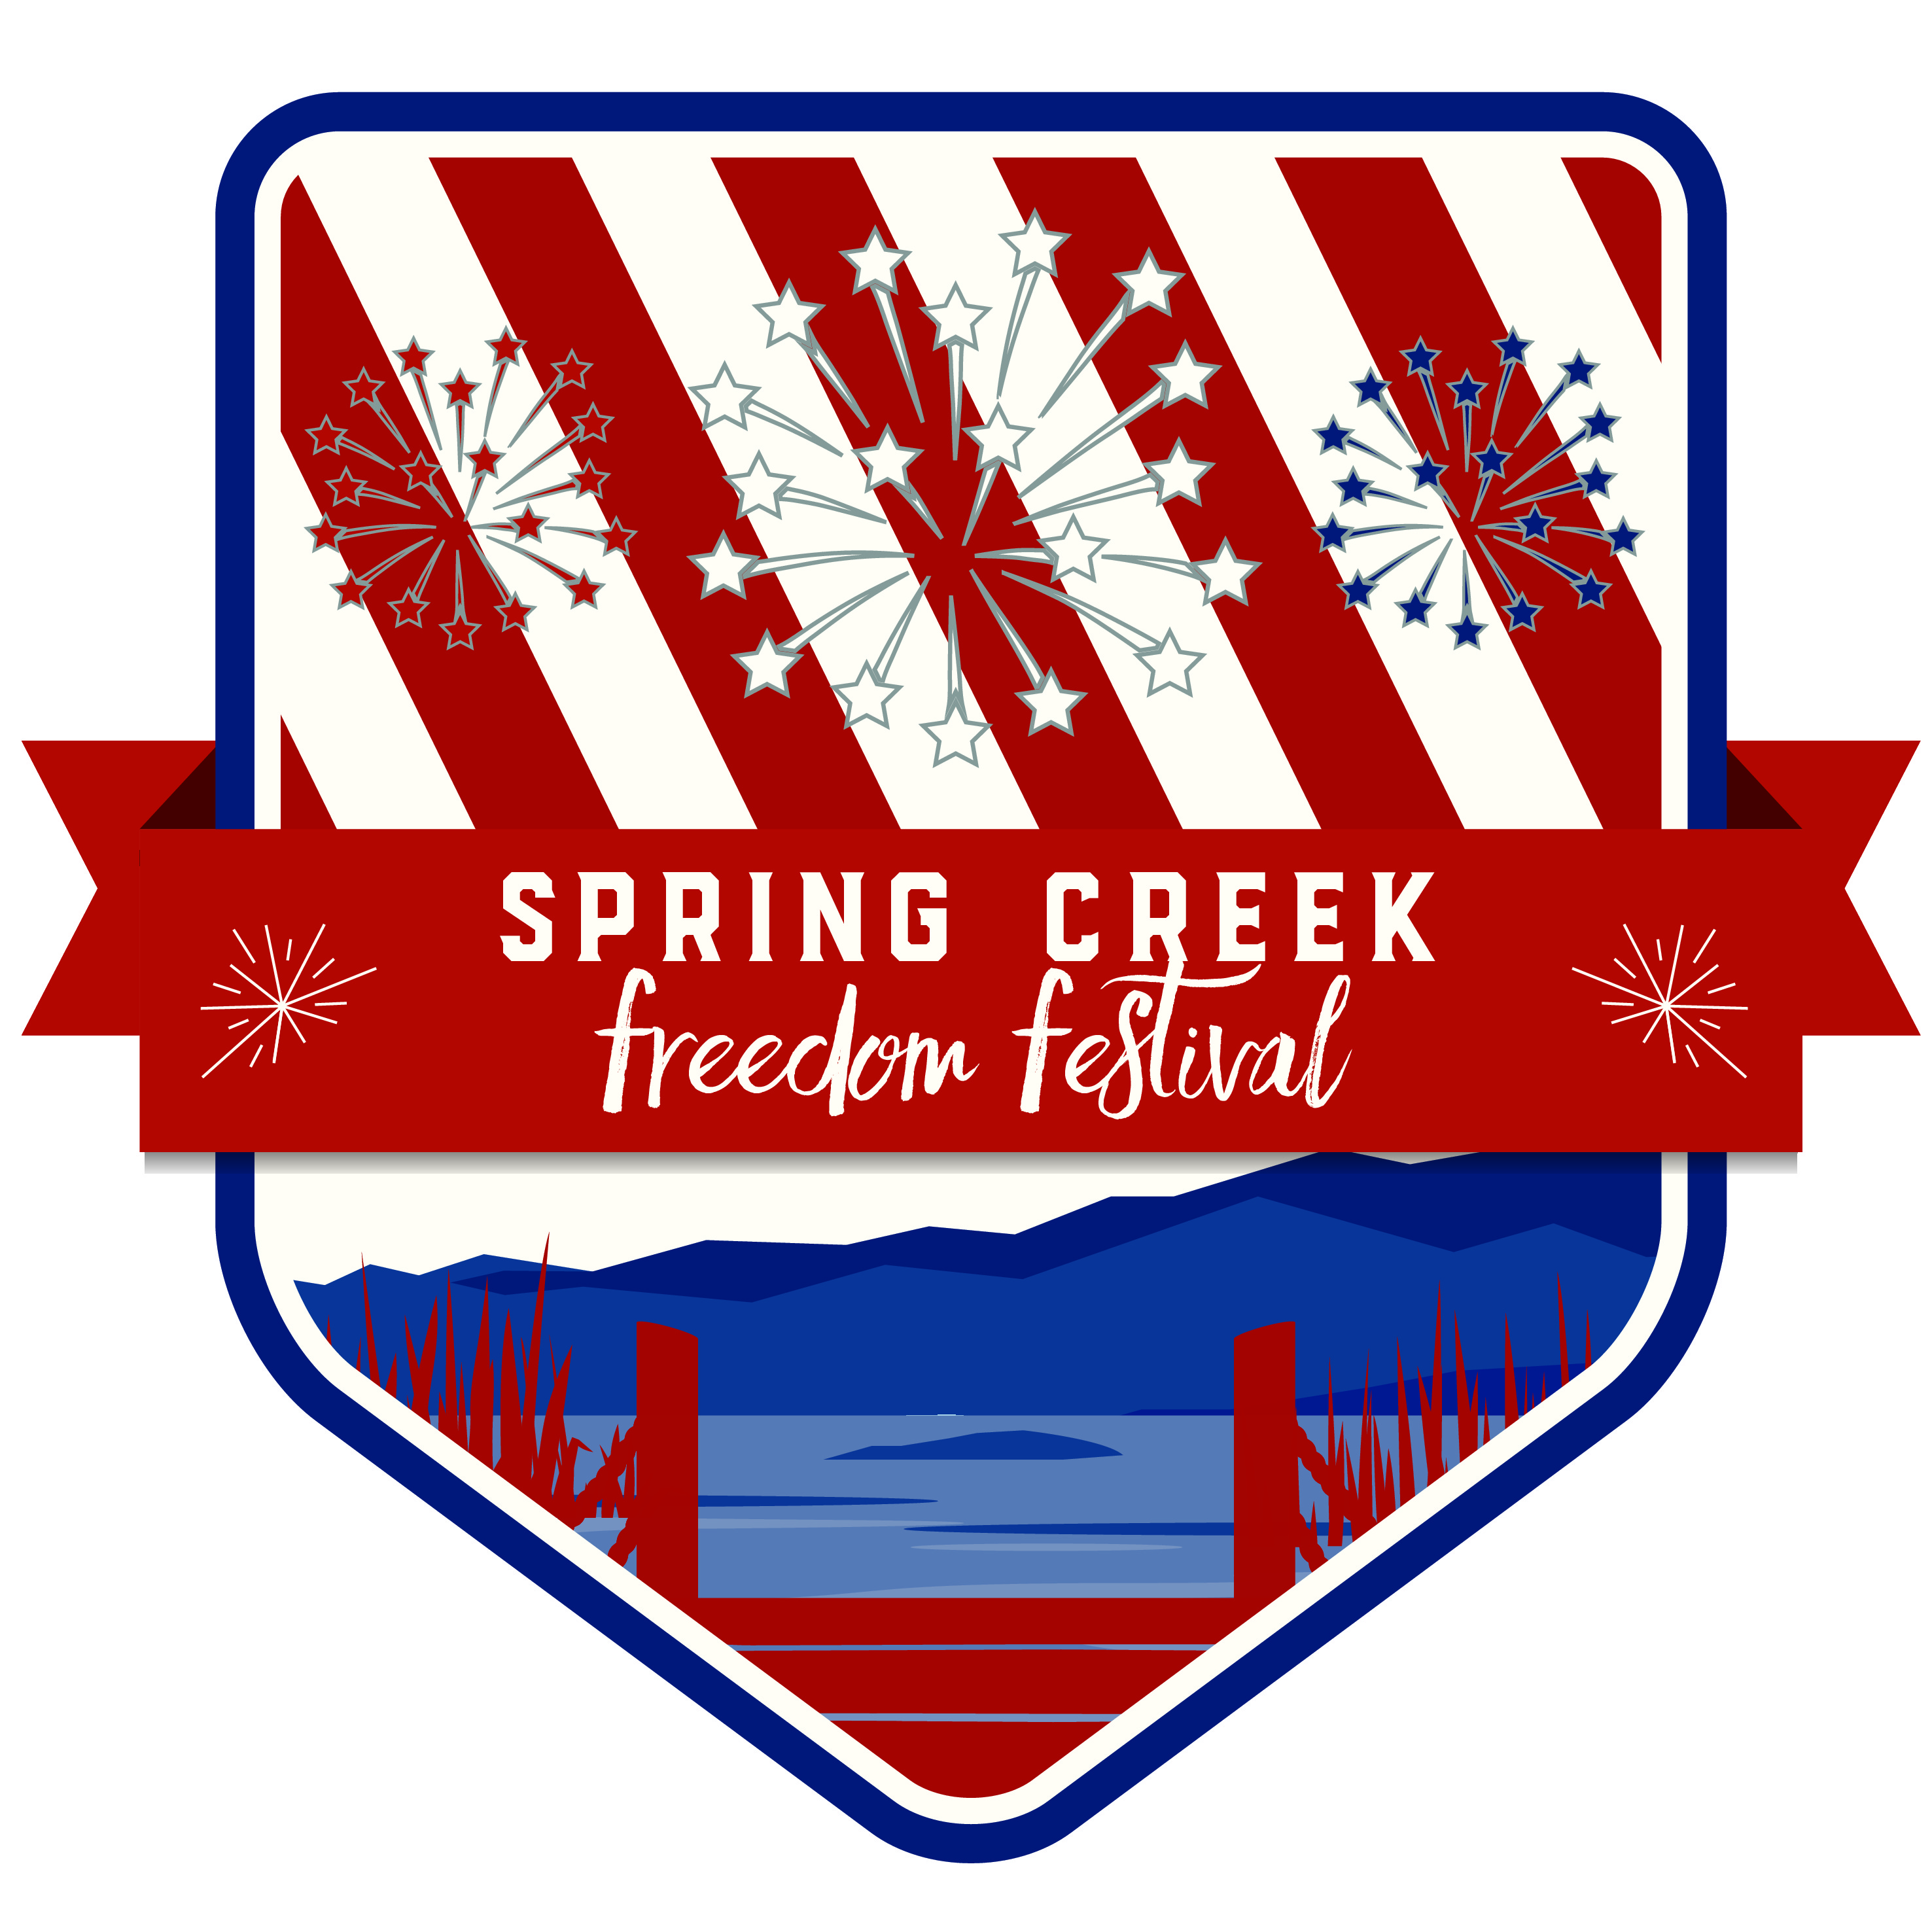**Spring Creek Freedom Festival Committee**

401 Fairway Blvd.

Spring Creek, Nevada 89815

Phone: (775)753-6295

Fax: (775) 753-9539

Email: events@springcreeknv.org

April 2025

The Spring Creek Association conducts a lot of business with both local and non-local businesses in and around Elko County. We are reaching out to many of those companies in hopes that they would like to give back to the biggest event of the year!

The Spring Creek Freedom Festival Committee is seeking sponsorship for our 19th annual community event. Last year’s event was spectacular, but we are hoping to make this year BIGGER and BETTER than ever before. Participation in the activities increase each year with many people coming in from out of town. The Festival will include the following: a 5k fun run/walk, the parade, and marina activities which will include games, inflatables, home run derby, mud volleyball, 3x3 basketball, vendors, DJ, and the 17th annual Lake of Fire 4th of July Show to end the day.

Our goal is to raise $30,000 to cover all of these events including the fireworks. Posters advertising the event will be displayed throughout Spring Creek and Elko starting June 1st. *The deadline for those wanting to be advertised on the poster will be Friday May 8th.*

|  |  |  |
| --- | --- | --- |
| **Level** | **Amount** | **Benefits** |
| **Bronze** | $200 | Small spot-on poster and booth space at Marina. |
| **Silver** | $400 | Medium spot-on poster and booth space at Marina. |
| **Gold** | $800 | Large spot-on poster, booth space at Marina, and a gift certificate to play **4** rounds of **18** holes of golf with cart at the Spring Creek Golf Course. A **4 x 4** banner with your business logo which will be  displayed, at the Marina, during the event. |
| **Platinum** | $1500 | Extra-large spot-on poster, booth space at Marina, and a gift certificate to play **8** rounds of **18** holes of golf with cart at Spring Creek Golf Course. A **4 x 8** banner with your business name/logo which will be displayed, at the Marina, during the event.  Mention in social media, website and radio advertising. |

**All sponsors** will receive recognition in the local newspaper and on social media (Facebook and SCA web page). Sponsors are also invited to set up a display area, booth or concession at the Marina for this celebration.

The mission of the Spring Creek Freedom Festival is to celebrate Independence Day, inspire patriotism and to unite the community by inviting all to participate and enjoy. This year’s theme is “Let Freedom Ring” and the Festival will be held on Tuesday, July 4th.

We hope we can count on you to sponsor this great event. Thank you for your time in considering this worthy cause. Please call Bailey at the Spring Creek Association office if you have any questions or comments.

Sincerely,

Spring Creek Freedom Festival Committee