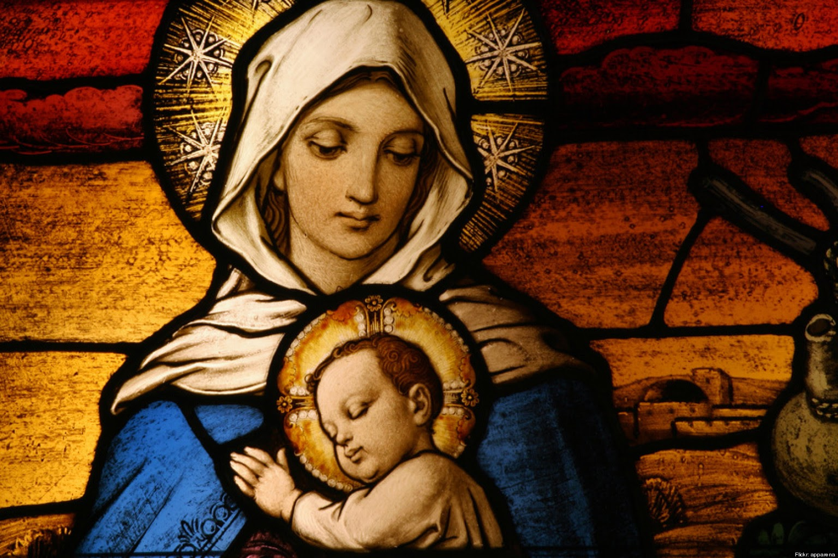

"Jesus, Mary, and Joseph, I love you very much. I beg you to spare the life of (baby's name) the unborn baby that I have spiritually adopted who is in danger of abortion. "

Prayer of Archbishop Fulton J. Sheen