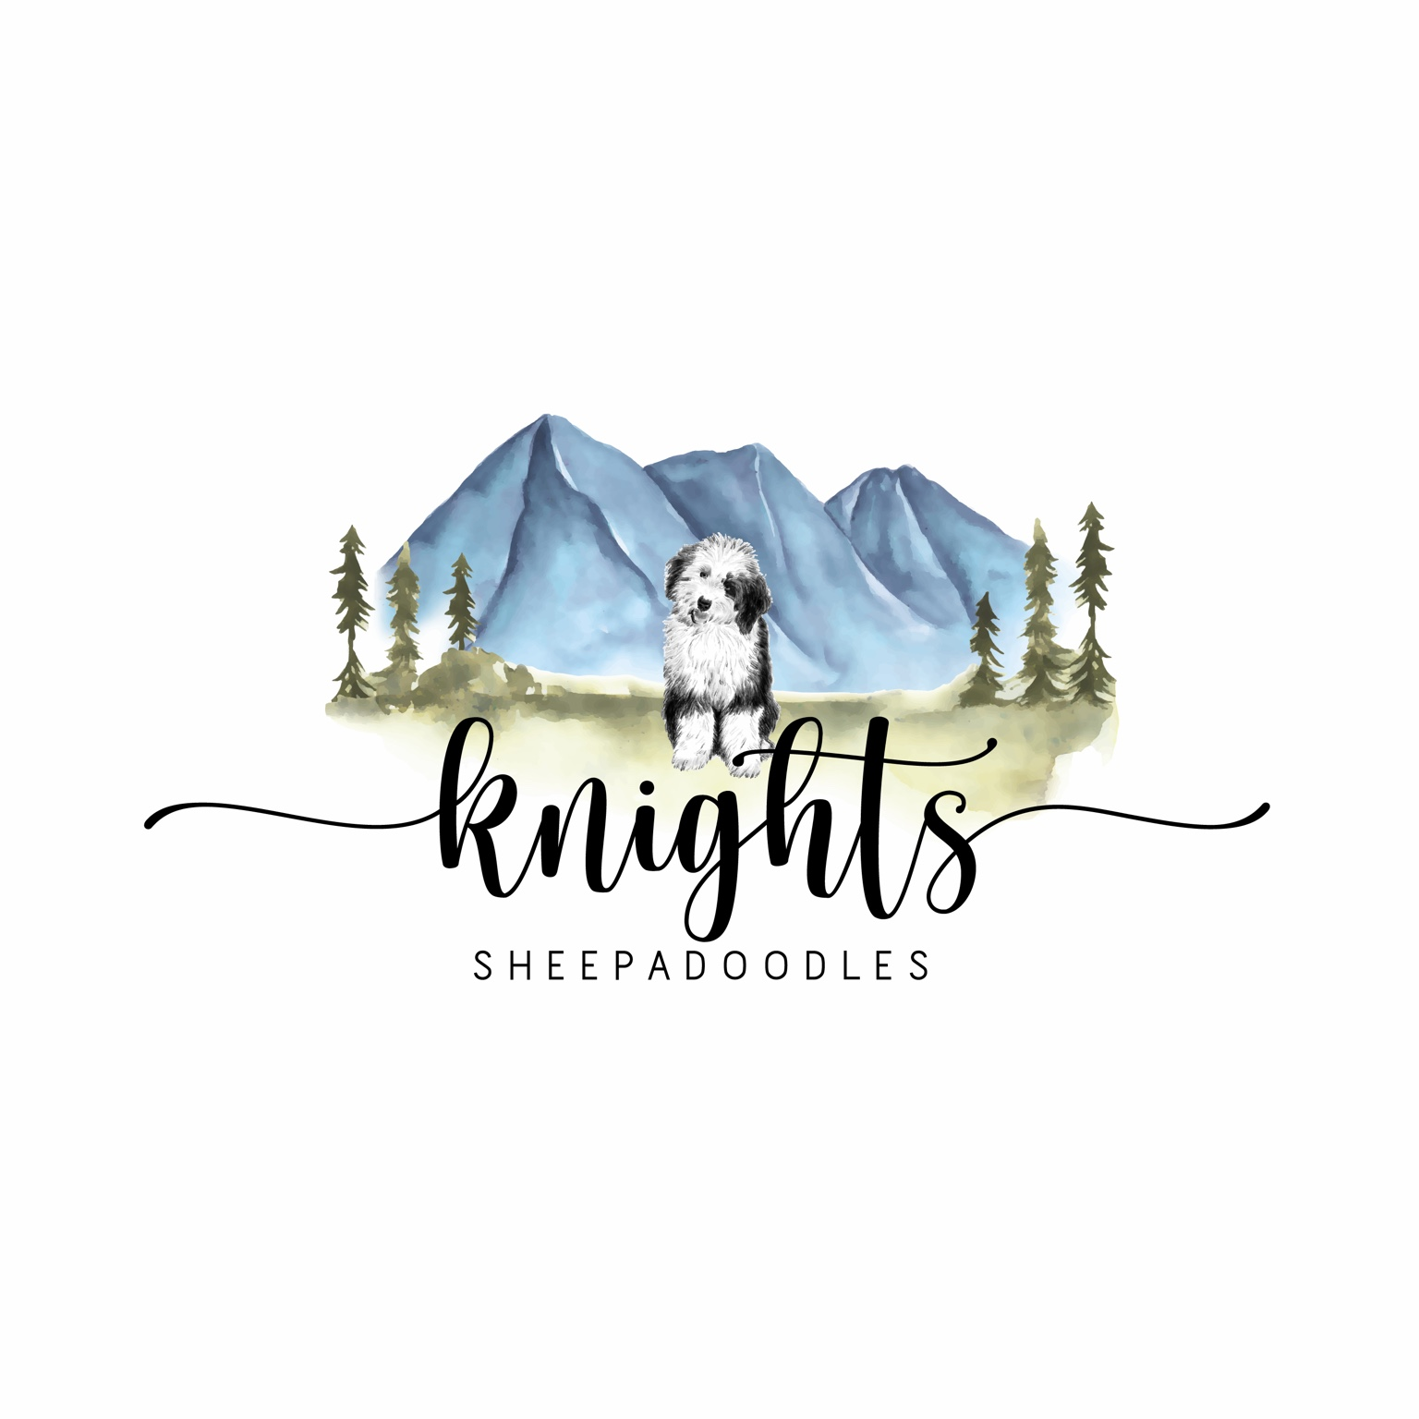
KNIGHTS SHEEPADOODLES
Sales Contract & Health Guarantee

11102 S Old Highway 191
Malad, Idaho 83252
Phone: 435-279-5208
Email: knightsheepadoodles@gmail.com
Website: www.knightssheepadoodles.com

BREEDER INFORMATION
Name: Elna Knight
Address: 11102 S Old Highway 191, Malad, Idaho 83252
Phone: 435-279-5208
Email: knightsheepadoodles@gmail.com

PURCHASER INFORMATION
Name:
Address:
City/State/Zip:
Email:
Phone:

PUPPY INFORMATION
Breed: Sheepadoodle
Color:
Date of Birth:
Mother:
Father:
Registration Status: Pet Only – NO BREEDING RIGHTS

Purchase Price: _________

Payment Method:
Cash / Check / Venmo / PayPal / Credit Card

HEALTH GUARANTEE
The seller guarantees the puppy is believed to be healthy at the time of sale and has received age-appropriate vaccinations and deworming.
The Buyer has three (3) days from receiving the puppy to have the puppy examined by a licensed veterinarian. Failure to do so voids the health guarantee.

GENETIC DISEASE GUARANTEE
We guarantee our puppies will not be affected by DM, PRA, VWDI, PCD, OCD, EIC, or GM2 until 2 years of age.

HIP DYSPLASIA POLICY
Knights Sheepadoodles does NOT cover hip dysplasia.
All breeding dogs have PennHIP and/or OFA testing. Hip dysplasia is influenced by environmental factors such as over-exercise, stairs, jumping, obesity, slippery floors, early spay/neuter, or injury. Because it is not strictly genetic, no compensation or warranty is offered.

CONDITIONS NOT COVERED
This guarantee does NOT cover:
• Dental issues
• Luxating patella
• Viral illness
• Infection
• Improper bites
• Hernias
• Hypoglycemia
• Heartworm
• Giardia
• Coccidiosis
• Injury, toxins, ingested objects
• Issues appearing after the 3-day exam
• Trauma, over-exercise, improper care

NECROPSY REQUIREMENT
If the dog dies for ANY reason, a necropsy MUST be performed by an accredited diagnostic facility.
Necropsies done in general veterinary clinics do NOT qualify.
Failure to obtain an accredited necropsy voids ALL rights to refund, replacement, or compensation.

REPLACEMENT/REFUND POLICY
If a hereditary defect (not hip dysplasia) is confirmed by two veterinarians:
1. Replacement puppy of equal value (within 24 months), OR
2. 25% refund of purchase price (excluding all expenses).

REHOMING AGREEMENT
If Buyer cannot keep the dog, it must be returned to Seller or Seller must be contacted to help rehome. The dog may NEVER be surrendered to a shelter. No refunds for rehoming.

LIMITATIONS
Seller does not guarantee size, coat type, color changes, or temperament.

EXPENSES
Buyer assumes all veterinary, training, grooming, and future expenses. No refunds for allergies, landlord issues, family disagreements, or training needs.

SPAY/NEUTER AGREEMENT
The dog may NOT be spayed/neutered before 12 months old.
The procedure MUST be completed by 18 months old.
Proof must be provided to seller.
Failure to comply voids the health guarantee and incurs a $7,500 breeding rights fee.
Any accidental or intentional pregnancy also incurs the $7,500 fee.

LEGAL
All disputes are handled in Oneida County, Idaho.
This is the full and final contract. No verbal agreements apply.

SIGNATURES
Breeder Signature: ____________________ Date: ___________
Purchaser Signature: ___________________ Date: ___________

